## NetSim - Batch Automation

NetSim Batch Automation allows users to execute a series of simulations without manual intervention.

Consider the example, where a user wishes to create and simulate thousands of network scenarios and store and analyze the performance metrics of each simulation run. It is impossible to do this manually using the GUI. However, this can be done by using NetSim Batch Automation script which runs NetSim via CLI.

Following is a depiction of how the files related to Batch automation is organized.

**File Organization**

**Pre – Configuring Batch Automation for first run:**

1. Open the folder Config_batch_run present in the NetSim_Batch_Automation directory.

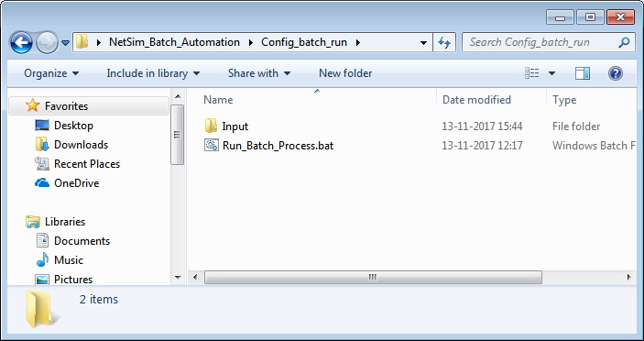

1. Open Run_Batch_Process.bat file in a text editor and modify the value of the variable NETSIM_PATH to the path where NetSim is installed in your system. Make sure that the path separator is modified to “\\” wherever you have “\”.

For Eg: If the path is “C:\Program Files\NetSim Standard\bin”, modify it to “C:\\Program Files\\NetSim Standard\\bin”. Save and close the file.

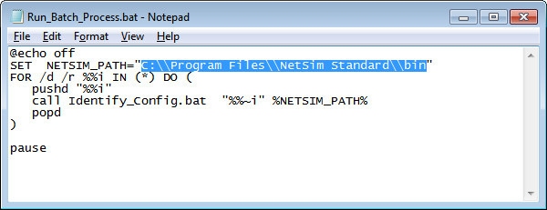

1. Open the Input folder present in the Config_batch_run directory.

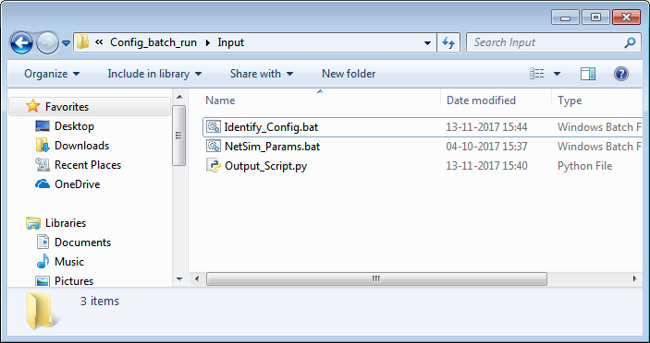

1. Open NetSim_Params.bat in a text editor and modify the NetSim license server IP as per the IP of the system that is running licenses in your network. Save and close the file.

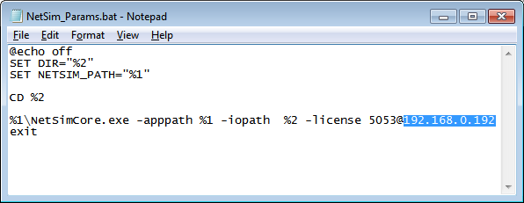

1. Open Output_Script.py in a text editor and modify the value of the variable OUTPUT_PATH to the path of NetSim_Batch_Automation directory in your system. This is the directory where the Output folder is present.

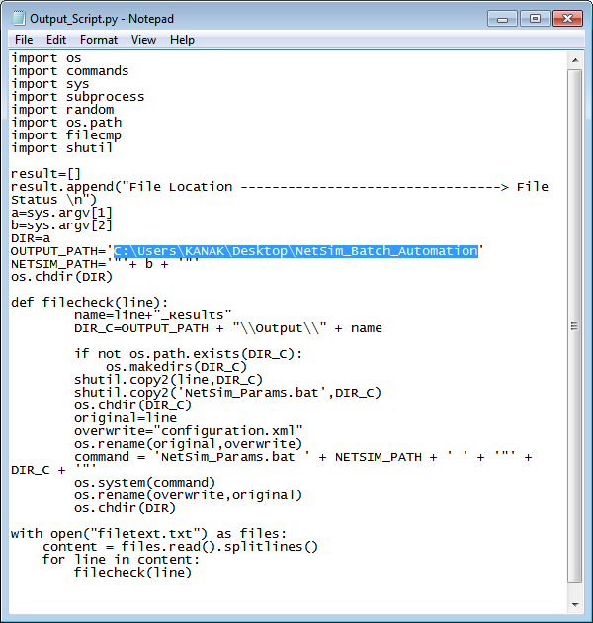

1. Create a system environment variable with name NETSIM_AUTO and set its value to 1. This is required to prevent user keystroke at the end of simulation.

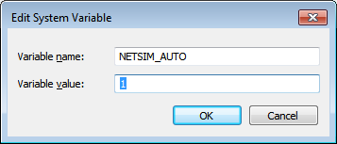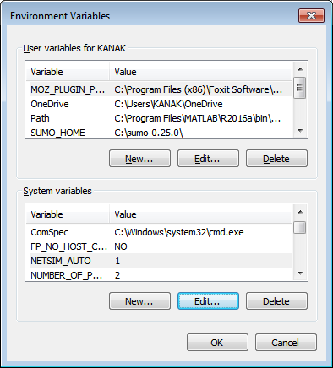

1. Users can place the input Configuration files inside the Input directory. The Configuration files need to be suitably renamed to avoid conflict, before placing in the input directory.

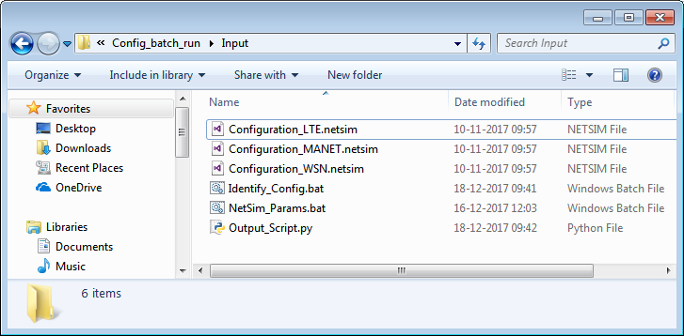

1. To start the Batch script the file Run_Batch_Process.bat can be double clicked. This will initiate a command window as shown below:

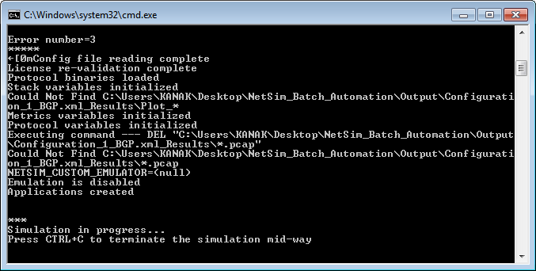

Configuration files placed in the Input Directory will be executed one after the other and the progress of each simulation can be viewed in the above window. This is similar to what happens when users click on the run simulation button in NetSim’s GUI.

1. Output files (Metrics.xml, PacketTrace.csv, EventTrace.csv, Animation.txt etc) based on whichever features were enabled, will be stored in dedicated folders inside the Output directory. The folders will have the Configuration file name followed by “_Results”.

For eg: If the configuration file has the name “Configuration_LTE.netsim” then the Output directory will have the name “Configuration_LTE.netsim_Results”.

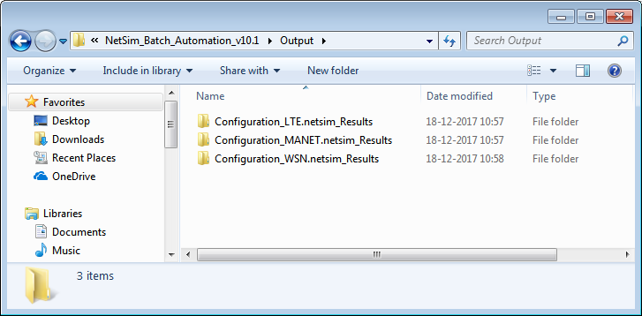

1. The Output folders can be backed up to prevent getting overwritten on subsequent runs. This may happen if a Configuration file with a similar name is simulated later.