# **NetSim - Batch Automation**

**Software:** NetSim Standard v13.3

**Project Download Link:**

## **Introduction**

NetSim Batch Auto Simulation allows users to execute a series of simulations without manual intervention.

Consider the example, where a user wishes to create and simulate hundreds of network scenarios, store and analyse the performance metrics of each simulation run. It is impossible to do this manually using the GUI. However, this can be done by using NetSim Batch Auto Simulation script which runs NetSim via CLI.

The project directory consists of a Batch_Script folder with the main batch script file and readme file as shown below:

Figure 1: Batch Script folder contains

## **Steps to Follow:**

1. The Batch file can be placed in a directory containing the NetSim experiment folders with Configuration.netsim file and other associated files such as static routing, mobility, acl etc if any.

Figure 2: NetSim experiment folders

1. Each input folder should contain a Configuration.netsim file as shown below:

Figure 3: Each folder should contains Configuration.netsim

1. A folder can also contain sub-folders with Configuration files as shown below:

Figure 4: Folder can also contain sub-folders

1. Additional files associated with the configuration file can also be present in the input folders as shown below:

Figure 5: Additional Input files

1. To start the Batch script open command window with current directory as the path where the BatchAutoSimulation.bat is present as shown below:

Figure 6: Open cmd prompt where BatchAutoSimulation.bat is present

1. Run the command with two arguments – app path (path of NetSim binaries) and license information respectively

**>BatchAutoSimulation.bat <apppath> <license information>**

* <apppath> - path of NetSim binaries

For Eg:

**C:\Users\ADMIN\Documents\NetSim\Workspaces\v13.3_std\bin_x64**

**<license information>** - License server details or the path of license file in case of node locked or cloud licenses

For Eg:

Server based license (<port no>@<server ip address>) – **5053@192.168.0.9**

Node Locked or Cloud licenses (path of license file) - **C:\Program Files\NetSim\Standard_v13_3\bin**

Command window with arguments passed to BatchAutoSimuation script in case of server-based licenses is shown below:

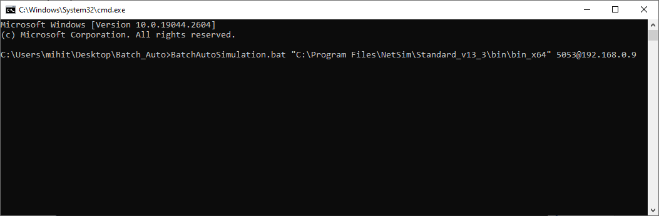

Figure 7: Run with Server-based licenses

Command window with arguments passed to BatchAutoSimulation script in case of node locked or cloud license is shown below:

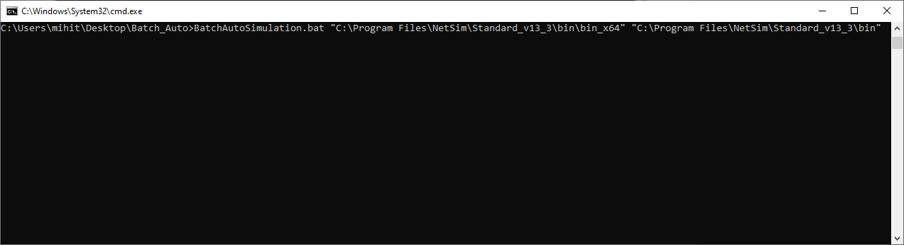

Figure 8: Run with of node locked or cloud license

1. After passing the arguments and running batch script, Configuration files placed in the Input Directories will be executed one after the other from each folder and subfolders.
2. Output files (Metrics.xml, PacketTrace.csv, EventTrace.csv, Animation.txt etc) based on whichever features were enabled, will be stored in respective folders which contained the Configuration.netsim file as shown below:

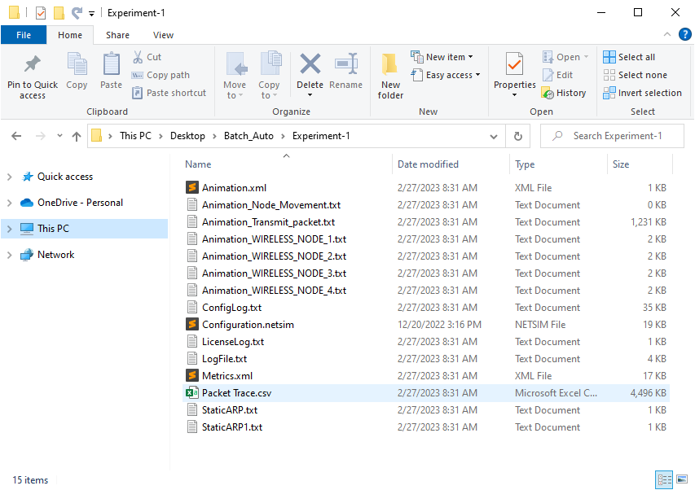

Figure 9: The generated output files present in respective folders

**Notes:**

* If you want to stop the simulation tests mid-way, close the CMD window prior to closing NetSim simulation window.
* If you pass the wrong arguments, quit the simulation by ending the process of 'Windows Command Processor' from Task Manager.
* Do not run the BatchAutoSimulation.bat by double-clicking. Run it only in a CMD window along with 2 arguments.