**NetSim SUMO Interfacing with Python 3.6**

**Software Used:** NetSim Standard v11, python-3.6.8, pywin32-224

Vehicular Adhoc Networks (VANETs) have been quite a rapidly growing research area in the last few years and has attracted much attention in both academia and industry. Prior to the implementations of VANETs on the roads, realistic computer simulations of VANETs using a combination of Urban Mobility simulation and Network simulation are necessary. Typically, a road traffic simulator and a network simulator are combined to study the performance of VANETs.

NetSim network simulator offers seamless interfacing with open source road traffic simulator SUMO on this regard. NetSim’s VANET simulation framework allows modelling VANETs per WAVE specifications, and covers IEEE1609, IEEE802.11p, SAE standard J2735.

NetSim provides facilities to customize various simulation parameters and provides extensive analysis on the network performance.

SUMO – Simulation of Urban Mobility is an open source, road traffic simulation package where we can model roads, vehicles, traffic signals etc.

NetSim can take a SUMO network configuration as input and additionally instantiate network stack for each vehicle and the underlying protocols and the communication medium, facilitating VANET simulations. No additional effort is required to interface NetSim with SUMO. NetSim installer is bundled with SUMO and gets locally installed along with NetSim.

NetSim versions starting from v9 to v11 are shipped with the following python scripst which are compatible with Python 2.7 and Pywin 32-220:

* SumoRun.py
* DevicePlacement.py

Download the Project directory using the GitHub link.

The python scripts present in the code folder has been updated to support Python 3.6.8 and Pywin 32-220

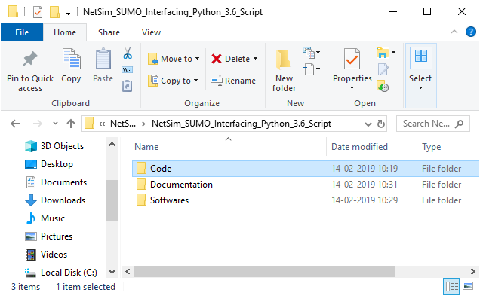

Procedure:

1. Go to the Software’s folder and install the Python and Pywin software setup one after the other.

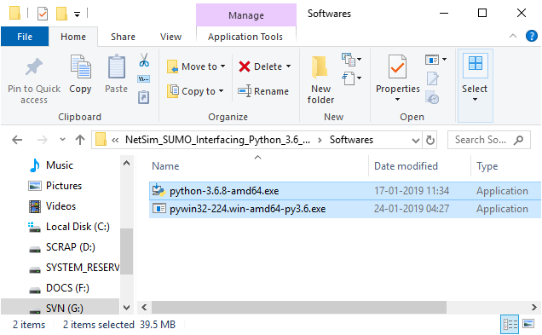

1. Copy the files DevicePlacement.py and SumoRun.py from the code folder.

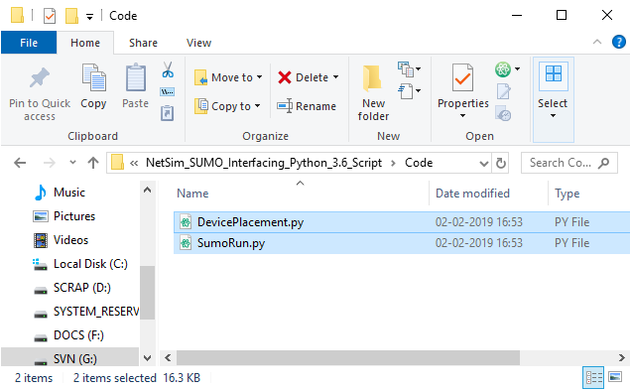

1. Replace the copied files instead of the existing ones in **<NetSim_Install_Directory>/bin** folder.

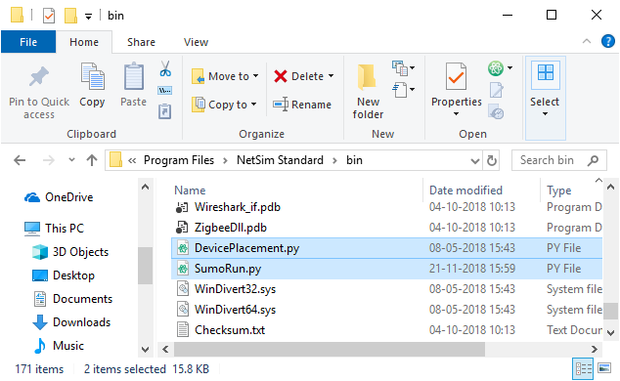

This will allow you to run VANET simulations in NetSim with Python 3.6 without the need for Python 2.7 which is an older version.

For additional information refer:

* NetSim User Manual section on VANETs
* Knowledge base articles at

<https://tetcos.freshdesk.com/support/solutions/folders/14000118424>

* Videos:
  + [How to Simulate VANETs in NetSim?](https://www.youtube.com/watch?v=koagJbQvZT8&list=PLS8vhyBd_bXlG_mD2CqGufiMCJ-AHJbSV&index=1)
  + [NetSim External Interfacing](https://www.youtube.com/watch?v=DGUGp6d6Un0&index=12&list=PLS8vhyBd_bXlG_mD2CqGufiMCJ-AHJbSV)
  + [Research on VANETs using NetSim](https://www.youtube.com/watch?v=5RW6PqF3gEg&index=38&list=PLS8vhyBd_bXlG_mD2CqGufiMCJ-AHJbSV)