### LCD Display Experiment

A liquid-crystal display (LCD) is a [flat-panel display](https://en.wikipedia.org/wiki/Flat_panel_display) or other [electronically modulated optical device](https://en.wikipedia.org/wiki/Electro-optic_modulator) that uses the light-modulating properties of [liquid crystals](https://en.wikipedia.org/wiki/Liquid_crystal). Liquid crystals do not emit light directly, instead using a [backlight](https://en.wikipedia.org/wiki/Backlight) or [reflector](https://en.wikipedia.org/wiki/Reflector_(photography)) to produce images in colour or [monochrome](https://en.wikipedia.org/wiki/Monochrome).[[1]](https://en.wikipedia.org/wiki/Liquid-crystal_display#cite_note-1) LCDs are available to display arbitrary images (as in a general-purpose computer display) or fixed images with low information content, which can be displayed or hidden, such as preset words, digits, and [7-segment](https://en.wikipedia.org/wiki/7-segment) displays, as in a [digital clock](https://en.wikipedia.org/wiki/Digital_clock). They use the same basic technology, except that arbitrary images are made up of a large number of small [pixels](https://en.wikipedia.org/wiki/Pixel), while other displays have larger elements.

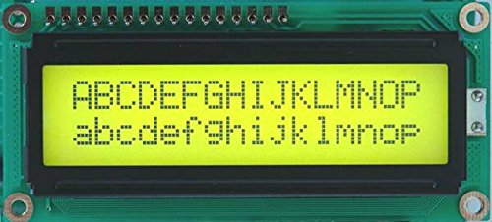

**Pin table to make connection**

|  |  |  |
| --- | --- | --- |
| LCD Pin | Function | GPIO Pin |
| 1 | GND | 6 |
| 2 | +5V | 2 |
| 3 | Contrast | 6 |
| 4 | Rs | 26 |
| 5 | RW | 6 |
| 6 | E | 24 |
| 11 | Data 4 | 22 |
| 12 | Data 5 | 18 |
| 13 | Data 6 | 16 |
| 14 | Data 7 | 12 |
| 16 | GND | 6 |

LCD Pin number 7,8,9,10 and 15 are not used

**Pin Diagram**

**Note:** In the pin diagram (below), pin numbering on Raspberry starts from Top Right Side. Therefore while making the connection start from the right side as below image does not represent the Entire board (left part of board is cut out).

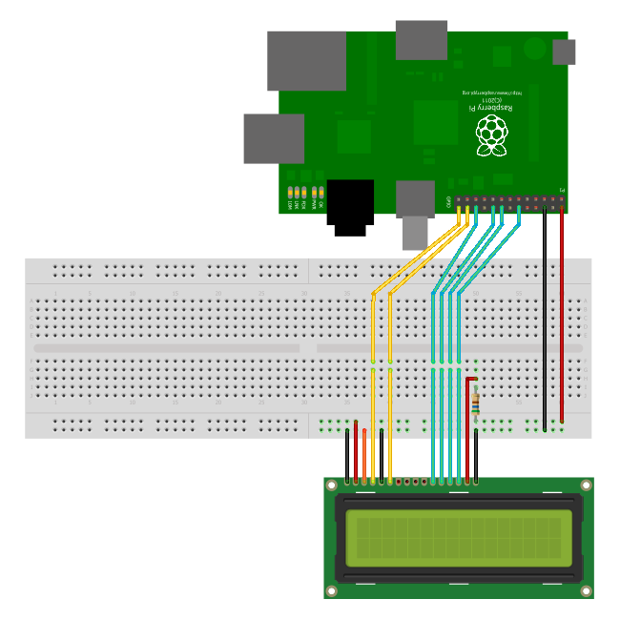

Sample Code to Display “TETCOS NETSIM”: **lcd_sample.py**

Code to receive the data from Socket and Display: **lcd.py**

**Note:**

1. By default UDP Port is set to “5005”, to change the port number make changes in line 9
2. Regularly check the console for errors.