### Numpad (4x4 Matrix Keypad) experiment

A keypad is a set of buttons arranged in a block or "pad" which bear digits, symbols or alphabetical letters. Pads mostly containing numbers are called a numeric keypad. Numeric keypads are found on [alphanumeric keyboards](https://en.wikipedia.org/wiki/Alphanumeric_keyboard) and on other devices which require mainly numeric input such as [calculators](https://en.wikipedia.org/wiki/Calculators), [push-button telephones](https://en.wikipedia.org/wiki/Push-button_telephone), vending machines, ATMs, Point of Sale devices, [combination locks](https://en.wikipedia.org/wiki/Combination_locks), and [digital door locks](https://en.wikipedia.org/wiki/Digital_door_lock). Many devices follow the [E.161](https://en.wikipedia.org/wiki/E.161) standard for their arrangement.

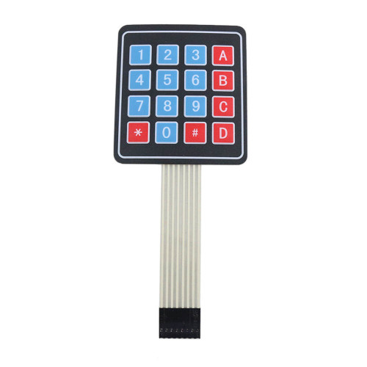

**Pin table to make connection**

|  |  |  |
| --- | --- | --- |
| Matrix Keypad | Resistor | BCM GPIO |
| 1 | Yes | 7 |
| 2 | Yes | 11 |
| 3 | Yes | 13 |
| 4 | Yes | 15 |
| 5 | Yes | 12 |
| 6 | Yes | 16 |
| 7 | Yes | 18 |
| 8 | Yes | 22 |

**Pin Diagram**



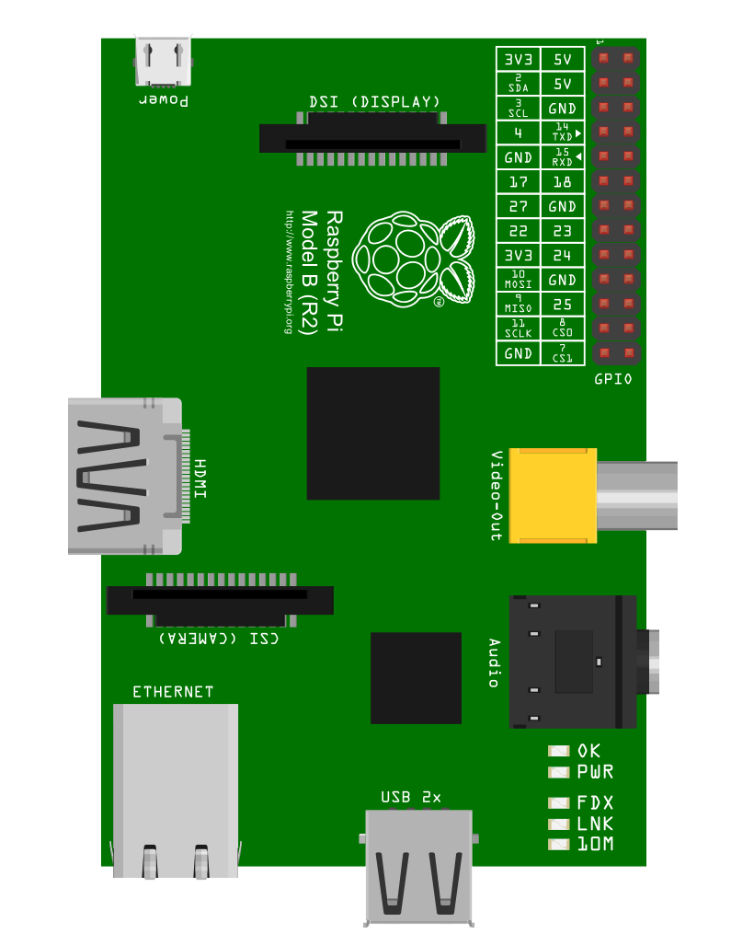

[7,11,13, 15, 12,16,18,22]

Sample Code to Display Input pressed in console: **keypad.py**

Code to send the input data through Socket: **keypad.py**

**Note:**

1. By default UDP Port is set to “5005” and IP to “10.10.1.20 “ to change the port number and IP address according to your receiver make changes in line 8 and 9
2. Regularly check the console for errors.