### 7 segment display experiment

A seven-segment display (SSD), or seven-segment indicator, is a form of electronic [display device](https://en.wikipedia.org/wiki/Display_device) for displaying [decimal](https://en.wikipedia.org/wiki/Decimal) [numerals](https://en.wikipedia.org/wiki/Numeral_system) that is an alternative to the more complex [dot matrix displays](https://en.wikipedia.org/wiki/Dot_matrix_display).

Seven-segment displays are widely used in [digital clocks](https://en.wikipedia.org/wiki/Digital_clock), electronic meters, basic calculators, and other electronic devices that display numerical information.

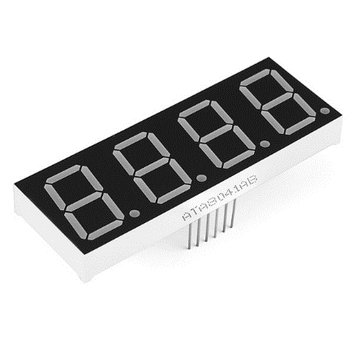

|  |  |  |  |
| --- | --- | --- | --- |
| Sed / digit | 7Seg Pin | Resistor | BCM GPIO |
| Bot left | 1 | Yes | 7 |
| Bot centre | 2 | Yes | 8 |
| Decimal pt | 3 | Yes | 25 |
| Bot right | 4 | Yes | 23 |
| Centre centre | 5 | Yes | 18 |
| Digit 4 | 6 | No | 24 |
| Top right | 7 | Yes | 4 |
| Digit 3 | 8 | No | 17 |
| Digit 2 | 9 | No | 27 |
| Top left | 10 | Yes | 10 |
| Top Centre | 11 | No | 11 |
| Digit 1 | 12 | Yes | 22 |

**Pin table to make connection**

**Pin Diagram**

**Note:** In the pin diagram (below), pin numbering on Raspberry starts from Top Right Side. Therefore while making the connection, start from the right side as below image does not represent the entire board (left part of board is cut out)

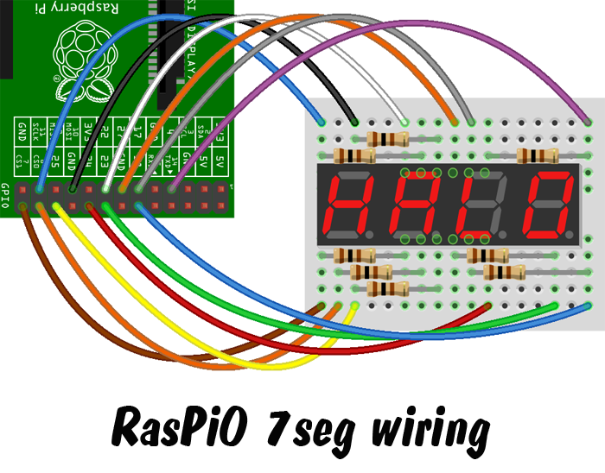

Sample Code to Display Time: **7segment_sample.py**

Code to receive the data from Socket and Display: **7segment.py**

**Note:**

1. By default, UDP Port is set to “5005” to change the port number make changes in line 12
2. Regularly check the console for errors.
3. If below error has occurred than it is because it received a character which is not present in the dictionary. This can be added by add an entry in num variable present in line 25