## Sensor Emulation. NetSim – Raspberry Pi Interfacing

### Introduction

The Raspberry Pi is a series of small [single-board computers](https://en.wikipedia.org/wiki/Single-board_computer) developed in the [United Kingdom](https://en.wikipedia.org/wiki/United_Kingdom) by the [Raspberry Pi Foundation](https://en.wikipedia.org/wiki/Raspberry_Pi_Foundation) to promote the teaching of basic [computer science](https://en.wikipedia.org/wiki/Computer_science) in schools and in [developing countries](https://en.wikipedia.org/wiki/Developing_countries). Several generations of Raspberry Pis have been released.

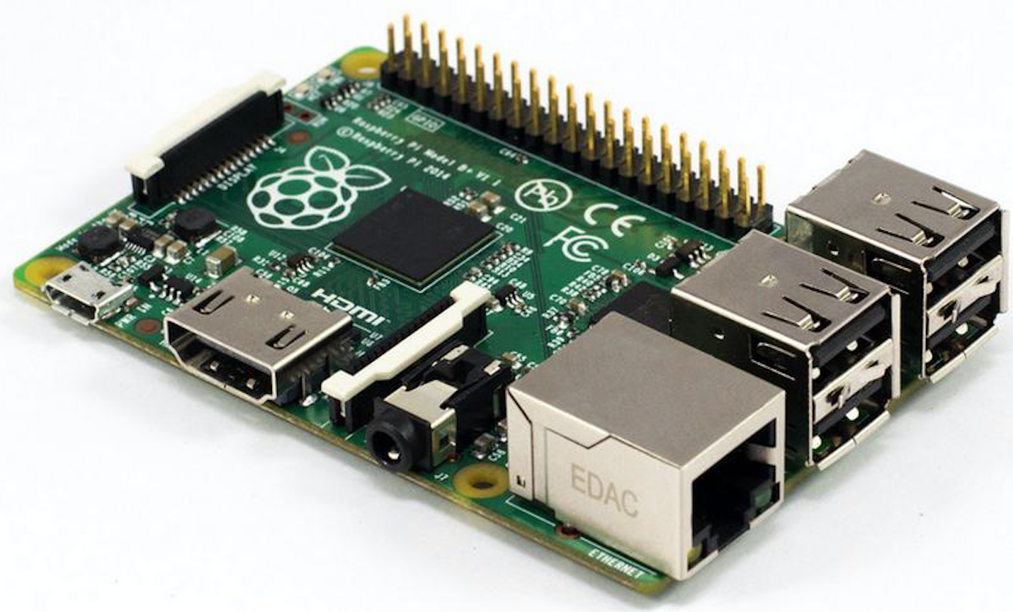

All models feature a [Broadcom](https://en.wikipedia.org/wiki/Broadcom) [system on a chip](https://en.wikipedia.org/wiki/System_on_a_chip) (SoC) with an integrated [ARM](https://en.wikipedia.org/wiki/ARM_architecture) compatible [central processing unit](https://en.wikipedia.org/wiki/Central_processing_unit) (CPU) and [on-chip graphics processing unit](https://en.wikipedia.org/wiki/Graphics_processing_unit#Integrated_graphics) (GPU). Processor speed ranges from 700 MHz to 1.2 GHz for the Pi 3 and on-board memory range from 256 MB to 1 GB RAM. [Secure Digital](https://en.wikipedia.org/wiki/Secure_Digital) (SD) cards are used to store the operating system and program memory in either SDHC or MicroSDHC sizes. Depending on the model; the boards have either a single USB port or up to four USB ports. For video output, [HDMI](https://en.wikipedia.org/wiki/HDMI) and [composite video](https://en.wikipedia.org/wiki/Composite_video) are supported, with a standard 3.5 mm phono jack for audio output. Lower level output is provided by a number of GPIO pins which support common protocols like [I²C](https://en.wikipedia.org/wiki/I%C2%B2C). The B-models have an [8P8C](https://en.wikipedia.org/wiki/8P8C) [Ethernet](https://en.wikipedia.org/wiki/Ethernet) port and the Pi 3 and Pi Zero W have on-board Wi-Fi 802.11n and [Bluetooth](https://en.wikipedia.org/wiki/Bluetooth).

The Foundation provides [Raspbian](https://en.wikipedia.org/wiki/Raspbian), a Debian-based [Linux distribution](https://en.wikipedia.org/wiki/Linux_distribution) for download, as well as third-party [Ubuntu](https://en.wikipedia.org/wiki/Ubuntu_(operating_system)), [Windows 10 IOT Core](https://en.wikipedia.org/wiki/Windows_10_IoT_Core), [RISC OS](https://en.wikipedia.org/wiki/RISC_OS), and specialised [media center](https://en.wikipedia.org/wiki/OpenELEC) distributions. It promotes [Python](https://en.wikipedia.org/wiki/Python_(programming_language)) and [Scratch](https://en.wikipedia.org/wiki/Scratch_(programming_language)) as the main programming language, with support for many other languages The default [firmware](https://en.wikipedia.org/wiki/Firmware) is [closed source](https://en.wikipedia.org/wiki/Closed_source), while an unofficial [open source](https://en.wikipedia.org/wiki/Open_source) is available.

### Getting Started

Setting up the Raspberry Pi involves the following steps:

1. Installing Operating System
2. Booting up Raspberry Pi
3. Assigning Static IP to pi
4. Change password of Raspberry pi and update it
5. Changing routes connecting to NetSim Emulator
6. Installing Operating System
   1. Install Raspbian or any other Raspberry pi supported OS on the Micro sd card. You can download Raspbian Jessie with Desktop from <https://www.raspberrypi.org/downloads/raspbian/> .
   2. Format the SD card using some SD card formatter like sdFormatter from <https://www.sdcard.org/downloads/formatter_4/> for Windows and Mac.
   3. Flash the Operating system image file into the SD card. Win32DiskImager or Etcher can be used for that purpose.
7. Booting up Raspberry Pi
   1. Booting with Monitor, Keyboard, and Mouse connected with Raspberry pi

A USB compatible Keyboard, Mouse and a HDMI Monitor is required if you are following this method for first booting. If Monitor available is VGA, then a VGA to HDMI converter may be used to connect Monitor to pi.

On Connecting monitor, keyboard and mouse, the O.S. would boot up and prompt for user id and password.

The default user id for Raspberry pi is “pi” and password is “raspberry”.

* 1. Booting without Monitor in a windows based system
     1. Create a blank file with name ssh and put it into the boot directory of SD card installation files.
     2. This is required because ssh is by default disabled in the latest version of Raspberry pi.
     3. Download putty from <https://www.chiark.greenend.org.uk/~sgtatham/putty/latest.html> .
     4. Install 32 bit version or 64 bit version as per your computer specifications.
     5. Insert SD card into pi and connect 5v power cable to a AC power source. Connect pi with your computer through LAN cable. Your computer should be connected to a Wi-Fi Network and which should be shared with Ethernet so as the Raspberry pi can also access Internet.
     6. Pi would automatically boot up.
     7. Open command prompt and execute the following command-
     8. Ping raspberrypi.mshome.net. You would get the ip address associated with the pi like 192.168.137.42. Initially it might give some error because pi takes some time to boot up.
     9. Open putty and enter the ip address of pi.
     10. In connection, set the time between keep lives to 10 s. In X11 submenu in ssh, Enable X11 forwarding.
     11. Go to session menu and click on Open Session.
     12. You would be redirected to a ssh terminal.
     13. Enter the login id as pi
     14. Enter password as “raspberry”.

After boot up, you may connect pi to an Ethernet Network port. Then get the IP of the pi and you may login from any device connected to the same Network using VNC viewer.

1. Assigning static IP to Pi

To assign a static IP address to the Raspberry Pi execute the command

**sudo nano /etc/dhcpcd.conf** in the terminal.

Add the following lines at the top of file:

**Interface eth0**

**static ip_address=192.168.0.121**

**static routers= 192.168.0.1**

**static domain_name_servers=192.168.0.1**

1. Configuring and updating the Raspberry Pi
2. Change your keyboard layout-
   1. sudo raspi-config
   2. Select <Localisation Options menu>, Select < Change Keyboard Layout> , select Keyboard model as default model which is <Generic 105-Key (Intl) PC>. Select keyboard Layout as <Other>. Select Country of Origin for the Keyboard as English (US).
   3. Select the default options after that till it comes back to the home page of rasp-config.
   4. Exit using Esc.
3. You can change your password using-
   1. passwd
4. Update the softwares installed on pi using
   1. sudo apt-get update
   2. sudo apt-get upgrade
5. To Install realvncserver
   1. sudo apt-get install realvnc-vnc-server
   2. sudo apt-get install realvnc-vnc-viewer
6. To enable vnc on pi, run
   1. sudo raspi-config
   2. Go to <Interfacing Options> and then select <Yes> when “would you like the VNC server to be enable” is prompted.
   3. Similarly, you may enable ssh by going to ssh option.
7. You can change the resolution of your pi by going to <Advanced Options> , select <Resolution> and then select the desired resolution.
   1. Set resolution so as to match with your Monitor. When you directly connect the pi to Monitor, the default resolution is recommended otherwise you might not be able to get display signals on Monitor if resolution is set to a high value.
8. You may now open vnc viewer and log in to your pi remotely using the login id and password.
9. Changing routes for connecting to NetSim Emulator
   1. Open Raspberry PI terminal and apply **“sudo su”**
   2. Apply **“nano /etc/sysctl.conf”** command and edit the file by adding the following comment
   3. **net.ipv4.ip_forward=1**
   4. To save and Exit
   5. **[Ctrl] + X, then chose yes or no**
   6. Apply **“nano /etc/sysctl”** command
   7. Then add the following comments
      1. **IP_DYNIP=”no”**
      2. **IP_TCP_SYNCOOKIES=”yes”**
      3. **IP_FORWARD=”yes”**
   8. Follow step 3
      1. Apply **“nano /etc/dhcpcd.conf”**
   9. Change the ”static routers” to NetSim Server IP as shown in the below image

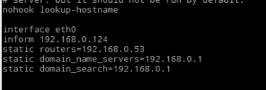

* 1. Apply **“route”** command



* 1. Apply **“ip r del <network ip>/24”**

**Eg: ip r del 192.168.0.0/24**

* 1. Apply **“ping <any ip within the network>”**.

**Eg: ping 192.168.0.202**

### Interfacing Raspberry Pi with NetSim

Steps to interface Raspberry Pi with NetSim:

1. Physically connect Sensor and Raspberry pi and connect the raspberry pi with network.
2. Perform standalone experiment with raspberry pi and sensor to check the connections and Understanding of working of sensor with Raspberry Pi
3. Performing Experiment with two Raspberry Pi across the network
4. Run NetSim Internet of Things (IOT) Emulation with default network parameters
5. Analysis of network with NetSim with different parameters in NetSim e.g. Delay, Path loss, Jitter, etc.

### Different Experiments with Raspberry Pi

1. Blink experiment - Simple LED on/off experiment
2. Distance Ultrasonic experiment – Measure obstacle distance from the sensor
3. 4X4 Matrix Keypad experiment – Take the Input from keypad and display it
4. Light Sensor experiment – Measure the light intensity with the sensor
5. Motion Sensor experiment – Intrusion detection using PIR Motion Sensor
6. 7 segment display experiment – output the numerical value on the display
7. 3D Accelerometer experiment – Measure the direction of motion and acceleration of Sensor using Triaxle Accelerometer (ADXL345)
8. Scrolling Text experiment- Display the Scrolling Text on 8X8 Matrix Led.
9. Humidity Measurement experiment – Measure the surrounding humidity with DHT-11 (Blue) Sensor
10. LCD experiment – Display custom content on LCD Screen
11. 74HC595 IC experiment - 74HC595 can transform serial input of 8-bit data into parallel output of 8-bit data. Driving 10 LED with single raspberry pi

### Different Experiments with NetSim Interfacing

1. Send the data Input via Numpad (4X4 Keypad) of Raspberry Pi 1 to seven-segment display of Raspberry Pi 2 through NetSim
2. Use NetSim to send data collected by 3D accelerometer sensor of Raspberry Pi 1 to LCD Display of Raspberry Pi 2
3. Send pings between 2 Raspberry Pi’s and check the ping statistics by changing network parameters in NetSim
4. Turn LED on/off in Raspberry Pi 1 based on intrusion detection in Raspberry Pi 2, via NetSim
5. Use Wireshark and analyze the real-time traffic of network in the above experiments