**NetSim Network Scenario Generator**

**Software:** NetSim v13.1 (64 bit), Visual Studio 2019 Community edition or higher.

**Project Download Link:**

**Introduction**

NetSim uses an XML Configuration file (Configuration.netsim) which contains the network scenario details including the device configuration, connection information, simulation parameters, etc. This file is automatically generated by the GUI whenever user creates a Network scenario using the GUI. This file is read by the simulation process when simulation is started. This file also acts as an input to the GUI to load any saved network scenarios.

The configuration file writing process can be automated to generate large network scenarios with specific device, link and traffic settings.

The NetSim Network Scenario Generator is an example of how users can generate network configuration files.

**File Organization**

The project directory consists of Documentation, Network Scenario Generator Scripts and associated source codes.

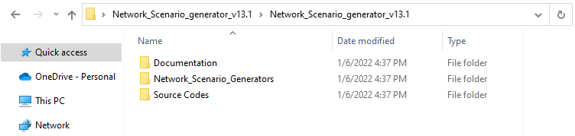

**Figure 1:** Project directory

The directory of Network Scenario Generator associated with each network consists of an executable to which users can pass arguments via command line to generate a Configuration.netsim file.

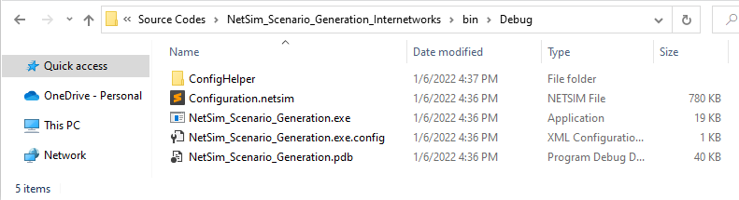

**Figure 2:** Network Scenario Generator associated with executable files

The ConfigHelper directory which is part of the directory each Network’s Scenario Generator consists of the properties of devices, links and applications that are supported in the specific network in NetSim.

**Figure 3:** Network’s Scenario Generator consists of the properties of devices, links, and applications etc

The properties related to Devices, Links and Applications can be modified by editing respective files in the ConfigHelper folder. A short explanation about the contents of the ConfigHelper directory is given in the following table:

|  |  |
| --- | --- |
| **File Name** | **Description** |
| Node Folder | Parameters related to Wired Node properties.  (All 5 Layers) |
| Router Folder | Parameters related to Router properties. (Incl Routing protocol) |
| Switch Folder | Parameters related to switching properties. |
| Application.txt and Application_Config.txt | Parameters related to Application Properties |
| guiInfo.txt | Parameters related to Network Design Environment settings |
| Link.txt | Parameters related to link properties |
| Protocol_Configuration.txt | Parameters related to general protocol configuration like ARP. |
| Statistics_Collection.txt | Parameters related to advanced options like Packet Trace, Event Trace, and Emulator PCAP files. |

**Table 1:** Different folder available in Config Helper folder

**Running the Scenario Generator:**

To run the scenario generator command prompt should be opened in the directory containing the scenario generator executable file. Then arguments can be passed to the executable via command line. Upon successful execution of the script the output Configuration.netsim file gets created the same folder that contains the scenario generator executable file.

The input arguments may vary for the scenario generator associated with each network technology.

**Internetworks:**

**NetSim_Scenario_Generation.exe**<space>**<Number_of_Router_Interface>**<Space>**<Number_of_Hops>**<Space>**<Number_of_Nodes>**<Space>**<Number_of_application>**<Space>**<ConfigHelper_Path>**<Space>**<ExperimentName>**<Space>**<NetSim_Version_Name>**Space>**<Simulation_Time>**

|  |  |
| --- | --- |
| **Parameter** | **Description** |
| **<Number of Router Interfaces>** | Specifies the number of interfaces of each router where the minimum is 3 and the maximum is 24. |
| **<Number of Hops>** | Specifies the number of hops to reach the destination. i.e 2, 4 or 6. |
| **<Number of Nodes>** | Specifies the number of Wired nodes to generate, which takes a value in the range 1 to 1,00,000. |
| **<Number of applications>** | Specifies the number of applications to model with a minimum of 1 and a maximum of 1,00,000 Applications.  Formula: No. of node*(No. of node-1)/2 |
| **<ConfigHelper_Path>** | Specifies the path to the ConfigHelper folder in the directory. *Eg: C:\Users\SPEED MT5811\Desktop\Internetworks Scenario Generator* |
| **<Experiment Name>** | Specifies the name of the experiment. |
| **<NetSim_Version_Name>** | Specifies the NetSim Version, For example '**PRO**' or ‘**STANDARD’** |
| **<Simulation Time> in seconds** | Specifies the simulation time in seconds to simulate the network scenario   30s < T <100000s |

**Table 2:** Each commands ParameterDescription

For example,

To generate a network scenario with 10 routers, a hop count of 5, 100 wired nodes and 100 applications following arguments are passed as input to the NetSim_Scenario_Generation.exe file.

C:\Users\Navya\Desktop\Network_Scenario_generator_v13.1\Network_Scenario_generator_v13.1\Source Codes\NetSim_Scenario_Generation_Internetworks\bin\Debug NetSim_Scenario_Generation.exe 10 5 100 100 "C:\Users\Navya\Desktop\Network_Scenario_generator_v13.1\Network_Scenario_generator_v13.1\Source Codes\NetSim_Scenario_Generation_Internetworks\bin\Debug" "INTERNETWOKS" "PRO" 100

**Figure 4:** Run all above the cmds in cmdprompt

After successful execution of the command, the output Configuration.netsim file gets created in the same location where the NetSim_Scenario_Generator.exe file is present.

**Figure 5:**Outputconfiguration.netsim created in particular folder

The network when opened in NetSim after importing the output Configuration.netsim file that gets generated is shown below:

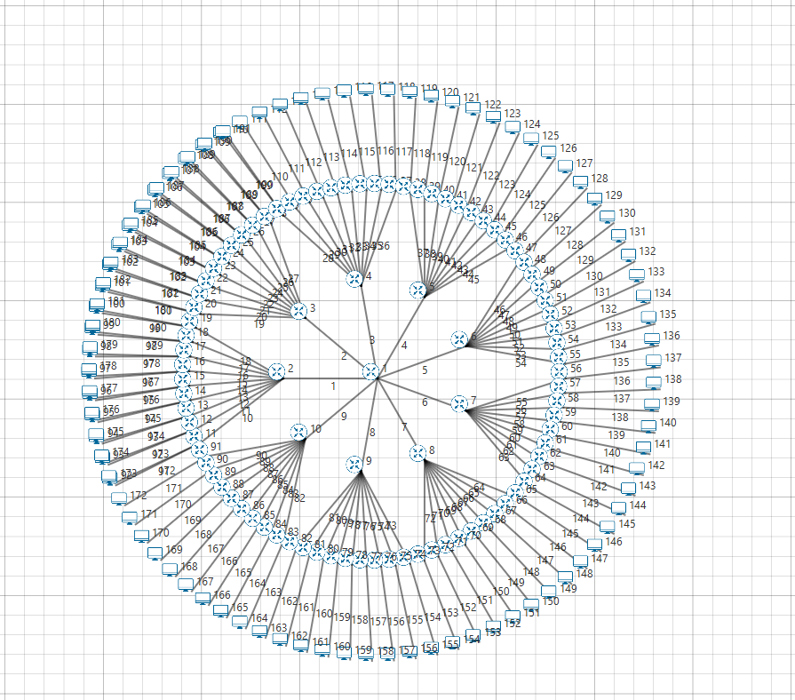

**Figure 6:** Network Scenario created using Generator

**5GNR:**

**NetSim_Scenario_Generation_5GLTE.bat <space> <Number of Router> <Space> <Number of Wirednode> <Space> <Number of gNB> <Space><Number of UE><space><Number of EPC><space><Number of applications> <Space><ConfigHelper_Path> <Space> <Experiment Name> <Space><NetSim_Version_Name> <Space><NetSim_Version_Number> <Space> <Simulation Time>**

|  |  |
| --- | --- |
| Parameter | Description |
| <Number of Router > | Specifies the number of interfaces of each router where the minimum is 1 and the maximum is 24. |
| <Number of Nodes> | Specifies the number of Wired nodes to generate, which takes a value in the range 4*(max_router - 1) |
| <Number of gNbs> | Specifes the number of gNnbs |
| <Number of UEs> | Specifies the number of Ues to generate, which takes a value in the range 1 – 10000 and multiple of max_enbs |
| <EPC> | Fixed to 1 only don’t change |
| <Number of applications> | Specifies the number of applications to model with a minimum of 1 and a maximum of 1,00,00 0 Applications. Formula: No. of node*(No. of node-1)/2) |
| <ConfigHelper_Path> | Specifies the path to the ConfigHelper folder in the directory. *Eg: C:\Users\SPEED MT5811\Desktop\Network Scenario Generator* |
| <Experiment Name> | Specifies the name of the experiment. |
| <NetSim_Version_Name> | Specifies the NetSim Version, For example '**PRO**' or ‘**STANDARD’** |
| <NetSim_Version_Number> | “13.1.26” |
| <Simulation Time> in seconds | Specifies the simulation time in seconds to simulate the network scenario   30s < T <100000s |

**Table 3**: Each commands Parameter Description

For example,

To generate a network scenario with 1 router, 1 wired node, 1 gNB, 100 UEs, 1 EPC and 1 applications following arguments are passed as input to the NetSim_Scenario_Generation.exe file.

**E:\AE_Task\FE_Project_V13_1\Network_Scenario_generator_v13.1\Network_Scenario_generator_v13.1\Network_Scenario_Generators\NetSim_Scenario_Generation_5GLTE>NetSim_Scenario_Generation_5GLTE.bat 1 1 1 100 1 1 "E:\AE_Task\FE_Project_V13_1\Network_Scenario_generator_v13.1\Network_Scenario_generator_v13.1\Network_Scenario_Generators\NetSim_Scenario_Generation_5GLTE" "100_NODES" "PRO" "13.1.26" 100**

**Figure 7:** Run all above the cmds in cmd prompt for both SA and NSA mode

After successful execution, the output Configuration.netsim file gets created inside the NetworkScenarioGenerator_v13directory which contains the NetSim_Scenario_Generation_5GLTE.bat file as shown below:

**Figure 8:** Output Configuration.netsim created in particular folder

The network when opened in NetSim after importing the output Configuration.netsim file that gets generated is shown below:

**Figure 9:** Network Scenario created using Generator

**LTE:**

**NetSim_Scenario_Generation_LTE.exe**<space>**<Number_of_Router>**<Space>**<Number_of_Nodes>**<Space**><Number_of_eNBs>**<Space>**<Number_of_Ues>**<Space>**<EPC>**<Space>**<Number_of_application>**<Space>**<ConfigHelper_Path>**<Space>**<ExperimentName>**<Space>**<NetSim_Version_Name><**Space>**<NetSim_Version_Number>**<Space>**<Simulation_Time>**

|  |  |
| --- | --- |
| Parameter | Description |
| <Number of Router > | Specifies the number of interfaces of each router where the minimum is 1 and the maximum is 24. |
| <Number of Nodes> | Specifies the number of Wired nodes to generate, which takes a value in the range 4*(max_router - 1) |
| <Number of enbs> | Specifes the number of enbs to generate, which takes a value in the range 1 to 98 |
| <Number of Ues> | Specifies the number of Ues to generate, which takes a value in the range 1 – 10000 and multiple of max_enbs |
| <EPC> | Fixed to 1 only don’t change |
| <Number of applications> | Specifies the number of applications to model with in the range of : 1- max_node * max_ue. |
| <ConfigHelper_Path> | Specifies the path to the ConfigHelper folder in the directory. *Eg: C:\Users\SPEED MT5811\Desktop\Network Scenario Generator* |
| <Experiment Name> | Specifies the name of the experiment. |
| <NetSim_Version_Name> | Specifies the NetSim Version, For example '**PRO**' or ‘**STANDARD’** |
| <NetSim_Version_Number> | “13.1.26” |
| <Simulation Time> in seconds | Specifies the simulation time in seconds to simulate the network scenario   30s < T <100000s |

**Table 4:** Each commands Parameter Description

**For example,**

To generate a network scenario with 1 router, 1 wired node, 1 eNB, 10 UEs, 1 EPC and 10 applications following arguments are passed as input to the NetSim_Scenario_Generation_LTE.exe file.

C:\Users\Mataji\OneDrive\Desktop\Network_Scenario_generator_v13.1\Network_Scenario_generator_v13.1\Network_Scenario_Generators\NetSim_Scenario_Generation_LTE>NetSim_Scenario_Generation_LTE.exe 1 1 1 10 1 10 "C:\Users\Mataji\OneDrive\Desktop\Network_Scenario_generator_v13.1\Network_Scenario_generator_v13.1\Source Codes\NetSim_Scenario_Generation_LTE\bin\Debug" "LTE" "STANDARD" "13.1.25" 100

**Figure 10:** Run all above the cmds in cmdprompt

After successful execution of the command, the output Configuration.netsim file gets created in the same location where the NetSim_Scenario_Generation_LTE.exe file is present.

**Figure 11:** Output Configuration.netsim created in particular folder

The network when opened in NetSim after importing the output Configuration.netsim file that gets generated is shown below:

**Figure 12:**Network Scenario created using Generator

**MANETs:**

**NetSim_Scenario_Generation_Manet.exe**<space>**<Number_of_Nodes>**<space>**<Number_of_applications>**<space>**<ConfigHelper_Path>**<space>**<ExperimentName>**<Space>**<NetSim_Version_Name>**<Space>**<Simulation Time>**

|  |  |
| --- | --- |
| **Parameter** | **Description** |
| **<Number of Nodes>** | Specifies the number of Wireless nodes to generate, which takes a value in the range 2 to 1,00,000. |
| **<Number of applications>** | Specifies the number of applications to model with a minimum of 1 and a maximum of 1,00,000 Applications.  Formula: No. of node*(No. of node-1)/2 |
| **<ConfigHelper_Path>** | Specifies the path to the ConfigHelper folder in the directory. *Eg: C:\Users\Admin\Desktop\Internetworks Scenario Generator* |
| **<Experiment Name>** | Specifies the name of the experiment. |
| **<NetSim_Version_Name>** | Specifies the NetSim Version, For example '**PRO**' or ‘**STANDARD’** |
| **<Simulation Time> in seconds** | Specifies the simulation time in seconds to simulate the network scenario   30s < T <100000s |

**Table 5:** Each commands Parameter Description

For example,

To generate a network scenario with 100 wireless nodes and 100 applications following arguments are passed as input to the NetSim_Scenario_Generation.exe file.

C:\Users\Mataji\OneDrive\Desktop\Network_Scenario_generator_v13.1\Network_Scenario_generator_v13.1\Network_Scenario_Generators\NetSim_Scenario_Generation_Manet>NetSim_Scenario_Generation_Manet.exe 100 100 "C:\Users\Mataji\OneDrive\Desktop\Network_Scenario_generator_v13.1\Network_Scenario_generator_v13.1\Source Codes\NetSim_Scenario_Generation_Manet\bin\Debug" "MANET" "STD" 100

**Figure 13:** Run all above the cmds in cmdprompt

After successful execution of the command, the output Configuration.netsim file gets created in the same location where the NetSim_Scenario_Generation_MANET.exe file is present.

**Figure 14:** Output Configuration.netsim created in particular folder

The network when opened in NetSim after importing the output Configuartion.netsim file that gets generated is shown below:

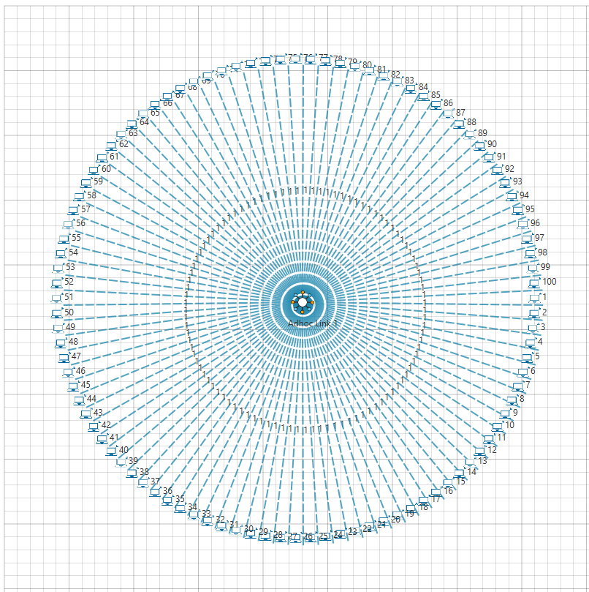

**Figure 15:** Network Scenario created using Generator

**IoT:**

**NetSim_Scenario_Generation_IOT.exe**<space>**<Number_of_Routers>**<space>**<Number_of_WiredNodes>**<space>**<Number_of_Sensors>**<space>**<Number_of_applications>**<space>**<ConfigHelper_Path>**<Space>**<Experiment_Name>**<Space>**<NetSim_Version_Name>**<Space>**<Simulation_Time>**

|  |  |
| --- | --- |
| **Parameter** | **Description** |
| **<Number of Routers>** | Specifies the number of routers to generate, which takes a value in the range 1 to 1,00,000. |
| **<Number of Wired Nodes>** | Specifies the number of Wired nodes to generate, which takes a value in the range 1 to 1,00,000. |
| **<Number of Sensor Nodes>** | Specifies the number of Sensor nodes to generate, which takes a value in the range 1 to 1,00,000. |
| **<Number of applications>** | Specifies the number of applications to model with a minimum of 1 and a maximum of 1,00,000 Applications. |
| **<ConfigHelper_Path>** | Specifies the path to the ConfigHelper folder in the directory. *Eg: C:\Users\SPEED MT5811\Desktop\Internetworks Scenario Generator* |
| **<Experiment Name>** | Specifies the name of the experiment. |
| **<NetSim_Version_Name>** | Specifies the NetSim Version, For example '**PRO**' or ‘**STANDARD’** |
| **<Simulation Time> in seconds** | Specifies the simulation time in seconds to simulate the network scenario   30s < T <100000s |

**Table 6:** Each commands Parameter Description

For example,

To generate a network scenario with 2 routers, 1 wired node, 100 sensors and 100 applications following arguments are passed as input to the NetSim_Scenario_Generation.exe file.

C:\Users\Mataji\OneDrive\Desktop\Network_Scenario_generator_v13.1\Network_Scenario_generator_v13.1\Network_Scenario_Generators\NetSim_Scenario_Generation_IOT>NetSim_Scenario_Generation_IOT.exe 2 1 100 100 "C:\Users\Mataji\OneDrive\Desktop\Network_Scenario_generator_v13.1\Network_Scenario_generator_v13.1\Source Codes\NetSim_Scenario_Generation_IOT\bin\Debug" "IOT" "STANDARD" 100

**Figure 16:** Run all above the cmds in cmdprompt

After successful execution of the command, the output Configuration.netsim file gets created in the same location where the NetSim_Scenario_Generation_5GLTE.exe file is present.

**Figure 17**: Output Configuration.netsim created in particular folder

The network when opened in NetSim after importing the output Configuartion.netsim file that gets generated is shown below:

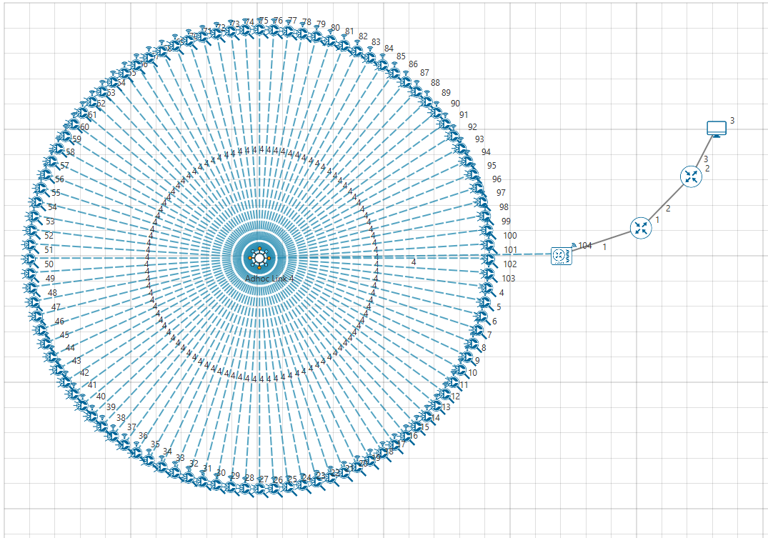

**Figure 18:** Network Scenario created using Generator

**Note:**

The following warning message that may be displayed when attempting to open the Configuration.netsim file generated using the scenario generator, can be ignored by clicking on the proceed button.

**Customizing the Network Scenario Generator:**

The Source Codes directory that is part of the project consists of the source codes associated with the Scenario Generators of Internetworks, 5G NR, MANETs and IoT.

**Figure 19:** Scenario Generators of Internetworks, 5G NR, MANETs and IoT

The source codes are written in C# and can be loaded in visual studio by double-clicking on the visual studio solution file (*.sln) from the respective network folder.

**Figure 20:** Double-clicking on (*.sln) code loaded to visual studio solution file

NetworkScenario.cs is the main file that contains the source codes to generate the Configuration.netsim file as per the user input.

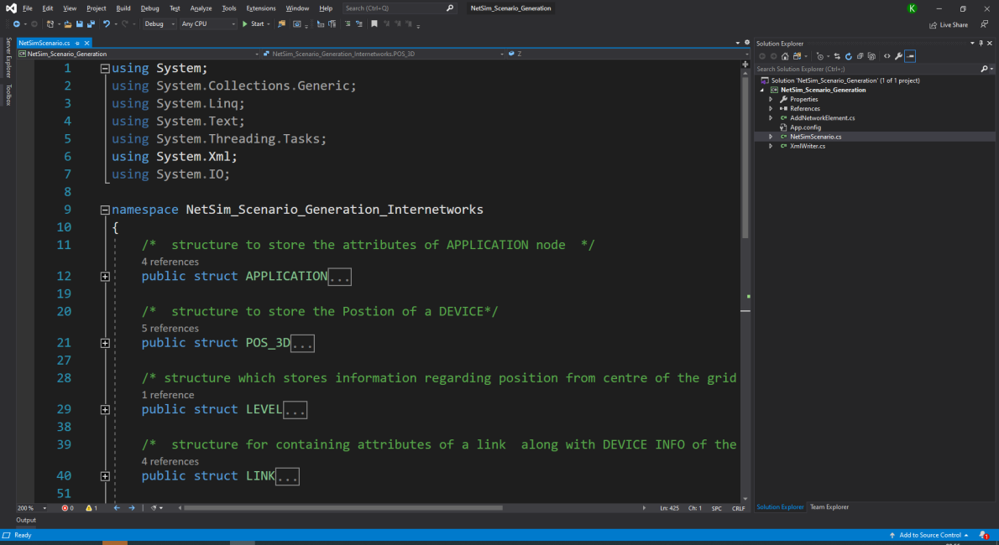

**Figure 21:**NetworkScenario.cs contains the source codes to generate the Configuration.netsim

AddNetworkElement.cs is the file which reads from the text files present in the ConfigHelper directory of the scenario generator and accordingly updates the Configuration.netsim file for addition of nodes, links, applications, etc. This file also consists of functions for generating IP addresses, MAC addresses, etc.

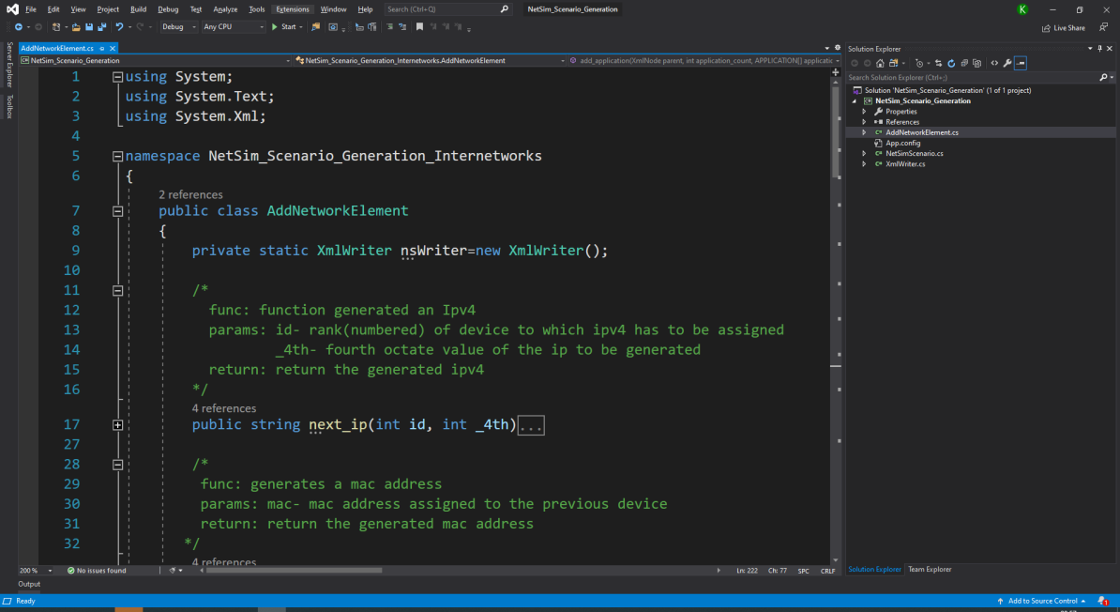

Figure 22: AddNetworkElement.cs contains the code to read text files present in the ConfigHelper directory of the scenario generator

Similar to the Network Scenario Generators folder each Source Code Folder contains a ConfigHelper directory in the *<Network_Source_Code_Folder>/bin/Debug* path with text files containing the properties related devices, links and applications.

**Figure 23:** Network Scenario Generators folder contains Source Code Folder contains a ConfigHelper

If source codes are modified, the codes must be rebuilt and the newly generated Network Scenario Generator in the*<Network_Source_Code_Folder>/bin/Debug* path should be used to generate a configuration file for changes done to take effect.