Primary User Emulation (PUE) Attack in Cognitive Radio Networks

**Software Recommended:** NetSim Standard v14.3, Visual Studio 2022

**Project Download Link:**

<https://github.com/NetSim-TETCOS/PUE_Attack-14.2/archive/refs/heads/main.zip>

Follow the instructions specified in the following link to download and setup the Project in NetSim:

<https://support.tetcos.com/en/support/solutions/articles/14000128666-downloading-and-setting-up-netsim-file-exchange-projects>

# Introduction

Cognitive Radio technology addresses the spectrum shortage problem by enabling unlicensed users equipped with CRs to coexist with incumbent users in licensed spectrum bands while causing no interference to incumbent communications. Spectrum sensing is one of the essential mechanisms of CRs and its operational aspects are being investigated actively.

In a hostile environment, an attacker may modify the air interface of a CR to mimic a primary user signal’s characteristic, thereby causing legitimate secondary users to erroneously identify the attacker as a primary user. There is a realistic possibility of PUE attacks since CRs are highly reconfigurable due to their software-based air interface.

We create a PUE attack by adding two incumbents in the scenario in NetSim. One of the incumbents represents a “real” primary user while the second represents a “Malicious” primary user.

Our objective is to detect PUE attacks, with detection times proportionate to the distance of secondary users from the malicious primary user.

Figure 1: Primary User Emulation(PUE)Attack in Cognitive Radio Networks

PUE attacks are a type of cyberattack where a malicious user impersonates a PU in order to disrupt the communication of Secondary users. This can be done by transmitting a signal that mimics the characteristics of a Primary user signal.

The above image shows a PUE attacker transmitting a signal that is very similar to the signal of a legitimate Primary user. This causes the secondary users to believe that a primary user is present, even though there is not one. As a result, the secondary user vacates the spectrum, even if they are currently using it legitimately.

**Note:** In NetSim, primary users are configured within the base station itself and are referred to as incumbents.

# Example

1. The **PUE_Attack_Workspace** comes with a sample network configuration that is already saved. To open this example, go to Your work in the Home screen of NetSim and click on the **PUE-Attack-Example**.
2. The network scenario loads as shown below:

Figure 2: Network Topology

# Settings done in this example

1. The following properties are set for

**Base_Station_1 à INTERFACE_1 (COGNITIVE_RADIO) à IEEE802.22** as shown in below given table.

|  |  |
| --- | --- |
| Datalink_Layer_Properties | |
| Incumbent count | 2 |
| Incumbent1(malicious)  ON_Duration(s)  OFF_Duration(s)  Keep Distance(m) | 4  10  500 |
| Incumbent2 (Incumbent)  ON_Duration(s)  OFF_Duration(s)  Keep Distance(m) | 9  9  500 |
| Physical_Layer_ Properties | |
| IFQP_Bitmap | 1000000000000000 |

Table 1: CR Base Station 1 Properties

The timing diagram is as follows for **Incumbent1(malicious)** and **Incumbent2(Incumbent):**

**Malicious** --- 0s to 10s (OFF), 10s to 14s (ON), 14s to 24s (OFF), 24s to 28s (ON) ... and so on **Incumbent** --- 0s to 9 s (OFF), 9s to 18s (ON), 18s to 27s (OFF), 27s to 36s (ON) ... and so on

1. Distance between the CR-CPE and Incumbent is < 500. This ensures that the incumbent is detected. If the incumbent is beyond the keep out distance, then it is not detected.
2. Now run the simulation 50 Sec.

**Note:** If the NetSim Simulation Console window halts after completing the simulation, manually terminate it by pressing Ctrl+C until it closes.

# Results and discussion

You can see the delay in the **CR_Incumbent_log** file from the log files in the result dashboard Window.

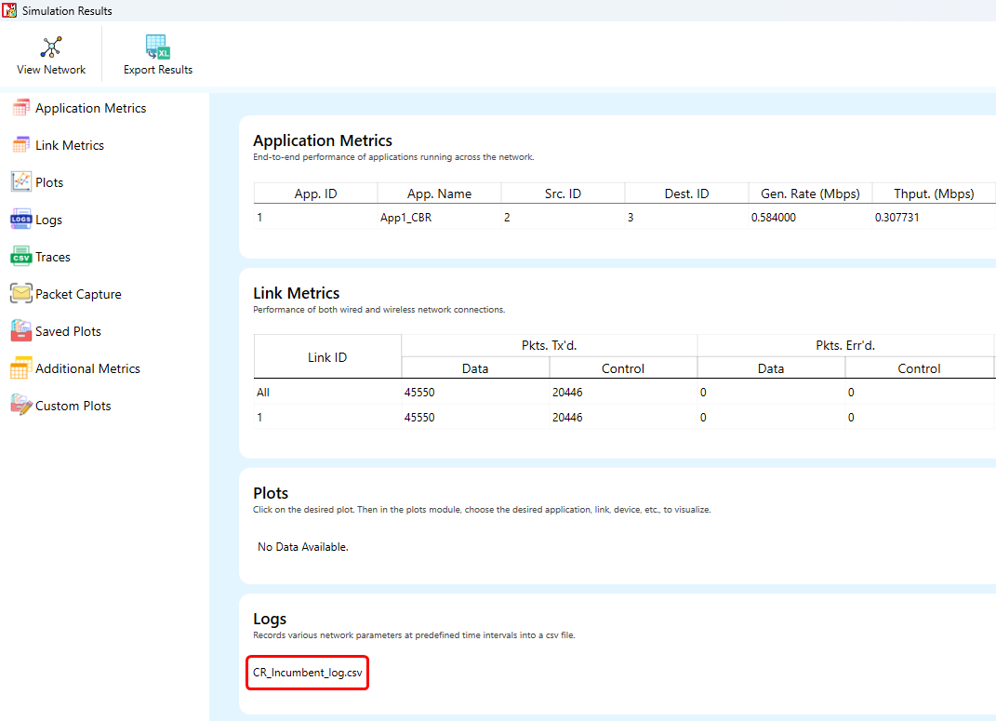

Figure 3: Network Topology

A file “**CR_Incumbent_log**” will be created in the log folder with the following contents:

In the “CR_ Incumbent_log.csv” file we can see secondary users CR-CPE 2 and CR-CPE 3 will detect the PUE attack by Incumbent1 which is the malicious user

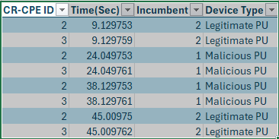

Figure 4: CR_ Incumbent_log.csv file created in Log Folder

**Appendix: NetSim source code modifications and steps.**

1. Open the Source code in Visual Studio by going to Your work-> Source Code and Clicking on Open code button.
2. Additional delay has been set by the following code:

In Solution Explorer, Go to **Cognitive Radio > SpectrumManager.c** and open it.

1. User modifications can be made in the **fn_NetSim_CR_CPE_SSF()** function as mentioned below.
2. Right click on Solution Explorer > Rebuild project.

## Additional_delay = dDistance / 10;

(You can also change the values as 10/100/1000 and analyze different variation in delay)

Figure 5: NetSim Project Source Code

This is a simple implementation of creating and detecting a PUE Attack by making modifications to primary user detection in CR.