**Performance analysis of 802.15.4 based wireless sensor networks using NetSim**

Applicable Release: NetSim v13.3.12 or higher

Applicable Version(s): All (Academic, Standard and Pro)

Project download link: See Appendix-1. The URL has the configuration files (scenario, settings, and other related files) of the examples discussed in this analysis for users to import and run in NetSim

# Introductions

Wireless sensor networks (WSNs), was a concept that originated in the mid-1990s, have now reached a stage in their evolution, where world is covered with wireless sensor networks with access to them via Internet of Things (IoT). WSNs have unlimited potential for application in areas such as environmental, medical, military, transportation, entertainment, crisis management, homeland defence and smart spaces.

A WSN comprises nodes/motes equipped with a microprocessor, memory, radio, and battery, which combine the functions of sensing, computing, and wireless communication onto a miniature smart sensor node. IEEE 802.15.4-2006 is the standard which specifies the physical layer and media access control of these motes [1].

IEEE 802.15.4 is a low-cost, low-data-rate wireless access technology for devices that are operated or work on batteries. This describes how low-rate wireless personal area networks (LR-WPANs) function.

A major challenge in the area of WSNs is designing the network. A sensor network design is influenced by many factors, including fault tolerance, scalability, cost, operating environment, sensor network topology, hardware constraints, transmission media, power consumption, and so on. Various industrial applications based on sensor networks have different Quality-of-Service (QoS) requirements like bounded latency (time taken for a generated packet to reach the base station), guaranteed throughput, maximum network lifetime (energy efficiency), etc.

IEEE 802.15.4 relies on spread spectrum digital modulation of a 2 MHz bandwidth carrier in the 2.4 GHz ISM band, and CSMA/CA medium access control. The standard defines two types of CSMA/CA algorithms- slotted and unslotted and is named based on the algorithm chosen - beaconed and beaconless, respectively.

In this document, we study the performance of beaconless operation of IEEE 802.15.4 and are concerned with the performance analysis of WSNs that rely on beaconless IEEE 802.15.4 multi-hop wireless networks for interconnecting the sensors with the base station.

**Pathloss, Transmission range and Carrier Sense (CS) Range**

**Pathloss**: The standard pathloss equation is

where, is the transmitter Power, is the transmit antenna gain, is the receiver antenna gain, is the reference distance pathloss, is the pathloss exponent and is the transmitter receiver separation in meters. The reference distance pathloss is given by

Per the 802.15.4 standard, the reference distance is 8m, while the operating frequency is Hz. Applying these in the above formula, we get .

**Transmission Range (**: The receive sensitivity in 802.15.4 is dBm. Given a transmitter power of mW or dBm, zero gains for the transmit and receive antennas, and , we can compute the transmit range, as follows:

**Carrier Sense Range**: In the examples in this document, we set the CS threshold as dB below the receive sensitivity. Thus, the CS range, can be computed as

**Simulation Scenarios**

We use NetSim to simulate and analyse the performance four sensor network scenarios:

1. Case 1: The network consists of two sensors transmitting data to a common sink node. Each sensor is placed 150m away from the sink node, such that sensor 1 and sink node are in transmission range and similarly, sensor 2 and sink node are in transmission range. The two sensors, sensor 1 and sensor 2 are beyond CS Range of one another. In other words, the sensors are “hidden” from one another.
2. Case 2: The network has sensors placed, equally spaced, along east, west, north, and south directions of the sink node. The sensor nodes are kept 170m away from the sink node such that each sensor and the sink node will be in transmission range. However, any two sensors will be beyond CS Range of one another. This case is like Case # 1, except that we have 4 sensors instead of 2.
3. Case 3: The network has 20 sensors placed in a circular manner around the sink node. Each sensor is placed at a radius of 75m from the sink node. Therefore, all sensors are within CS range of one another. All the sensors transmit data to the sink node.
4. Case 4: Multi-hop transmission via a relay
5. Case 5: Multi-hop transmission via a relay-sensor which also generates traffic

**Transmission time for a packet of size 100B (Application layer)**

# Case 1: Two sensors equidistant from a sink. Both nodes transmitting and beyond CS range of each other

**Network Layout**

Fig 1: Schematic of network layout. The sources of traffic are Sensor 1 (S1), and Sensor 2 with destination Sink Node (SN). S1 – SN = 150m and S1 – S2 = 300m. Transmission range = 177m and CS Range = 223m. Therefore S1 – S2 are not in CS range.

Fig 2:Throughput of Node 1 ( vs. Source rate. Source data: Table 5

Fig 3: Throughput of Node 2 ( vs. Source rate. Source data:Table 5

# Case 2: Four nodes equidistant from a sink. All nodes transmitting. No node within CS range.

**Network Layout**

Fig : Schematic of network layout. The sources of traffic are Sensor 1 (S1), Sensor 2 (S2), Sensor 3 (S3) and Sensor 4 (S4) with destination Sink Node (SN). S1–SN, S2-SN, S3- SN, S4-SN = 170m and S1–S2 = 240.42m. Transmission range = 177m and CS Range = 223m.

Fig 5: Throughput of Node 1 ( vs. Source rate. Source data:Table 7

Fig 6: Throughput of Node 3 ( vs. Source rate. Source data:Table 7

# Case 3: Twenty nodes equidistant from the sink. All transmitting. All in CS range of each other.

**Network Layout**

Fig 7: Schematic of network layout. The sources of traffic are Sensor 1 (S1), Sensor 2 (S2), Sensor 3 (S3) etc. Sensor 20 (S20) with destination Sink Node (SN). S1 – SN, S2-SN, S3- SN, S4-SN… S20-SN = 75m. Transmission range = 177m and CS Range = 223m.

Fig 8: Throughput of Node 1 ( vs. Source rate. Source data: Table 9

Fig 9: Throughput of Node 10 ( vs. Source rate. Source data: Table 9

# Case 4A: multi-hop transmission via a relay. Two transmitting nodes.

**Network Layout**

Fig 10 : Schematic of network layout. The sources of traffic are Sensor 2 (S2), Sensor 3 (S3) with destination Sink Node (SN). Each sensor is 150m from the relay and the relay is 150m from the sink node. Transmission range = 177m and CS Range = 223m.

Fig : Throughput of Node 2 () and Node 3 () vs. Source rate. Source data: Table 11

# Case 4B: multi-hop transmission via a relay. Two transmitting nodes.

**Network Layout**

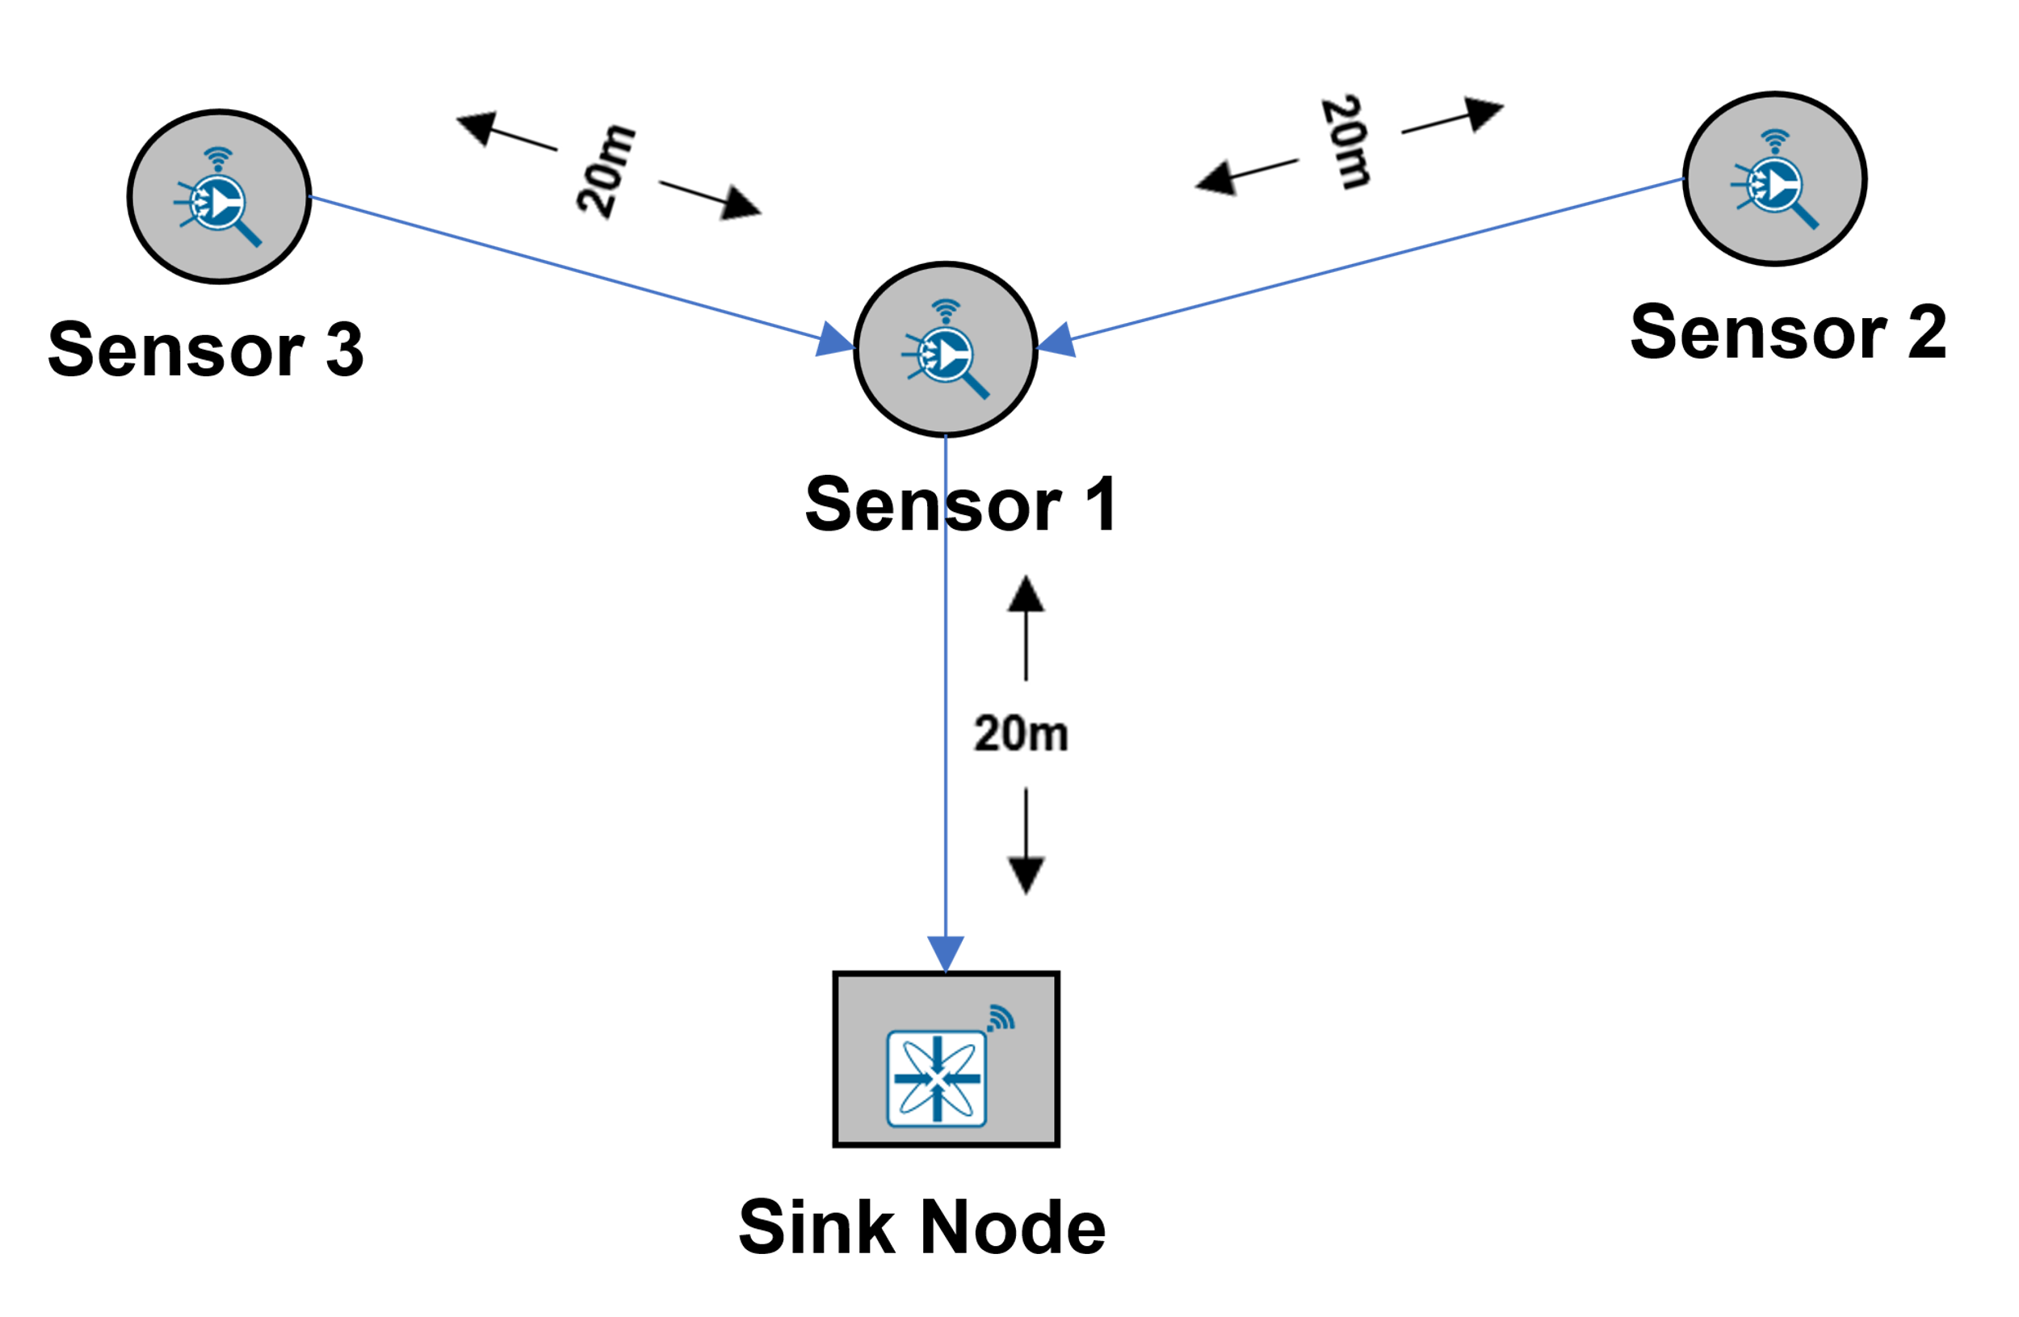

Fig 12: Schematic of network layout. The sources of traffic are Sensor 2 (S2), Sensor 3 (S3) with destination Sink Node (SN). Each sensor is 20m from the relay and the relay is 20m from the sink node. Transmission range = 177m and CS Range = 223m.

Fig : Throughput of Node 2 () and Node 3 () vs. Source rate. Source data:

# Case 5A: multi-hop transmission via a relay sensor which also generates traffic. Three transmitting nodes

**Network Layout**

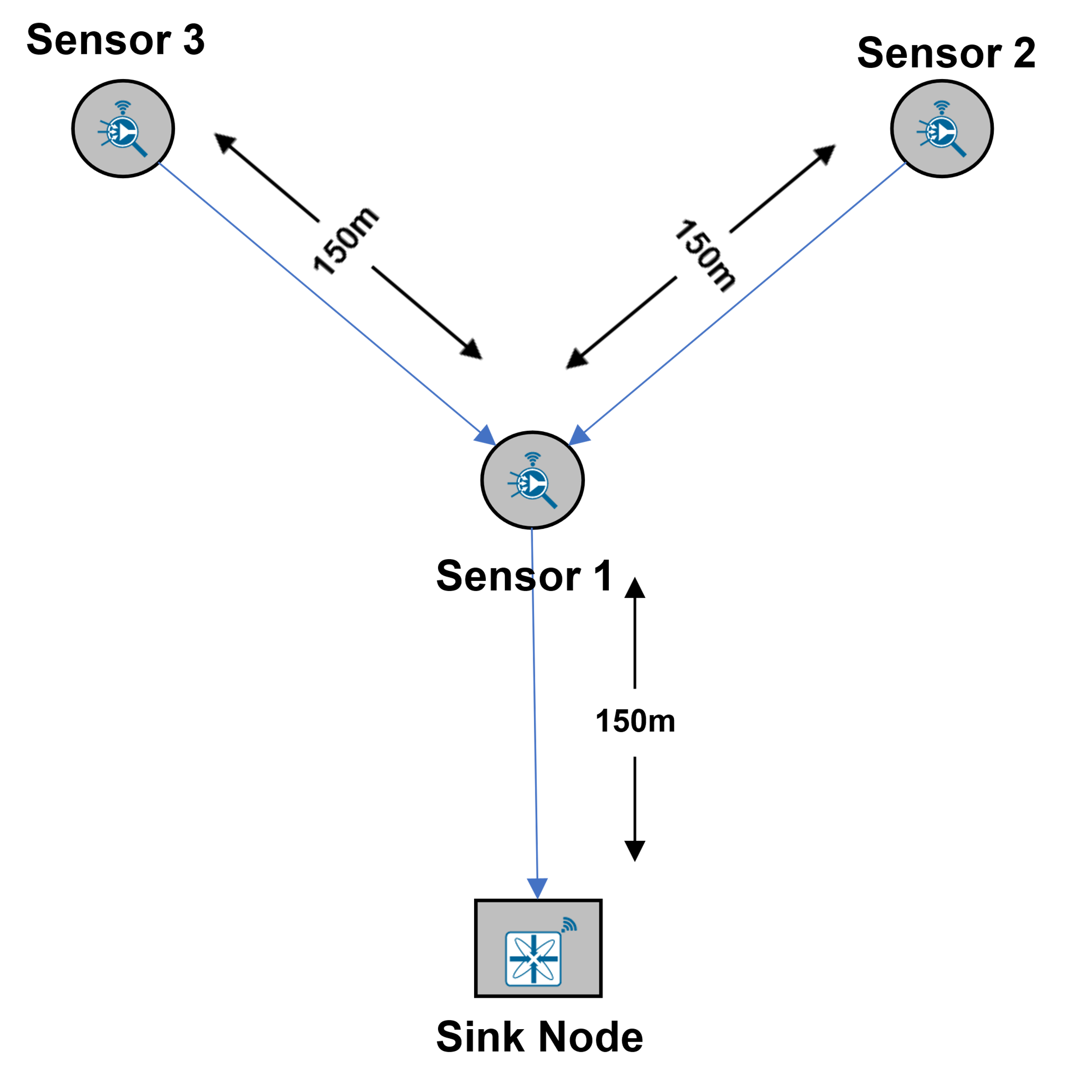

Fig 14 : Schematic of network layout. The sources of traffic are Relay, Sensor 2 (S2), Sensor 3 (S3) with destination Sink Node (SN). Each sensor is 150m from the relay and the relay are 150m from the sink node. Transmission range = 177m and CS Range = 223m.

Fig :Throughput of Node 1 (), Node 2 () m Node 3 () vs. Source rate. Source data: Table 15

# Case 5B: multi-hop transmission via a relay sensor which also generates traffic. Three transmitting nodes

**Network Layout**



Fig 16 : Schematic of network layout. The sources of traffic are Sensor 1 (S1), Sensor 2 (S2), Sensor 3 (S3) with destination Sink Node (SN). Each sensor is 20m from each other. Transmission range = 177m and CS Range = 223m.

The results show that the relation between the input rate 𝜆 and the throughput 𝜇 can be divided into three distinct phases according to 𝜆:

* 𝜆 < 𝜆1 (50 packet/s): It occurs when the source rate is within capacity. In this case no queues build up and 𝜇 is an increasing function of 𝜆 and it reaches its maximum at 𝜇1 (𝜇1 = 𝜆1).
* 𝜆 > 𝜆2 (75 packet/s): It corresponds to the saturated regime, where the source always has packets to send.
* 𝜆1 < 𝜆 < 𝜆2: It is the phase during which a form of congestion collapse occurs. Indeed, 𝜇 is a decreasing function of 𝜆 in this region. This performance drop is caused by the queue build-up at the first relay that consumes resources.

Fig : Throughput of Node 1 (), Node 2 () m Node 3 () vs. Source rate. Source data:

**Appendix**

**Network Settings:**

The following settings were configured in all the cases.

|  |  |  |
| --- | --- | --- |
| Sensor and Sink Node Properties | | |
| General Properties | | |
| Mobility Model | No Mobility |
| Interface Zigbee Properties- Physical Layer | | |
| Frequency | 2.4 GHz |
| PhySHRDuration (Symbols) | 3 |
| CCA Mode | Carrier Sense Only |
| Receiver Sensitivity (dBm) | -85 |
| EDThreshold (dBm) | -87 |
| Transmitter Power (mW) | 1 |
| Antenna Gain | 0 |
| Antenna Height (m) | 1 |
| Reference Distance d0 (m) | 8 |
| Interface Zigbee- Datalink Layer | | |
| Ack Request | Disable |
| Beacon Mode | Disable |
| Max CSMA BO | 4 |
| Max Backoff Expo | 5 |
| Min Backoff Expo | 3 |
| Max Frame Retries | 3 |

Table 1: Values set for different parameters in simulation

|  |  |
| --- | --- |
| Application Properties | |
| Application Method | Unicast |
| Application Type | Custom |
| Source Id | Sensor_1, Sensor_2….12 |
| Destination Id | WSN_Sink_13 |
| Start Time(s) | 0 |
| Transport Protocol | UDP |
| Packet Size Distribution | Constant |
| Packet Size (B) | 100 |
| IAT Distribution | Exponential |
| IAT Mean | 200000, 100000, 66667, 50000,40000,33333,28571,  25000,22222,20000 |

Table 2: Application properties set in these experiments.

|  |  |
| --- | --- |
| Wireless Link Properties | |
| Channel Characteristics | Pathloss Only |
| Pathloss Model | Log Distance |
| Pathloss Exponent | 2 |
| Simulation Parameters | |
| Simulation Time(s) | 1000 |

Table 3: Wireless Link parameter and Simulation time

# Case 1

**Network Scenario**

Fig 18: Network Scenario for Case 1

**Static Route configuration**

Static routes were configured in each source node such that the data gets transmitted directly from source to destination without any dynamic route formation by the routing protocols.

Static routes (whereby always transmits to ) are set to ensure single hop transmission. Thereby each node transmits data to the next-hop node according to the topology.

To set the static routes, go to Wireless_Sensor properties > Network Layer > Enable Static Route IP.

The Static route IP were configured in Wireless_Sensor_1, and Wireless_ Sensor_2 as shown below:

|  |  |  |  |  |  |
| --- | --- | --- | --- | --- | --- |
| **Device** | **Network Destination** | **Gateway** | **Subnet Mask** | **Metrics** | **Interface ID** |
| Wireless_ Sensor_1 | 11.1.1.0 | 11.1.1.1 | 255.255.255.0 | 1 | 1 |
| Wireless_ Sensor_2 | 11.1.1.0 | 11.1.1.1 | 255.255.255.0 | 1 | 1 |

Table 4: Static route configured in devices

**Results**

|  |  |  |  |
| --- | --- | --- | --- |
| Per node source rate, pkts/sec | Inter packet arrival time (µs) = | N1 throughput, pkts/sec | N2 throughput, pkts/sec |
| 5 | 200,000 | 4.78 | 4.80 |
| 10 | 100,000 | 9.06 | 9.25 |
| 15 | 66,667 | 12.96 | 13.13 |
| 20 | 50,000 | 16.56 | 16.83 |
| 25 | 40,000 | 19.73 | 19.95 |
| 30 | 33,333 | 22.48 | 22.62 |
| 35 | 28,571 | 24.80 | 24.91 |
| 40 | 25,000 | 26.87 | 26.92 |
| 45 | 22,222 | 28.51 | 28.57 |
| 50 | 20,000 | 29.86 | 29.86 |

Table 5 :NetSim results for simulations of case 1

# Case 2

**Network Scenario**

Fig 19 : Network Scenario for Case 2

**Static Route configuration**

Static routes were configured in each source node such that the data gets transmitted directly from source to destination without any dynamic route formation by the routing protocols.

Static routes (whereby always transmits to ) are set to ensure single hop transmission. Thereby each node transmits data to the next-hop node according to the topology.

To set the static routes, go to Wireless_Sensor properties > Network Layer > Enable Static Route IP.

The Static route IP were configured in Wireless_Sensor_1, Wireless_ Sensor_2, Wireless_Sensor_3 and Wireless_Sensor_4 as shown below:

|  |  |  |  |  |  |
| --- | --- | --- | --- | --- | --- |
| **Device** | **Network Destination** | **Gateway** | **Subnet Mask** | **Metrics** | **Interface ID** |
| Wireless_ Sensor_1 | 11.1.1.0 | 11.1.1.1 | 255.255.255.0 | 1 | 1 |
| Wireless_ Sensor_2 | 11.1.1.0 | 11.1.1.1 | 255.255.255.0 | 1 | 1 |
| Wireless_ Sensor_3 | 11.1.1.0 | 11.1.1.1 | 255.255.255.0 | 1 | 1 |
| Wireless_ Sensor_4 | 11.1.1.0 | 11.1.1.1 | 255.255.255.0 | 1 | 1 |

Table 6: Static route configured in devices

**Results**

|  |  |  |  |  |  |
| --- | --- | --- | --- | --- | --- |
| Per node source rate, pkts/sec | Inter packet arrival time (µs) = | N1 throughput, pkts/sec | N2 throughput, pkts/sec | N3 throughput, pkts/sec | N4 throughput, pkts/sec |
| 5 | 200,000 | 4.33 | 4.40 | 4.47 | 4.30 |
| 10 | 100,000 | 7.55 | 7.76 | 7.72 | 7.44 |
| 15 | 66,667 | 9.87 | 9.98 | 10.05 | 9.90 |
| 20 | 50,000 | 11.46 | 11.59 | 11.46 | 11.40 |
| 25 | 40,000 | 12.26 | 12.44 | 12.28 | 12.29 |
| 30 | 33,333 | 12.74 | 12.67 | 12.60 | 12.69 |
| 35 | 28,571 | 12.63 | 12.55 | 12.60 | 12.47 |
| 40 | 25,000 | 12.18 | 12.16 | 12.16 | 11.97 |
| 45 | 22,222 | 11.52 | 11.49 | 11.45 | 11.27 |
| 50 | 20,000 | 10.63 | 10.64 | 10.60 | 10.56 |

Table : NetSim results for simulations of case 2.

# Case 3

**Network Scenario**

Fig 20: Network Scenario for Case 3

**Static Route configuration**

Static routes were configured in each source node such that the data gets transmitted directly from source to destination without any dynamic route formation by the routing protocols.

Static routes (whereby always transmits to ) are set to ensure single hop transmission. Thereby each node transmits data to the next-hop node according to the topology.

To set the static routes, go to Wireless_Sensor properties > Network Layer > Enable Static Route IP.

The Static route IP were configured in Wireless_Sensor_1, Wireless_ Sensor_2, Wireless_Sensor_3 etc. and Wireless_Sensor_20 as shown below:

|  |  |  |  |  |  |
| --- | --- | --- | --- | --- | --- |
| **Device** | **Network Destination** | **Gateway** | **Subnet Mask** | **Metrics** | **Interface ID** |
| Wireless_ Sensor_1 | 11.1.1.0 | 11.1.1.1 | 255.255.255.0 | 1 | 1 |
| Wireless_ Sensor_2 | 11.1.1.0 | 11.1.1.1 | 255.255.255.0 | 1 | 1 |
| Wireless_ Sensor_3 | 11.1.1.0 | 11.1.1.1 | 255.255.255.0 | 1 | 1 |
| Wireless_ Sensor_4 | 11.1.1.0 | 11.1.1.1 | 255.255.255.0 | 1 | 1 |
| Wireless_Sensor_i | 11.1.1.0 | 11.1.1.1 | 255.255.255.0 | 1 | 1 |
| Wireless_Sensor_20 | 11.1.1.0 | 11.1.1.1 | 255.255.255.0 | 1 | 1 |

Table 8: Static route configured in devices

**Results**

|  |  |  |  |
| --- | --- | --- | --- |
| Per node source rate, pkts/sec | Inter packet arrival time (µs) = | N1 throughput, pkts/sec | N10 throughput, pkts/sec |
| 5 | 200,000 | 4.51 | 4.52 |
| 10 | 100,000 | 6.69 | 6.79 |
| 15 | 66,667 | 7.11 | 7.27 |
| 20 | 50,000 | 6.90 | 6.98 |
| 25 | 40,000 | 6.58 | 6.62 |
| 30 | 33,333 | 6.16 | 6.15 |
| 35 | 28,571 | 5.77 | 5.72 |
| 40 | 25,000 | 5.46 | 5.20 |
| 45 | 22,222 | 4.82 | 4.98 |
| 50 | 20,000 | 4.71 | 4.47 |

Table 9: NetSim results for simulations of case 3

# Case 4A

**Network Scenario**

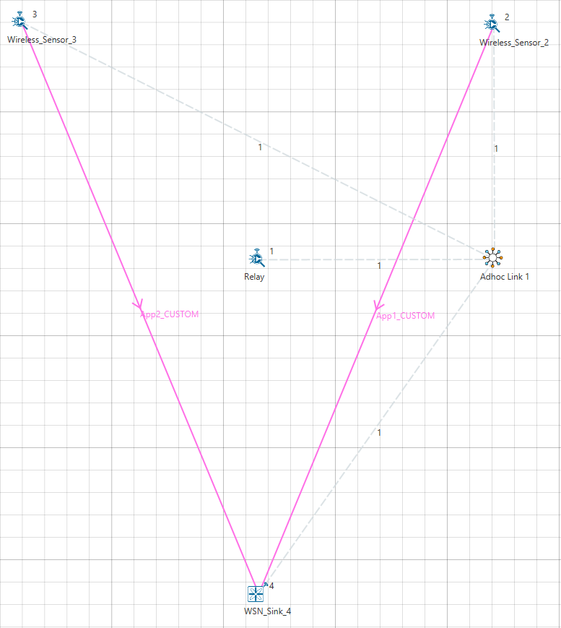

Fig : Network Scenario for Case 4A

**Static Route configuration**

Static routes were configured in each source node such that the data gets transmitted to the destination through intermediate nodes.

To set the static routes, go to Wireless_Sensor properties > Network Layer > Enable Static Route IP.

The Static route IP were configured in Wireless_Sensor_1, Wireless_ Sensor_2, Wireless_Sensor_3 as shown below:

|  |  |  |  |  |  |
| --- | --- | --- | --- | --- | --- |
| **Device** | **Network Destination** | **Gateway** | **Subnet Mask** | **Metrics** | **Interface ID** |
| Wireless_ Sensor_1 | 11.1.1.1 | 11.1.1.1 | 255.255.255.255 | 1 | 1 |
| Wireless_ Sensor_2 | 11.1.1.1 | 11.1.1.2 | 255.255.255.255 | 1 | 1 |
| Wireless_ Sensor_3 | 11.1.1.1 | 11.1.1.2 | 255.255.255.255 | 1 | 1 |

Table 10: Static route configured in devices

**Results**

|  |  |  |  |
| --- | --- | --- | --- |
| Per node source rate, pkts/sec | Inter packet arrival time (µs) = | N2 throughput, pkts/sec | N3 throughput, pkts/sec |
| 5 | 200000 | 4.82 | 4.83 |
| 10 | 100000 | 9.05 | 8.99 |
| 15 | 66667 | 12.65 | 12.56 |
| 20 | 50000 | 15.72 | 15.47 |
| 25 | 40000 | 18.21 | 18.02 |
| 30 | 33333 | 20.18 | 20.08 |
| 35 | 28571 | 21.58 | 21.67 |
| 40 | 25000 | 22.68 | 22.59 |
| 45 | 22222 | 23.35 | 23.43 |
| 50 | 20000 | 23.75 | 23.85 |
| 55 | 18182 | 23.95 | 24.06 |
| 60 | 16667 | 23.71 | 23.76 |
| 65 | 15385 | 23.39 | 23.41 |
| 70 | 14286 | 22.88 | 22.99 |
| 75 | 13333 | 22.07 | 22.11 |
| 80 | 12500 | 21.17 | 21.30 |
| 85 | 11775 | 20.27 | 20.16 |
| 90 | 11111 | 19.11 | 19.17 |
| 95 | 10526 | 17.98 | 17.84 |
| 100 | 10000 | 16.77 | 16.57 |
| 105 | 9524 | 15.41 | 15.30 |
| 110 | 9091 | 13.86 | 13.83 |
| 115 | 8696 | 12.45 | 12.36 |
| 120 | 8333 | 11.08 | 10.76 |
| 125 | 8000 | 9.60 | 9.14 |
| 130 | 7692 | 8.02 | 7.59 |
| 135 | 7407 | 6.44 | 5.94 |
| 140 | 7143 | 4.88 | 4.25 |
| 145 | 6897 | 3.24 | 2.59 |
| 150 | 6667 | 1.52 | 0.99 |
| 155 | 6452 | 0.00 | 0.00 |
| 160 | 6250 | 0.00 | 0.00 |
| 165 | 6061 | 0.00 | 0.00 |
| 170 | 5882 | 0.00 | 0.00 |
| 175 | 5714 | 0.00 | 0.00 |
| 180 | 5556 | 0.00 | 0.00 |
| 185 | 5405 | 0.00 | 0.00 |
| 190 | 5263 | 0.00 | 0.00 |
| 195 | 5128 | 0.00 | 0.00 |
| 200 | 5000 | 0.00 | 0.00 |

Table 11: NetSim results for simulations of case 4A

# Case 4B

**Network Scenario**

Fig 22 : Network Scenario for Case 4B

**Static Route configuration**

Static routes were configured in each source node such that the data gets transmitted to the destination through intermediate nodes.

To set the static routes, go to Wireless_Sensor properties > Network Layer > Enable Static Route IP.

The Static route IP were configured in Wireless_Sensor_1, Wireless_ Sensor_2, Wireless_Sensor_3 as shown below:

|  |  |  |  |  |  |
| --- | --- | --- | --- | --- | --- |
| **Device** | **Network Destination** | **Gateway** | **Subnet Mask** | **Metrics** | **Interface ID** |
| Wireless_ Sensor_1 | 11.1.1.1 | 11.1.1.1 | 255.255.255.255 | 1 | 1 |
| Wireless_ Sensor_2 | 11.1.1.1 | 11.1.1.2 | 255.255.255.255 | 1 | 1 |
| Wireless_ Sensor_3 | 11.1.1.1 | 11.1.1.2 | 255.255.255.255 | 1 | 1 |

Table 12: Static route configured in devices

**Results**

|  |  |  |  |
| --- | --- | --- | --- |
| Per node source rate, pkts/sec | Inter packet arrival time (µs) = | N2 throughput, pkts/sec | N3 throughput, pkts/sec |
| 5 | 200000 | 4.96 | 4.99 |
| 10 | 100000 | 9.64 | 9.62 |
| 15 | 66667 | 14.02 | 13.90 |
| 20 | 50000 | 18.08 | 17.85 |
| 25 | 40000 | 21.56 | 21.37 |
| 30 | 33333 | 24.60 | 24.66 |
| 35 | 28571 | 27.28 | 27.28 |
| 40 | 25000 | 29.28 | 29.32 |
| 45 | 22222 | 31.13 | 31.31 |
| 50 | 20000 | 32.60 | 32.39 |
| 55 | 18182 | 33.48 | 33.62 |
| 60 | 16667 | 33.91 | 34.19 |
| 65 | 15385 | 34.52 | 34.33 |
| 70 | 14286 | 34.49 | 34.50 |
| 75 | 13333 | 34.30 | 34.21 |
| 80 | 12500 | 34.31 | 34.18 |
| 85 | 11775 | 34.30 | 34.20 |
| 90 | 11111 | 34.41 | 34.13 |
| 95 | 10526 | 34.26 | 34.22 |
| 100 | 10000 | 34.31 | 34.22 |
| 105 | 9524 | 34.26 | 34.22 |
| 110 | 9091 | 34.31 | 34.20 |
| 115 | 8696 | 34.29 | 34.20 |
| 120 | 8333 | 34.26 | 34.22 |
| 125 | 8000 | 34.26 | 34.22 |
| 130 | 7692 | 34.26 | 34.22 |
| 135 | 7407 | 34.26 | 34.22 |
| 140 | 7143 | 34.26 | 34.22 |
| 145 | 6897 | 34.26 | 34.22 |
| 150 | 6667 | 34.26 | 34.22 |
| 155 | 6452 | 34.26 | 34.22 |
| 160 | 6250 | 34.26 | 34.22 |
| 165 | 6061 | 34.26 | 34.22 |
| 170 | 5882 | 34.26 | 34.22 |
| 175 | 5714 | 34.26 | 34.22 |
| 180 | 5556 | 34.26 | 34.22 |
| 185 | 5405 | 34.26 | 34.22 |
| 190 | 5263 | 34.26 | 34.22 |
| 195 | 5128 | 34.26 | 34.22 |
| 200 | 5000 | 34.26 | 34.22 |

Table 13: NetSim results for simulations of case 4B

# Case 5A

**Network Scenario**

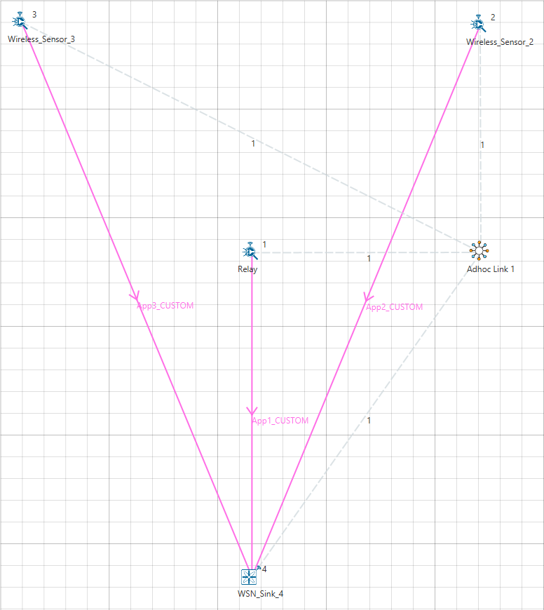

Fig : Network Scenario for Case 5A

**Static Route configuration**

Static routes were configured in each source node such that the data gets transmitted to the destination through intermediate nodes.

To set the static routes, go to Wireless_Sensor properties > Network Layer > Enable Static Route IP.

The Static route IP were configured in Wireless_Sensor_1, Wireless_ Sensor_2, Wireless_Sensor_3 as shown below:

|  |  |  |  |  |  |
| --- | --- | --- | --- | --- | --- |
| **Device** | **Network Destination** | **Gateway** | **Subnet Mask** | **Metrics** | **Interface ID** |
| Wireless_ Sensor_1 | 11.1.1.1 | 11.1.1.1 | 255.255.255.255 | 1 | 1 |
| Wireless_ Sensor_2 | 11.1.1.1 | 11.1.1.2 | 255.255.255.255 | 1 | 1 |
| Wireless_ Sensor_3 | 11.1.1.1 | 11.1.1.2 | 255.255.255.255 | 1 | 1 |

Table 14: Static route configured in devices

**Results**

|  |  |  |  |  |
| --- | --- | --- | --- | --- |
| Per node source rate, pkts/sec | Inter packet arrival time (µs) = | N1 throughput, pkts/sec | N2 throughput, pkts/sec | N3 throughput, pkts/sec |
| 5 | 200000 | 4.77 | 4.82 | 5.03 |
| 10 | 100000 | 8.94 | 8.89 | 9.96 |
| 15 | 66667 | 12.31 | 12.24 | 14.95 |
| 20 | 50000 | 15.11 | 14.91 | 19.97 |
| 25 | 40000 | 17.10 | 16.88 | 25.00 |
| 30 | 33333 | 18.36 | 18.27 | 29.99 |
| 35 | 28571 | 18.88 | 19.10 | 34.98 |
| 40 | 25000 | 19.08 | 19.05 | 40.07 |
| 45 | 22222 | 18.61 | 18.77 | 45.03 |
| 50 | 20000 | 17.85 | 18.02 | 49.97 |
| 55 | 18182 | 16.75 | 16.90 | 55.01 |
| 60 | 16667 | 15.36 | 15.55 | 60.05 |
| 65 | 15385 | 13.81 | 13.87 | 65.15 |
| 70 | 14286 | 12.13 | 12.13 | 65.11 |
| 75 | 13333 | 10.53 | 10.69 | 63.84 |
| 80 | 12500 | 9.07 | 9.03 | 62.70 |
| 85 | 11775 | 7.73 | 7.76 | 60.98 |
| 90 | 11111 | 6.49 | 6.50 | 59.11 |
| 95 | 10526 | 5.38 | 5.52 | 56.72 |
| 100 | 10000 | 4.33 | 4.50 | 54.54 |
| 105 | 9524 | 3.42 | 3.50 | 52.21 |
| 110 | 9091 | 2.59 | 2.68 | 49.36 |
| 115 | 8696 | 1.98 | 2.02 | 46.01 |
| 120 | 8333 | 1.43 | 1.41 | 42.92 |
| 125 | 8000 | 1.02 | 1.05 | 39.80 |
| 130 | 7692 | 1.02 | 0.96 | 39.88 |
| 135 | 7407 | 0.98 | 0.92 | 39.96 |
| 140 | 7143 | 0.95 | 0.88 | 40.02 |
| 145 | 6897 | 0.91 | 0.85 | 40.08 |
| 150 | 6667 | 0.88 | 0.82 | 40.14 |
| 155 | 6452 | 0.85 | 0.79 | 40.21 |
| 160 | 6250 | 0.79 | 0.80 | 40.25 |
| 165 | 6061 | 0.76 | 0.78 | 40.30 |
| 170 | 5882 | 0.74 | 0.76 | 40.34 |
| 175 | 5714 | 0.72 | 0.73 | 40.39 |
| 180 | 5556 | 0.70 | 0.71 | 40.43 |
| 185 | 5405 | 0.68 | 0.69 | 40.47 |
| 190 | 5263 | 0.65 | 0.67 | 40.51 |
| 195 | 5128 | 0.64 | 0.65 | 40.55 |
| 200 | 5000 | 0.63 | 0.64 | 40.57 |

Table 15: NetSim results for simulations of case 5A

# Case 5B

**Network Scenario**

Fig 24 : Network Scenario for Case 5B

**Static Route configuration**

Static routes were configured in each source node such that the data gets transmitted to the destination through intermediate nodes.

To set the static routes, go to Wireless_Sensor properties > Network Layer > Enable Static Route IP.

The Static route IP were configured in Wireless_Sensor_1, Wireless_ Sensor_2, Wireless_Sensor_3 as shown below:

|  |  |  |  |  |  |
| --- | --- | --- | --- | --- | --- |
| **Device** | **Network Destination** | **Gateway** | **Subnet Mask** | **Metrics** | **Interface ID** |
| Wireless_ Sensor_1 | 11.1.1.1 | 11.1.1.1 | 255.255.255.255 | 1 | 1 |
| Wireless_ Sensor_2 | 11.1.1.1 | 11.1.1.2 | 255.255.255.255 | 1 | 1 |
| Wireless_ Sensor_3 | 11.1.1.1 | 11.1.1.2 | 255.255.255.255 | 1 | 1 |

Table 16: Static route configured in devices

**Results**

|  |  |  |  |  |
| --- | --- | --- | --- | --- |
| Per node source rate, pkts/sec | Inter packet arrival time (µs) = | N1 throughput, pkts/sec | N2 throughput, pkts/sec | N3 throughput, pkts/sec |
| 5 | 200000 | 5.01 | 4.94 | 4.97 |
| 10 | 100000 | 9.85 | 9.59 | 9.51 |
| 15 | 66667 | 14.65 | 13.63 | 13.59 |
| 20 | 50000 | 19.35 | 17.31 | 17.16 |
| 25 | 40000 | 23.95 | 20.39 | 20.19 |
| 30 | 33333 | 28.22 | 22.47 | 22.61 |
| 35 | 28571 | 32.44 | 24.21 | 24.38 |
| 40 | 25000 | 36.54 | 25.41 | 25.26 |
| 45 | 22222 | 40.36 | 25.86 | 26.05 |
| 50 | 20000 | 43.83 | 25.93 | 26.09 |
| 55 | 18182 | 41.82 | 24.45 | 24.62 |
| 60 | 16667 | 40.01 | 23.05 | 23.04 |
| 65 | 15385 | 38.28 | 21.61 | 21.64 |
| 70 | 14286 | 36.55 | 20.35 | 20.23 |
| 75 | 13333 | 36.16 | 19.44 | 19.18 |
| 80 | 12500 | 37.29 | 18.90 | 18.59 |
| 85 | 11775 | 38.50 | 18.23 | 18.05 |
| 90 | 11111 | 39.54 | 17.59 | 17.66 |
| 95 | 10526 | 40.47 | 17.23 | 17.08 |
| 100 | 10000 | 41.51 | 16.58 | 16.69 |
| 105 | 9524 | 42.32 | 16.33 | 16.13 |
| 110 | 9091 | 43.10 | 15.97 | 15.71 |
| 115 | 8696 | 43.96 | 15.54 | 15.28 |
| 120 | 8333 | 44.78 | 14.96 | 15.04 |
| 125 | 8000 | 45.39 | 14.77 | 14.62 |
| 130 | 7692 | 46.17 | 14.43 | 14.18 |
| 135 | 7407 | 46.86 | 14.12 | 13.81 |
| 140 | 7143 | 47.42 | 13.83 | 13.54 |
| 145 | 6897 | 48.13 | 13.48 | 13.18 |
| 150 | 6667 | 48.66 | 13.22 | 12.90 |
| 155 | 6452 | 49.17 | 12.99 | 12.62 |
| 160 | 6250 | 49.78 | 12.67 | 12.34 |
| 165 | 6061 | 50.29 | 12.41 | 12.08 |
| 170 | 5882 | 50.75 | 12.13 | 11.91 |
| 175 | 5714 | 51.16 | 11.93 | 11.69 |
| 180 | 5556 | 51.65 | 11.69 | 11.45 |
| 185 | 5405 | 52.09 | 11.47 | 11.21 |
| 190 | 5263 | 52.49 | 11.25 | 11.04 |
| 195 | 5128 | 52.77 | 11.11 | 10.90 |
| 200 | 5000 | 53.32 | 10.94 | 10.52 |

Table 17: NetSim results for simulations of case 5B

# References

|  |  |
| --- | --- |
| [1] | S. M. Ladwa and A. Kumar, “An Analytical Performance Model for Beaconless,” Master’s Thesis, IISc, Bangalore, 2011. |
| [2] | R. Srivastava and A. Kumar, “Performance Analysis of Beacon-Less IEEE 802.15.4 Multi-Hop Networks,” *International Conference on Communication Systems and Networks (COMSNETS),* 2012. |

# Appendix 1 : Download Link

The configuration files (scenario, settings, and other related files) of the examples discussed in this analysis are available for users to import and run in NetSim.

Users can download the files from NetSim’s git-repository.

**Link:**

1. Click on the link given and download the folder
2. Extract the zip folder. The extracted project folder consists of one NetSim Experiments file, namely Performance-Analysis-of-802.15.4.netsimexp
3. Import as per steps given in section 4.10 in NetSim User Manual
4. All the experiments can now be seen folder wise within NetSim > Your Work. It will look like the image shown below

