Performance Analysis of Tactical Radio Networks using NetSim

Applicable Release: NetSim v13.3.17 or higher

Applicable Version(s): Pro

Project download link: See Appssendix-1. The URL has the configuration files (scenario, settings, and other related files) of the examples discussed in this analysis for users to import and run in NetSim.

**Table of Contents**

1. MAC Layer 2

1.1 DTDMA Single hop slot allocation using round robin 2

1.2 DTDMA Single hop slot allocation using slot planner 3

1.3 DTDMA two hop transmissions with slot allocation using round robin 5

1.4 DTDMA two hop transmissions with slot allocation using slot planner 5

1.5 DTDMA Multi hop transmissions with slot allocation using round robin 7

1.6 DTDMA Multi hop transmissions with slot allocation using Slot Planner. 8

1.7 Comparative Plots 9

1.8 Slot capacity not an integral multiple of packet size 10

1.9 Appendix 1: Download Link 12

## MAC Layer

# DTDMA Single hop slot allocation using round robin

Consider following DTDMA Network Scenario in NetSim for case 1a and 1b with single Hop, comprising 3 Wireless Nodes.

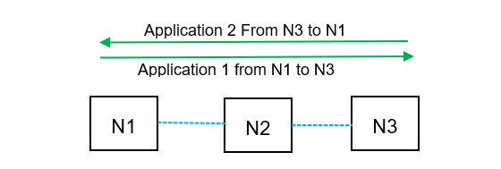 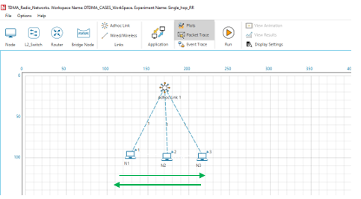

Figure 1: Schematic of network. An Adhoc network in which N1 transmits data to N3 via N2, and N3 transmits data to N1 via N2. The equivalent network of the schematic in NetSim is shown on the right.

Configure static route in Network layer of Nodes such that packets are getting transmitted N1>N2>N3 and N3>N2>N1. Properties configured in Wireless Nodes are as shown below.

|  |  |
| --- | --- |
| Interface1 _Wireless Properties | |
| Protocol (Phy &MAC) | DTDMA |
| Bandwidth (KHz) | 512 |
| Data symbol rate(kBd) | 512 |
| Modulation Technique | 16QAM |
| Coding Rate | 1/2 |
| Band | HF |
| MAC _layer Properties | |
| Slot Duration(ms) | 10 |
| Slot Allocation Technique | Round Robin/Slot planner |
| General Properties | |
| Mobility | No Mobility |
| Wireless Link Properties | |
| Channel Characteristics | No Pathloss |

Table 1: MANET Radio properties.

**PHY Rate Calculation**

Calculation for PHY Rate in the wireless links used for all 6 cases.

$$SymbolsPerSlot=SlotDuration(ms)×DataSymbolRate(kBd)$$

$$BitsPerSlot=SymbolsPerSlot×ModulationOrder×CodingRate$$

$$Phy Rate\left(kbps\right)=\frac{BitsPerSlot}{SlotDuration\left(ms\right)}=1.024 kbps$$

The Slot Duration, Data Symbol rate, Modulation Technique, Bandwidth and Coding rate can be configured in the Wireless Nodes.

**Application configuration**

In all cases the application settings are as follows:

|  |  |
| --- | --- |
| Application Parameters | |
| Application | CBR |
| Start Time (s) | 1 |
| Packet Size (bytes) | 100 |
| Packet Size Distribution | Constant |
| Inter-Arrival Time (µs) | 800  (1Mbps Application Rate) |
| Transport Protocol | UDP |

Table 2 :Application parameters

Simulate scenario for 100s and observe the throughput.

# DTDMA Single hop slot allocation using slot planner.

1. Properties configured in Wireless Nodes are as shown below.
2. Slot Allocation for Nodes is done using the slot planner as follows

Figure 2: Slot planner configuration in NetSim. One slot each is allotted to N1 and N3 and two slots to N2.

1. Simulate scenario for 100s and Observe the Throughput.

**Results**

|  |  |  |  |
| --- | --- | --- | --- |
| Application ID | Application Name | Case 1A (Round Robin) Throughput (Mbps) | Case 1B (Balanced slots) Throughput (Mbps) |
| 1 | App1 | 0.132 | 0.198 |
| 2 | App2 | 0.132 | 0.198 |

Table 3: Comparison of throughputs for both applications, for cases (i) Round Robin and (ii) Balanced slot allocation using the slot planner

**Observation**

From the packet trace we see the following

1. **Round Robin:** With RR allocation, N2 gets a slot once every three slots. Given two applications in either direction, data from source reaches the destination once every 6 slots.

|  |  |  |  |  |  |  |
| --- | --- | --- | --- | --- | --- | --- |
| **Slot Number** | **Allotted to** | **Application Source** | **Application Destination** | **Transmitter** | **Receiver** | **Packet reception instances** |
| 1 | N1 | 3 | 1 | 3 | 2 |  |
| 2 | N2 | 1 | 3 | 1 | 2 |  |
| 3 | N3 | 3 | 1 | 2 | 1 | Packet received from 3 |
| 4 | N1 | 3 | 1 | 3 | 2 |  |
| 5 | N2 | 1 | 3 | 1 | 2 |  |
| 6 | N3 | 1 | 3 | 2 | 3 | Packet received from 1 |
| 7 | … | … | … | … | … |  |
| 8 | … | … | … | … | … | The same cycle continues |

Table 4: We see the instances at which packets are received at the destination when the slot allocation to the nodes is round robin.

1. **Slot planner:** N1 to N3 and N3 to N1 application rates are equal; the intermediate node N2 has no traffic originating from them. In this scenario, the intermediate becomes the bottleneck, since for each packet of N1 and N3, the intermediate node N2 must make two transmissions i.e., one in each direction.

|  |  |  |  |  |  |  |
| --- | --- | --- | --- | --- | --- | --- |
| **Slot Number** | **Allotted to** | **Application Source** | **Application Destination** | **Transmitter** | **Receiver** | **Packet reception instances** |
| 1 | N1 | 1 | 3 | 1 | 2 |  |
| 2 | N2 | 1 | 3 | 2 | 3 | Packet received from 1 |
| 3 | N3 | 3 | 1 | 3 | 2 |  |
| 4 | N2 | 3 | 1 | 2 | 1 | Packet received from 3 |
| 5 | N1 | 1 | 3 | 1 | 2 |  |
| 6 | N2 | 1 | 3 | 2 | 3 | Packet received from 1 |
| 7 | N3 | 3 | 1 | 3 | 2 |  |
| 8 | N2 | 3 | 1 | 2 | 1 | Packet received from 3 |
| 9 | … | … | … | … | … |  |
| 10 | … | … | … | … | … | The same cycle continues |

Table 5: We see the instances at which packets are received at the destination when the slot allocation to the nodes is slot planner.

1. Using the slot planner, we have set two slots for each for each slot of N1 and N3. This means N2 is able to transmit two packets as required, thereby balancing the traffic flow.
2. Per this slot plan, data from the source reaches the destination once every 4 slots. Each slot is 10ms + 0.1 ms (guard interval). Thus, for a source-destination pair, delivery happens once every $40.4$ ms.
3. **Analytical Estimate**: Let us consider the case where we have 100B packets. The overhead for each packet is 28B (Transport layer = 8B, Network layer = 20B). Hence the PHY layer packet size in bits is $128×8=1024$
4. Since the PHY rate is 1 Mbps, in each slot $\frac{\left(1.024×{10}^{6}\right)*{10×10}^{-3}}{1024}=10$ packets can be sent. Hence in 1s it is possible to transmit $\frac{1}{40.4×{10}^{-3}}×10=247.52$ packets. Therefore, the predicted application throughput for with balanced slot allocation is $\frac{247.52×100×8}{1000}=198.02$ kbps.
5. NetSim Simulation output is 198 Kbps, which matches prediction.
6. **Comparison**: We also see that the ratio of throughputs of RR to slot planner is $\frac{0.132}{0.198 }=\frac{2}{3}$, which is the same as the analytically predicted ratio of packets transmitted i.e., $\frac{RoundRobin}{BalancedSlots}=\frac{\frac{1}{6}}{\frac{1}{4}}=\frac{2}{3}$

# DTDMA two hop transmissions with slot allocation using round robin

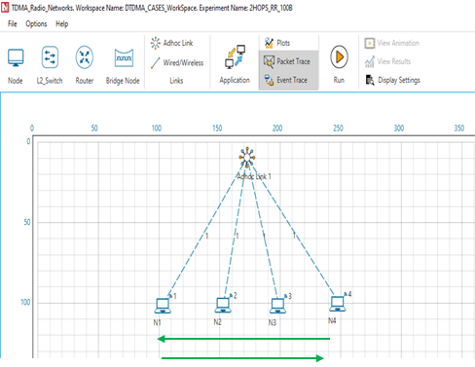Consider following DTDMA Network Scenario in NetSim, comprising 4 Wireless Nodes.

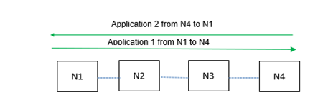

Figure 3: Network Topology. Node1 transmits data to node4 via node 2 and node3 (two hops). Similarly, node4 transmits data to node 1 via node3 and node2 (2 hops).

1. Properties configured in Wireless Nodes is the same as in case 1
2. Application Configuration:In cases where 2 Applications are configured, from N1 to N4, and from N4 to N1. The application settings are as per Table 2.
3. Configure static route in Network layer of Nodes such that packets are getting transmitted N1>N2>N3>N4 and N4>N3>N2>N1.
4. Simulate scenario for 100s and observe the Throughput.

# DTDMA two hop transmissions with slot allocation using slot planner

1. Properties configured in Wireless Nodes is the same as in case 1
2. Application Configuration:In cases where 4 Applications are configured, from N1 to N4, and from N4 to N1. The application settings are as per Table 2.
3. Configure static route in Network layer of Nodes such that packets are getting transmitted N1>N2>N3>N4 and N4>N3>N2>N1
4. The Slot Allocation for Nodes is as follows

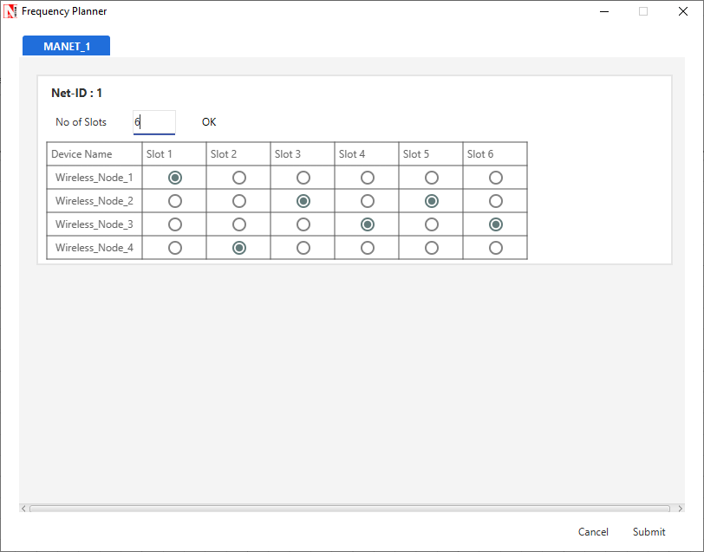

Figure 4: Slot planner configuration in NetSim. One slot each is allotted to N1 and N4 and two slots to N2 and N3

1. Simulate scenario for 100s and observe Throughput.

**Results:**

|  |  |  |  |
| --- | --- | --- | --- |
| Application ID | Application Name | Case 2A (Round Robin) Throughput (Mbps) | Case 2B(Balanced Slots) Throughput (Mbps) |
| 1 | App1 | 0.076 | 0.132 |
| 2 | App2 | 0.076 | 0.132 |

Table 6: Comparison of throughputs for both applications, for cases (i) Round Robin and (ii) Balanced slot allocation using the slot planner.

**Observation**

1. **Round Robin:** From Table *7* we see that data from source reaches the destination approximately once every 10 slots in the case of Round Robin

|  |  |  |  |  |  |  |
| --- | --- | --- | --- | --- | --- | --- |
| **Slot Number** | **Allotted to** | **Application Source** | **Application Destination** | **Transmitter** | **Receiver** | **Packet reception instances** |
| 1 | N1 | N1 | N4 | 1 | 2 |  |
| 2 | N2 | N1 | N4 | 2 | 3 |  |
| 3 | N3 | N1 | N4 | 3 | 4 | Packet received at 4 |
| 4 | N4 | N4 | N1 | 4 | 3 |  |
| 5 | N1 | N1 | N4 | 1 | 2 |  |
| 6 | N2 | N1 | N4 | 2 | 3 |  |
| 7 | N3 | N4 | N1 | 3 | 2 |  |
| 8 | N4 | N4 | N1 | 4 | 3 |  |
| 9 | N1 | N1 | N4 | 1 | 2 |  |
| 10 | N2 | N4 | N1 | 2 | 1 | Packet received at 1 |
| 11 | … | … | … | … | … |  |
| 12 | … | … | … | … | … | Approximately the same cycle continues |

Table 7: We see the instances at which packets are received at the destination when the slo*t* allocation to the nodes is round robin. This cycle is not periodic.

1. **Balanced slot allocation:** The arguments put forth in case 1 apply in this case as well. Here again, the intermediate nodes N2 and N3 have no traffic originating. Thus, both N2 and N3 must make two transmissions to balance the packet flow from N1 and N4

The exact slots at which packets are received for at N4 and N1, are got from the packet trace. These are:

|  |  |  |  |
| --- | --- | --- | --- |
| **Slot Number** | **Packet # Rx at N4** | **Slot Number** | **Packet # at Rx at N1** |
| 6 | 1 | 5 | 1 |
| 12 | 2 | 11 | 2 |
| 18 | 3 | 17 | 3 |
| 24 | 4 | 23 | 4 |
| 30 | 5 | 29 | 5 |
| 36 | 6 | 35 | 6 |
| 42 | 7 | 41 | 7 |
| 48 | 8 | 47 | 8 |
| 54 | 9 | 53 | 9 |
| 60 | 10 | 59 | 10 |

Table 8: Slots at which packets are received at N4 and N1

|  |  |  |  |  |  |  |
| --- | --- | --- | --- | --- | --- | --- |
| **Slot Number** | **Allotted to** | **Application Source** | **Application Destination** | **Transmitter** | **Receiver** | **Packet reception instances** |
| 1 | N1 | N1 | N4 | 1 | 2 |  |
| 2 | N4 | N4 | N1 | 4 | 3 |  |
| 3 | N2 | N1 | N4 | 2 | 3 |  |
| 4 | N3 | N4 | N1 | 3 | 2 |  |
| 5 | N2 | N4 | N1 | 2 | 1 | Packet received at 1 |
| 6 | N3 | N1 | N4 | 3 | 4 | Packet received at 4 |
| 7 | N1 | N1 | N4 | 1 | 2 |  |
| 8 | N4 | N4 | N1 | 4 | 3 |  |
| 9 | N2 | N1 | N4 | 2 | 3 |  |
| 10 | N3 | N4 | N1 | 3 | 2 |  |
| 11 | N2 | N4 | N1 | 2 | 1 | Packet received at 1 |
| 12 | N3 | N1 | N4 | 3 | 4 | Packet received at 4 |
| 13 | … | … | … | … | … |  |
| 14 | … | … | … | … | … | The same cycle continues |

Table 9: We see the instances at which packets are received at the destination when the slot allocation to the nodes is slot planner. Two packets are received per application every 12 slots.

1. **Analytical Estimate**: Let us consider the case where we have 100B packets with balanced slot allocation. Data from the source reaches the destination once every 6 slots. Each slot is 10ms + 0.1 ms (guard interval). Thus, once every $60.6$ ms
2. As explained earlier, the PHY layer packet size in bits is $128×8=1024$, and in each slot $10$ packets can be sent. Hence in 1s it is possible to transmit $\frac{1}{60.6×{10}^{-3}}×10=165.02$ packets. This implies an application throughput of $\frac{165.02×100×8}{1000}=132.02$ kbps.
3. NetSim Simulation output is 132 Kbps which agrees with the analytical estimate.
4. However, using the slot planner we have set two slots for each for each slot of N1 and N3. This means N2 is able to transmit two packets as required thereby balancing the network.
5. **Comparison**: The predicted (approximate) ratio of packets transmitted slots $\frac{RoundRobin}{BalancedSlots}=\frac{\frac{1}{10}}{\frac{1}{6}}=\frac{3}{5}=0.6$. NetSim simulation ratio of throughputs $\frac{0.076}{0.132 }=0.575$.

# DTDMA Multi hop transmissions with slot allocation using round robin.

1.Consider following DTDMA Network Scenario in NetSim, comprising 5 Wireless Nodes

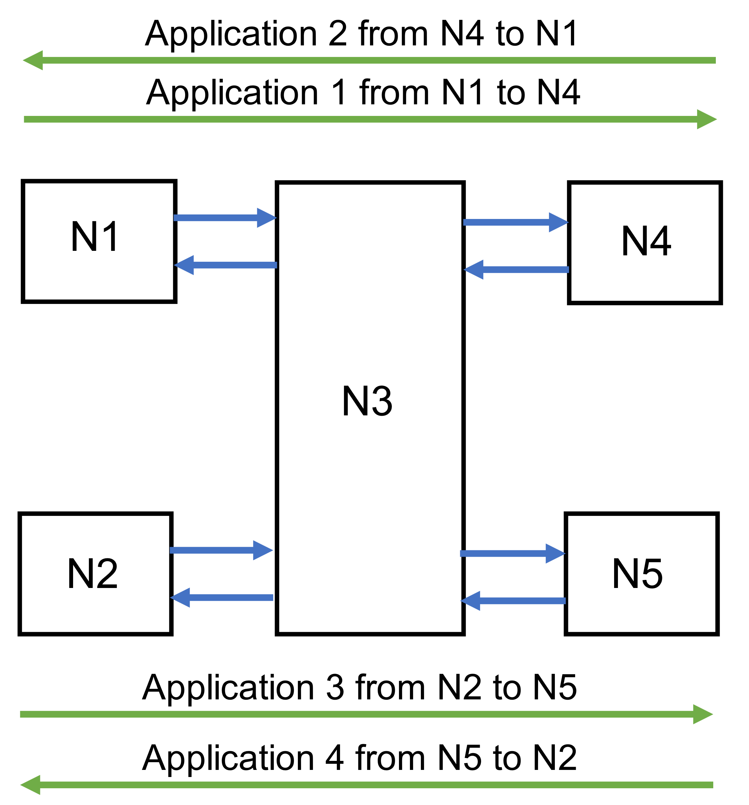

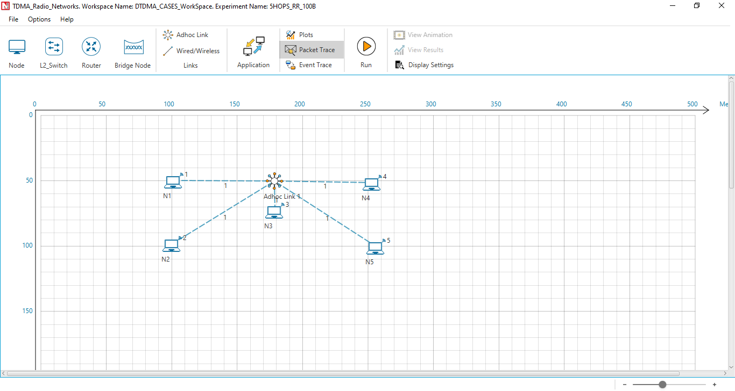

Figure 5**:**Network Topology. Node 1 transmits data to Node 4 via Node 2 and node 3 (two hops). Similarly, node 4 transmits data to Node 1 via Node 3 and Node 2 (two hops) and Node 2 transmits data to Node 5 via Node 3 and Node 4 (two hops). Similarly, Node 5 transmits data to Node 2 via Node 4 and Node 3 (two hops).

1. Properties configured in Wireless Nodes are the same as in case 1.
2. Application Configuration: In cases where 4 Applications are configured, from N1 to N4, N4 to N1, N2 to N5 and from N5 to N2. The application settings are as per Table 2.
3. Configure static route in Network layer of Nodes such that packets are getting transmitted N1>N3>N4 & N4>N3>N1 & N2>N3>N5 & N5>N3>N2.
4. Simulate scenario for 100s & observe Throughput.

# DTDMA Multi hop transmissions with slot allocation using Slot Planner.

1. Properties configured in Wireless Nodes, is the same as in Case 1.
2. Application Configuration: In cases where 2 Applications are configured, from N1 to N4, N4 to N1, N2 to N5 and from N5 to N2. The application settings are as per Table 2.
3. Configure static route in Network layer of Nodes such that packets are getting transmitted N1>N3>N4 & N4>N3>N1 & N2>N3>N5 & N5>N3>N2.
4. Slot Allocation for Wireless Nodes is as follows.

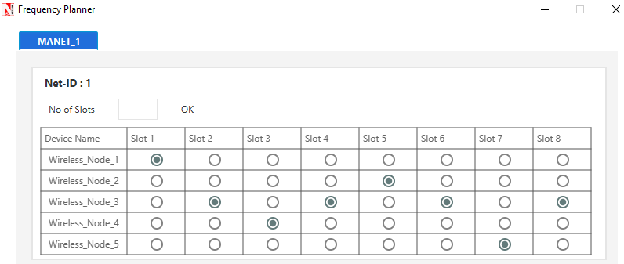

Figure 6: Slot planner configuration in NetSim. One slot each is allotted to N1, N2, N4 and N5 and four slots to N3.

1. Simulate scenario for 100s and observe the throughput.

**Results:**

|  |  |  |  |
| --- | --- | --- | --- |
| Application ID | Application Name | Case 3A (Round Robin) Throughput (Mbps) | Case 3B (Balanced slots) Throughput (Mbps) |
| 1 | App1 | 0.040 | 0.099 |
| 2 | App2 | 0.040 | 0.099 |
| 3 | App3 | 0.040 | 0.099 |
| 4 | App4 | 0.040 | 0.099 |

Table 10: Comparison of throughputs for both applications, for cases (i) Round Robin and (ii) Balanced slot allocation using the slot planner.

**Observations and discussion**

|  |  |  |  |  |  |  |
| --- | --- | --- | --- | --- | --- | --- |
| **Slot Number** | **Allotted to** | **Application Source** | **Application Destination** | **Transmitter** | **Receiver** | **Packet reception instances** |
| 1 | N1 | N1 | N4 | 1 | 3 |  |
| 2 | N2 | N2 | N5 | 2 | 3 |  |
| 3 | N3 | N1 | N4 | 3 | 4 | Packet received at 4 |
| 4 | N4 | N4 | N1 | 4 | 3 |  |
| 5 | N5 | N5 | N2 | 5 | 3 |  |
| 6 | N1 | N1 | N4 | 1 | 3 |  |
| 7 | N2 | N2 | N5 | 2 | 3 |  |
| 8 | N3 | N2 | N5 | 3 | 5 | Packet received at 5 |
| 9 | N4 | N4 | N1 | 4 | 3 |  |
| 10 | N5 | N5 | N2 | 5 | 3 |  |
| 11 | N1 | N1 | N4 | 1 | 3 |  |
| 12 | N2 | N2 | N5 | **2** | **3** |  |
| 13 | N3 | N4 | N1 | **3** | **1** | Packet received at 1 |
| 14 | N4 | N4 | N1 | **4** | **3** |  |
| 15 | N5 | N5 | N2 | **5** | **3** |  |
| 16 | N1 | N1 | N4 | **1** | **3** |  |
| 17 | N2 | N2 | N5 | **2** | **3** |  |
| 18 | N3 | N5 | N2 | **3** | **2** | Packet received at 2 |
| 20 | …… | …… | …… | …… | …… |  |
| 21 | …… | …… | …… | …… | …… | **The cycle Continues** |

Table 11: We see the instances at which packets are received at the destination when the slot allocation to the nodes is round robin.

**Table for balanced slot allocation:**

|  |  |  |  |  |  |  |
| --- | --- | --- | --- | --- | --- | --- |
| **Slot Number** | **Allotted to** | **Application Source** | **Application Destination** | **Transmitter** | **Receiver** | **Packet reception instances** |
| 1 | N1 | N1 | N4 | 1 | **3** |  |
| 2 | N2 | N1 | N4 | **3** | **4** | **Packet received at 4** |
| 3 | N3 | N4 | N1 | **4** | **3** |  |
| 4 | N4 | N4 | N1 | **3** | **1** | **Packet received at 1** |
| 5 | N5 | N2 | N5 | **2** | **3** |  |
| 6 | N6 | N2 | N5 | **3** | **5** | **Packet received at 5** |
| 7 | N7 | N5 | N2 | **5** | **3** |  |
| 8 | N8 | N5 | N2 | **3** | **2** | **Packet received at 2** |
| 9 | N1 | N1 | N4 | 1 | **3** |  |
| 10 | N2 | N1 | N4 | **3** | **4** | **Packet received at 4** |
| 11 | N3 | N4 | N1 | **4** | **3** |  |
| 12 | N4 | N4 | N1 | **3** | **1** | **Packet received at 1** |
| 13 | N5 | N2 | N5 | **2** | **3** |  |
| 14 | N6 | N2 | N5 | **3** | **5** | **Packet received at 5** |
| 15 | N7 | N5 | N2 | **5** | **3** |  |
| 16 | N8 | N5 | N2 | **3** | **2** | **Packet received at 2** |
| 17 | …… | …… | …… | …… | …… |  |
| 18 | …… | …… | …… | …… | …… | **The cycle Continues** |

Table 12: We see the instances at which packets are received at the destination when the slot allocation to the nodes is slot planner.

1. **Round Robin**: With round robin slot allocation, N3 get one slot in every five slots. Thus, one packet is transmitted in 5 slots.
2. **Balanced Slots**: With balanced slot allocation i.e., four slots for N3 for one slot of N1, N2, N4, and N5 they are able to transmit two packets i.e., one packet is each direction.
3. **Analytical Estimate**: Let us consider the case where we have 100B packets with balanced slot allocation. Data from the source reaches the destination once every 10 slots. Each slot is 10ms + 0.1 ms (guard interval). Thus, once every $60.4$ ms
4. The overhead for each packet is 28 B (Transport layer = 8B, Network layer = 20B). Hence the PHY layer packet size in bits is $128×8=1024$
5. Since the PHY rate is 1 Mbps, in each slot $\frac{\left(1.024×{10}^{6}\right)*{10×10}^{-3}}{1024}=10$ packets can be sent. This means 9 complete packets plus one fragmented packet.
6. Hence in 1s it is possible to transmit $\frac{1}{80.8×{10}^{-3}}×10=123.76$ packets. This implies a application throughput of $\frac{123.76×100×8}{1000}=99$ kbps.
7. **Comparison**: The predicted (approximate) ratio of packets transmitted slots the ratio of throughputs $\frac{0.040}{0.099}=0.404$ is the same as the ratio of packets transmitted slots $\frac{RoundRobin}{BalancedSlots}=\frac{\frac{1}{5}}{\frac{4}{8}}=\frac{2}{5}=0.4$

# Comparative Plots

Figure 7: End-to-end throughput for various multi-hop cases. Balanced slot allocation shows almost 2x improvement over round robin

# Slot capacity not an integral multiple of packet size

|  |  |
| --- | --- |
| Interface1 _Wireless Properties | |
| Protocol (Phy &MAC) | DTDMA |
| Bandwidth (KHz) | 500 |
| Data symbol rate(kBd) | 500 |
| Modulation _Technique | 16_QAM |
| Coding Rate | ½ |
| Band | HF |
| MAC _layer Properties | |
| Slot Duration(ms) | 10 |
| Slot Allocation Technique | Round Robin/Slot planner |
| General Properties | |
| Mobility | No Mobility |
| Wireless Link Properties | |
| Channel Characteristics | No Pathloss |

Table 13: MANET Radio properties.

**Results:**

|  |  |  |  |
| --- | --- | --- | --- |
| Application ID | Application Name | Round Robin  Throughput (Mbps) | Balanced Slots  Throughput (Mbps) |
| 1 | App1 | 0.073 | 0.110 |
| 2 | App2 | 0.073 | 0.110 |

Table 14: Comparison of throughputs for both applications, for cases (i) Round Robin and (ii) Balanced slot allocation using the slot planner.

**Comparative plot**

Table 15 : Throughput versus slot capacity with different slot allocation techniques.

# Appendix 1: Download Link

The configuration files (scenario, settings, and other related files) of the examples discussed in this analysis are available for users to import and run in NetSim.

Users can download the files from NetSim’s git-repository.

Link: s

1. Click on the link given and download the folder.
2. Extract the zip folder. The extracted project folder consists of one NetSim Experiments file, namely *Performance-Analysis-of-Tactical-Radio-Networks_v13.3.17.netsimexp*
3. Import per steps given in section 4.9.2 in NetSim User Manual

All the experiments can now be seen folder wise within NetSim > Your Work.