# **MATLAB INTERFACE FOR RPL DODAG VISUALIZATION**

**Software Recommended:** NetSim Standard v11.1 (32bit/ 64bit), Visual Studio 2015/2017, MATLAB (32bit/ 64bit)

**Note:** This project works only MATLAB v2015b and onwards.

**Steps to run MATLAB interface**

1. After you unzip the downloaded project folder, Open NetSim Home Page click on **Open Simulation** option,

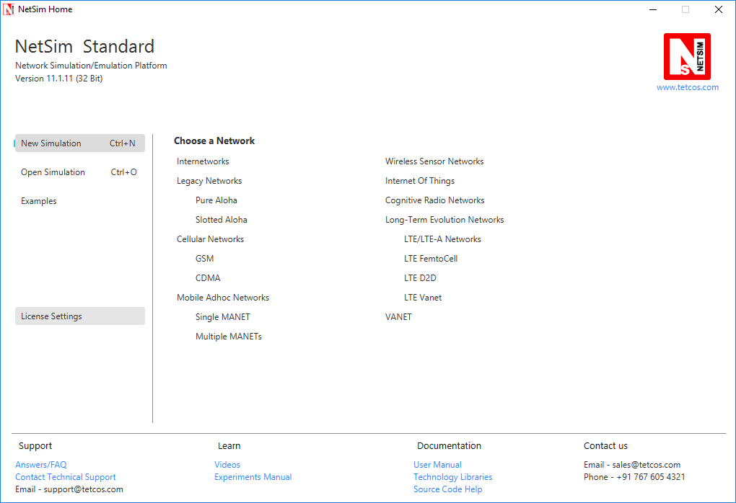

1. Click on **Workspace options**

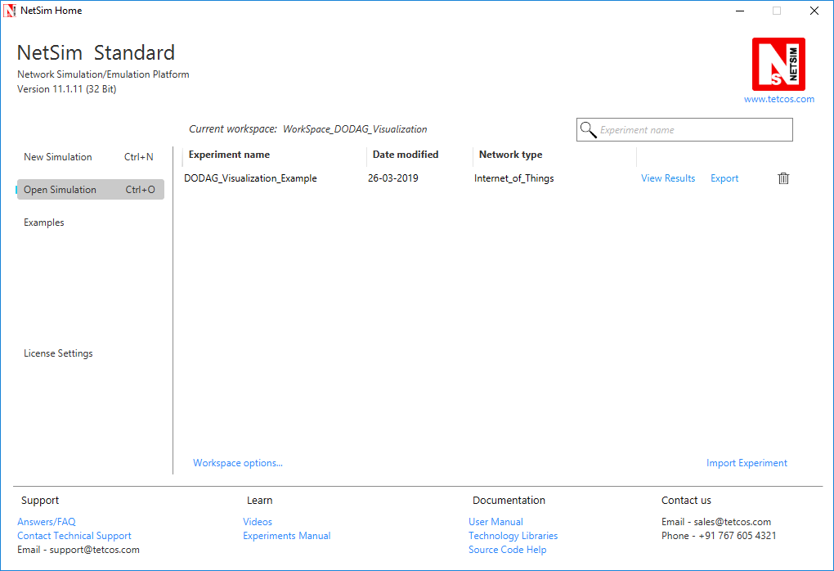

1. Click on **More Options,**

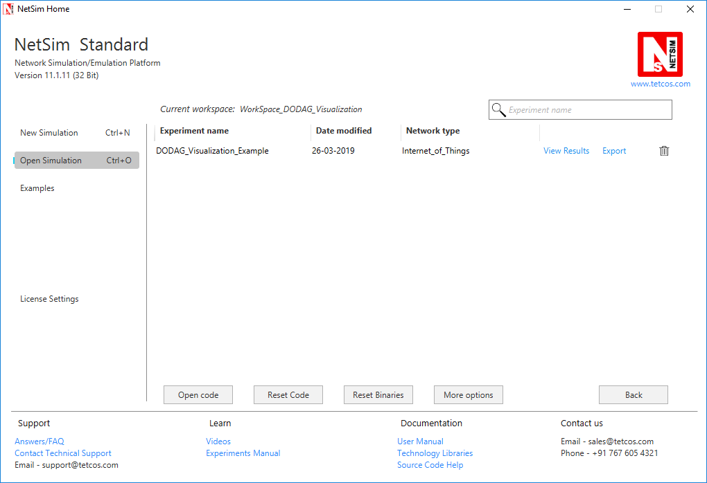

1. Click on **Import**, browse the extracted folder path and go into the Workspace_DODAG_Visualization directory. Click on the Select folder button and then on **OK.**

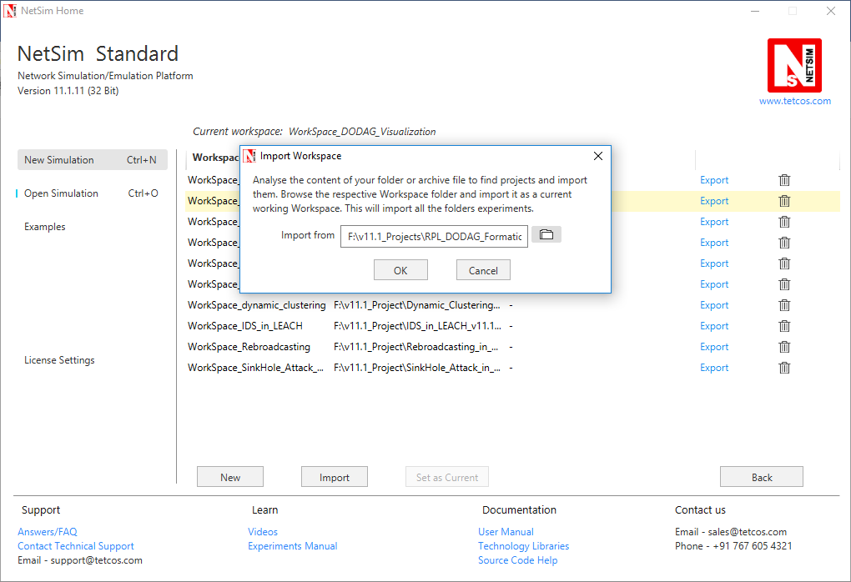

1. Go to home page, Click on **Open Simulation** 🡪 **Workspace options** 🡪 **Open code**

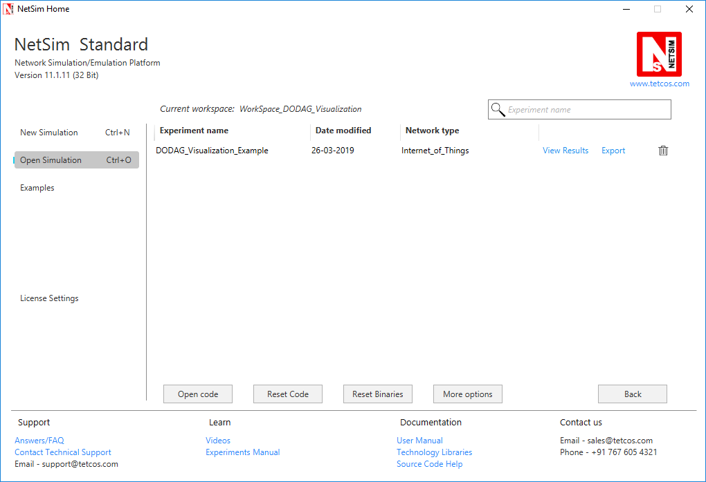

1. Place **PlotDAG.m** file inside the MATLAB root directory. For Eg: **“<MATLAB installed path>\MATLAB\R2015b”, (Note: PlotDAG.m** is provided inside the MATLAB_Code directory)
2. Following modifications were done to the RPL project for this implementation:
3. Open RPL.c file and add **fn_netsim_matlab_init()**, **fn_netsim_matlab_DODDAG_run()** and **fn_netsim_matlab_DODDAG_Init()** inside **fn_NetSim_RPL_Init()** and **fn_netsim_matlab_Finish()** inside **fn_NetSim_WLAN_Finish ()**.

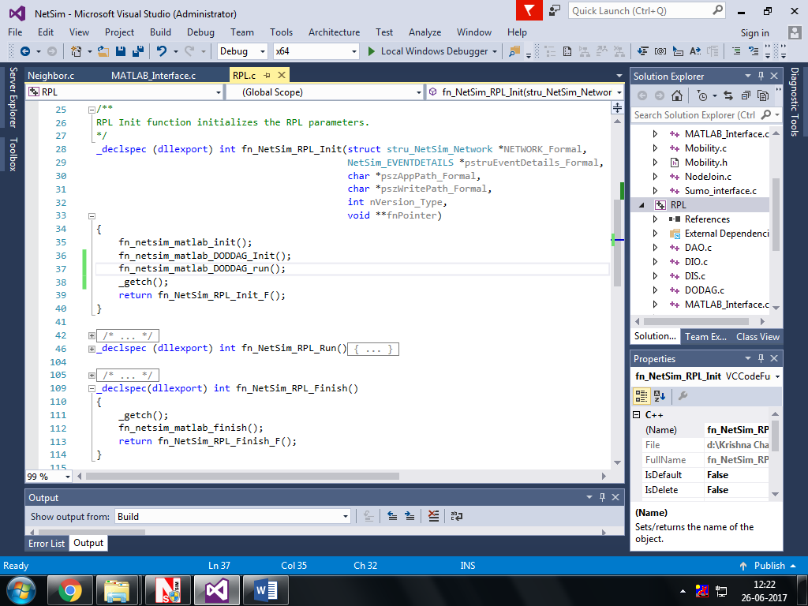

1. Add definitions of the following functions inside **RPL.h** file
   1. **double fn_netsim_matlab_init();**
   2. **double fn_netsim_matlab_DODDAG_Init();**
   3. **double fn_netsim_matlab_DODDAG_run();**
2. 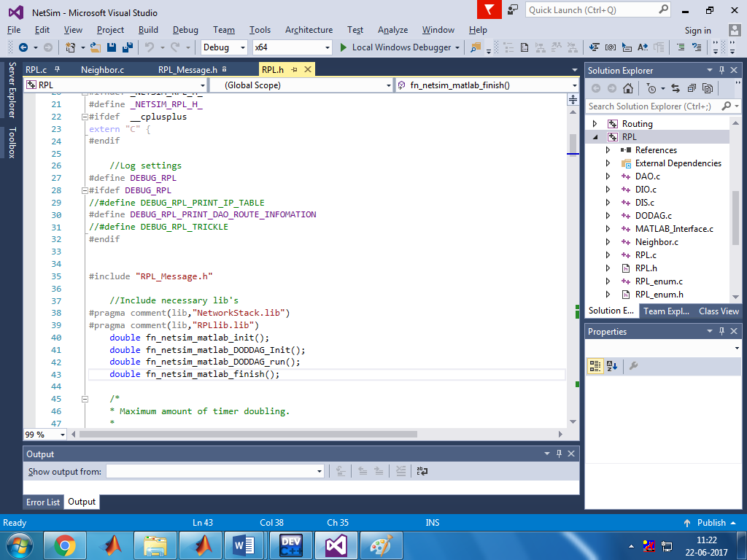 **double fn_netsim_matlab_finish();**
3. Go to the **Neighbor.c** file. Inside Function **void choose_parents_and_siblings(NETSIM_ID d)** add **fn_netsim_matlab_DODDAG_run()** below **rpl_add_route_to_parent()**

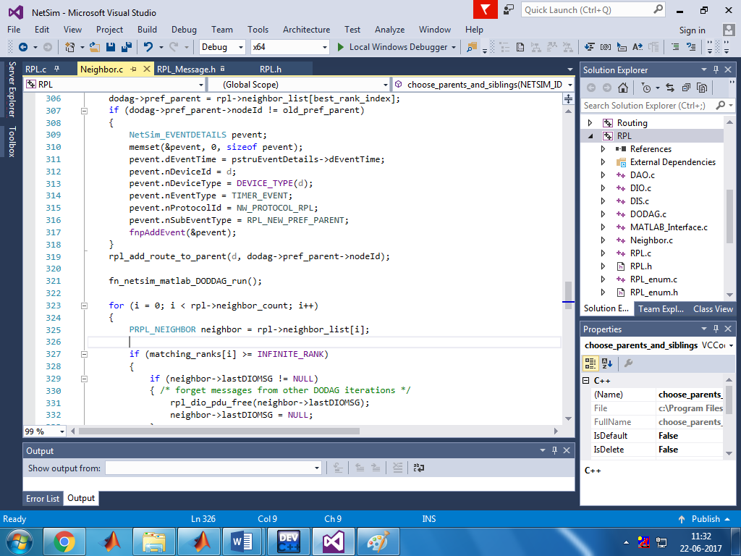

1. Create a user variable with the name of MATLAB_PATH and provide the path of the installation directory of user’s respective MATLAB version.

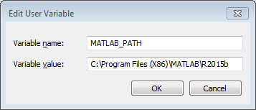

1. Make sure that the following directory is in the PATH(Environment variable)

<Path where MATLAB is installed>\bin\win32

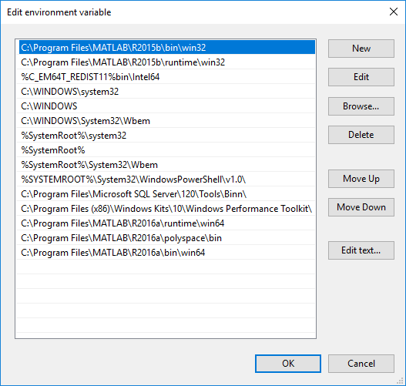

(**Note:** To run this code 32- bit version of MATLAB must be installed in your system. If you are interfacing for the first time then open command window and go to the **<NetSim installed directory>\bin** and type **matlab -regserver**)

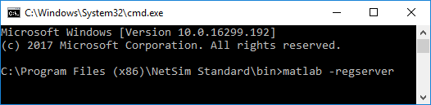

1. Now Right Click on RPL project and select Rebuild.
2. Upon rebuilding, **RPL.dll** will automatically be updated in the respective bin folder of the current workspace.

**Note:**

* Based on whether you are using NetSim 32 bit or 64 bit setup you can configure Visual studio to build 32 bit or 64 bit Dll files respectively as shown below:

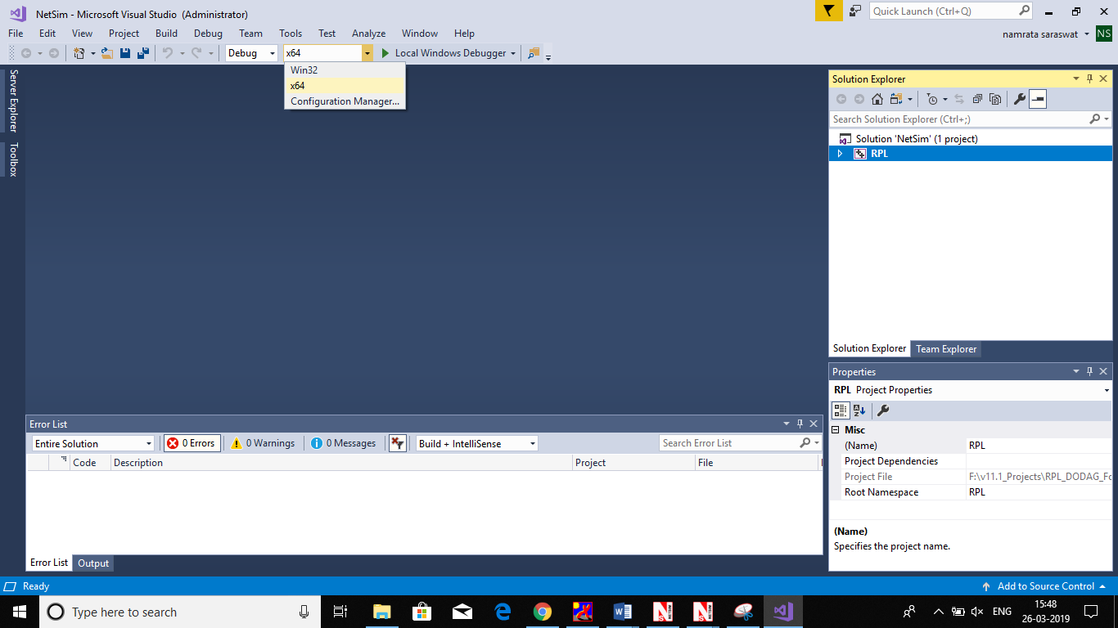

* While importing the workspace, if the following warning message indicating Software Version Mismatch is displayed, you can ignore it and proceed.

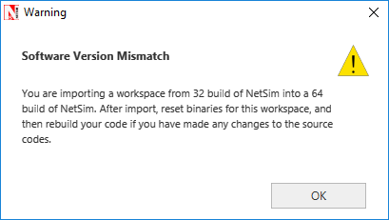

* Go to NetSim home page, click on **Open Simulation**, Click on **DODAG_Visualization_Example**.

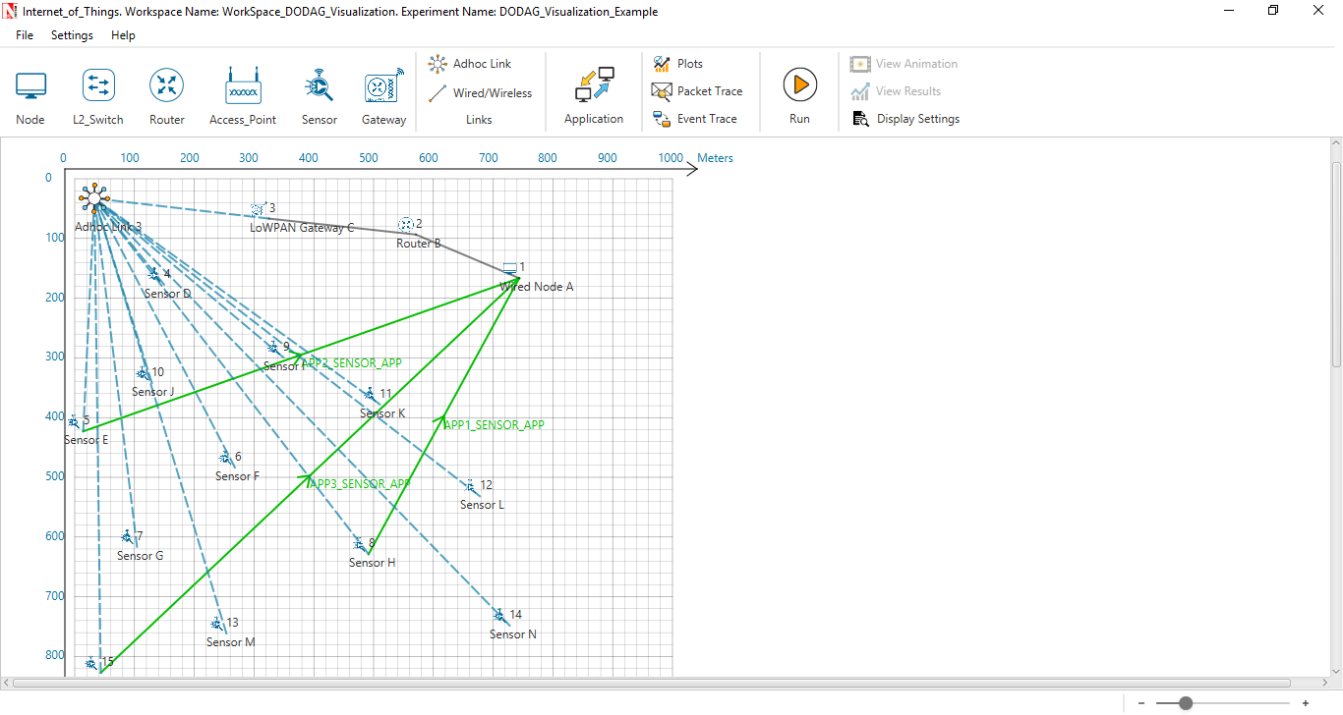

Set Velocity to the sensors

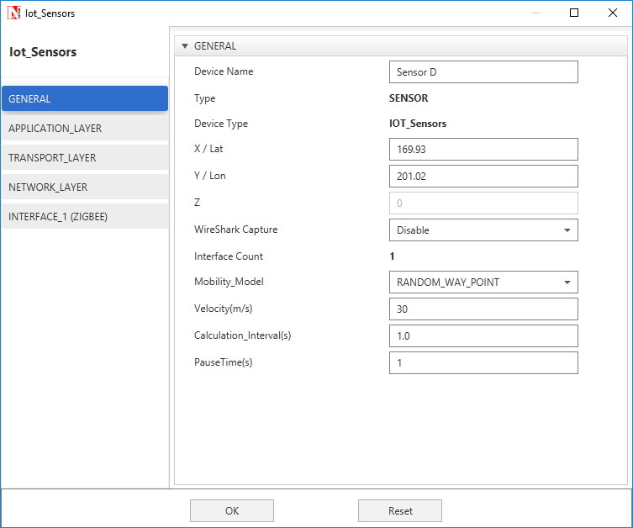

**Output:**

A plot will open, showing the DODAG when the simulation is started and the first route is formed between sink node and the sensor. And the DODAG will be dynamically updated.

**Initially formed DODAG**

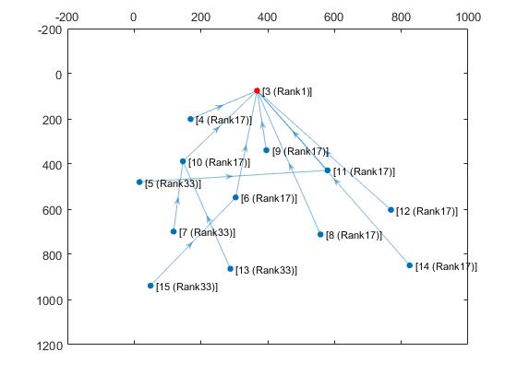

**DODAG formed after some time due to movement in sensors**

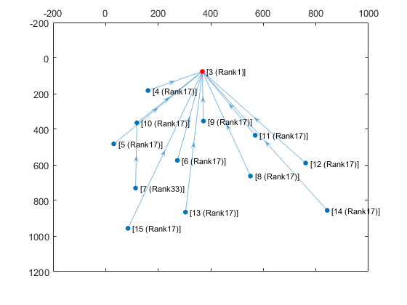

After simulation press any key in the NetSim command window to close the MATLAB.