# **MATLAB INTERFACE FOR RPL DODAG VISUALIZATION**

**Software Recommended:** NetSim Standard v12.0 (32bit/ 64bit), Visual Studio 2015/2017/2019, MATLAB (32bit/ 64bit)

**Note:** This project works only with MATLAB v2015b or higher versions.

RPL (Routing Protocol for Low-Power and Lossy Networks) is a routing protocol for wireless networks with low power consumption and generally susceptible to packet loss. It is a proactive protocol based on distance vectors and operates on IEEE 802.15.4, optimized for multi-hop and many-to-one communication, but also supports one-to-one messages.

This protocol is specified in RFC 6550 with special applications in RFCs 5867, 5826, 5673 and 5548. RPL can support a wide variety of link layers, including those with limitations, with potential losses or that are used in devices with limited resources. This protocol can quickly create network routes, share routing knowledge and adapt the topology in an efficient way.

RPL creates a topology similar to a tree (DAG or directed acyclic graph). Each node within the network has an assigned rank (Rank), which increases as the teams move away from the root node (DODAG). The nodes resend packets using the lowest range as the route selection criteria.

The DODAG formed as part of RPL protocol in NetSim can be visualized by interfacing NetSim with MATLAB.

**Steps to run MATLAB interface**

1. After you unzip the downloaded project folder, Open NetSim Home Page click on **Open Simulation** option,

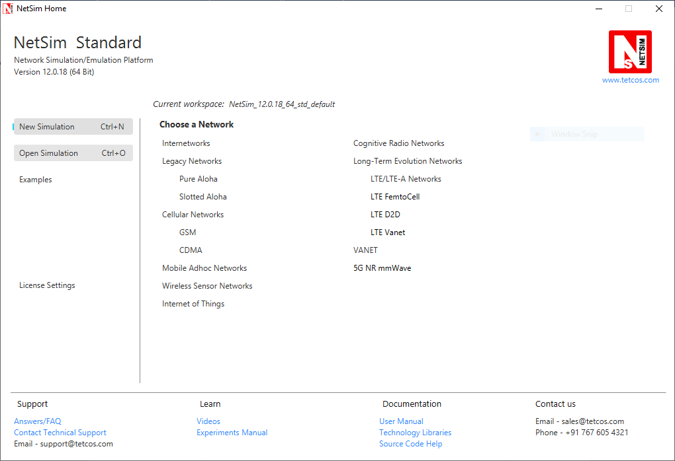

1. Click on **Workspace options**

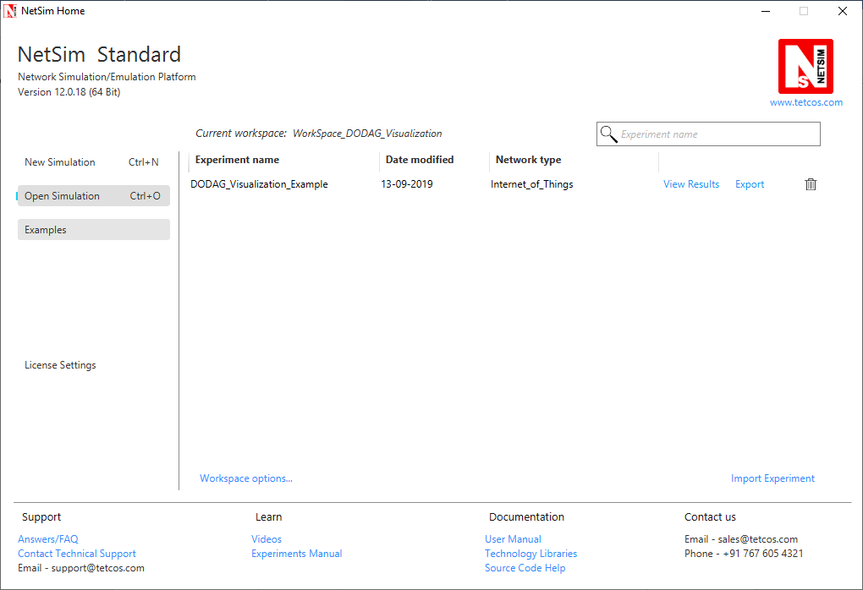

1. Click on **More Options,**

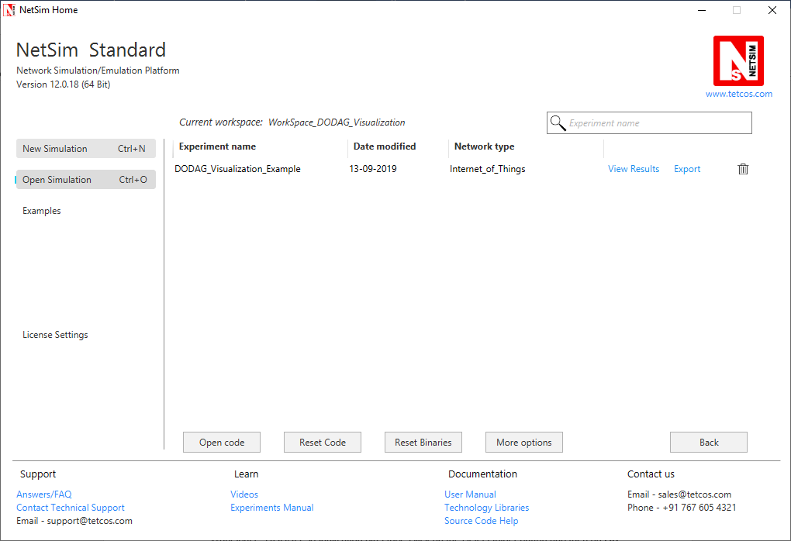

1. Click on **Import**, browse the extracted folder path and go into the Workspace_DODAG_Visualization directory. Click on the Select folder button and then on **OK.**

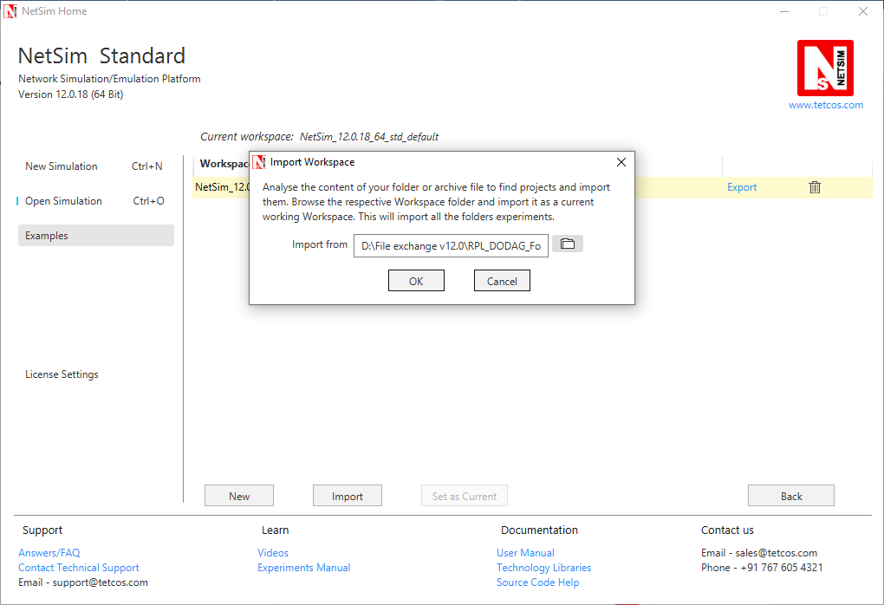

1. Go to home page, Click on **Open Simulation** 🡪 **Workspace options** 🡪 **Open code**

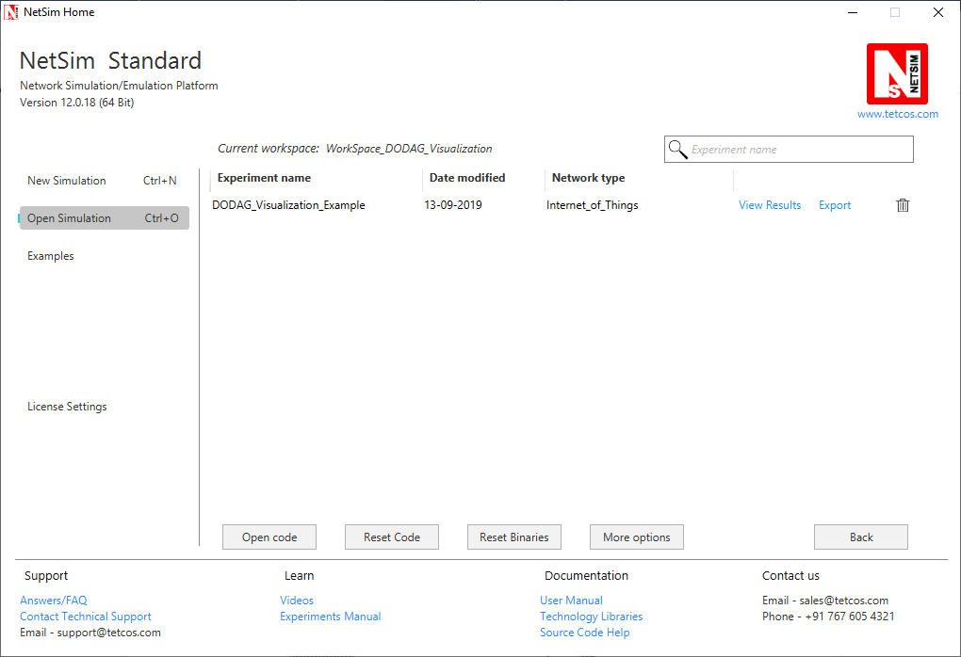

1. Place **PlotDAG.m** file inside the MATLAB root directory. For Eg: **“<MATLAB installed path>\MATLAB\R2015b”, (Note: PlotDAG.m** is provided inside the MATLAB_Code directory)
2. Following modifications were done to the RPL project for this implementation:
3. Open RPL.c file and add **fn_netsim_matlab_init()**, **fn_netsim_matlab_DODDAG_run()** and **fn_netsim_matlab_DODDAG_Init()** inside **fn_NetSim_RPL_Init()** and **fn_netsim_matlab_finish()** inside **fn_NetSim_RPL_Finish ()**.

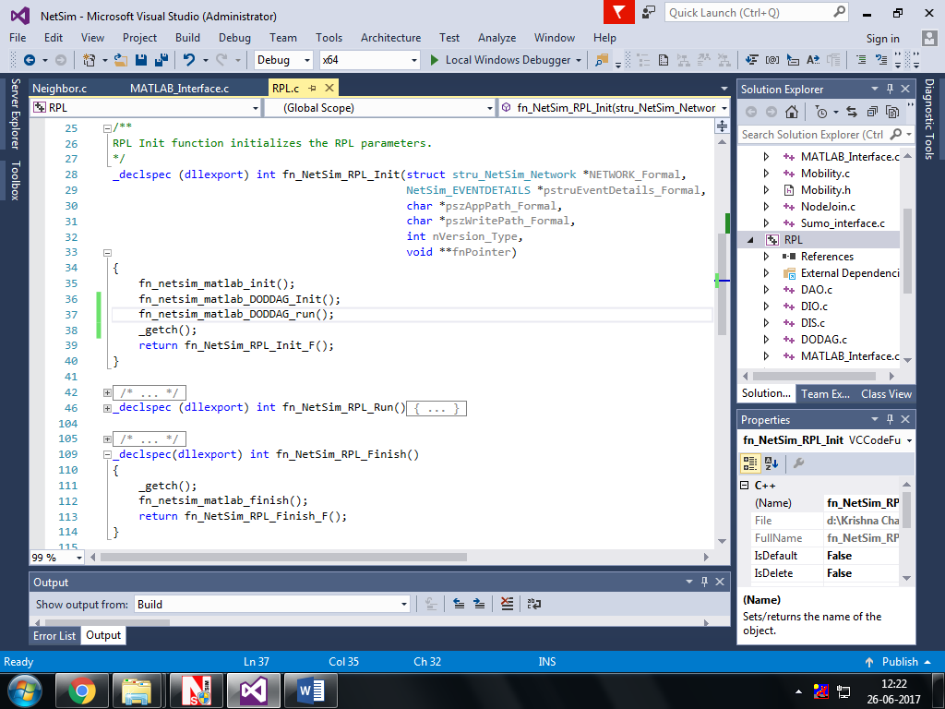

1. Add definitions of the following functions inside **RPL.h** file
   1. **double fn_netsim_matlab_init();**
   2. **double fn_netsim_matlab_DODDAG_Init();**
   3. **double fn_netsim_matlab_DODDAG_run();**
2. 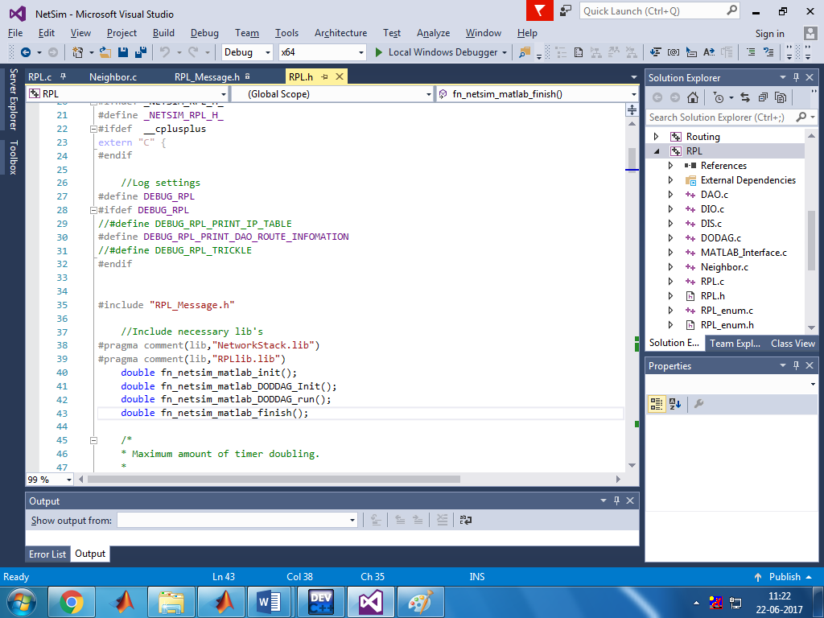 **double fn_netsim_matlab_finish();**
3. Go to the **Neighbor.c** file. Inside Function **void choose_parents_and_siblings(NETSIM_ID d)** add **fn_netsim_matlab_DODDAG_run()** below **rpl_add_route_to_parent()**

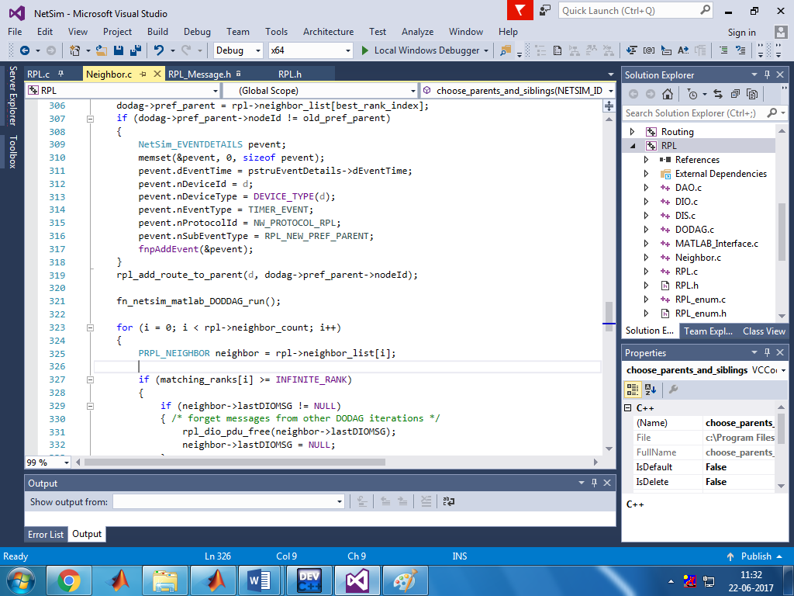

1. Create a user variable with the name of MATLAB_PATH and provide the path of the installation directory of user’s respective MATLAB version.

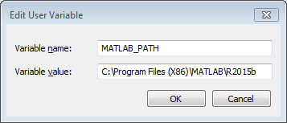

1. Make sure that the following directory is in the PATH(Environment variable)

<Path where MATLAB is installed>\bin\win32

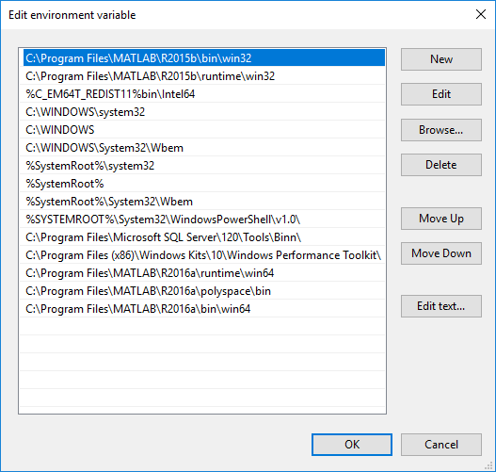

(**Note:** To run this code 32- bit version of MATLAB must be installed in your system. If you are interfacing for the first time then open command window and go to the **<NetSim installed directory>\bin** and type **matlab -regserver**)

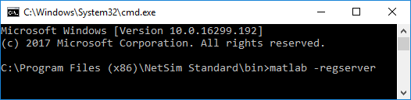

1. Now Right Click on RPL project and select Rebuild.
2. Upon rebuilding, **RPL.dll** will automatically be updated in the respective bin folder of the current workspace.

**Note:**

* Based on whether you are using NetSim 32 bit or 64 bit setup you can configure Visual studio to build 32 bit or 64 bit Dll files respectively as shown below:

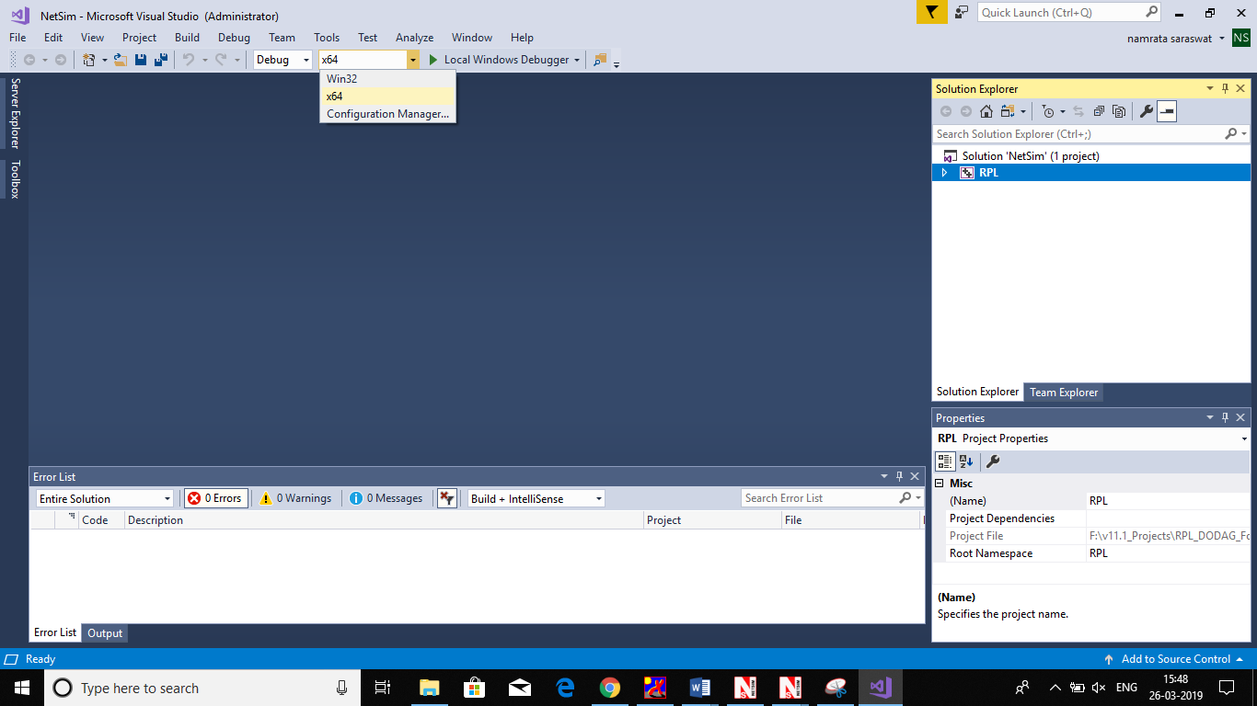

* While importing the workspace, if the following warning message indicating Software Version Mismatch is displayed, you can ignore it and proceed.

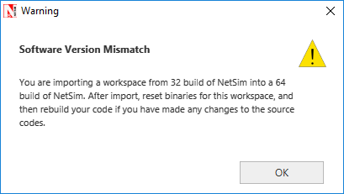

* Go to NetSim home page, click on **Open Simulation**, Click on **DODAG_Visualization_Example**.

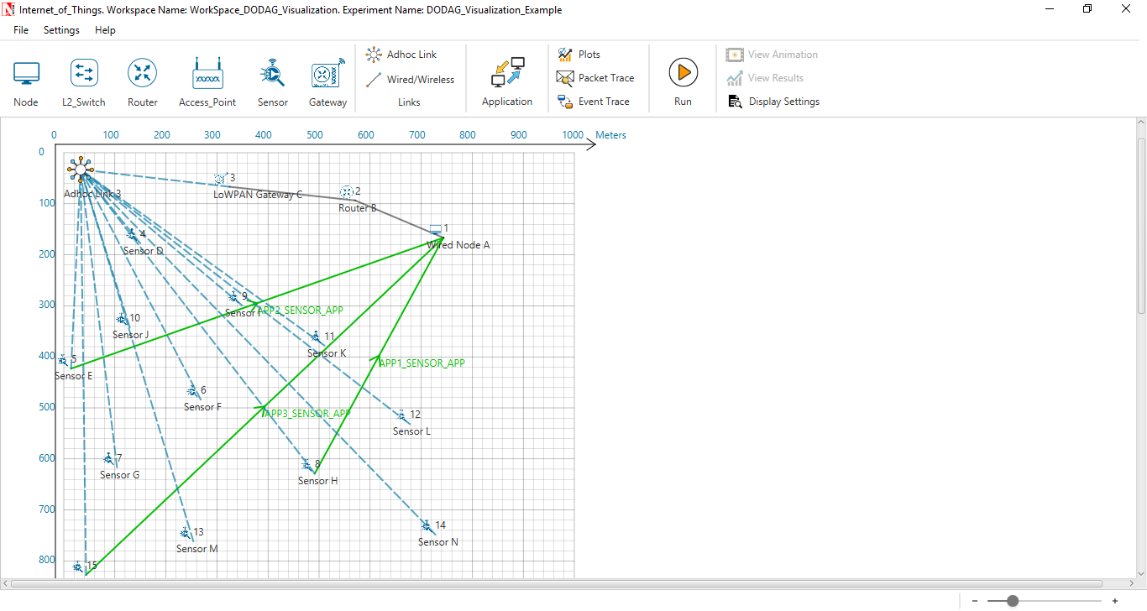

Set Velocity to the sensors

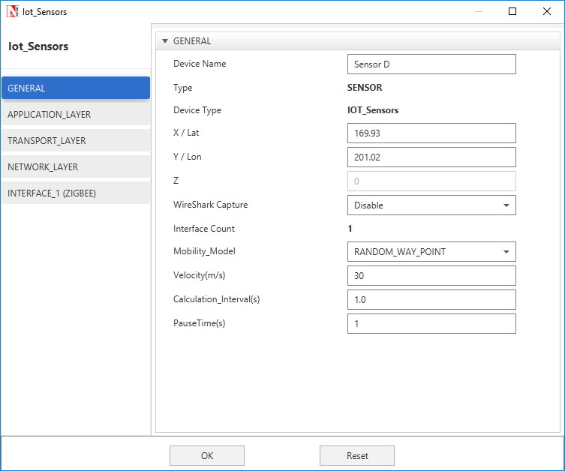

**Output:**

A plot will open, showing the DODAG when the simulation is started and the first route is formed between sink node and the sensor. And the DODAG will be dynamically updated.

**Initially formed DODAG**

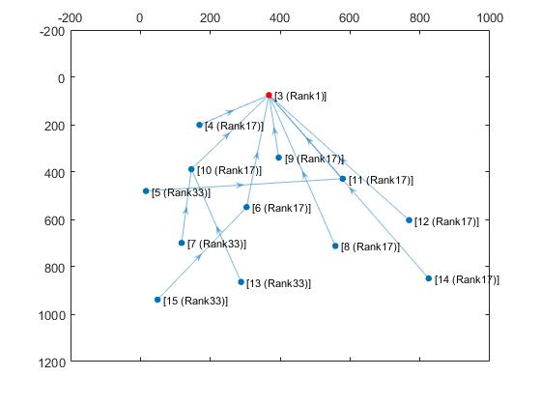

**DODAG formed after some time due to movement in sensors**

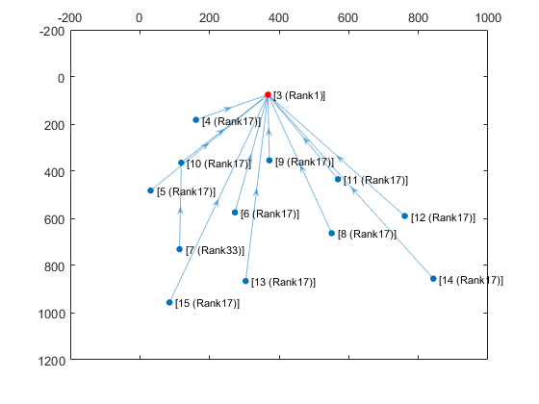

After simulation press any key in the NetSim command window to close the MATLAB.