# MATLAB INTERFACE FOR RPL DODAG VISUALIZATION ( .m FILE)

Steps to run MATLAB interface

1. Create **MATALB_Interface.c** file inside **RPL** folder, path to this folder **<NetSim installed directory>\src\Simulation\**

**(Note: MATLAB_Interface.c** file is provided in the folder)

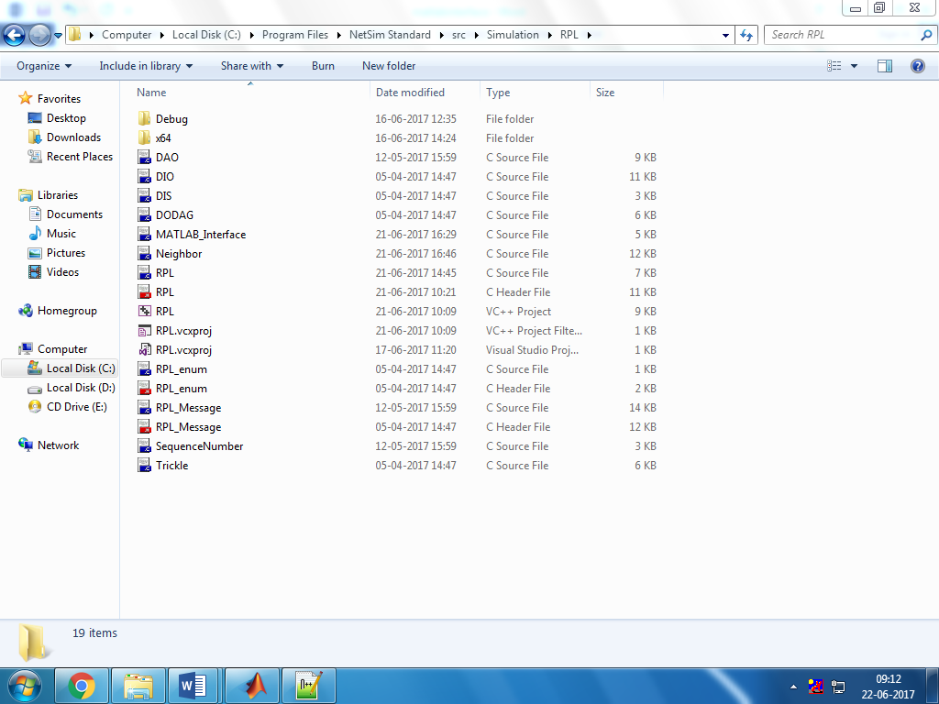

1. Open Nesim.sln, Path toNetSim.sln is **<NetSim installed directory>\src\Simulation\**

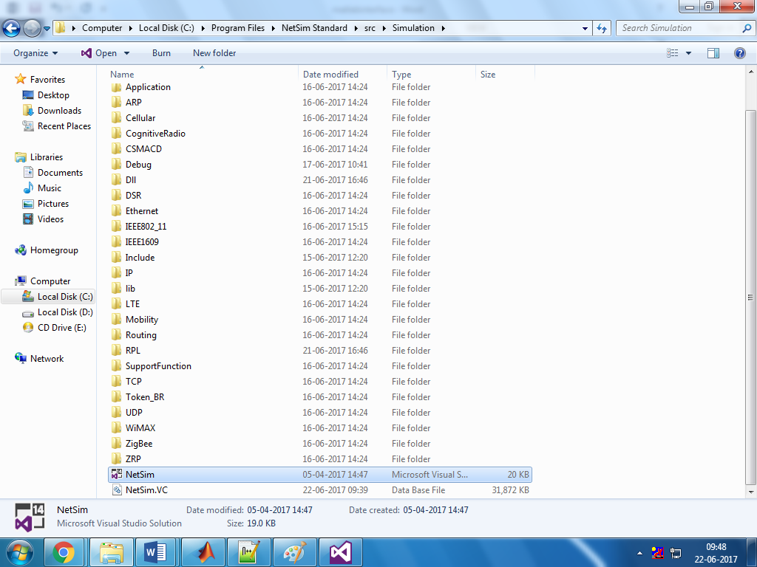

1. Right click on RPL🡪Add🡪 Existing Item🡪 Select MATLAB_Interface.c file.

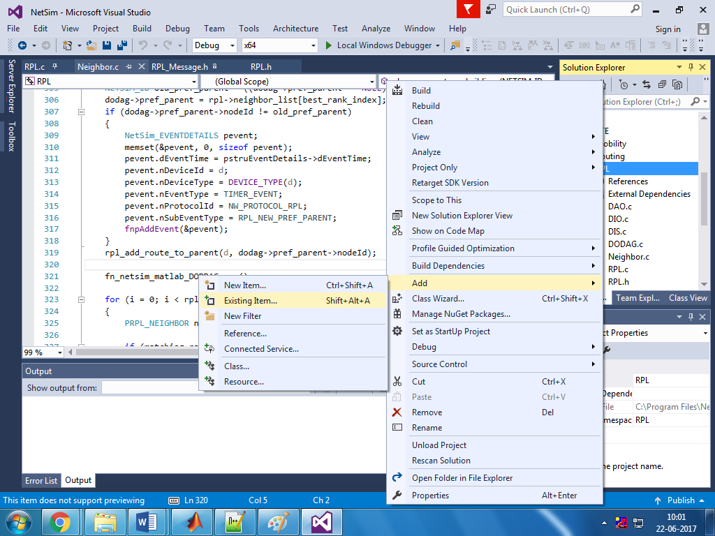

1. Place **PlotDAG.m** file inside the installation folder of MATLAB i.e. **“C:\Program Files\MATLAB\R2016a”, (Note: PlotDAG.m** is provided in the folder)

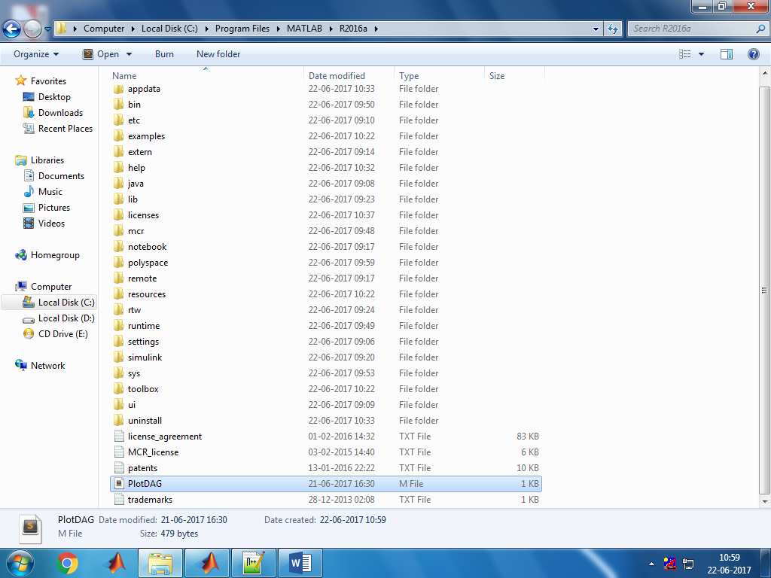

1. Open RPL.c file and add **fn_netsim_matlab_init()** and **fn_netsim_matlab_DODDAG_Init()** inside **fn_NetSim_RPL_Init()** and **fn_netsim_matlab_Finish()** inside **fn_NetSim_WLAN_Finish ()**.

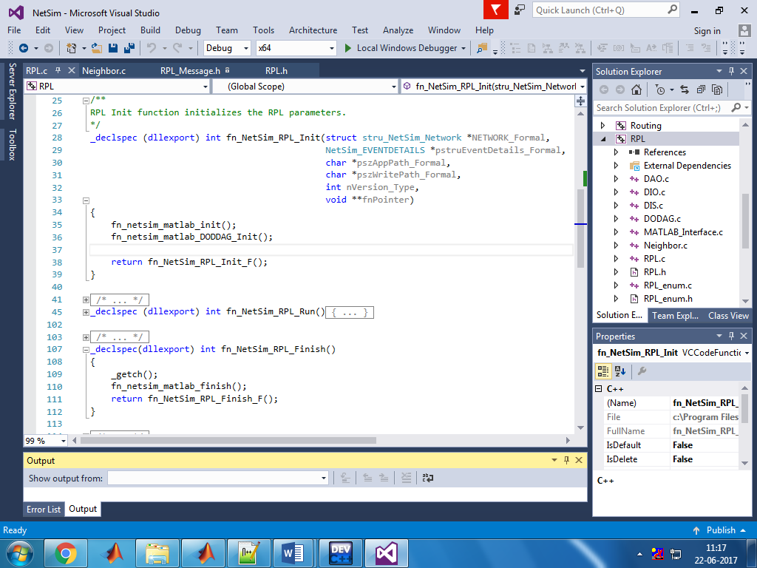

1. Add definitions of the following functions inside **RPL.h** file

**double fn_netsim_matlab_init();**

**double fn_netsim_matlab_DODDAG_Init();**

**double fn_netsim_matlab_DODDAG_run();**

**double fn_netsim_matlab_finish();**

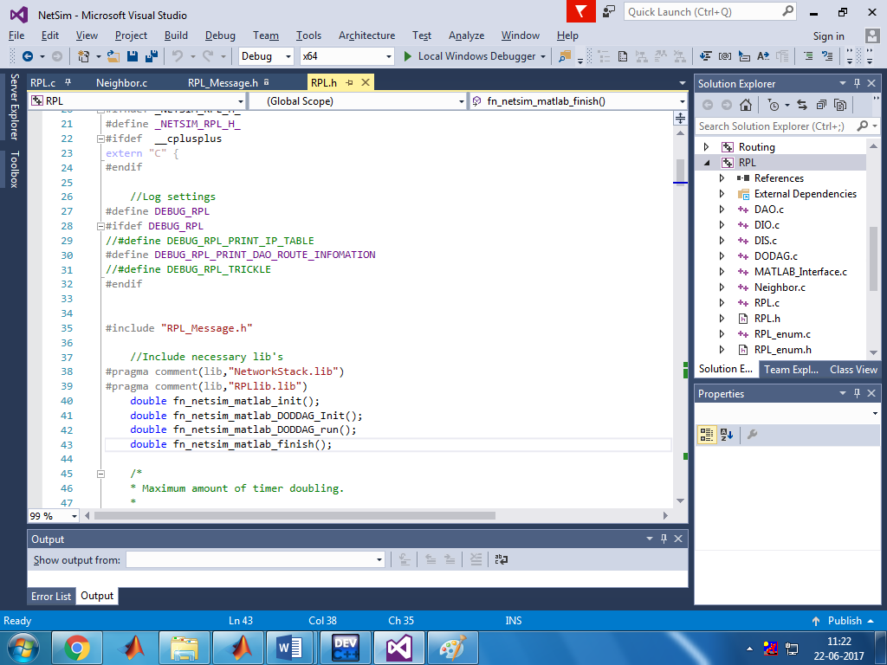

1. Go to the **Neighbor.c** file. Inside Function **void choose_parents_and_siblings(NETSIM_ID d)** add **fn_netsim_matlab_DODDAG_run()** below **rpl_add_route_to_parent()**

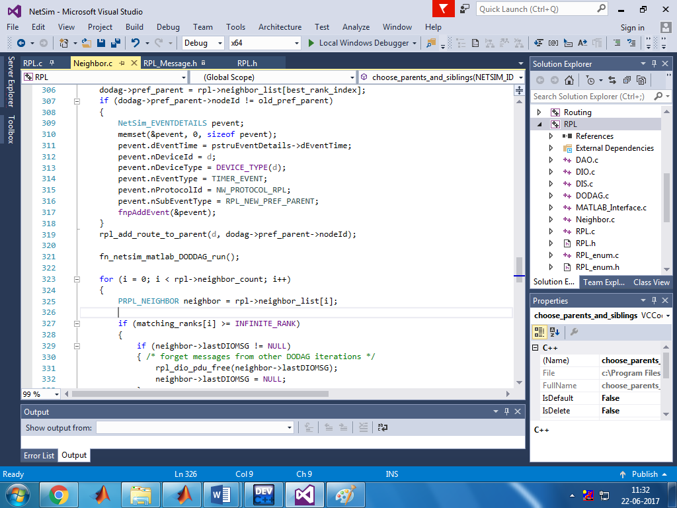

10. To compile a MATLAB engine application in the Microsoft Visual Studio 2015 environment, Right click on the RPL project and select PROPERTIES in the solution explorer. Once this window has opened, make the following changes:  
 **a.** Under C/C++ General, add the following directory to the field ADDITIONAL INCLUDE DIRECTORIES: <Path where MATLAB is installed>\extern\include

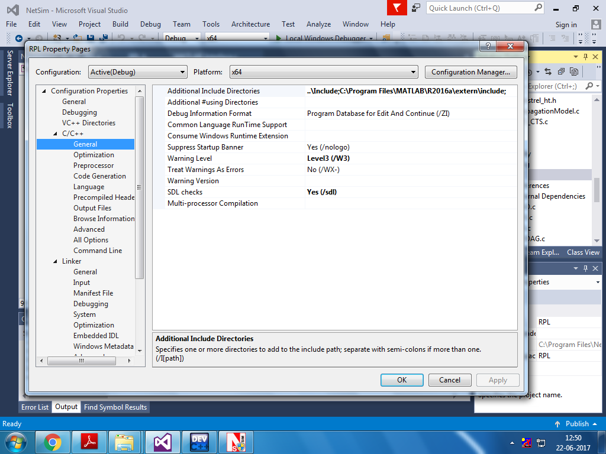

**b.** Under C/C++ Precompiled Headers, select "Not Using Precompiled Headers".

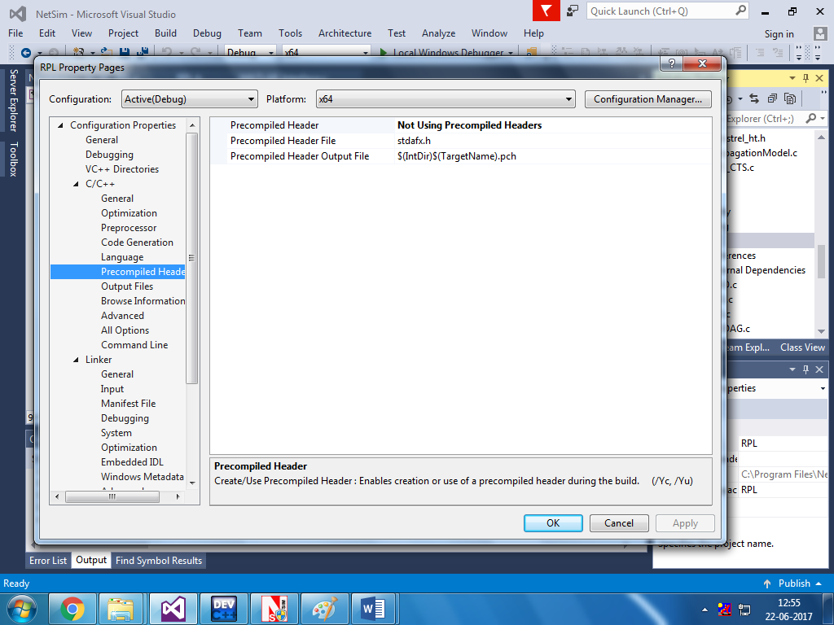

**c.** Under Linker General, add the directory to the field ADDITIONAL LIBRARY DIRECTORIES:

<Path where MATLAB is installed>\extern\lib\win64\microsoft

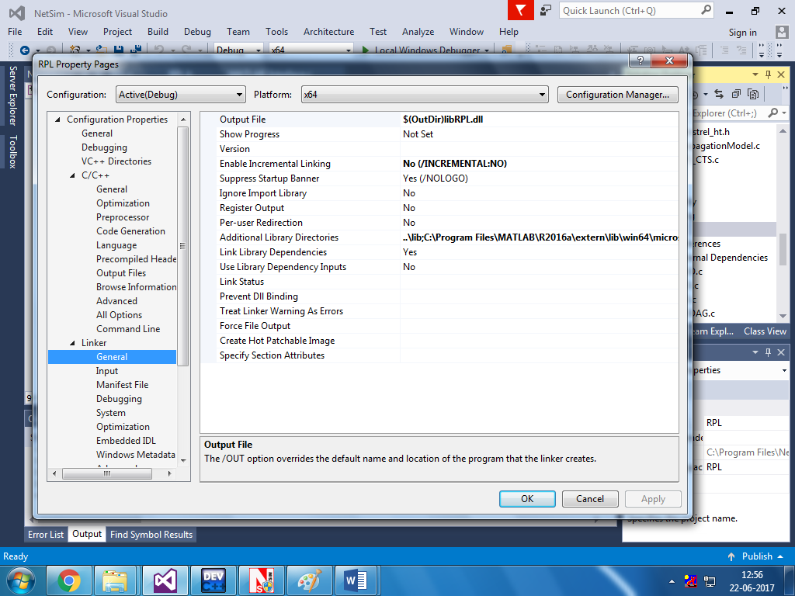

**d.** Under Configuration Properties ->Debugging

Add the following Target path in the *Environment*:

<Path where MATLAB is installed>\bin\win64

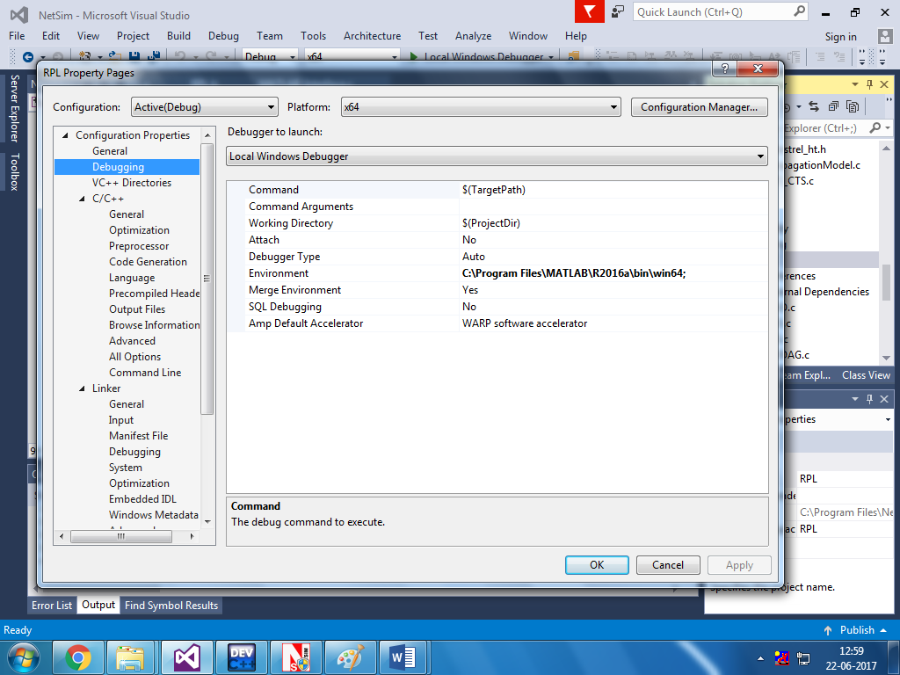

**e.** Under Linker Input, add the following names to the field marked ADDITIONAL DEPENDENCIES:

libmx.lib; libmat.lib; libeng.lib by separating them with a semicolon.

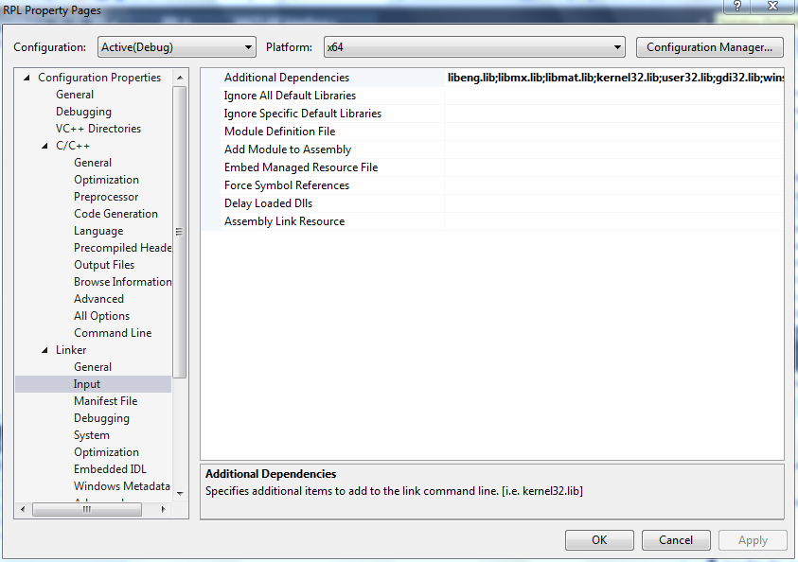

Click on Apply and then on ok.

**f.** Make sure that the following directory is in the PATH(Environment variable)

<Path where MATLAB is installed>\bin\win64

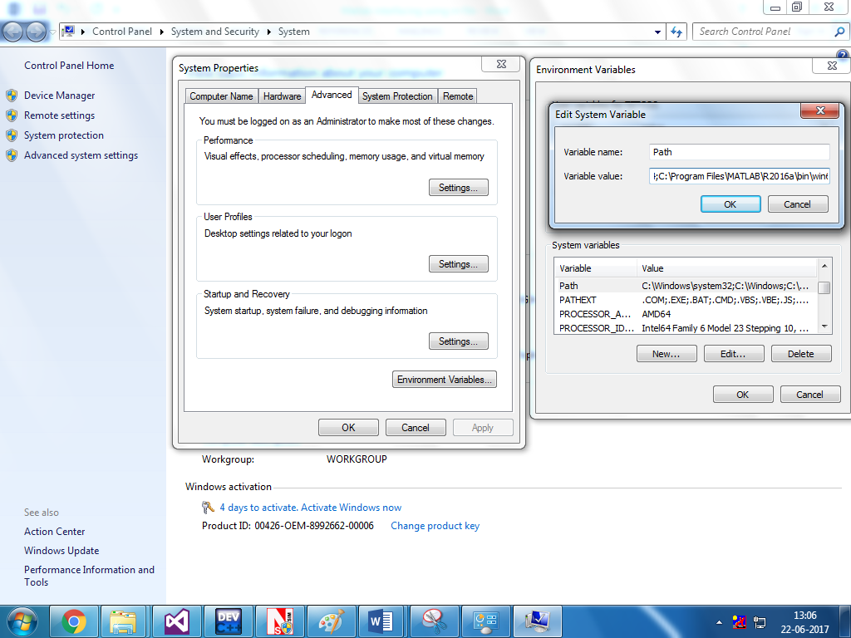

(**Note:** To run this code 64- bit version of MATLAB must be installed in your system. If you are interfacing for the first time then open command window and go to the **<NetSim installed directory>\bin** and type **matlab -regserver**)

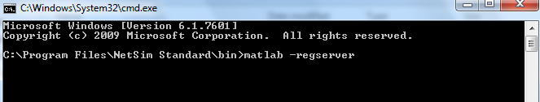

1. Now Right Click on RPL project and select Rebuild.
2. Now replace the newly built libRPL.dll from the DLL folder, into the NetSim bin folder. Please ensure you rename the original libRPL.dll file to retain a copy of the original file.
3. Run NetSim in Administrative mode. Create a Network scenario IoT.

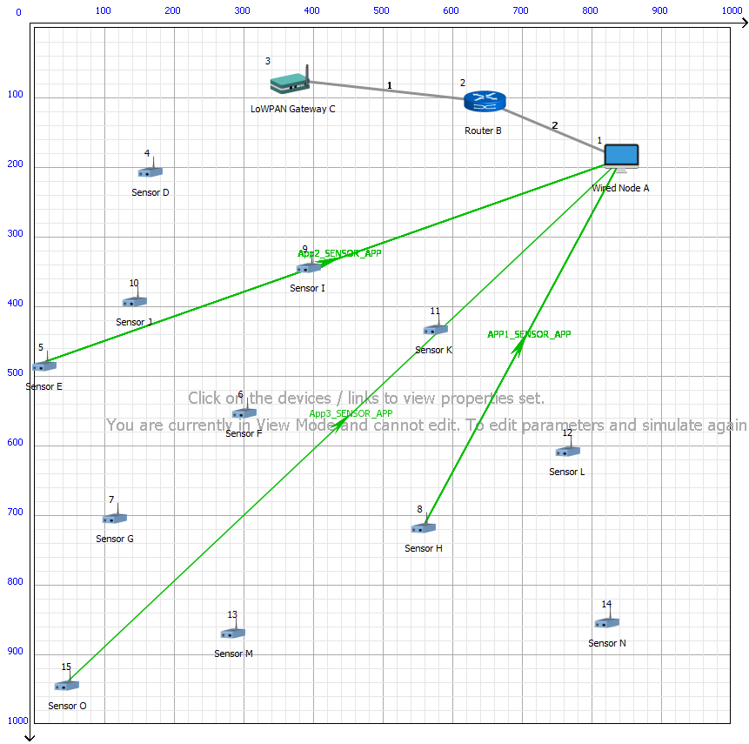

Multi point to Multipoint Link Properties are set accordingly

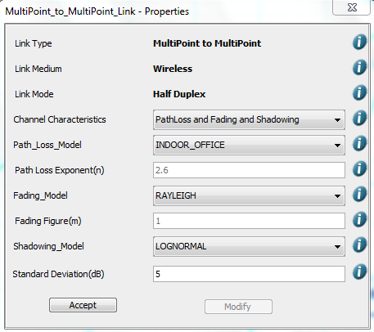

Set Velocity to the sensors

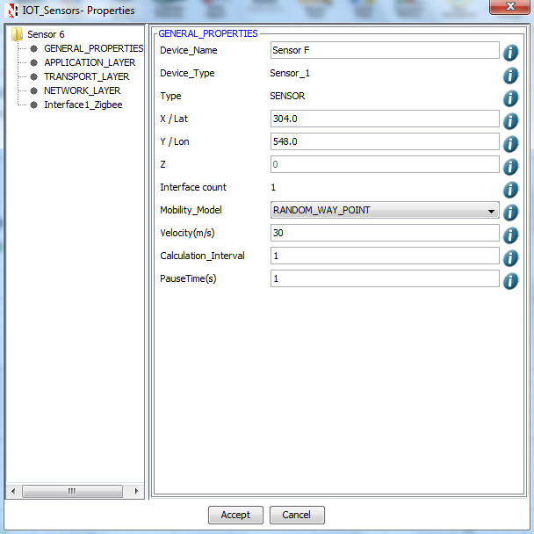

And set Receiver Sensitivity as -45

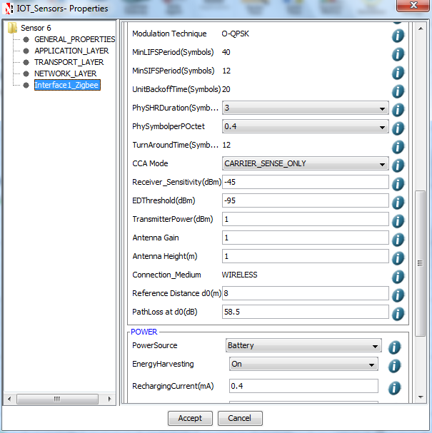

A plot will open, showing the DODAG when the simulation is started and the first route is formed between sink node and the sensor. And the DODAG will be dynamically updated.   
 **Initially formed DODAG**

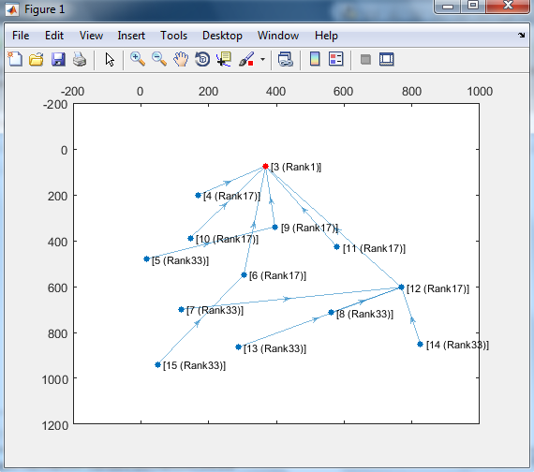

**DODAG formed after some time due to movement in sensors**

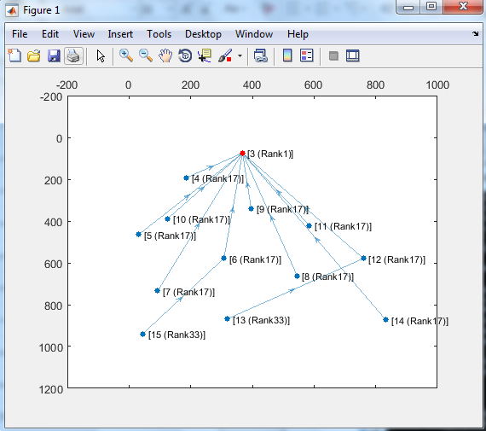

**DODAG at the end of the simulation**

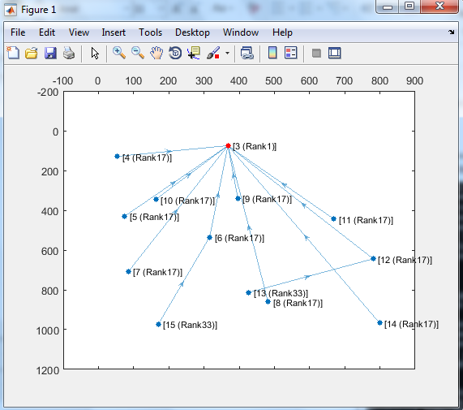

After simulation press any key in the NetSim command window to close the MATLAB