# **Sensor Energy Consumption Visualization using MATLAB**

**Software Recommended:** NetSim Standard V11.0, Visual Studio 2015/2017, MATLAB

NetSim has a dedicated power model for Sensor nodes that are part of WSN/IoT networks. The power model is user configurable and can be found in the ZigBee Interface properties of the Sensor nodes as shown below:

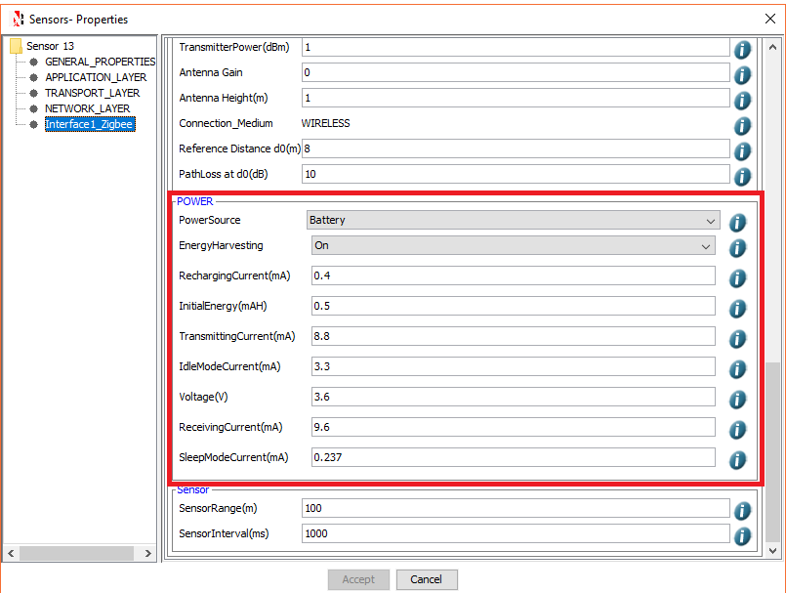

Energy consumption is calculated individually for each Sensor node that is part of the network scenario during various Radio States such as SLEEP, TRX_ON_BUSY, RX_ON_IDLE, RX_ON_BUSY, RX_OFF.

Based on the calculations done, NetSim provides a detailed Energy Metrics table which provides energy consumption of each device with respect to Transmission, Reception, Idle Mode, and Sleep Mode as shown below:

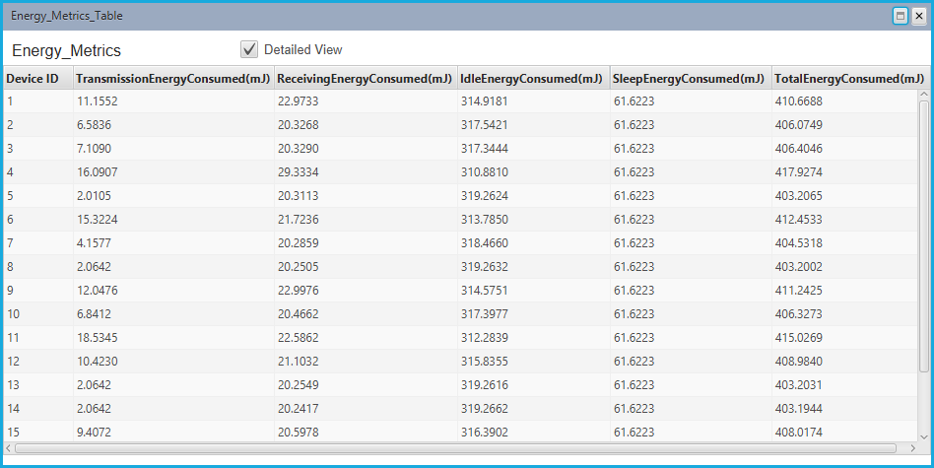

The metrics that are part of the Energy Metrics Table is related to the overall energy consumption during the simulation. Users can also obtain the status of the battery at different points of simulation time for taking certain decisions or to export to tools such as MATLAB for runtime analysis. Here we discuss one such example where we interface NetSim with MATLAB and generate runtime three dimensional plots to understand the energy consumption in the sensor network during the simulation.

**Steps to obtain plots in MATLAB:**

1. Copy the **energy_consumption.m** MATLAB M-Script file and place it inside the installation folder of MATLAB (For eg: **“C:\Program Files\MATLAB\R2016a”**)**, (Note: energy_consumption.m** is provided in the folder)

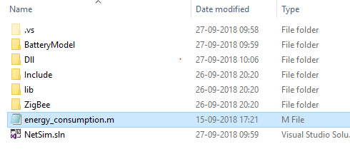

1. In system Environment Variable window, Create a user variable with the name of MATLAB_PATH and provide the path of the installation directory based on the version of MATLAB installed in your system (For Eg: C:\Program Files\MATLAB\R2016a)

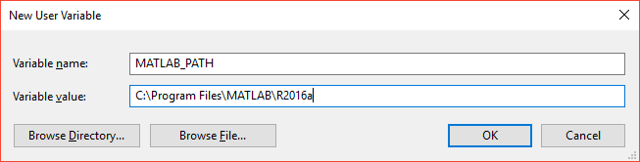

1. Add an entry to the PATH variable in Environment Settings Window Pointing to the win32 or win 64 directory of MATLAB installed in your system depending on the build(Environment variable)

<Path where MATLAB is installed>\bin\win32 or

<Path where MATLAB is installed>\bin\win64

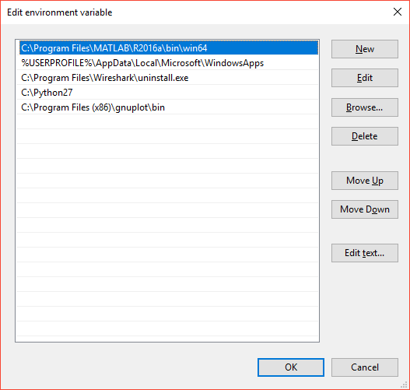

1. Open Command Prompt (CMD) window as administrator and execute the command

**matlab –regserver**

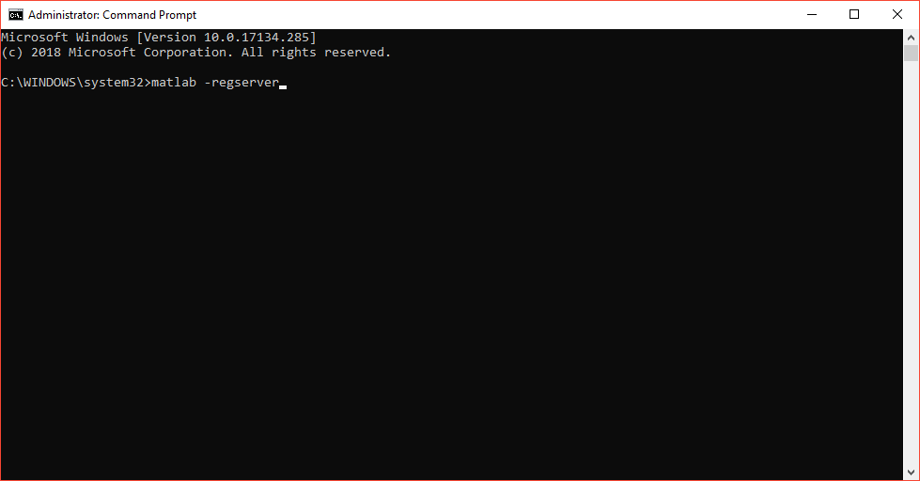

This is done to register MATLAB as a server for runtime interaction to happen between NetSim and MATLAB. MATLAB Command Window appears upon successful execution of this command and can be closed.

1. Open the source codes of this project in Visual Studio using the NetSim.sln file present in the Code folder.
2. Expand ZigBee project in the solution explorer and double click on the MATLAB_Interface.c file present.
3. MATLAB Interfacing C file contains the following functions:

**fn_netsim_matlab_init()** - This function is used to initialize the MATLAB Engine.

**fn_netsim_matlab_run()** -This is the function where runtime calls to MATLAB happens.

**fn_netsim_matlab_finish()** -This function is used to Close the MATLAB Engine.

1. Right click on the ZigBee project and select Rebuild to build the source codes.
2. Upon successful build copy the newly built libZigBee.dll file from the DLL folder present inside the Code folder.
3. Go to <NetSim_Install_Directory>/bin folder and rename the already existing libZigBee.dll file to say libZigBee_original.dll as a backup.
4. Paste the newly built libZigBee.dll file in <NetSim_Install_Directory>/bin folder.
5. Start NetSim as administrator by right clicking on the NetSim shortcut present in your desktop and selecting Run as administrator.
6. Open the Sample Configuration file provided inside the Config_File directory in NetSim using Open Network option present in NetSim Home Screen. You can also create your own Network scenario either in WSN or IoT modules in NetSim to visualize the energy consumption in nodes during runtime.

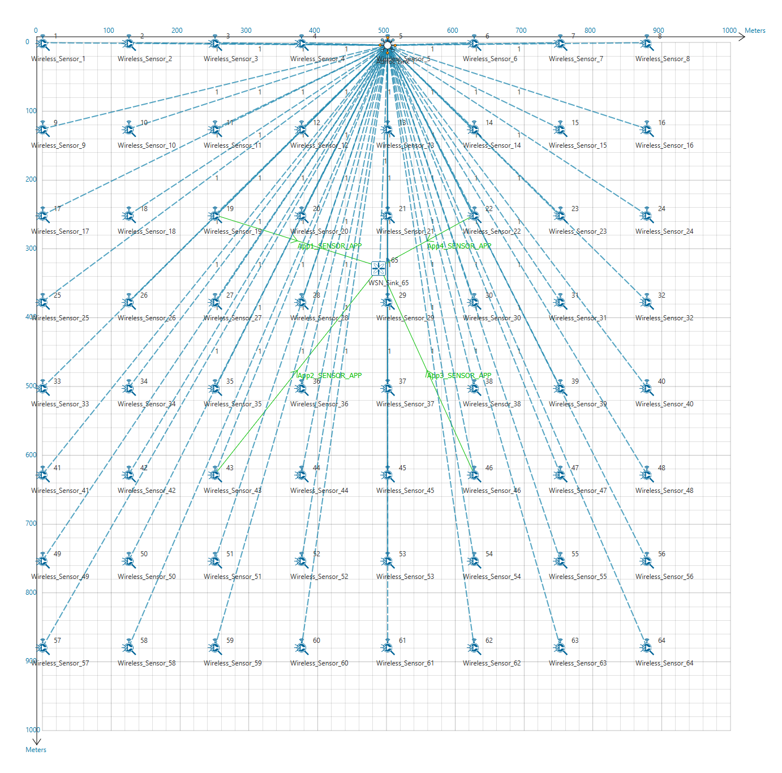

1. Run Simulation for a Simulation time of 300 Seconds. Upon Simulation Start NetSim Simulation Console will display a message “Press any key to start MATLAB”. Further MATLAB Command Window and MATLAB Desktop Windows will be loaded. This may take some time initially.
2. Once MATLAB is loaded simulation in NetSim will begin and in parallel a 3D plot related to energy consumption in the sensor network will be generated during runtime in MATLAB as shown below:

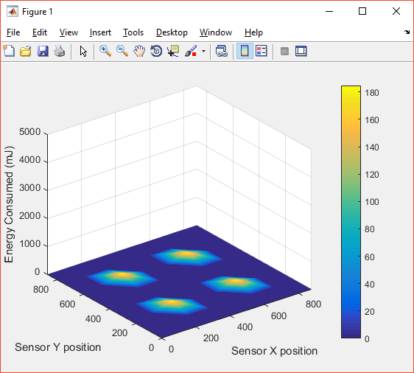

The parameters passed to MATLAB during runtime can be viewed in the MATLAB workspace.

1. In the plot shown above the X and Y coordinates correspond to the sensor positioning in the 2D plane in NetSim and the Z axis corresponds to the energy consumption in the Sensor nodes which varies as simulation progresses.
2. At simulation end NetSim Simulation console will display a message “Press any key to Close MATLAB” and NetSim will automatically close the MATLAB windows upon doing so.
3. This can be used to analyse energy consumption pattern in the sensor network for different protocols and parameters.