Sink Hole Attack using RPL in IOT

**Software:** NetSim Standard v13.1 (64-bit), Visual Studio 2017/2019

**Project Download Link:**

Follow the instructions specified in the following link to download and setup the Project in NetSim:

<https://support.tetcos.com/en/support/solutions/articles/14000128666-downloading-and-setting-up-netsim-file-exchange-projects>

**Introduction**

In sinkhole Attack, a compromised node or malicious node advertises fake rank information to form the fake routes. After receiving the message packet, it drops the packet information. Sinkhole attacks affect the performance of IoT networks protocols such as RPL protocol.

# Implementation in RPL (for 1 sink)

* In RPL the transmitter broadcasts the DIO during DODAG formation.
* The receiver on receiving the DIO from the transmitter updates its parent list, sibling list, rank and sends a DAO message with route information.
* Malicious node upon receiving the DIO message it does not update the rank instead it always advertises a fake rank.
* The other node on listening to the malicious node DIO message the update their rank according to the fake rank.
* After the formation of DODAG, if the node that is transmitting the packet has malicious node as the preferred parent, transmits the packet to it but the malicious node instead of transmitting the packet to its parent, it simply drops the packet resulting in zero throughput.

A file Malicious.c is added to the RPL project. The file contains the following functions.

* fn_NetSim_RPL_MaliciousNode(); //This function is used to identify whether a current device is malicious or not in-order to establish malicious behavior.
* fn_NetSim_RPL_MaliciousRank(); //This function is used to give a fake rank to the malicious node.
* rpl_drop_msg(); //This function is used to drop the packet by the malicious node if it enters into its network layer.
* **Sink Hole attack** The malicious node advertises the fake rank fn_NetSim_RPL_MaliciousRank(); is the sink hole attack function.
* **Black Hole attack** – The malicious node drops the packet. rpl_drp_msg() is the black hole attack function

You can set any device as malicious, and you can have more than one malicious node in a scenario. Device id’s of malicious nodes can be set inside the fn_NetSim_RPL_MaliciousNode() function.

# Steps to simualte

1. Open the Source codes in Visual Studio by going to Your work-> Source code and Clicking on Open code button in NetSim Home Screen window.
2. Now right click on Solution explorer and select Rebuild.

**Figure 1**: Screen shot of NetSim project source code in Visual Studio

1. Upon rebuilding, modified binarieswill automatically get updated in the respective bin folders of the current workspace.

**Example**

1. The **WorkSpace_SinkHole_Attack_RPL** comes with a sample network configuration that are already saved. To open this example, go to Your work in the Home screen of NetSim and click on the **SinkHole_Attack_in_RPL_Example** from the list of experiments.
2. The saved network scenario consists of
3. 5 Wireless Sensor
4. 1 6_LOWPAN Gateway
5. 1 Router
6. 1 Wired Node

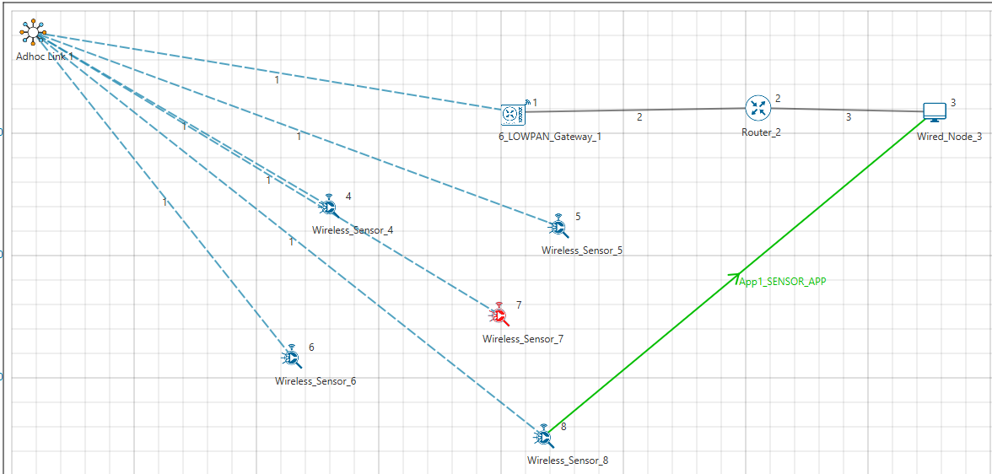

**Figure 2:** WSN Network Topology

* Channel Characteristics: Path Loss Only, Path Loss Model: Log Distance, Path Loss Exponent: 2
* Run Simulation for 100 Seconds.

**Results and discussion**

Open **rpllog.txt** file from simulation results window, then you will find the information about DODAG formation. For every DODAG, 6LoWPAN Gateway is the root of the DODAG.

* Root is 1 with rank = 1 (Since the Node Id_1 is 6LoWPAN Gateway)
* Wireless_Sensor_Node_7(Malicious Node)

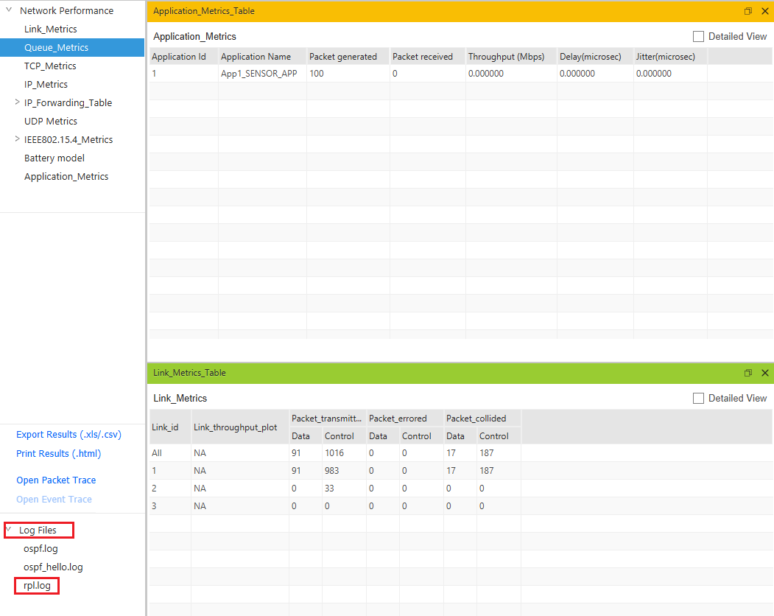

**Figure 3:** From the Result Dashboard window

Packet is **transmitted** by **node 8(Sensor_8)** is **received** by **node 7(Sensor_7)** since the node **7 is malicious** node it drops the packet. So, the **Throughput** in this scenario is **0**.

Open **Packet trace** file from simulation results window and filter the **Control Packet Type/App Name** to **App1_ Sensor _App**.

Check the data packets flow, the **Transmitter_Id and receiver_Id** column. Since the node 7 is malicious node, it drops the packet without forwarding it further.

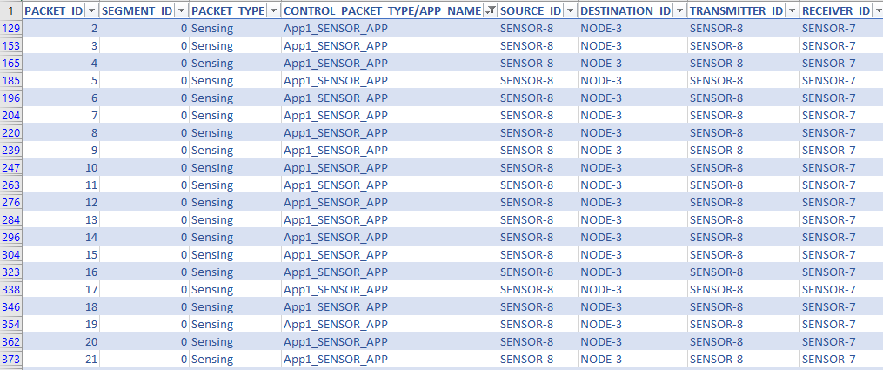

**Figure 4:** NetSim Packet Trace

**Appendix: NetSim source code modifications**

Set malicious node id and the fake Rank in malicious.c file which is present under RLP Project.

#include "main.h"

#include "RPL.h"

#include "RPL_enum.h"

#define MALICIOUS_NODE1 7

#define MALICIOUS_RANK1 3

#define MALICIOUS_NODE2 4

#define MALICIOUS_RANK2 4

Changes code to fn_NetSim_RPL_Run(), in RPL.c file, **within TCP project**

_declspec (dllexport) int fn_NetSim_RPL_Run()

{

switch (pstruEventDetails->nEventType)

{

case NETWORK_OUT_EVENT:

{

}

break;

case NETWORK_IN_EVENT:

{

rpl_add_to_neighbor_list();

if (is_rpl_control_packet(pstruEventDetails->pPacket))

{

if (fn_NetSim_RPL_MaliciousNode(pstruEventDetails))

fn_NetSim_RPL_MaliciousRank(pstruEventDetails);

else

rpl_process_ctrl_msg();

fn_NetSim_Packet_FreePacket(pstruEventDetails->pPacket);

pstruEventDetails->pPacket = NULL;

}

else if (pstruEventDetails->nPacketId && fn_NetSim_RPL_MaliciousNode(pstruEventDetails))

{

rpl_drop_msg();

}

}

break;