**NetSim - MATLAB Interfacing for UAV/Drone/Flying Ad hoc network simulations**

**Software Recommended:** NetSim Standard v13.0 (64 bit), Visual Studio 2019, MATLAB R2016 or higher. MATLAB, Simulink, Robotics and System Toolbox

**Project Download Link:**

Follow the instructions specified in the following link to download and setup the Project in NetSim:

<https://support.tetcos.com/en/support/solutions/articles/14000128666-downloading-and-setting-up-netsim-file-exchange-projects>

# Objective

In this project, we are going to explain how users can simulate UAV device in NetSim by interfacing with MATLAB's Simulink.

# 3D View in MATLAB and 2D View in NetSim

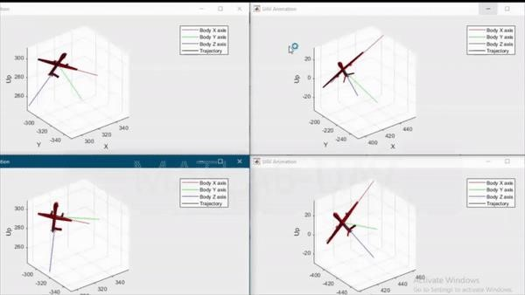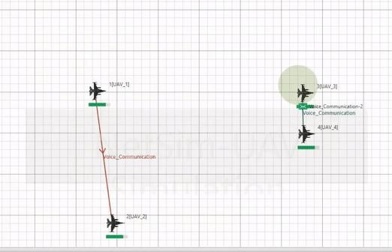

**2D- Animation in NetSim** **3D Animation in MATLAB**

# NetSim - Simulink Interfacing

Upon interfacing NetSim with MATLAB the following tasks are performed during simulation start:

* MATLAB Engine process is initialized
* SIMULINK Model is loaded

Upon simulating a network created in NetSim the following tasks are performed periodically:

* SIMULINK Model is simulated
* SIMULINK Model is paused
* NetSim reads the data generated by SIMULINK from MATLAB workspace
* Updates the co-ordinates of the devices.
* During the Simulation, the SIMULINK Model is started and paused several times for NetSim and SIMULINK simulations to run synchronously. The X, Y and Z coordinates obtained from SIMULINK are read from MATLAB workspace and given as input to NetSim's Mobility model. In this example, coordinates are taken every one second and updated to the device mobility.

# 

# Output/Metrics specific to this example

* NetSIm Animation- Mobility of the devices configured in NetSim is given as input from MATLAB

# Sections of source code modified

* Mobility.c
* fn_NetSim_Mobility_Init(): call to init_uav() function
* fn_NetSim_Mobility_Run(): Call to uav_run() function
* fn_NetSim_Mobility_Finish(): Call to finish_uav() function
* Mobility.h
* MATLAB Engine variable - Used to initiate and interact with MATLAB Engine process
* Mobility.vcxproj - This is a Visual Studio project file used to load and manage the source codes related to the Mobility in NetSim
* path to MATLAB application
* path to MATLAB include directory
* path to MATLAB lib directory
* information related to dependent MATLAB library files
* UAVBasedMobility.c
* init_uav(): Initializes MATLAB, Loads SIMULINK Model, starts and pauses SIMULINK simulation , and initializes the UAV devices in MATLAB to start simulation along with NetSim's simulation.
* uav_run(): Starts NetSim and MATLAB simulation simultaneously and gets the co-ordinates from MATLAB workspace for every step size set in NetSim.
* uavcorr(): Function to get co-ordinates from MATLAB.

# Running the NetSim scenario with UAV Based Mobility

* Before opening Example make sure that you have replaced the XML file in NetSim Installation directory mentioned above and then Open Example saved in the workspace.
* Make sure that all devices are UAV Mobility enabled
* Run the simulation with Play and record animation to have both Animations simultaneous

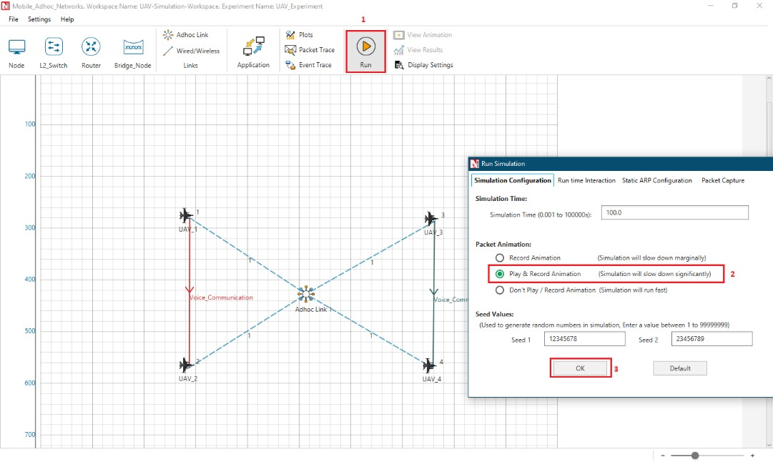

**Steps:**

1. Make sure that the following directory is in the PATH (Environment variable)

<MATLAB_INSTALL_DIRECTORY>\bin\win64

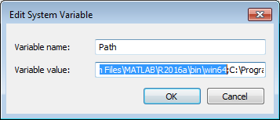

**Note**: If the machine has more than one MATLAB installed, the directory for the target platform must be ahead of any other MATLAB directory (for instance, when compiling a 64-bit application, the directory in the MATLAB 64-bit installation must be the first one on the PATH).

1. Open Command prompt as admin and execute the command “matlab -regserver”. This will register MATLAB as a COM automation server and is required for NetSim to start MATLAB automation server during runtime.

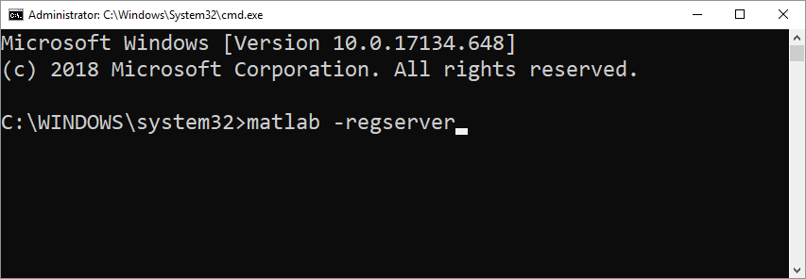

1. Open the Source codes in Visual Studio by going to Your work-> Workspace Options and Clicking on Open code button.
2. Under the Mobility project in the solution explorer you will be able to see that and **UAV_Matlab_Interface.c** files which contain source codes related to interactions with MATLAB and handling clustering in NetSim respectively.
3. Run NetSim as Administrator.
4. The UAV_Simulation_Workspace_v13 comes with a sample configuration that is already saved. To open this example, go to Your Work option in the Home Screen of NetSim and click on the UAV_Simulation_Example that is present under the list of experiments.
5. Run simulation and press any key to continue. NetSim simulation console will show the following message in the console “Waiting for NetSim MATLAB Interface to connect...”

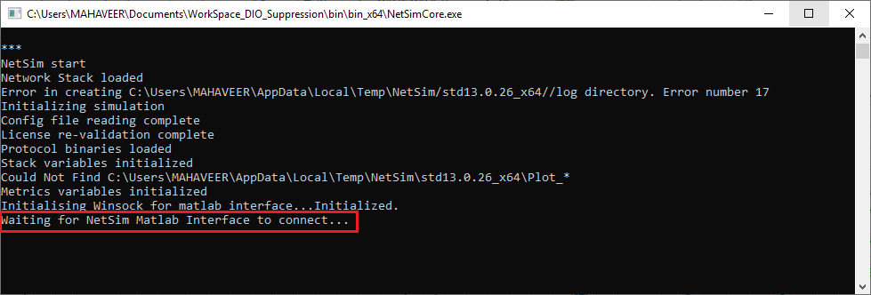

1. Click on **Options** from NetSim design window and click on **Open MATLAB Interface** as shown in below given screenshot

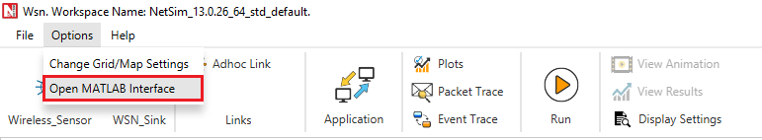

1. It will open the popup related MATLAB Interfacing, Click on **OK.**  As shown in below given screenshot

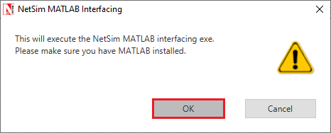

1. It will open MatlabInterface.exe console window. You will observe that as the simulation starts in NetSim, MATLAB gets initialized and UAV Animation for all the devices in NetSim gets initialized and as the simulation runs there will be continuous interaction between NetSim and MATLAB where the X,Y and Z co-ordinates will be updated in NetSim from MATLAB.

