**Localisation in WSN**

**Software Recommended:** NetSim Standard v10.2 (32-bit), Microsoft Visual Studio 2015

Localization is the process of finding the physical or relative location of a sensor node as data and information are useless if the nodes have no idea of their geographical positions. GPS (global positioning system) is the simplest method for localization of nodes, but it becomes very expensive if large number of nodes exists in a given network.

**Anchor Nodes:**

Sensor nodes with known location information are called “Anchor nodes‟. Typically, anchor nodes obtain their location information by using a global positioning system (GPS), or by manually being placed at defined coordinates.

**Unknown Nodes:**

Sensor nodes with unknown location information are called “Non-Anchor nodes‟ or “Unknown nodes”. Localization is estimated through communication between localized node and unknown node for determining their geometrical placement or position. Location is determined by means of distance and angle between nodes.

**Trilateration:**

Location of node is estimated through distance measurement from three nodes. In this concept, intersection of three circles is calculated, which gives a single point which is a position of unknown node.

Use the distance equation. If your unknown point is (x, y) and known points are (xi, yi) which are at distances ri from unknown point, then you get three equations:

$${(x – x1)}^{2}+ {(y – y1)}^{2} = {r1}^{2}$$

$${(x – x2)}^{2}+ {(y – y2)}^{2} = {r2}^{2}$$

$${(x – x3)}^{2}+ {(y – y3)}^{2} = {r3}^{2}$$

To calculate the distance between to sensors we have used NetSim API

DEVICE_DISTANCE(d1,d2)

Expand out the squares and subtract the second equation from the first and third equation from second, we get

$$2(x2 – x1)x + 2(y2 – y1)y = {r1}^{2} – {r2}^{2} + {x2}^{2 }– {x1}^{2} + {y2}^{2} – {y1}^{2}$$

$$2(x3 – x2)x + 2(y3 – y2)y = {r2}^{2} – {r3}^{2} + {x3}^{2 }– {x2}^{2} + {y3}^{2} – {y2}^{2}$$

This is a system of two equations with two unknowns:

$$Ax + By = C$$

$$Dx + Ey = F$$

The values of x and y is obtained from the below equations:

$$x = (CE – FB) / (EA – BD)$$

$$y = (CD – AF) / (BD – AE)$$

**Localisation in NetSim:**

1. To implement Localisation, we have added **Localisation.c** file in Zigbee project. The file contains the following functions:

* int fn_NetSim_localisation()

This function is used to find the anchor nodes based on the highest received powers received at unknown sensors from anchor nodes.

* int fn_NetSim_trilateration_method()

This function is used to implement the trilateration method to calculate the position / location of the unknown sensor.

* bool IsUnknownNode()

This function is used to check whether the given node is unknown node or not.

* bool determine_anchor_node()

This function is used to check whether the given node is anchor node or not.

1. Users can give their own unknown node IDs and unknown node count in **Localisation.c** file. NetSim knows all the positions of sensor nodes. Localisation is used to find the position of unknown nodes and then comparing this position with NetSim sensor positions.

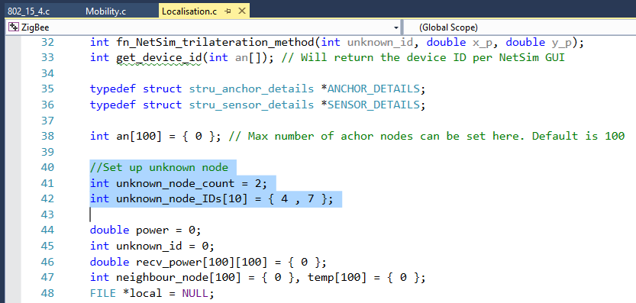

1. Since the unknown nodes are mobile, we have added a call to localisation in **fn_NetSim_Mobility_Run()** function present in **mobility.c** file inside Mobility project to calculate the new positions of the unknown node whenever a node moves.

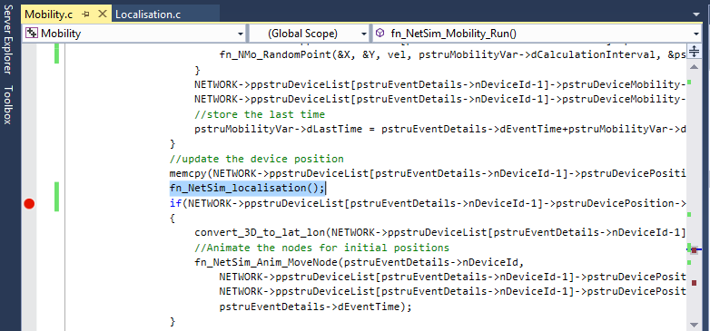

**Steps:**

* After you unzip the file open Code folder and double click on the NetSim.sln file present to open the project in Visual Studio 2015.

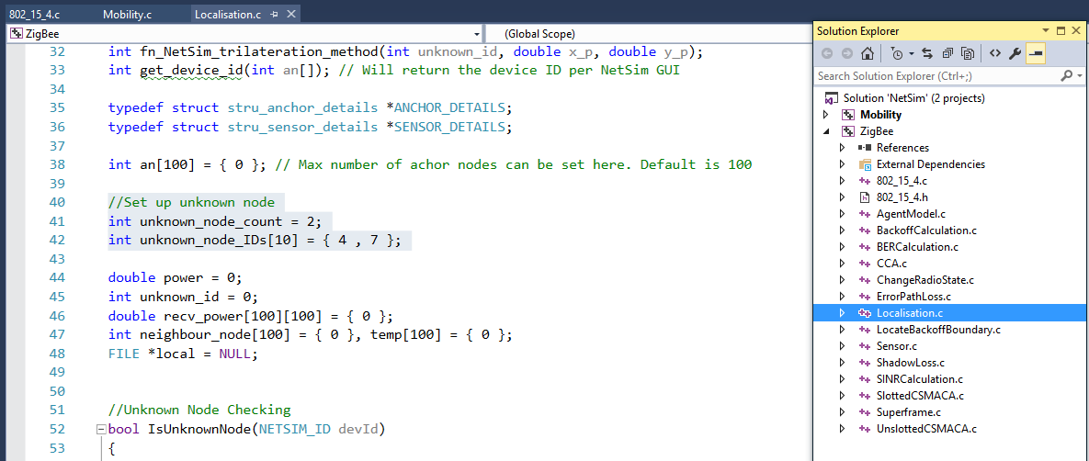

* 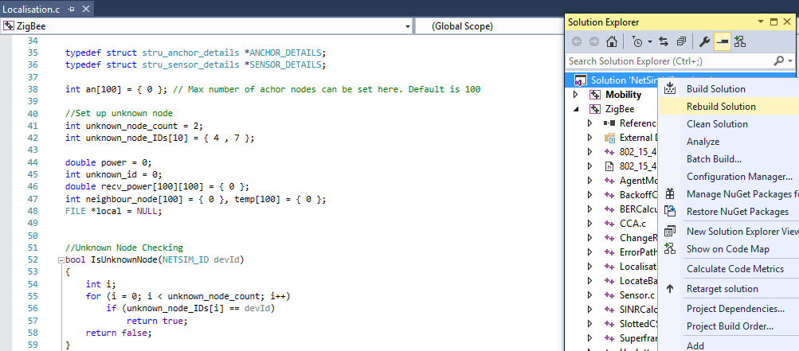Right click on Solution in Solution Explorer and select rebuild solution.
* Upon rebuilding, **libZigbee.dll** and **libMobility.dll** will get created in the DLL folder.

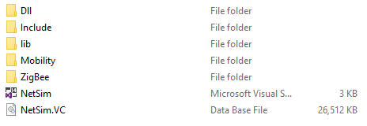

* Now copy the **libZigbee.dll** and **libMobility.dll** from this DLL folder and paste it in NetSim bin folder present in the NetSim installation directory. The NetSim install directory would look something like **“C:\Program Files (x86)\NetSim Standard\bin”**.
* Note that there exists **libZigbee.dll** and **libMobility.dll** in this bin folder. This is the default file being shipped with NetSim. The user is replacing this file with the newly built file.
* Therefore, take care to rename the original **libZigbee.dll** and **libMobility.dll** files, so that it isn’t lost. For example, you may rename it as **libZigbee_default.dll**, **libMobility_default.dll**.
* Run NetSim and open **Configuration.netsim** file present inside the Config_File folder and run the simulation.
* After simulation, localisation.txt file will get created in the bin folder of NetSim which logs the unknown node IDs, received powers from all anchor nodes to unknown nodes, anchor node IDs based on highest received powers and the position or coordinates of the unknown nodes with variation in time as shown below.

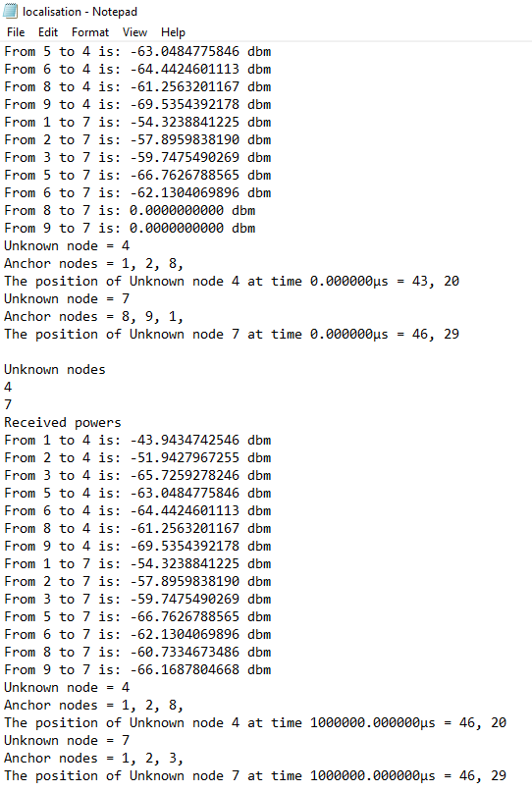

**Note:** Users can also create their own network scenarios in WSN and run simulation.

**Settings to be done to create the network scenario for localisation:**

* Set grid length 100*100 m.
* First drop sensors and then drop sink node and agent.
* Set the unknown node ids in the **Localisation.c** file as explained above (default unknown nodes are 4, 7).
* The unknown node IDs which are setting in the code should match with the sensor IDs in the GUI.
* Set mobility for unknown nodes (5m/s or 10m/s).
* Set channel characteristics as Path loss only, Path loss model as LOG DISTANCE and Path loss exponent as 3.5.
* Run simulation and check for localisation.txt file gets created in bin folder.
* Open the text file and compare the positions of unknown nodes with variation in time.