Install docker for windows from <https://www.docker.com/>

Now you can check your Docker installation. Open a cmd terminal, PowerShell or CMD, and check typing:

docker version

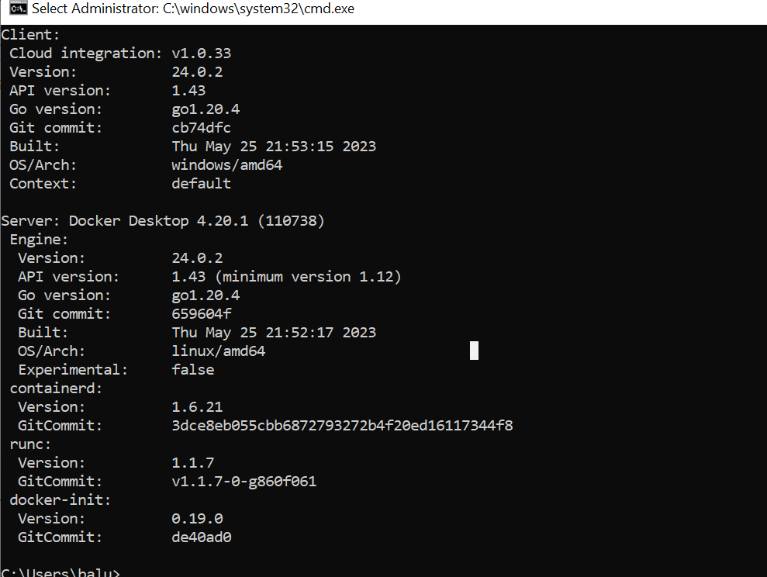

Create a java program using notepad and save it as “HelloWorld.java”

First create your HelloWorld in Java, compile and run it.

*public* *class* HelloWorld {

*public* *static* void main(String[] args) {

System.out.println("Running HelloWorld into docker");

System.out.println("Hello World Docker!!!");

System.out.println("Bye bye!");

}

}

C:\Users\swarna\Dock>HelloWorld.java

C:\Users\swarna\Dock>java HelloWorld

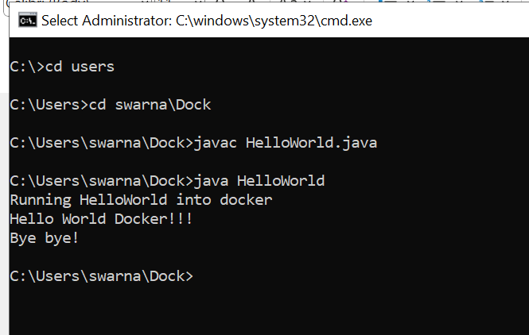

Then create your dockerfile file with the following instructions and save it as “Dockerfile” without any extention in the same directory

#baseimage

FROM eclipse-temurin:17-jdk-jammy

#copy from local directory to image direcotry

COPY /src /srcr

#remoteDirectory where data is copied

WORKDIR /srcr

#RUN ["javac","HelloWorld.java"]

ENTRYPOINT ["java", "HelloWorld"]

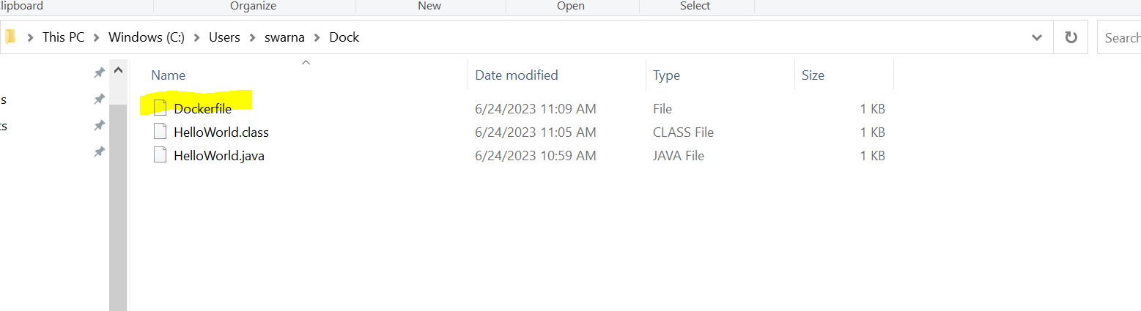

Now we build a dockerfile to create our image. Here we say make a dockerfile build with the name docker-hello-world and the tag (tag) latest

* docker build --tag "hellodocker:latest" .

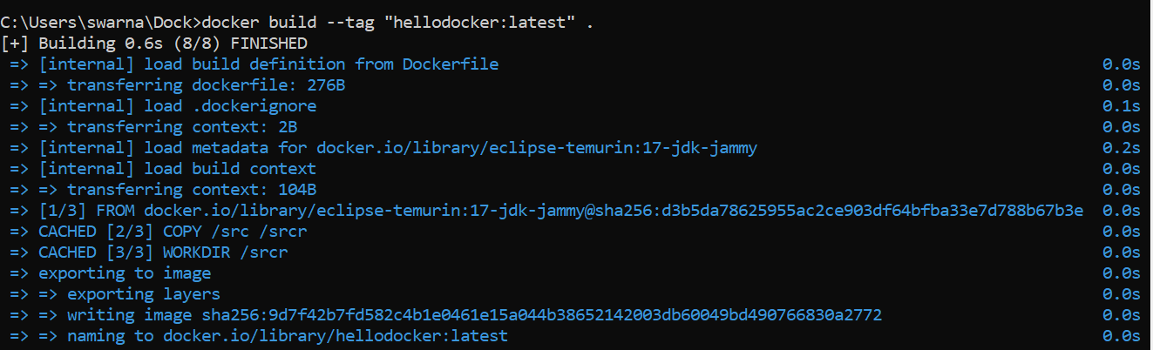

Now execute:

docker images

We will see our image created and available to be used.

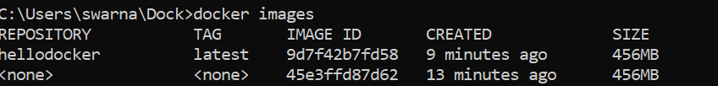

Now we can run docker with this image and see the result.

docker run hellodocker:latest

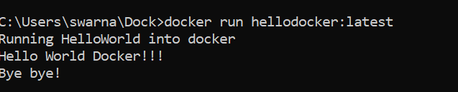

Remove an image

Docker rmi -f <imageidshown above from images command>

docker rmi -f 5bac6218d29b

