DLink IOS SDK Integration Steps
(Native, Flutter)

Versions history
Index | Date | Change logs
1 | 2022/02/22 | Init document
2 | 2022/02/22 | Add some comments
3 | 2022/02/22 | Update github repo
4 | 2022/02/22 | Config support calls feature
5 | 2022/02/22 | Edit Info.plist

Pre Requisites
  - Xcode 13.2.1 (13C100) (exactly version)
  - iOS 10.0 or above
  - Swift version 5 (exactly version)
  - Support bitcode: No
  - Support Features
    - Push notifications
    - Apps groups
    - Associated domains
    - Background modes: Audio, Location updates, Voice over IP, Background fetch, Remote notifications
    - I-cloud
    - Keychains
    - Notification extension service
    - Sharing extension service
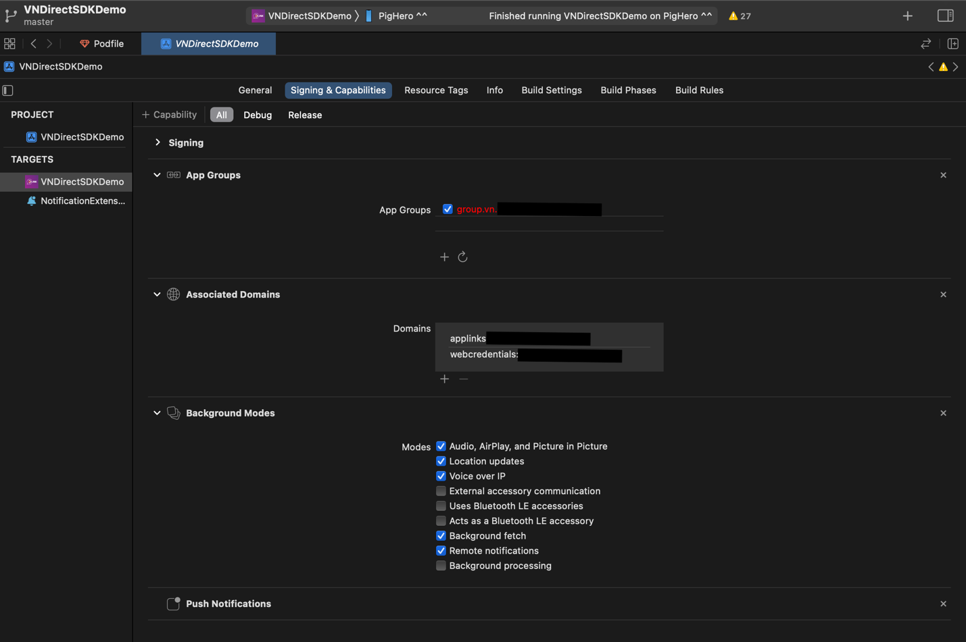

1. Add DLink SDK to your project
- Using Cocoapods
Integrate Cocoapods https://guides.cocoapods.org/using/using-cocoapods.html

// Edit Pod file
def rx_swift_pods
pod 'RxSwift', '~> 6.2.0'
pod 'RxCocoa', '~> 6.2.0'
pod 'XCoordinator', '~> 2.0'
pod 'RxGesture', '~> 4.0.2'
pod 'RxRelay', '~> 6.2.0'
end

def rx_swift_noti_pods
pod 'RxSwift', '~> 6.2.0'
pod 'RxCocoa', '~> 6.2.0'
pod 'RxRelay', '~> 6.2.0'
end

def database_pods
pod 'RealmSwift', '10.12.0'
end

def language_pods
pod 'Localize-Swift', :git => 'https://github.com/Netacom-NetAlo/Localize-iOS'
end

def netalo_pods
#switch 1 or 2
# pod 'NetacomSDKs', :git => 'http://github.com/Netacom-NetAlo/NetaloSDKs-iOS', branch: 'YOUR-BRANCH-SIMULATOR'
pod 'NetacomSDKs', :git => 'https://github.com/Netacom-NetAlo/NetaloSDKs-iOS', branch: 'YOUR-BRANCH'
noti_netalo_pods
end

def noti_netalo_pods
#switch 1 or 2
# pod 'NotificationSDK', :git => 'https://github.com/Netacom-NetAlo/NotiSDKs-iOS', branch: 'YOUR-BRANCH-SIMULATOR'
pod 'NotificationSDK', :git => 'https://github.com/Netacom-NetAlo/NotiSDKs-iOS', branch: 'YOUR-BRANCH'
end

def support_noti_pods
pod 'ZIPFoundation', '~> 0.9'
pod 'JitsiMeetSDK', git: 'https://github.com/Netacom-NetAlo/JitsiSDK-iOS.git', branch: 'dev_1.2'
end

def common_pods
pod 'MessageKit', :git => 'https://github.com/ Netacom-NetAlo/Messagekit-iOS'
pod 'SwiftLinkPreview', :git => 'https://github.com/Netacom-NetAlo/SwiftLinkPreview', branch: 'dev_1.0'
pod 'Kingfisher', '6.1.1'
support_noti_pods
end

def tracking_pods
pod 'Firebase/Analytics', '6.21.0'
pod 'Firebase/Crashlytics', '6.21.0'
pod 'FBSDKCoreKit', '8.2.0'
pod 'AppsFlyerFramework', '5.2.0'
pod 'Sentry', :git => 'https://github.com/getsentry/sentry-cocoa.git', :tag => "4.3.1"
end

def secret_pods
pod 'SignalCoreKit', git: 'https://github.com/signalapp/SignalCoreKit.git', :commit => 'eea6884e55261bf157ad6054c72c3c51d7788d4c'
pod 'AxolotlKit', git: 'https://github.com/signalapp/SignalProtocolKit.git', branch: 'master'
pod 'HKDFKit', git: 'https://github.com/signalapp/HKDFKit.git'
pod 'Curve25519Kit', git: 'https://github.com/signalapp/Curve25519Kit'
pod 'GRKOpenSSLFramework', git: 'https://github.com/signalapp/GRKOpenSSLFramework', branch: 'mkirk/1.0.2t'
end

def socket_pods
pod 'Socket.IO-Client-Swift', '14.0.0'
end

def testing_pods
# pod 'Quick', '~> 1.0'
# pod 'Nimble', '~> 7.0'
end

def resolver
pod 'Resolver', tag: '1.4.4', git: 'https://github.com/thanhphong-tran/Resolver'
end

def component_pods
pod 'Carbon', '~> 1.0.0-rc.6'
pod 'Kingfisher', '6.1.1'
end

# ======================================TARGET PODS==========================================
def app_pods
resolver
rx_swift_pods
component_pods
secret_pods
database_pods
language_pods
tracking_pods
socket_pods
common_pods
netalo_pods
end

target 'VNDirectSDKDemo' do
app_pods
end

# ============================Notification Extension================================
def app_notification_pods
database_pods
rx_swift_noti_pods
resolver
noti_netalo_pods
secret_pods
socket_pods
language_pods
support_noti_pods
end

target 'NotificationExtension' do
app_notification_pods
end

# ============================Share Extension=======================================

# Disable Bitcode because of JitsiMeetSDK
post_install do |installer|
installer.pods_project.targets.each do |target|
target.build_configurations.each do |config|
config.build_settings['ENABLE_BITCODE'] = 'NO'
config.build_settings['ARCHS'] = 'arm64 x86_64'
end
end
end

Replace the YOUR-BRANCH in actual implement

// Info.plist
Edit Info.plist File (See demo for more details)

<key>NSCameraUsageDescription</key>
<string>Sending photo and video call</string>
<key>NSContactsUsageDescription</key>
<string>NetAlo will continously upload your contacts to its heavily encrypted cloud servers to let you connect with your friends quickly</string>
<key>NSLocationAlwaysAndWhenInUseUsageDescription</key>
<string>If you’d like to share your Location with friends, DLink needs location access to use this feature</string>
<key>NSLocationAlwaysUsageDescription</key>
<string>If you’d like to share your Live Location with friends, DLink needs location access when the app is in background</string>
<key>NSLocationWhenInUseUsageDescription</key>
<string>If you’d like to share your Location with friends, DLink needs location access to use this feature</string>
<key>NSMicrophoneUsageDescription</key>
<string>Using voice call</string>
<key>NSPhotoLibraryUsageDescription</key>
<string>Sending photo and updating your profile</string>
<key>NSUserTrackingUsageDescription</key>
<string>Your data will be used to provide you a better and personalized ad experience</string>

- Install dependencies
pod install

2. Initialization of SDK
- Prepare configurations
  - AppBundle (ID, AppGroupID, Push P12)
    - ID: The unique ID register from apple developer portal. Ref: https://developer.apple.com/library/archive/documentation/General/Conceptual/DevPedia-CocoaCore/AppID.html
    - AppGroupID: The ID from app group feature in apple developer portal. Ref: https://developer.apple.com/documentation/bundleresources/entitlements/com_apple_security_application-groups
    - Push P12: The exported certificates use for push notifications. Ref: https://developer.apple.com/documentation/usernotifications/setting_up_a_remote_notification_server/establishing_a_certificate-based_connection_to_apns
  - DLink App (id, key, adminKey): Request DLink team to provide this information
  - Regis your app with DLink team: Provide the information in AppBundle to register your app to work with DLink ecosystem

- Import SDK
import NetAloFull

- Pre-defined environments
struct BuildConfig {
static var config = NetaloConfiguration(
enviroment: .production,
appId: "YOUR-APP-ID",
appKey: "YOUR-APP-KEY",
accountKey: "YOUR-ACCOUNT-KEY",
appGroupIdentifier: "YOUR-APP-GROUP",
storeUrl: URL(string: "https://apps.apple.com/vn/app/vndirect/id1594533471")!,
analytics: [],
featureConfig: FeatureConfig(
user: FeatureConfig.UserConfig(
forceUpdateProfile: false,
allowCustomUsername: false,
allowCustomProfile: false,
allowCustomAlert: false,
allowAddContact: false,
allowBlockContact: false,
allowSetUserProfileUrl: false,
allowEnableLocationFeature: true,
allowTrackingUsingSDK: true,
isHiddenEditProfile: true,
allowAddNewContact: false,
allowEditContact: false
),
chat: FeatureConfig.ChatConfig(
isVideoCallEnable: true,
isVoiceCallEnable: true,
isHiddenSecretChat: true
),
isSyncDataInApp: true,
allowReferralCode: false,
searchByLike: true,
allowReplaceCountrycode: false,
isSyncContactInApp: true
)
)
}

// Implement user
NetAloUserHolder(
id: 1234566789,
phoneNumber: "your-phone",
email: "",
fullName: "your-Name",
avatarUrl: "",
session: "token-key")

Replace the YOUR-APP-ID, YOUR-APP-KEY, YOUR-ACCOUNT-KEY, YOUR-APP-GROUP in the following code snippet with the actual appId, appKey, accountKey, appGroupIdentifier
- Init the SDK
@main
class AppDelegate: UIResponder, UIApplicationDelegate, UNUserNotificationCenterDelegate {

// MARK: Stored properties

private lazy var mainWindow = UIWindow(frame: UIScreen.main.bounds)

public var netAloSDK: NetAloFull!

private var disposeBag = DisposeBag()

// MARK: - Application Delegate

func application(_ application: UIApplication, didFinishLaunchingWithOptions launchOptions: [UIApplication.LaunchOptionsKey: Any]?) -> Bool {
self.netAloSDK = NetAloFull(
config: BuildConfig.config
)

// Only show SDK after start success, Waiting maximun 10s
self.netAloSDK
.start()
.timeout(.seconds(10), scheduler: MainScheduler.instance)
.catchAndReturn(())
.withUnretained(self)
.observe(on: MainScheduler.instance)
.do(onNext: { (owner, _) in
// Init rooter

let mainTabBarController = DemoMainTabbarVC()
mainTabBarController.initialize(sdk: owner.netAloSDK)

owner.netAloSDK.buildSDKModule()
owner.mainWindow.rootViewController = mainTabBarController
owner.mainWindow.makeKeyAndVisible()
//TODO -Make sure client must login successed to set user info here

owner.setUser()
})
.subscribe()
.disposed(by: disposeBag)

// Optional use notification
self.netAloSDK.requestNotificationtPermission()
UNUserNotificationCenter.current().delegate = self

return netAloSKD.application(application, didFinishLaunchingWithOptions: launchOptions)
}

public func setUser() {
let user = NetAloUserHolder(
id: 1234566789,
phoneNumber: "your-phone",
email: "",
fullName: "your-name",
avatarUrl: "",
session: "Token-key")
do {
try self.netAloSDK.set(user: user)
} catch let e {
print("Error \(e)")
}

bindingService()
}

// MARK: - AppDelegateViewModelOutputs

public func applicationDidBecomeActive(_ application: UIApplication) {
netAloSDK.applicationDidBecomeActive(application)
}

public func applicationWillResignActive(_ application: UIApplication) {
netAloSDK.applicationWillResignActive(application)
}

public func applicationWillTerminate(_ application: UIApplication) {
netAloSDK.applicationWillTerminate(application)
}

func application(_ application: UIApplication, supportedInterfaceOrientationsFor window: UIWindow?) -> UIInterfaceOrientationMask {
netAloSDK.application(application, supportedInterfaceOrientationsFor: window)
}

// UserActivity
func application(_ application: UIApplication, continue userActivity: NSUserActivity, restorationHandler: @escaping ([UIUserActivityRestoring]?) -> Void) -> Bool {
netAloSDK.application(application, continue: userActivity, restorationHandler: restorationHandler)
}

// Notification methods
public func application(_ application: UIApplication, didRegisterForRemoteNotificationsWithDeviceToken deviceToken: Data) {
netAloSDK.application(application, didRegisterForRemoteNotificationsWithDeviceToken: deviceToken)
}

func application(_ application: UIApplication, open url: URL, sourceApplication: String?, annotation: Any) -> Bool {
netAloSDK.application(application, open: url, sourceApplication: sourceApplication, annotation: application)
}

func application(_ app: UIApplication, open url: URL, options: [UIApplication.OpenURLOptionsKey : Any] = [:]) -> Bool {
netAloSDK.application(app, open: url, options: options)
}

// MARK: - UNUserNotificationCenterDelegate
public func userNotificationCenter(_ center: UNUserNotificationCenter, willPresent notification: UNNotification, withCompletionHandler completionHandler: @escaping (UNNotificationPresentationOptions) -> Void) {
netAloSDK.userNotificationCenter(center, willPresent: notification, withCompletionHandler: completionHandler)
}

public func userNotificationCenter(_ center: UNUserNotificationCenter, didReceive response: UNNotificationResponse, withCompletionHandler completionHandler: @escaping () -> Void) {
netAloSDK.userNotificationCenter(center, didReceive: response, withCompletionHandler: completionHandler)
}
}

- Set current user (Required)
public func setUser() {
let user = NetAloUserHolder(
id: 1234566789,
phoneNumber: "your-phone",
email: "",
fullName: "your-name",
avatarUrl: "",
session: "Token-key")
do {
try self.netAloFull.set(user: user)
} catch let e {
print("Error \(e)")
}

bindingService()
}

- Handle NetAloSDK delegates (Required)
//MARK: SDK call back
extension AppDelegate {
//SDK binding service
private func bindingService() {
self.netAloSDK.eventObservable
.asDriverOnErrorJustSkip()
.drive(onNext: { [weak self] event in
guard let self = self else { return }
dump("Event \(event)")
switch event {
case .pressedUrl(let url):
dump("PressedUrl: \(url)")
case .mediaURL(let imageUrls, let videoUrls):
dump("Images: \(imageUrls)")
dump("Video: \(videoUrls)")
case .checkUserIsFriend(let userId):
dump("Check Chat with: \(userId)")
case .didCloseSDK:
dump("didCloseSDK ")
case .pressedCall(let type):
dump("pressedCall type: \(type)")
case .sessionExpired:
dump("sessionExpired")
case .updateBadge(let badge) :
dump("updateBadge: \(badge)")
default: break
}
})
.disposed(by: disposeBag)
}
}

3. Use SDK DLink
- Open list Group:
netAloSDK?.showVNDemoVC()

- Open chat 1-1 (with user want chat):
let testContact = NAContact(id: 123456, phone: "phone", fullName: "fullname", profileUrl: "url")
netAloSDK?.showChat(with: testContact)

4. Use Push Notification (For calls & messages)
- Config builds
Please follow Section 2

- Config extension (For messages)
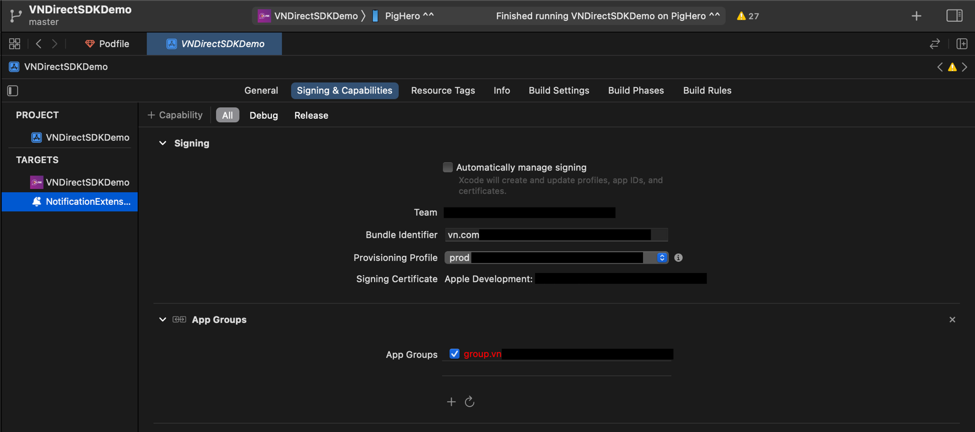

- Pre-defined environments
// BuildConfig.swift
import NetAloLite

struct BuildConfig {
static var enviroment = EnvironmentType.production
static var appGroupId = "APP-GROUP" // note: same with main app

- Init the SDK

// Injection.swift
import Resolver
import NotificationComponent

extension Resolver: ResolverRegistering {
public static func registerAllServices() {
register { NotificationComponentImpl(enviroment: BuildConfig.enviroment, appGroupId: BuildConfig.appGroupId) as NotificationComponent }
.scope(.cached)
}
}

// NotificationService.swift
} import UserNotifications
import RxSwift
import Resolver
import NotificationComponent

class NotificationService: UNNotificationServiceExtension {

var contentHandler: ((UNNotificationContent) -> Void)?
var bestAttemptContent: UNMutableNotificationContent?

private var disposeBag = DisposeBag()
@LazyInjected private var notificationRepo: NotificationComponent

override init() {
super.init()

notificationRepo.initialize()
}

override func didReceive(_ request: UNNotificationRequest, withContentHandler contentHandler: @escaping (UNNotificationContent) -> Void) {
self.contentHandler = contentHandler
bestAttemptContent = (request.content.mutableCopy() as? UNMutableNotificationContent)

if let bestAttemptContent = bestAttemptContent {
notificationRepo.replace(oldContent: bestAttemptContent)
.do(onSuccess: { (newContent) in
contentHandler(newContent)
})
.subscribe()
.disposed(by: disposeBag)
}
}

override func serviceExtensionTimeWillExpire() {
// Called just before the extension will be terminated by the system.
// Use this as an opportunity to deliver your "best attempt" at modified content, otherwise the original push payload will be used.
if let contentHandler = contentHandler, let bestAttemptContent = bestAttemptContent {
contentHandler(
notificationRepo.expired(oldContent: bestAttemptContent)
)
}
}

}
- Change sound ring notification

Use file: notification_sound.wav
if not found sound ring use default device.

5. Use Option SDK DLink
- Custom Theme color for app
Currently iOS SDK does not support config Theme. So each theme will have a custom build.

- Block/Unblock User
netAloSDK. blockUser(blockedID: "USER_ID", completion: @escaping (Bool) -> Void)
netAloSDK.unBlockUser(blockedID: "USER_ID", completion: @escaping (Bool) -> Void)
- Set Language
netAloSDK.setLanguage(language: String)

6. Contact
Email: sondh@netacom.vn
iOS developer
Mobile: (+84) 906600132

Headquarters:
5 Dien Bien Phu St., Dien Bien Ward, Ba Dinh District, Hanoi City, Vietnam

Ho Chi Minh City Office:
Ground Floor, Centre Point Tower, 106 Nguyen Van Troi St., Ward 8, Phu Nhuan District, HCMC, Vietnam.

7. Example
https://github.com/Netacom-NetAlo/DLinkSDK-iOS-Demo

