Hamming Encoder and Decoder Output waveform:

* Input bit provided here is 101010

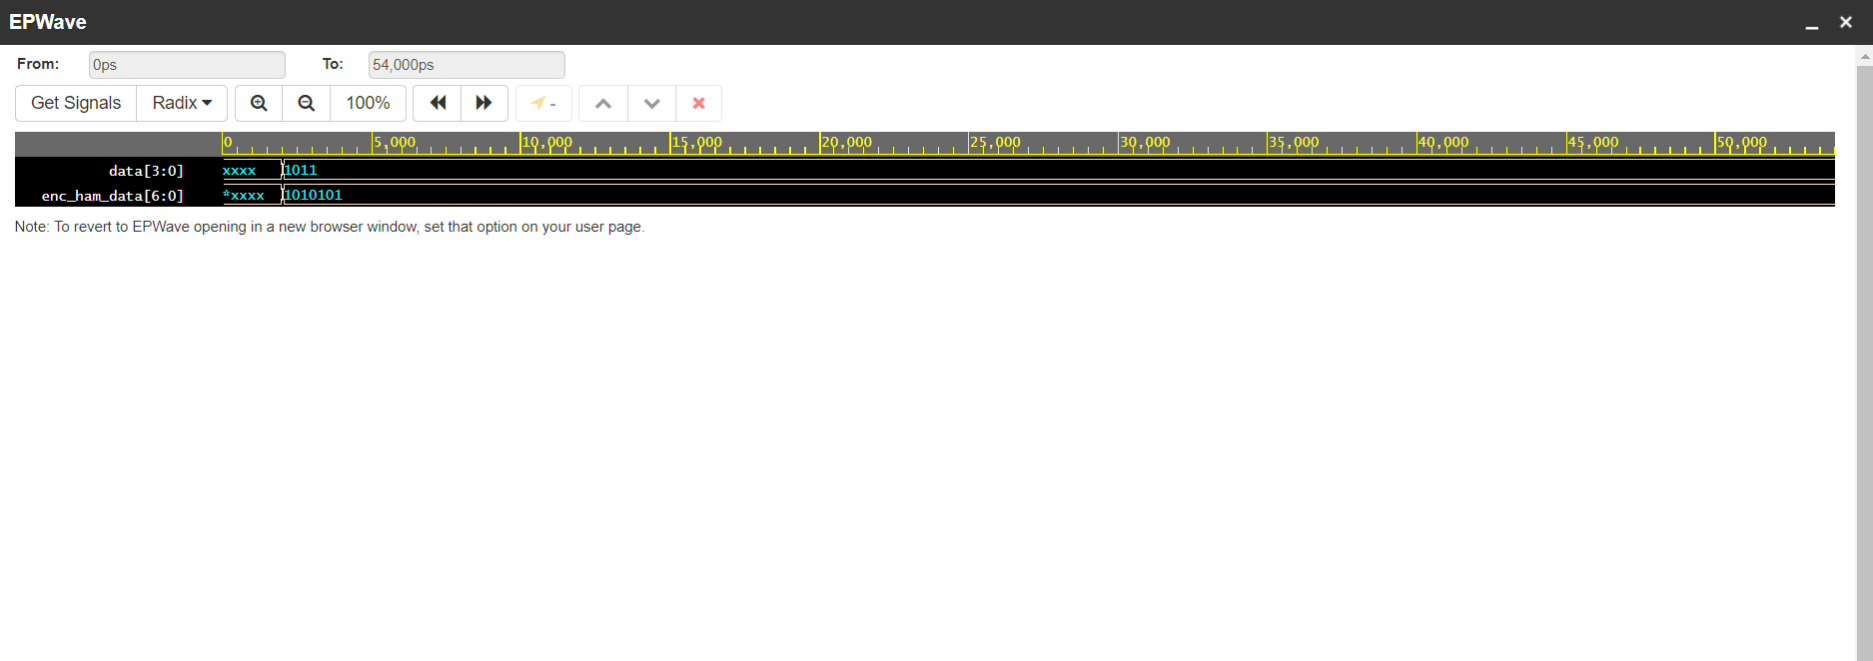

* On the decoder side if any of the bit incurred error in the bit it will show the error position, in this way error can be detected at the decoder side.
* Output waveform if error received.

