DevOps – Micflix

Fontys semester 6 software project

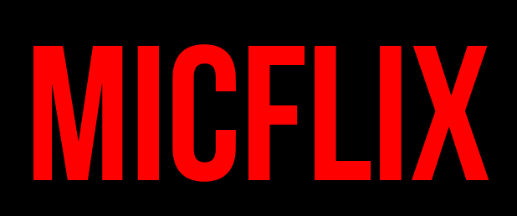

|  |  |
| --- | --- |
| Date | 07-03-2022 |
| Version | **0.1** |
| State | **In progress** |
| Author | **Mickey Krekels** |
| Class | **RB04** |

# Version History

|  |  |  |  |  |
| --- | --- | --- | --- | --- |
| Version | Date | Author(s) | Changes | State |
| 0.1 | 07-03-2022 | Mickey Krekels | Added the main structure of the document. | In progress |
|  |  |  |  |  |
|  |  |  |  |  |

# Preface

Table of content

Version History 2

Preface 3

1 Project description 5

1.1 Context 5

2 CI/CD pipeline 6

2.1 Context 6

2.2 Why github actions? 6

2.3 Pipeline set up 6

3 Conclusion 7

# 1 Project description

## Context

This document will describe the plan of the Micflix project, I will explain what part I will do, and what the goal of the assignment is. The project plan document will also contain the Scope and preconditions, the methodologies that will be used for the different research questions, explaining which stakeholders are involved and the testing within the project.

# CI/CD pipeline

## Context

## Why github actions?

## Pipeline set up

# Conclusion