technical design – Micflix

Fontys semester 6 software project

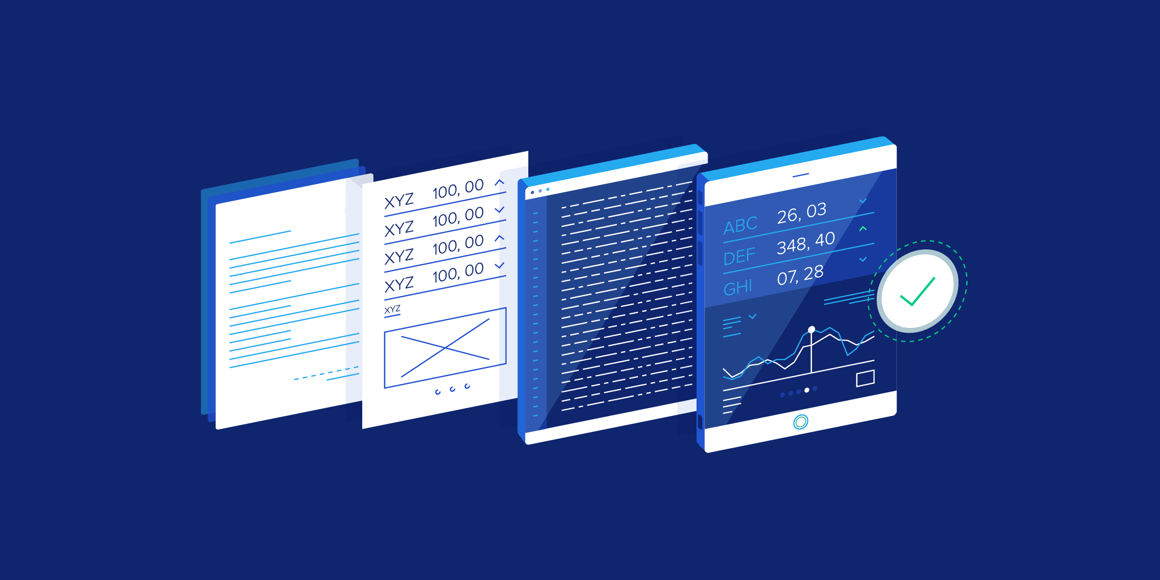

|  |  |
| --- | --- |
| Date | 07-03-2022 |
| Version | **0.1** |
| State | **In progress** |
| Author | **Mickey Krekels** |
| Class | **RB04** |

# Version History

|  |  |  |  |  |
| --- | --- | --- | --- | --- |
| Version | Date | Author(s) | Changes | State |
| 0.1 | 07-03-2022 | Mickey Krekels | Added the main structure of the document. | In progress |
|  |  |  |  |  |
|  |  |  |  |  |

# Preface

This project is made for the Fontys semester-6 personal assignment. The goal is to make a streaming service clone with a strong inspiration from the platform Netflix. This clone will be called Micflix and the final version of the project will be of enterprise quality.

This document contains all the technical designs of this assignment. The design will be split up into 4 different C model levels (1). Where each of the levels represents a different layer in the architecture, specifically context, container, component and code layer. In chapter, 2 the reason will be explained for each of the architecture choices. At the end of the document, there will be a short conclusion.

Table of content

Version History 2

Preface 3

1 Project Architecture 5

1.1 C1 model 5

1.2 C2 model 5

1.3 C3 model 6

1.4 C4 model 6

2 Decision justification 7

3 CONCLUSION 8

# Project Architecture

## C1 model

## C2 model

## C3 model

## C4 model

# Decision justification

# CONCLUSION