**SUSTAINABLE SMART CITY**

**TEAM ID (NM2025TMID01938)**

# 1.Introduction

# • Project Title : Sustainable Smart City

# • Team Leader : Nethaji S (C2A8B4D62A582DDA2F642FE432859E98)

• Team Member : Ragul R (1250A4FF0AB2FBD862F44FC5D4AF8AAA)

• Team Member : Rupas E (799D6DB353E881D8AF34DD35C3E5A9EE)

• Team Member : Santhosh R **(**695112D58D4FAB7B03C403038A9E14CB**)**

# • Team Member : Udhayan M (7AEF892F6C325128AB74902BE40C6263)

# 2. Project Overview

The Sustainable Smart City Assistant is an AI-powered platform that supports urban sustainability, government, and citizen participation by utilizing contemporary data pipelines and IBM Watsonx's Granite LLM. Through a modular FastAPI backend and a Streamlit-based frontend dashboard, it connects multiple modules, including the City Health Dashboard, Citizen Feedback, Document Summarization, Eco-Advice, Anomaly Detection, KPI forecasting, and Chat Assistant.

Key integrated modules include:

- City Health Dashboard  
- Citizen Feedback  
- Document Summarization  
- Eco-Advice  
- Anomaly Detection  
- KPI Forecasting  
- Chat Assistant

**3. Use Case Scenarios**

## 3.1 Policy Search & Summarization

A municipal planner uploads a complex city policy document to the assistant’s interface. Within seconds, the assistant uses IBM Granite LLM to summarize it into a concise, citizen-friendly version. This enables planners to quickly interpret key points, provisions, and implications, ensuring effective governance.

## 3.2 Citizen Feedback Reporting

A resident notices a burst water pipe on a city street. Instead of contacting helplines, they submit a report through the assistant’s feedback form. The issue is instantly logged with category tagging (e.g., 'Water') and sent to relevant city administrators. This process ensures faster response times and improved civic engagement.

## 3.3 KPI Forecasting

A city administrator uploads last year’s water usage KPI CSV file. The assistant uses built-in machine learning models to forecast next year’s consumption. This predictive insight helps in planning budgets, resource allocation, and infrastructure upgrades, contributing to a more sustainable city ecosystem.

4**. System Architecture**

1.High-Level Overview

2.Component-wise Breakdown

3.Technology Stack

4.Data Flow Diagram

5.Optional Enhancements (for scalability)

**1. High-Level System Architecture**

+----------------------------+

| User Interface |

| (Gradio Web App UI) |

+------------+---------------+

|

v

+------------------------+------------------------+

| Application Backend |

| (Python, Gradio Blocks, Business Logic Layer) |

+---------+--------------------+------------------+

| |

+---------v-------+ +--------v---------+

| Prompt Builder | | PDF/Text Handler |

+-----------------+ +------------------+

| |

+---------v--------------------v---------+

| Language Model Inference Layer |

| (IBM Granite via HuggingFace Model) |

+-------------------+--------------------+

|

+----------v----------+

| Tokenizer & Model |

| (Transformers API) |

+--------------------+

|

+----------v----------+

| Hardware Backend |

| (GPU/CPU via PyTorch) |

+--------------------+

**2. Component-wise Breakdown**

A. User Interface Layer (Gradio)

* Framework: Gradio Blocks, Tabs, Textbox, File
* Responsibilities:
  + Receive user input (keywords or policy documents)
  + Display model-generated eco tips or policy summaries
  + Manage user interactions, file uploads, and button clicks

B. Application Logic Layer

* Main Script: sustainable_smart_city_assistance.py
* Responsibilities:
  + Accept and validate user inputs
  + Route requests to appropriate function (eco_tips_generator or policy_summarization)
  + Prepares prompts dynamically
  + Calls the inference function

C. PDF/Text Extraction Module

* Library: PyPDF2 or (optional upgrade: pdfplumber)
* Responsibilities:
  + Extract clean, readable text from PDF files
  + Handle errors in PDF parsing (scanned pages, corrupted files)
  + Return plain text for summarization

D. Prompt Builder & Model Inference

* Library: transformers (Hugging Face)
* Model Used: ibm-granite/granite-3.2-2b-instruct
* Functions:
  + generate_response(prompt): Formats input → tokenizes → model → decodes output
  + Handles GPU/CPU via torch.device mapping
  + Manages sampling (temperature, max_length)

E. Tokenizer & Model Interface

* Tokenizer: Automatically loads with AutoTokenizer.from_pretrained(...)
* Model: Loaded via AutoModelForCausalLM.from_pretrained(...)
* Device Optimization: Supports both CPU and GPU with conditional logic
* Memory Optimization: Uses torch.float16 if GPU available

F. Hardware Backend

* Local Machine / Cloud VM:
  + GPU-enabled (for real-time inference) — e.g., NVIDIA RTX, A100
  + CPU fallback for smaller workloads
* Optional: Deploy on platforms like Hugging Face Spaces, AWS SageMaker, or Google Colab Pro for scalability

**3. Technology Stack**

| Layer | Technology |
| --- | --- |
| UI / Frontend | Gradio (Python-based) |
| Backend Logic | Python |
| ML Framework | HuggingFace Transformers, PyTorch |
| Model | IBM Granite 3.2 2B Instruct |
| File Parsing | PyPDF2 / pdfplumber |
| Tokenization | AutoTokenizer (HF Transformers) |
| Deployment (Optional) | Hugging Face Spaces, Streamlit, Docker |

**4. Data Flow Diagram**

Here’s a simplified data flow from input to output:

User Input (Textbox or PDF Upload)

↓

Input Validation & Preprocessing

↓

↓ ↓

[eco_tips_generator] [policy_summarization]

↓ ↓

Prompt Construction PDF Text Extraction (if PDF)

↓ ↓

Tokenization (HF tokenizer)

↓

Model Inference (Granite 3.2 via Transformers)

↓

Output Decoding & Postprocessing

↓

Display in Gradio UI

**5. Optional Enhancements** (Modular or Scalable Architecture)

If you want to evolve this into a microservice-style application or deploy in production:

| Enhancement | Suggestion |
| --- | --- |
| Caching | Use Redis to cache common responses (e.g., for repeated keywords) |
| Queueing | Use Celery + Redis for long document processing jobs |
| Asynchronous PDF Processing | Run PDF extraction as async task (e.g., asyncio, FastAPI) |
| API-First Design | Convert Gradio functions to REST APIs using FastAPI/Flask |
| Persistent Storage | Save uploaded PDFs or logs to a DB (e.g., MongoDB, PostgreSQL) |
| Dockerization | Package the app as a container for deployment anywhere |
| Monitoring/Logging | Add error logging and request logs with tools like Sentry |

📌 Summary

Your system is a modular, prompt-based LLM app with:

🔍 Input modalities: text & PDFs

🤖 Intelligent processing: IBM Granite LLM

📤 Output: human-readable, task-specific responses

📁 Frameworks: Gradio for UI, Transformers for ML

🧩 Ready for extensibility with modular design

# 5. Modules in Detail

Each module of the Sustainable Smart City Assistant plays a critical role in enhancing city operations, sustainability, and citizen engagement. Together, these modules form an integrated ecosystem that supports decision-making, promotes transparency, and empowers communities.

**5.1 City Health Dashboard**

The City Health Dashboard serves as the central monitoring hub of the platform. It provides administrators and policymakers with real-time visualization of Key Performance Indicators (KPIs) related to essential city functions such as water consumption, energy usage, waste management, and air quality.

By consolidating data from various sources into a single, user-friendly interface, the dashboard enables decision-makers to track urban resource usage and environmental impact at a glance. For example, if water consumption exceeds expected levels, the system highlights it, allowing officials to intervene promptly.

Benefits:

Promotes data transparency for city administrators.

Helps in early detection of inefficiencies.

Encourages citizen awareness of city health indicators.

**5.2 Document Summarization**

Policy and governance documents are often lengthy and difficult for ordinary citizens to interpret. The Document Summarization module, powered by IBM Granite LLM, transforms such complex documents into easy-to-read summaries that highlight the most relevant information.

This ensures that both citizens and administrators can quickly understand key policies, laws, and regulations without going through hundreds of pages of text. For instance, a waste management regulation of 50 pages can be condensed into a two-page summary highlighting citizen responsibilities, fines, and city initiatives.

**Benefits:**

Enhances policy accessibility for all citizens.

Saves time for administrators and decision-makers.

Reduces the risk of misinterpretation of official documents.

**5.3 Eco-Advice**

The Eco-Advice module focuses on sustainability awareness and behavioral change. It generates personalized, actionable tips for sustainable living tailored to city-specific challenges such as reducing electricity usage, minimizing water waste, or adopting waste segregation practices.

For example, if energy usage in a neighborhood is higher than average, the system might suggest simple actions like switching to LED lights or optimizing appliance usage. Citizens receive advice not just as general guidelines, but as context-aware recommendations derived from city data.

**Benefits:**

Promotes eco-friendly habits among citizens.

Supports the city’s sustainability goals.

Reduces environmental footprint at both household and community levels.

**5.4 Anomaly Detection**

Anomaly Detection is a proactive problem-identification tool within the assistant. It uses machine learning models to automatically flag irregularities in large datasets, such as sudden spikes in water consumption, unexpected power outages, or abnormal traffic congestion patterns.

By detecting anomalies early, the system ensures that administrators can take corrective measures before small issues escalate into major disruptions. For example, a sudden surge in water usage in one area may indicate a pipeline leak, which can be fixed quickly if flagged in real-time.

Benefits:

Enables faster response times to critical issues.

Prevents resource wastage and service disruptions.

Improves efficiency in infrastructure management.

**5.5 KPI Forecasting**

The KPI Forecasting module uses historical city datasets and predictive algorithms to forecast future performance indicators. Administrators can view predicted trends in water usage, traffic volume, air quality, and energy demand.

This predictive capability enables data-driven urban planning and ensures that resources are allocated efficiently. For instance, forecasting electricity demand during summer months helps prepare for power surges, while predicting waste generation trends assists in optimizing collection routes.

Benefits:

Enhances long-term planning for city resources.

Reduces chances of service shortages.

Supports evidence-based policymaking.

**5.6 Chat Assistant**

The Chat Assistant is the interactive communication module of the system. It allows both citizens and administrators to ask questions in natural language and receive instant AI-powered responses.

For citizens, the Chat Assistant can explain policies, give eco-advice, or help with reporting issues. For administrators, it can provide quick insights into datasets, forecast summaries, or document interpretations. This two-way interaction ensures greater accessibility, inclusivity, and transparency in city governance.

For example, a citizen might ask, *“What are the city’s current air quality levels?”* and instantly receive a data-backed answer. Similarly, an administrator could ask, *“Forecast energy demand for the next quarter”* and get predictive insights in real time.

Benefits:

Improves citizen engagement through interactive communication.

Reduces workload for city staff by automating routine queries.

Enhances trust and transparency in governance.

Summary of Modules

Together, these six modules make the Sustainable Smart City Assistant a powerful, modular, and scalable platform. The City Health Dashboard ensures real-time monitoring, Document Summarization makes policies accessible, Eco-Advice empowers citizens with sustainable tips, Anomaly Detection prevents disruptions, KPI Forecasting supports future planning, and the Chat Assistant enables interactive governance.

By combining these modules into one system, the platform bridges the gap between technology and urban governance, making cities more efficient, sustainable, and citizen-friendly.

**6. Implementation Workflow**

The Sustainable Smart City Assistant follows a structured and modular workflow that ensures smooth integration of data, AI models, and user-facing services. The workflow can be divided into five major steps:

**6.1 Data Ingestion**

* Data is collected from multiple sources such as IoT sensors, city databases, citizen feedback forms, and historical records.
* Examples include water consumption data, energy usage logs, traffic congestion reports, and environmental monitoring datasets.
* Data ingestion pipelines ensure that both structured (numerical, categorical) and unstructured (text, documents, feedback) data are captured.

**6.2 Data Processing**

* Once ingested, raw data undergoes cleaning, transformation, and normalization.
* Missing values are handled, outliers are flagged, and text data is pre-processed for natural language tasks.
* This stage ensures that the data is reliable, consistent, and ready for model inference.

**6.3 Model Inference**

* Processed data is sent to the IBM Granite LLM and other machine learning models for analysis.
* Examples:
  + The LLM summarizes policy documents.
  + Forecasting models predict future KPIs.
  + Anomaly detection algorithms flag unusual patterns in data.
* Model inference forms the intelligence layer of the system, enabling data-driven insights.

**6.4 API Serving**

* The insights generated by AI models are exposed through a FastAPI backend.
* This API layer ensures modularity, making it easy for different modules (dashboard, chatbot, etc.) to interact with each other.
* It also allows scalability, so additional modules can be integrated without disturbing the core architecture.

**6.5 Visualization**

* Processed results are presented to users via a Streamlit-based dashboard and interactive chat interface.
* Citizens can view city health indicators, receive eco-advice, or query policies in natural language.
* Administrators can track KPIs, monitor anomalies, and view forecasts in real time.

Summary:

This step-by-step workflow ensures a seamless flow from raw data to actionable insights, bridging the gap between complex AI models and user-friendly applications.

**7. Benefits of the System**

The Sustainable Smart City Assistant delivers significant advantages to citizens, administrators, and policymakers.

**7.1 Enhanced Governance**

* Administrators can monitor KPIs and anomalies in real time.
* Policies become transparent and easy to communicate through summarization and chat assistance.
* Data-driven insights improve accountability and responsiveness in governance.

**7.2 Improved Citizen Engagement**

* Citizens can directly interact with the system via the Chat Assistant.
* Eco-advice provides personalized sustainability tips, encouraging public participation.
* Policy summaries make information more inclusive and understandable.

**7.3 Predictive Planning**

* KPI forecasting enables evidence-based decision-making.
* Helps city planners allocate resources efficiently, anticipate demand, and prepare for challenges such as energy surges or waste management spikes.

**7.4 Cost Efficiency**

* Early detection of anomalies reduces infrastructure damage and repair costs.
* Predictive maintenance lowers operational expenses.
* Efficient resource allocation saves both time and money.

**7.5 Sustainability and Resilience**

* Promotes eco-friendly behaviors through citizen-focused recommendations.
* Reduces environmental footprints by optimizing energy and water usage.
* Enhances the resilience of cities against climate change and rapid urbanization.

Summary:  
The system not only improves governance efficiency but also creates a citizen-centric and sustainable smart city ecosystem.

**8. Challenges & Considerations**

While the assistant brings many benefits, several technical, ethical, and operational challenges must be addressed for successful large-scale adoption.

**8.1 Data Privacy and Security**

* Sensitive city data (e.g., citizen reports, utility usage, feedback) must be protected.
* Implementation of data encryption, anonymization, and compliance with privacy laws is critical.
* Building trust among citizens requires strict data governance practices.

**8.2 Integration with Legacy Systems**

* Many cities operate with outdated IT infrastructure that may not easily integrate with modern AI-based platforms.
* Interoperability standards and gradual adoption strategies are necessary.
* Without proper planning, integration costs can become a barrier.

**8.3 Model Interpretability**

* AI models, especially large language models, can act as black boxes.
* Policymakers and citizens need explainable AI outputs to trust the system.
* Techniques such as feature importance visualization and transparent policy summarization must be incorporated.

**8.4 Ensuring Fairness and Reducing Bias**

* AI models may unintentionally favor certain demographics if datasets are biased.
* Continuous monitoring and retraining with diverse data are essential to ensure fairness.
* Ethical guidelines must be followed to avoid discrimination in service delivery.

**8.5 Operational and Cultural Barriers**

* City staff may resist AI adoption due to lack of technical expertise.
* Citizens may hesitate to trust automated systems initially.
* Training programs, awareness campaigns, and gradual rollout are necessary to build confidence.

Summary:  
Overcoming these challenges requires strong governance policies, ethical AI practices, and robust technical infrastructure.

**9. User Interface**

* The Sustainable Smart City Assistant provides an intuitive, modular, and citizen-friendly user interface built with Streamlit. The UI is designed to make navigation simple for city administrators, planners, and citizens while ensuring transparency and accessibility.

**10. Testing**

**10.1 Unit Testing**

Tools: PyTest, unittest (Python)

Scope:

Document Summarization: Check if summaries are concise & relevant.

KPI Forecasting: Validate model outputs against known datasets.

Anomaly Detection: Ensure anomalies are flagged correctly.

Eco-Advice: Verify tailored suggestions are generated.

API Endpoints (FastAPI): Confirm correct response status codes (200, 400, 500).

**10.2 Integration Testing**

Tools: Postman, PyTest, Docker test environments

Scope:

Validate communication between FastAPI backend & Streamlit frontend.

Ensure IBM Granite LLM is invoked correctly for summarization/chat.

Test feedback reports flowing from frontend → backend → database → admin dashboard.

Check KPI CSV upload → ML pipeline → forecast visualization.

**10.3 Functional Testing**

Scenarios:

Upload a city policy → Get accurate summary.

Submit citizen feedback (burst water pipe) → Logged in DB & displayed to admin.

Upload water usage dataset → Forecast displayed correctly.

Real-time dashboard updates KPIs without errors.

**10.4 Performance Testing**

Tools: JMeter, Locust

Scope:

Stress test document summarization with 100+ uploads simultaneously.

Load test dashboard with 500 concurrent users.

Measure API latency for Granite LLM calls (< 2s target).

Database read/write under heavy feedback submission.

**10.5 Security Testing**

Tests:

SQL Injection on feedback forms.

API key & token authentication validation.

Access control (citizen vs. admin roles).

Data privacy checks for uploaded documents.

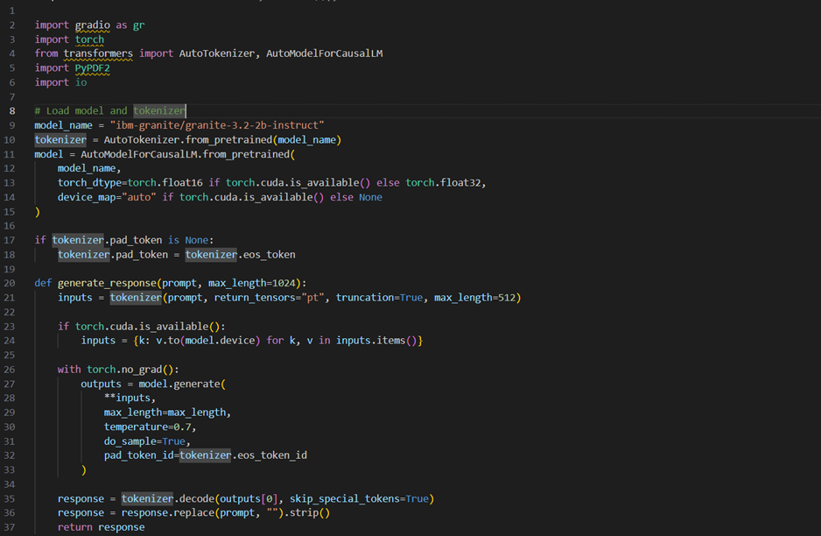**11. Screenshort**

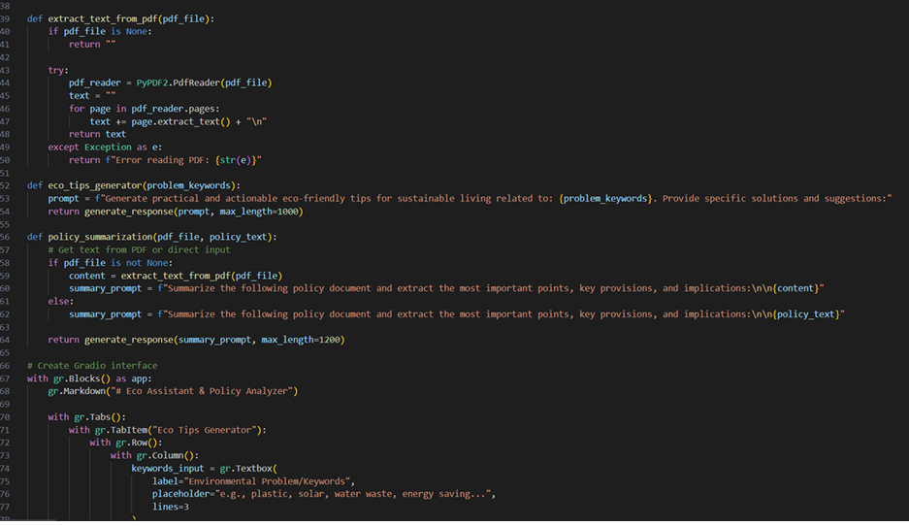

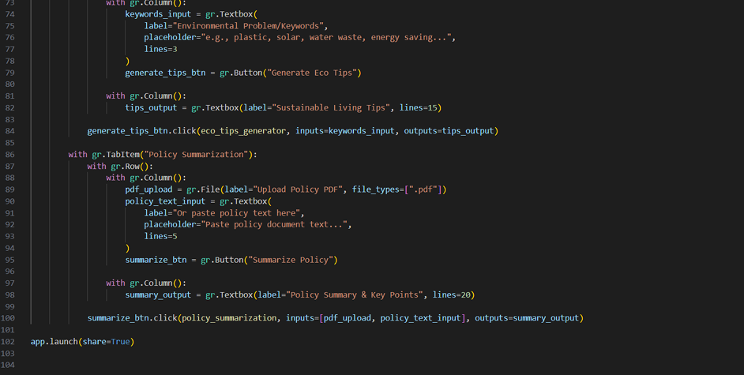

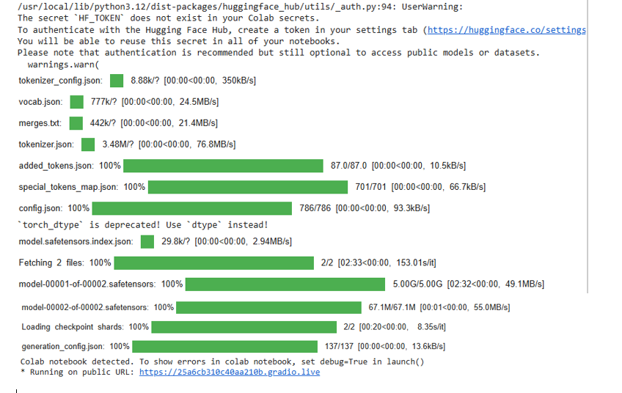

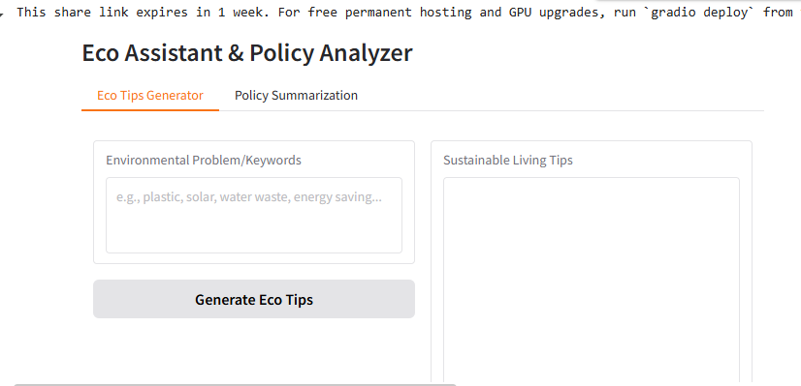

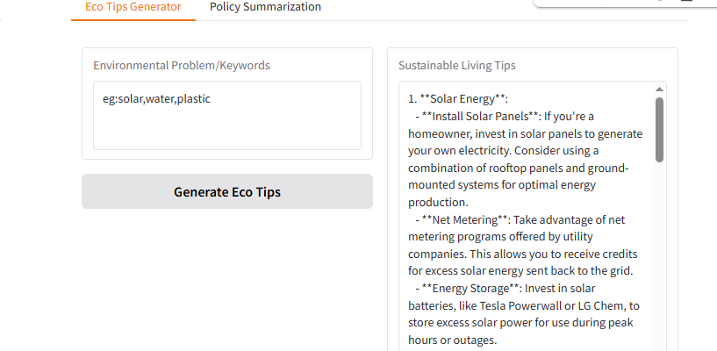

**12. Conclusion**

**12.1 Recap of the Project**

The Sustainable Smart City Assistant is a pioneering attempt to integrate advanced AI-powered decision-support systems into the governance and sustainability operations of modern urban environments. By leveraging IBM Watsonx Granite LLM, the project introduces a framework where policy documents are simplified, citizens can directly provide actionable feedback, administrators can forecast critical KPIs, and anomalies can be detected in real time.

The project bridges the gap between technological capabilities and civic needs, demonstrating how an AI-based assistant can act as both a tool for policymakers and a platform for citizen empowerment.

**12.2 The Role of AI in Sustainable Urban Governance**

Urban governance has historically faced challenges such as bureaucratic inefficiency, poor citizen engagement, delayed policy interpretation, and lack of real-time insights. By deploying IBM Granite LLM:

* Policy Summarization transforms inaccessible documents into easy-to-understand guides.
* Chat Assistance enables interactive Q&A, ensuring instant accessibility of city information.
* Eco-Advice helps citizens adapt sustainable behaviors tailored to their community.
* This synergy between data-driven insights and natural language communication sets a new benchmark for citizen-centered governance.

**12.3 Societal Benefits**

1. For Citizens
   * Direct access to understandable policies.
   * Faster issue reporting and resolution (e.g., burst water pipe reporting).
   * Personalized eco-advisory promoting greener lifestyles.
2. For Administrators
   * Real-time dashboards for resource management.
   * AI-driven predictions for budgeting and infrastructure planning.
   * Better prioritization of public issues via automated tagging and feedback analysis.
3. For Policymakers
   * Quick interpretation of lengthy legal documents.
   * Transparent citizen feedback loops.
   * Evidence-based decision-making grounded in predictive analytics.

**12.4 Contribution to Smart City Ecosystems**

The Sustainable Smart City Assistant goes beyond a typical city management tool by integrating AI, machine learning pipelines, and modular system design into one cohesive platform. Its contributions can be mapped to:

* Sustainability: Reducing environmental impact through eco-advice and forecasting.
* Inclusivity: Providing multilingual and citizen-friendly summaries.
* Resilience: Detecting anomalies and preparing cities for resource challenges.
* Transparency: Building trust between government institutions and the public.
* This positions the assistant as a model for digital public infrastructure that aligns with UN Sustainable Development Goals (SDG 11 – Sustainable Cities and Communities).

**12.5 Challenges and Ethical Considerations**

* While the system has clear benefits, several challenges must be acknowledged:
* Data Privacy & Security: Protecting citizen reports, location data, and sensitive urban datasets.
* Model Interpretability: Ensuring AI recommendations are explainable and not black-box outputs.
* Bias & Fairness: Avoiding systemic bias that could lead to unequal service delivery.
* Integration Barriers: Many cities operate with outdated IT infrastructures, making integration costly.
* Citizen Trust: Adoption depends on citizens believing that AI-driven systems are reliable and transparent.
* Addressing these challenges requires regulatory compliance, robust cybersecurity frameworks, and ethical AI governance policies.

**12.6 Future Vision of the Assistant**

Looking ahead, the assistant has enormous potential to expand into a comprehensive urban digital ecosystem:

1. IoT Integration – Live feeds from smart meters, traffic signals, and pollution sensors for real-time decision-making.
2. Predictive Maintenance – AI models to detect weak infrastructure points before failures occur.
3. Geospatial Visualization – GIS mapping for resource distribution, traffic heat maps, and environmental monitoring.
4. Digital Twin Simulation – Creating a virtual replica of the city to simulate policy impacts and disaster management strategies.
5. Blockchain Integration – Recording citizen feedback and city transactions to build public trust and accountability.
6. Multilingual Expansion – Supporting regional and global languages for inclusivity.
7. AI-driven Crisis Management – Providing real-time alerts and automated guidance during floods, earthquakes, or pandemics.

* Such enhancements will transform the assistant into a dynamic, self-improving system capable of scaling across multiple cities and even entire nations.

**12.7 Broader Implications**

* The assistant is not just a city tool; it represents a paradigm shift in how AI can be embedded into public governance. Broader implications include:
* Global Adoption: Cities worldwide can customize the framework to suit local governance needs.
* Policy Innovation: Data-driven insights can lead to smarter, evidence-based policies.
* Citizen Empowerment: A transparent platform ensures people are more connected to governance processes.
* Economic Efficiency: Optimized resource allocation reduces waste, saving millions in urban budgets.
* Sustainability Impact: Long-term reduction in carbon footprints, better waste management, and improved quality of life.

**12.8 Concluding Thoughts**

The Sustainable Smart City Assistant exemplifies how AI-driven urban platforms can shape the cities of tomorrow. It is more than just a technological tool—it is a strategic governance framework that connects citizens, policymakers, and technology into a single intelligent ecosystem.

As cities continue to face pressures from urbanization, climate change, and resource scarcity, adopting such systems will be vital. The project demonstrates a pathway where innovation meets governance, and technology meets sustainability.

Ultimately, this assistant stands as a blueprint for the future of smart cities, ensuring they are not only technologically advanced but also citizen-centric, transparent, and sustainable.

**13. Known Issues**

Project Deliverables (Directory & Components)

Backend (FastAPI app): Modular APIs (forecast, summarize, feedback, etc.), RESTful URLs → /summarize, /feedback, /forecast, /docs.

Frontend (Streamlit dashboard): Tabs → Dashboard, Feedback, Summarization, Forecasting, Chat. Connects to FastAPI via HTTP.

Models/ML Pipelines: KPI forecasting + anomaly detection.

Docs: API specs, architecture, references.

Config & Deployment:

requirements.txt + pyproject.toml dependencies

Dockerfile (multi-stage, Hugging Face optimized)

Hugging Face Spaces deployment setup

Entry points: app.py (Streamlit), FastAPI scaffold starter.

**14. Future enhancement**

1. IoT Sensor Integration
   * Connect with real-time IoT devices (smart meters, traffic sensors, pollution monitors) for live city data streams.
   * Enables proactive detection of anomalies (e.g., sudden rise in pollution levels).
2. Edge AI Deployment
   * Move certain inference tasks (like anomaly detection or eco-advice) closer to data sources on edge devices.
   * Reduces latency and supports offline/low-bandwidth scenarios.
3. Geospatial Intelligence
   * Integrate GIS mapping to visualize incidents, KPIs, and resource usage by location.
   * Helps city planners identify hotspots for traffic, waste, or water leakage.
4. Multilingual Citizen Support
   * Expand the Chat Assistant with multilingual LLM capabilities.
   * Ensures inclusivity in diverse cities with multiple spoken languages.
5. Predictive Maintenance
   * Use AI to forecast failures in infrastructure (e.g., predicting water pipeline bursts before they happen).
   * Lowers repair costs and prevents service disruptions.
6. Blockchain-based Transparency
   * Use blockchain to record feedback logs, policy changes, and KPI metrics.
   * Enhances transparency, trust, and auditability for citizens and administrators.
7. Personalized Citizen Eco-Advisory
   * Tailor sustainability tips to households based on their energy/water consumption patterns.
   * Gamify eco-behaviors (e.g., badges for reducing electricity usage).
8. AI-Powered Crisis Response
   * Integrate emergency alerting (e.g., during floods, heatwaves, or pandemics).
   * Provide AI-driven evacuation routes and emergency guidelines.
9. Integration with Digital Twin of the City
   * Create a virtual model of the city combining IoT, KPIs, and forecasts.
   * Allows simulation of future scenarios (e.g., traffic under new road rules, energy demand under growth).
10. Sustainability Score & Global Benchmarking
    * Provide each city department with a "Sustainability Score" based on KPIs.
    * Compare with global benchmarks for continuous improvement.