Task 1: AI Website Copy Generator
Business: Glow Beauty Salon, Vijayawada
Tool Used: ChatGPT

1.Homepage Copy:
Prompt:
Act as a professional website copywriter.

Create high-converting homepage content for a premium beauty salon named "Glow Beauty Salon" located in Vijayawada.

Include:
- A powerful headline with a clear value proposition
- A sub headline targeting modern women (18–40)
- A short introduction highlighting quality, hygiene, and customer satisfaction

Tone: Friendly, elegant, and trustworthy
Goal: Attract new customers and encourage bookings
Avoid generic phrases and make it sound like a real premium brand.
Output:
Headline
Radiance That Feels Like You — Elevated Beauty, Expertly Delivered
Subheadline
For modern women who value self-care without compromise—Glow Beauty Salon brings premium treatments, personalized attention, and effortless confidence into your routine.
Introduction
At Glow Beauty Salon, every detail is designed with you in mind. From meticulously maintained hygiene standards to high-quality products and skilled professionals, we create a space where beauty meets trust. Whether it’s a quick refresh or a complete transformation, our focus is simple—delivering results you’ll love and an experience you’ll want to return to.
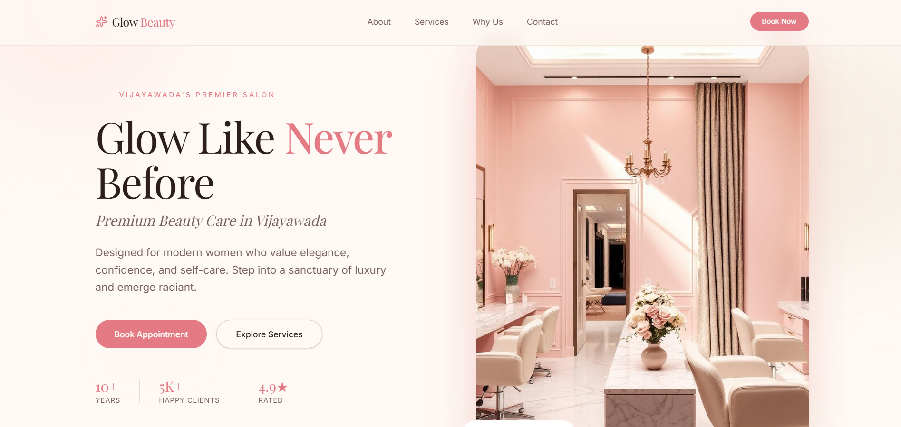

2.Services Page:
Prompt:
Act as a branding and copywriting expert.

Create a service page for "Glow Beauty Salon" in Vijayawada.

Include:
- Service categories: Hair, Skin, Makeup
- For each category, write:
• Service name
• Short description
• Benefit to the customer
- Add a short section explaining why customers should choose this salon

Tone: Clear, customer-focused, and slightly premium
Make the content feel personalized and not AI-generated.
Output:
Our Services at Glow Beauty Salon
At Glow Beauty Salon, every service is thoughtfully designed to match your lifestyle, your preferences, and your individuality. We don’t believe in one-size-fits-all beauty—everything here is tailored to help you look and feel your best.

Hair Services
Precision Haircut & Styling
A customized haircut designed to suit your face shape, hair texture, and personal style.
Benefit: Walk out with a look that’s easy to maintain and effortlessly flattering every day.
Nourishing Hair Spa
Deep-conditioning treatments that repair damage, restore shine, and improve scalp health.
Benefit: Stronger, smoother hair that feels healthier from root to tip.
Hair Coloring & Highlights
Premium color services, from subtle tones to bold transformations, using high-quality products.
Benefit: Rich, long-lasting color that enhances your overall look without damaging your hair.

Skin Services
Glow Facial Therapy
A rejuvenating facial tailored to your skin type, targeting dullness, dryness, or breakouts.
Benefit: Instantly refreshed, radiant skin with visible results you can feel.
Advanced Skin Treatments
Specialized care including detan, acne control, and skin-brightening solutions.
Benefit: Clearer, more even-toned skin with consistent improvement over time.
Clean-Up & Maintenance Care
Gentle yet effective skin clean-ups for regular upkeep.
Benefit: Keeps your skin fresh, balanced, and glowing between major treatments.

Makeup Services
Party Makeup
Elegant, long-lasting makeup designed for special occasions and celebrations.
Benefit: Look polished and confident, with makeup that stays flawless for hours.
Bridal Makeup
Complete bridal makeup tailored to your outfit, event, and personal style.
Benefit: A timeless, picture-perfect look that enhances your natural beauty on your big day.
Natural Day Makeup
Light, breathable makeup for everyday wear or casual events.
Benefit: A fresh, radiant appearance that feels comfortable and looks effortlessly beautiful.
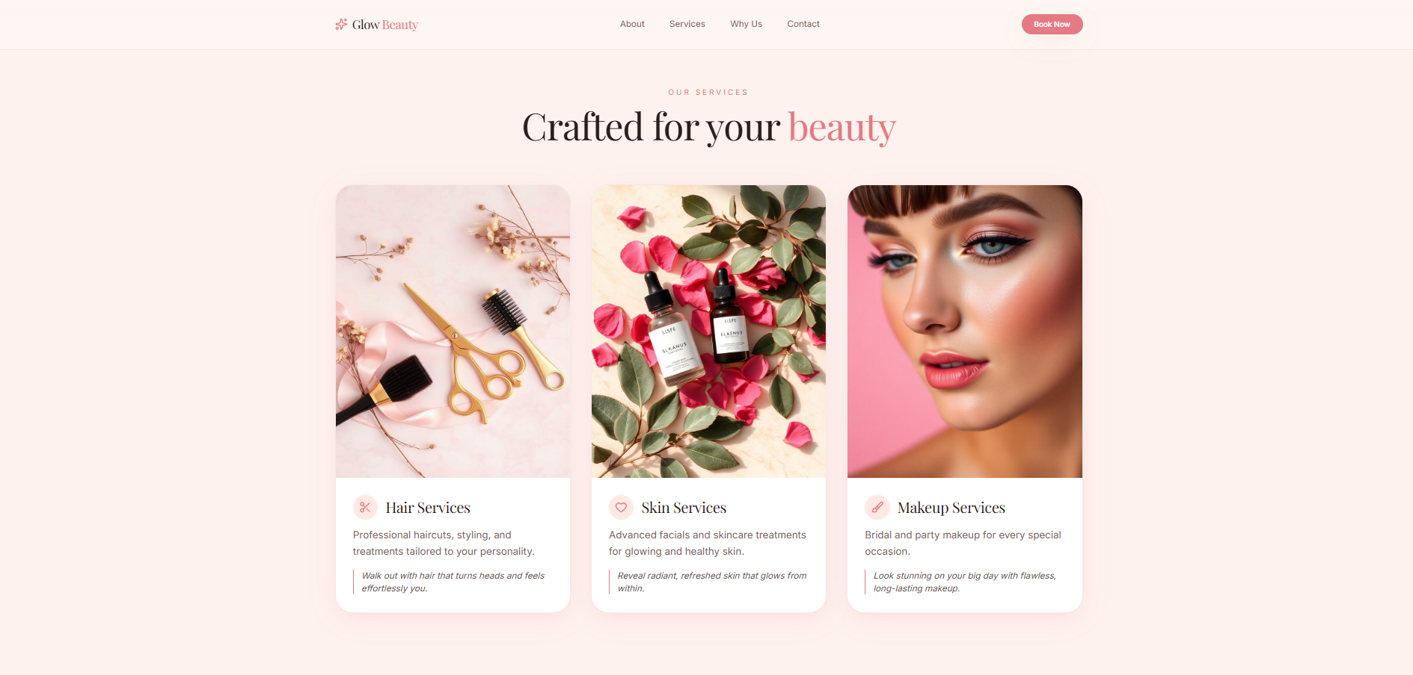

Why Choose Glow Beauty Salon?
Choosing the right salon isn’t just about services—it’s about trust. At Glow Beauty Salon, we combine skilled expertise with a genuine understanding of what our clients want. Every treatment is carried out with strict hygiene standards, premium products, and a focus on comfort.
We take the time to listen, recommend what truly suits you, and deliver results that feel personal—not rushed or routine. It’s this attention to detail that keeps our clients coming back, not just for how they look, but for how they feel after every visit.
Because at Glow, it’s not just beauty—it’s confidence, care, and consistency.
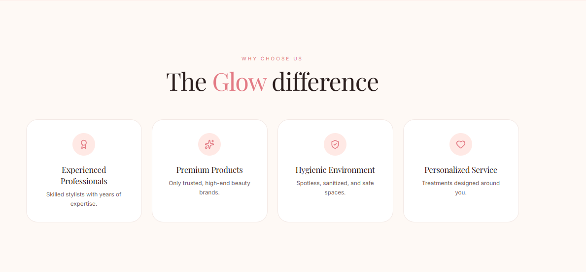

3. CTA Section:
Prompt:
Act as a marketing expert specializing in conversion-focused copy.

Generate strong call-to-action (CTA) content for a beauty salon website.

Include:
- Booking CTA (encourage immediate appointments)
- Contact CTA (phone/visit message)
- Urgency-based CTA (limited slots, weekend rush, etc.)

Tone: Persuasive but friendly
Goal: Increase customer bookings and engagement
Make CTAs short, impactful, and action-oriented.
Output:
Booking CTA (Immediate Action)
Book Your Glow-Up Today — Your Perfect Look Is Just One Appointment Away
Reserve your slot now and let our experts take care of the rest.
[Book Appointment Now]

Contact CTA (Call / Visit)
Have questions or need quick advice? We’re just a call away.
Walk in or speak with our team to find the right service for you.
Call Now | Visit Us Today

Urgency-Based CTA (Limited Slots)
Weekend slots fill fast — don’t miss your chance to shine.
Limited appointments available for this week. Secure yours before it’s gone.
Hurry, Book Your Slot Now
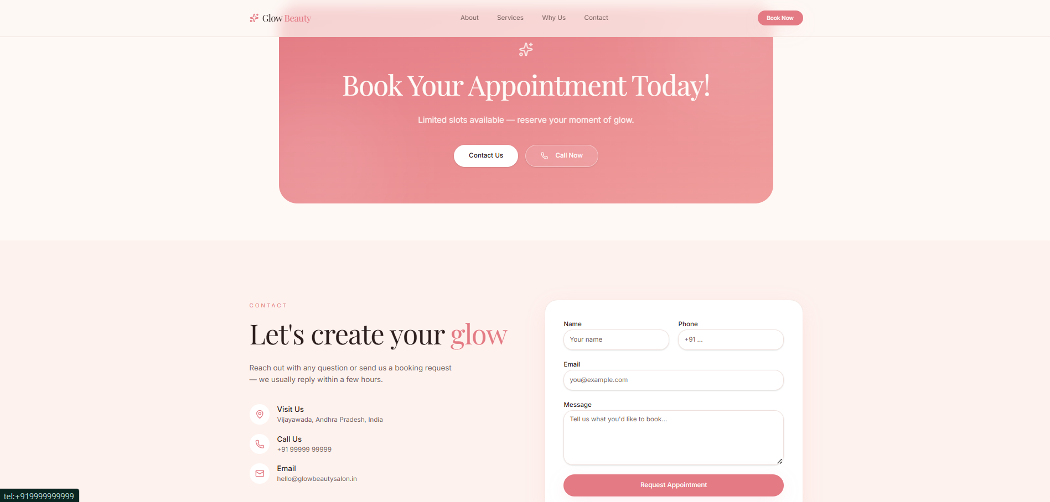

4. Prompt Logic:
The prompt system was designed to generate professional website copy by dividing the content into sections such as homepage, services, and CTAs. Each prompt includes role-based instructions, target audience, tone, and clear output structure. This helps in generating specific, high-quality, and business-focused content instead of generic responses. The prompts are reusable and can be adapted for different local businesses.

