Overview

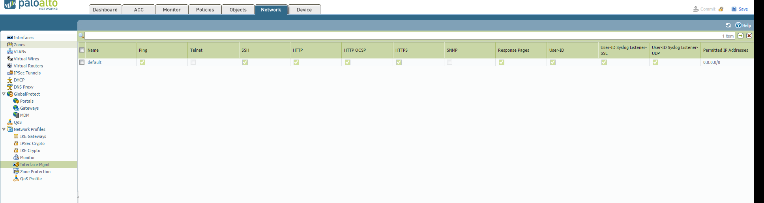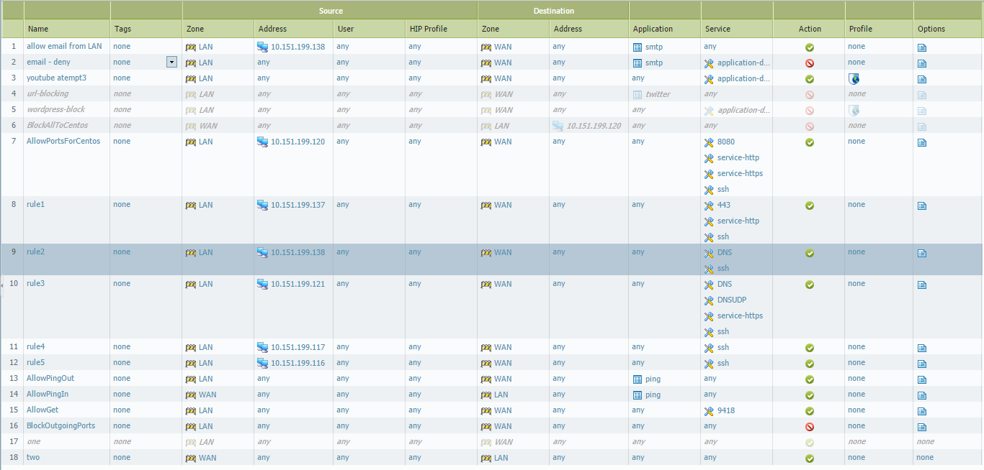

Ingress: overview



Step 1: source and destination zones are untrusted. Destination interface and source address are any. Destination address is destination. Set service to whatever port the translated address is using

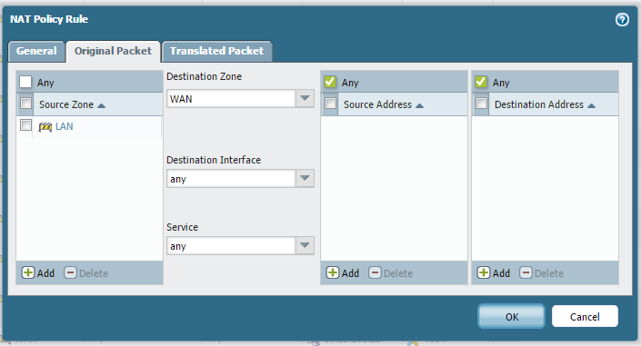

Step 2: select destination address translation and input your source ip address, and port. Make sure the translated address is the firewall.

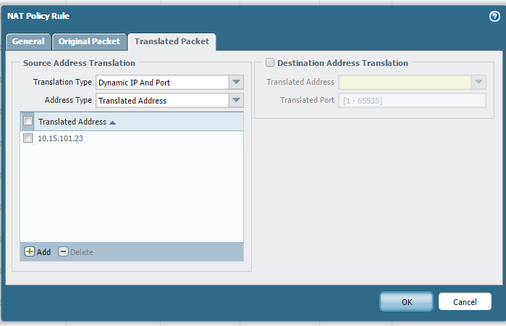

allow mail server ports and setupish:

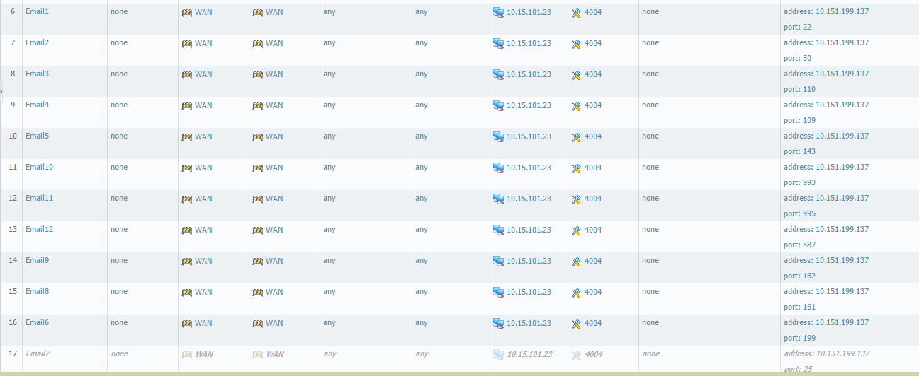

Step 1: set source and destination zones to untrusted. Set the service to were the mail server will be. And set that boxes ip address as destination address.

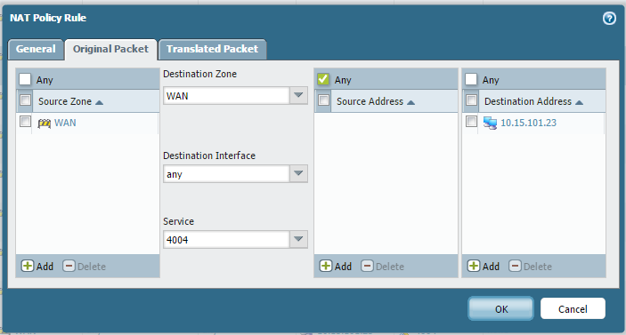

Step 2: select destination address translation and select the ip of the box you want the mail server to be on and what port u want to open.

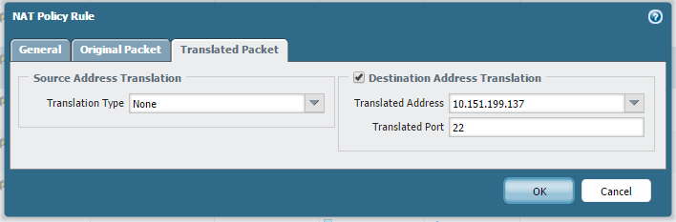

AD egress

Step 1: source zone is trusted source address is ad’s ip

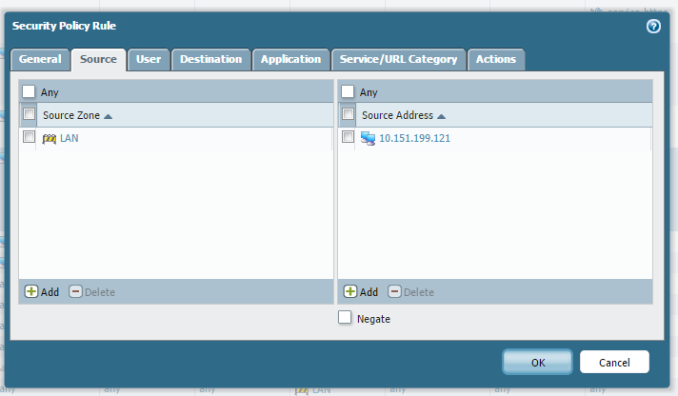

Step 2: select the services you wish to allow and url category is any. Step 3 for actions set it to allow

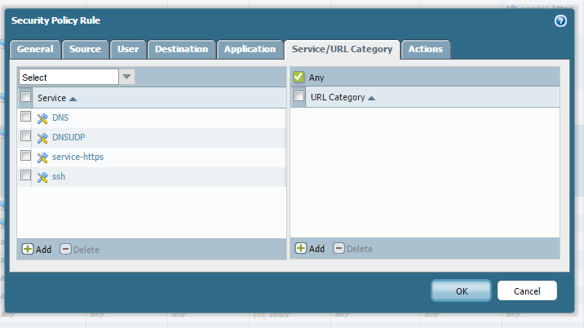

Centos engress:

Step 1: source zone to LAN. Source address to Centos box’s ip

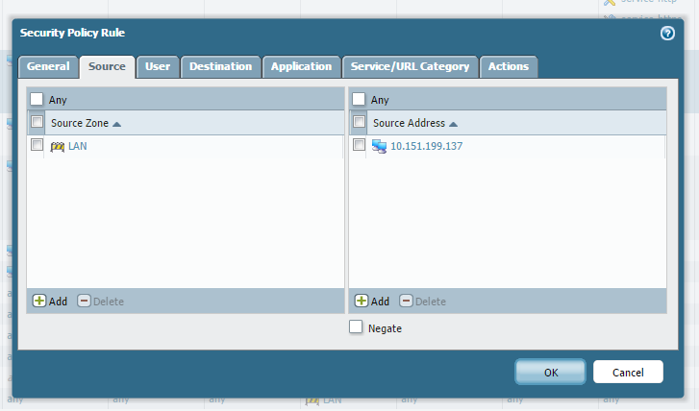

Step 2: input the services you wish to allow for Centos

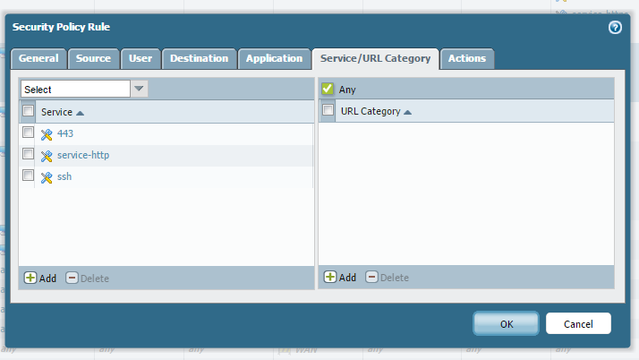

Egress ECOM:



Step 1: select LAN as source zone and the ECOM’s ip for source address

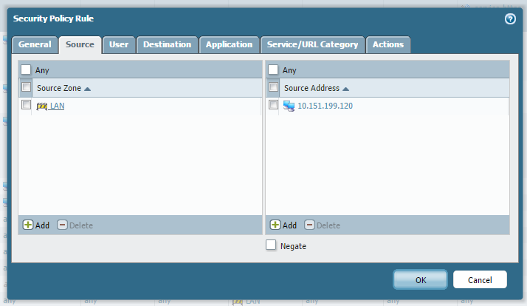

Step 2: select services you wish to allow

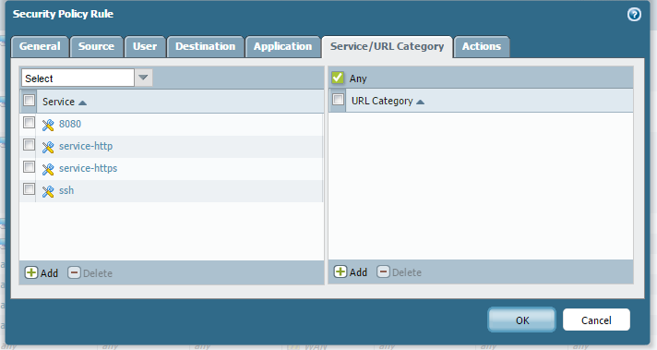

Allow ping in and out



Allow get command:

C:\Users\Ben\AppData\Local\Microsoft\Windows\INetCache\Content.Word\alowget.png

Step one: set the rule up to allow from the LAN to the WAN. Then for service make it port 9418 and any url category. And set it to allow.

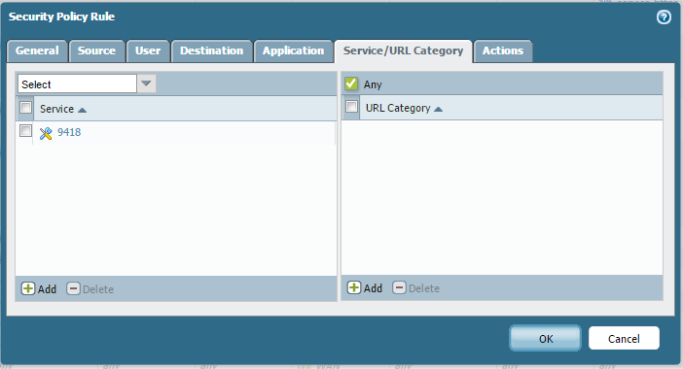

Email spam inject:

Step one make a protocol that allows email to email server:

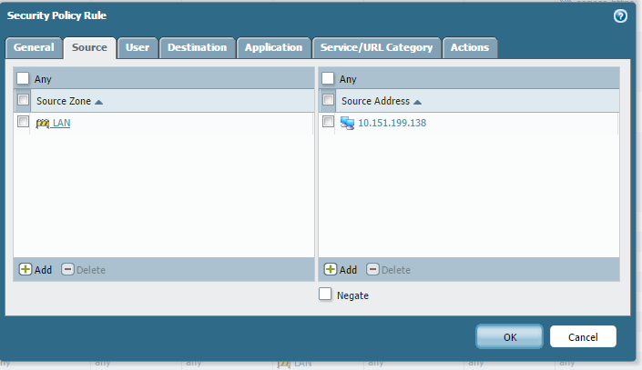

Step 2: then block smtp going to all other boxes by stacking the block all rule and the rule we just made allowing email to email

