Name________________________ Mark _____________________/50

[**Instructions**: Remove everything that is not a heading below and fill in with your own diagrams, etc.]

## Brief introduction __/3

The player character will move through the levels of the game and interact with items and non-playable characters.

## Use case diagram with scenario __14

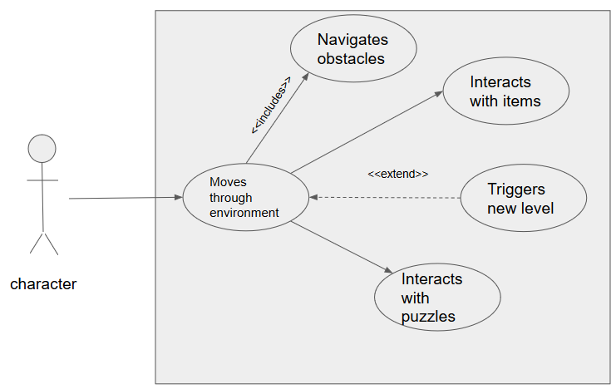

### Scenarios

**Name:** Moves through environment

**Summary:** The player moves the character around the environment

**Actors:** Player

**Preconditions:** Character and environment have been initialized

**Basic sequence:**

**Step 1:** button is pressed

**Step 2:** holding down the button causes continued movement

**Exceptions:**

**Step 1:** A button other than one mapped to a movement direction is ignored: ignore input

**Post conditions:** character moves

**Priority:** 1*

**ID:** C01

**Name:** Interact with Items

**Summary:** The character collides with an item

**Actors:** Player

**Preconditions:** character and items must be initialized

**Basic sequence:**

**Step 1:** character collides with item

**Step 2:** item is removed from environment space

**Post conditions:** item is added to character inventory

**Priority:** 2*

**ID:** C02

**Name:** navigates obstacles

**Summary:** character jumps or climbs over obstacles like trees, etc..

**Actors:** Player

**Preconditions:** player has been initialized

**Basic sequence:**

**Step 1:** character runs into obstacle and is prevented from moving forward

**Step 2:** a button is pressed to move over obstacle

**post conditions**: obstacle crossed

**Priority:** 2*

**ID:** C05

**Trigger end of level**

**Summary**: Colliding with end of level location should end the current level and start next level

**Actors**: player

**Preconditions**: player and levels have been initialized

**Basic sequence**:

**Step 1**: character reaches end of level

**Step 2**: current level is ended

**Step 3**: new level is loaded

**Exceptions**: is all puzzles haven’t been solved new level won’t be triggered

**Post condition**: character moved to next level

**Priority**: 2

**ID**: C06

## Data Flow diagram(s) from Level 0 to process description for your feature _______14

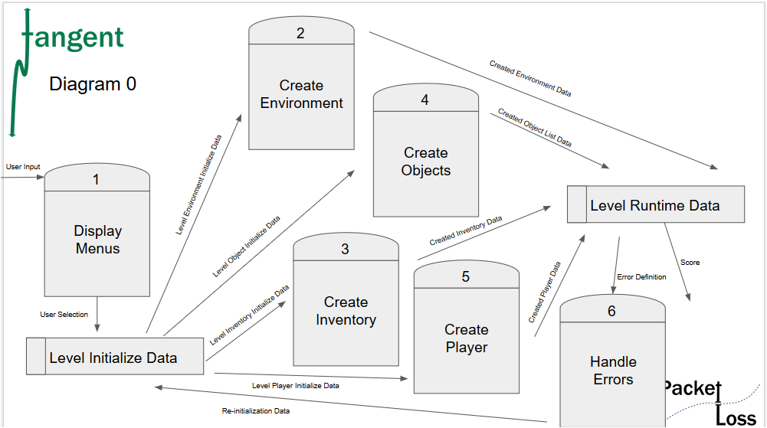

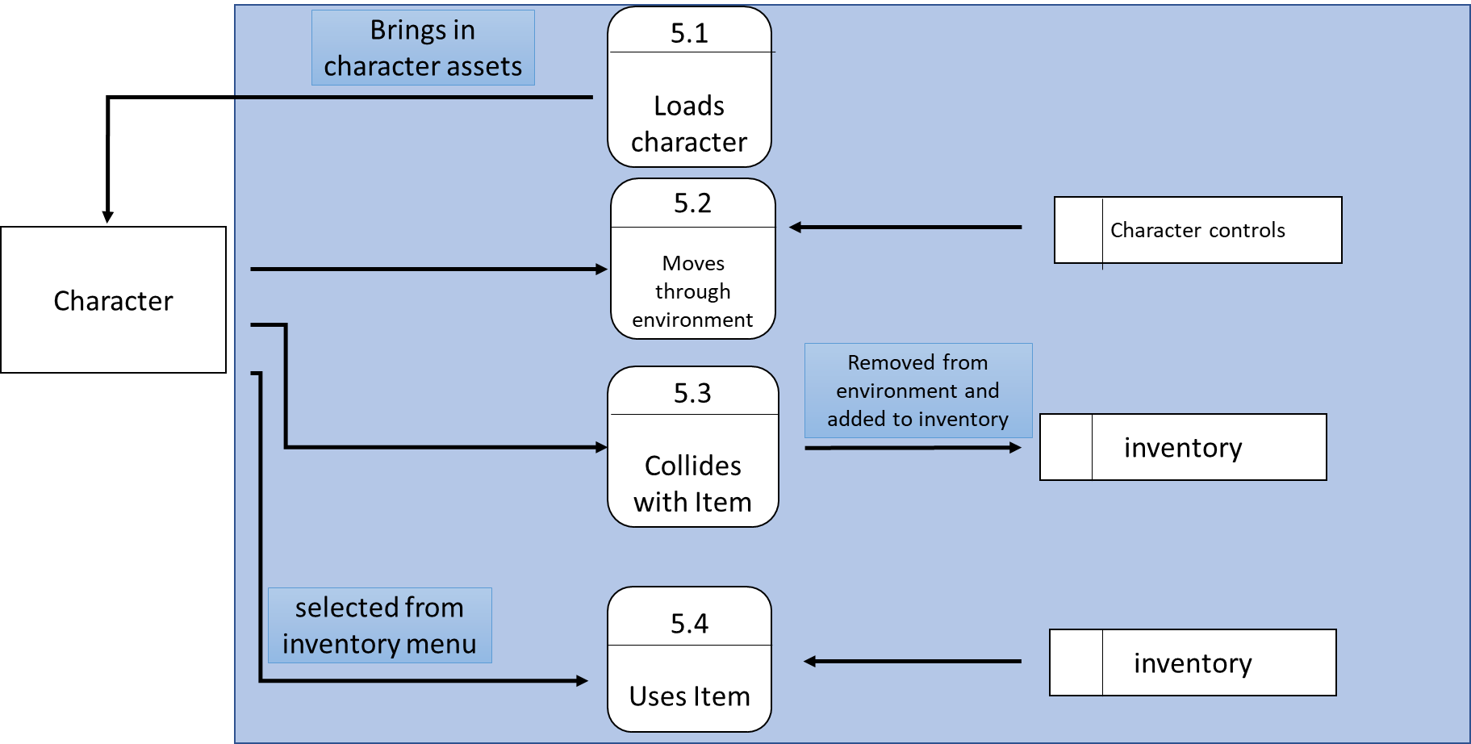

### Process Descriptions

Moves through environment

While key is pressed

Character moves

End while

Collects items

If collision with item

Item added to inventory

Uses item

While in menu

If item selected

Item used in game world

End while

## Acceptance Tests ________9

Character will load into environment navigate through obstacles, collect items that are input into inventory and successfully interact with puzzles.

## Timeline _________/10

|  |  |  |
| --- | --- | --- |
| **Task** | **Duration (hours)** | **Predecessor task(s)** |
| Requirements collection | 8 | - |
| Movement controls | 10 | 1 |
| Figure design | 12 | 1 |
| Figure animation | 13 | 2,3 |
| Testing | 7 | 2,3,4 |

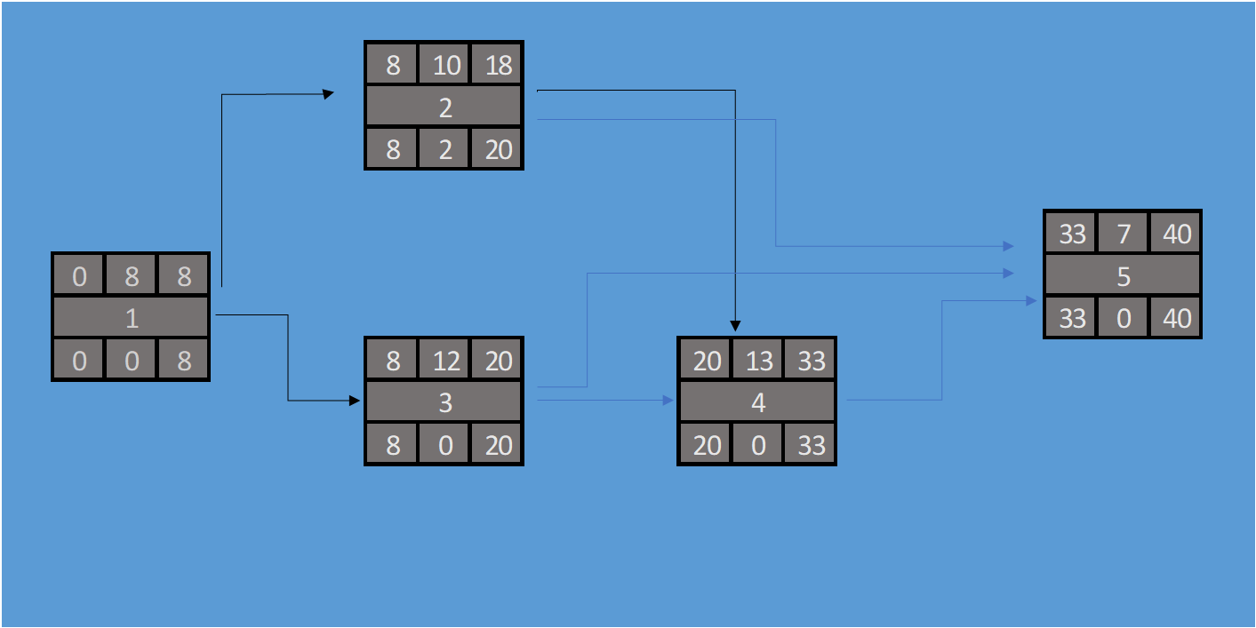

### Gantt timeline

|  |  |  |  |  |  |  |  |  |  |  |  |  |  |  |  |  |  |  |  |  |  |  |  |  |
| --- | --- | --- | --- | --- | --- | --- | --- | --- | --- | --- | --- | --- | --- | --- | --- | --- | --- | --- | --- | --- | --- | --- | --- | --- |
| 1 | 1 |  |  |  |  |  |  |  |  |  |  |  |  |  |  |  |  |  |  |  |  |  |  |  |
| 2 |  |  |  |  |  | 2 |  |  |  |  |  |  |  |  |  |  |  |  |  |  |  |  |  |  |
| 3 |  |  |  |  |  | 3 |  |  |  |  |  |  |  |  |  |  |  |  |  |  |  |  |  |  |
| 4 |  |  |  |  |  |  |  |  |  |  |  | 4 |  |  |  |  |  |  |  |  |  |  |  |  |
| 5 |  |  |  |  |  |  |  |  |  |  |  |  |  |  |  | 5 |  |  |  |  |  |  |  |  |
|  | 1 | 2 | 3 | 4 | 5 | 6 | 7 | 8 | 9 | 10 | 11 | 12 | 13 | 14 | 15 | 16 | 17 | 18 | 19 | 20 | 21 | 22 | 23 | 24 |