Name___Aaron Sherwood___________ Mark _____________________/50

## Brief introduction __/3

My role is to make the animal NPCs interact with their environment, the player character and with each other.

## Use case diagram with scenario __14

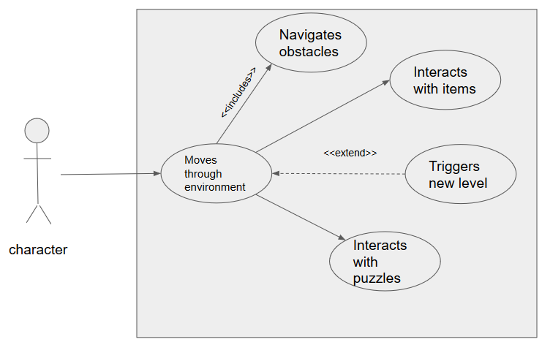

### Scenarios

**Name:** Moves through environment

**Summary:** The NPC moves in a random path

**Actors:** NPC

**Preconditions:** NPCs and environment have been initialized

**Basic sequence:**

**Step 1:** NPC is initialized

**Step 2:** NPC chooses a random direction

**Exceptions:**

**Step 1:** if a character is detected NPC will switch to character interaction

**Post conditions:** NPC moves

**Priority:** 2*

**ID:** C01

**Name:** Interacts with character

**Summary:** when a visual or sound trigger is set the NPC will either run from or towards the player

**Actors:** NPC, Player

**Preconditions:** character, NPC and environment must be initialized

**Basic sequence:**

**Step 1:** NPC “sees” or “hears” character

**Step 2:** if it is hostile it will move towards character otherwise it will move away

**Post conditions:** character is killed, NPC is killed or character or NPC moves out of trigger radius

**Priority:** 2*

**ID:** C02

**Name:** navigates obstacles

**Summary:** NPC move around obstacles like trees and rocks

**Actors:** NPC

**Preconditions:** NPC and obstacles have been initialized

**Basic sequence:**

**Step 1:** obstacle enters NPC’s visual cone

**Step 2:** NPC chooses new random direction

**post conditions**: obstacle crossed

**Priority:** 2*

**ID:** C05

## Data Flow diagram(s) from Level 0 to process description for your feature _______14

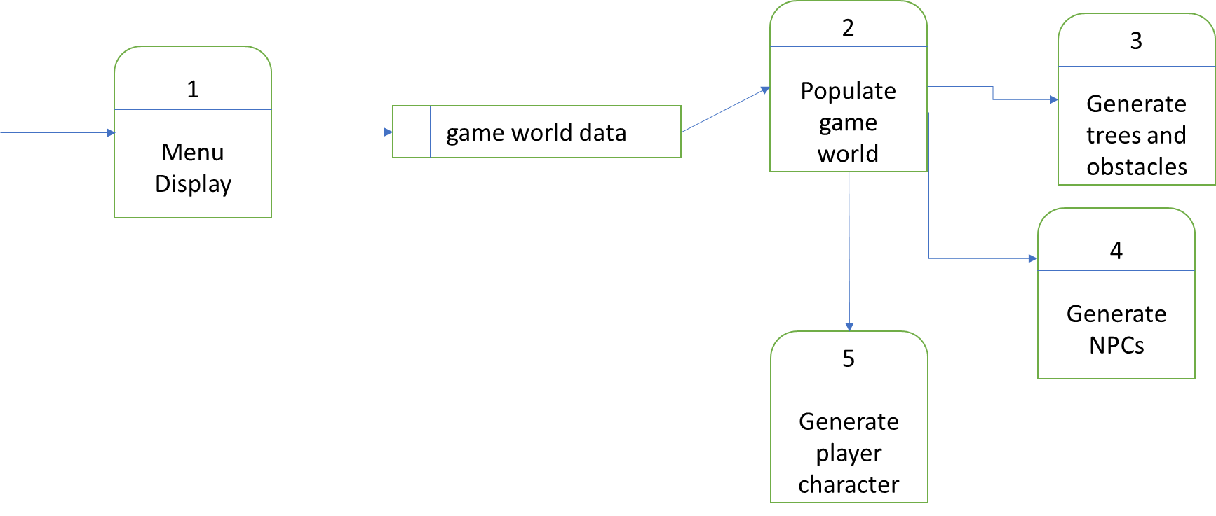

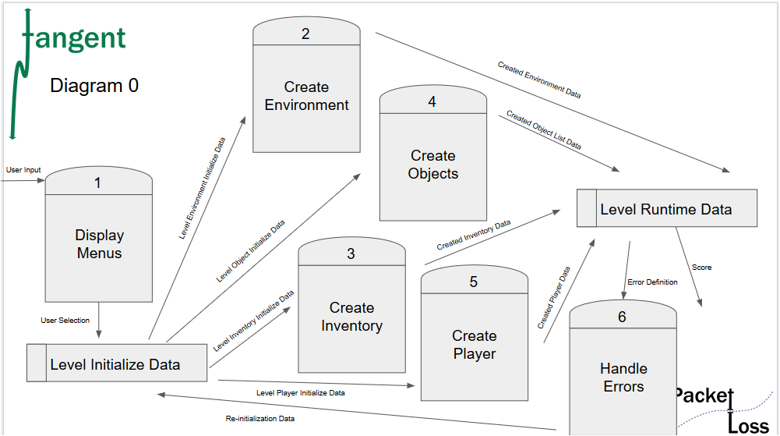

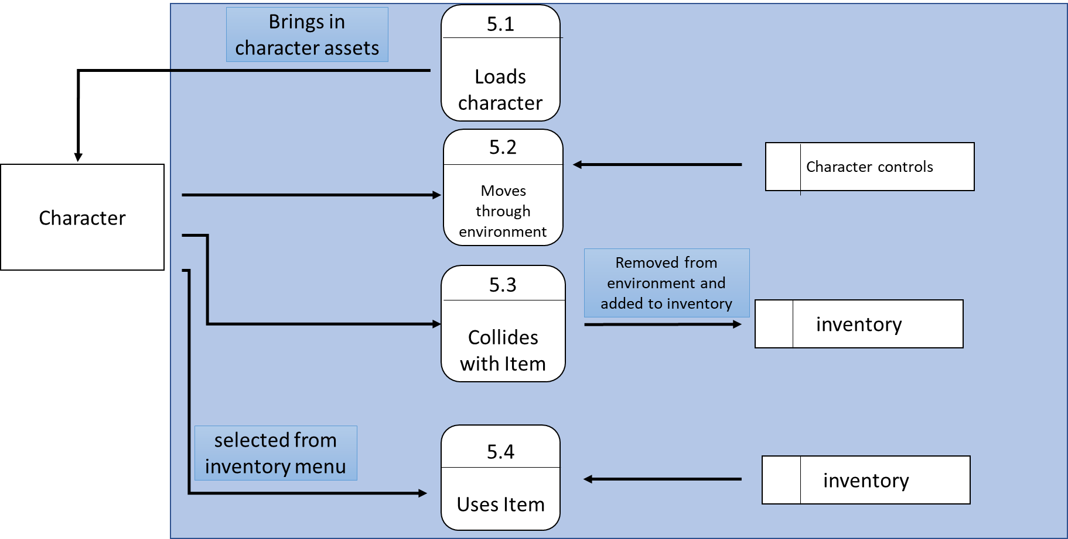

### Process Descriptions

Moves through environment

While key is pressed

Character moves

End while

Collects items

If collision with item

Item added to inventory

Uses item

While in menu

If item selected

Item used in game world

End while

## Acceptance Tests ________9

Character will load into environment navigate through obstacles, collect items that are input into inventory and successfully interact with puzzles.

## Timeline _________/10

|  |  |  |
| --- | --- | --- |
| **Task** | **Duration (hours)** | **Predecessor task(s)** |
| Requirements collection | 8 | - |
| Movement controls | 10 | 1 |
| Figure design | 12 | 1 |
| Figure animation | 13 | 2,3 |
| Testing | 7 | 2,3,4 |

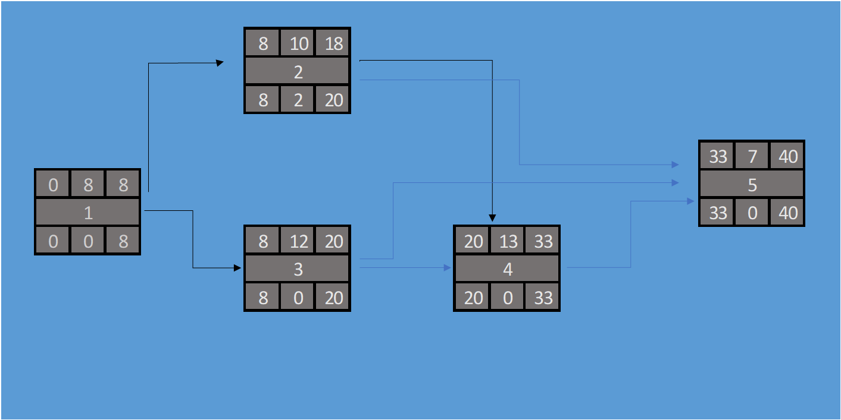

### Gantt timeline

|  |  |  |  |  |  |  |  |  |  |  |  |  |  |  |  |  |  |  |  |  |  |  |  |  |
| --- | --- | --- | --- | --- | --- | --- | --- | --- | --- | --- | --- | --- | --- | --- | --- | --- | --- | --- | --- | --- | --- | --- | --- | --- |
| 1 |  |  |  |  |  |  |  |  |  |  |  |  |  |  |  |  |  |  |  |  |  |  |  |  |
| 2 |  |  |  |  |  | 1 |  |  |  |  |  |  |  |  |  |  |  |  |  |  |  |  |  |  |
| 3 |  |  |  |  |  | 1 |  |  |  |  |  |  |  |  |  |  |  |  |  |  |  |  |  |  |
| 4 |  |  |  |  |  |  |  |  |  |  |  | 3 |  |  |  |  |  |  |  |  |  |  |  |  |
| 5 |  |  |  |  |  |  |  |  |  |  |  |  |  |  |  | 4 |  |  |  |  |  |  |  |  |
|  | 1 | 2 | 3 | 4 | 5 | 6 | 7 | 8 | 9 | 10 | 11 | 12 | 13 | 14 | 15 | 16 | 17 | 18 | 19 | 20 | 21 | 22 | 23 | 24 |