# **AFTER BUG FIX 1 - Remaining issues and new issues after bug fix 1**

TEST DEVICES - Samsung Galaxy A50S, iphone 11, iphone X

***The remaining issues which were not fixed are highlighted in red and the others are the new issues occurred after bug fixes***

## **Home page**

1. The icon is blurred

***Actual Behavior Expected Behavior***

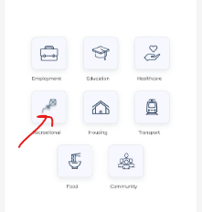

3. The gap between the search field and opened menu below is higher than that of in Figma

***Actual Behavior Expected Behavior***

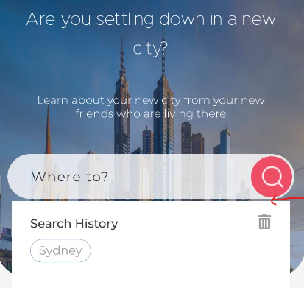 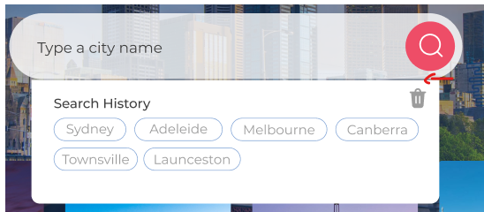

4. The Chat icon is not visible and when the search bar is clicked, the Chat icon shifts to the top. It should always display in right bottom corner

## **Tell us more about you**

1. The gap marked is high. Since the gap is high we have to scroll down to see Done button and SKIP button which is not necessary

2. The error message should be at the bottom

3. The button effect in the ‘Done’ button is not there

4. The right margin is not equal to the left margin.(Move buttons a bit to left)

5. The Done button and SKIP text is not inline with other texts from left and right side

***Actual Behavior Expected Behavior***

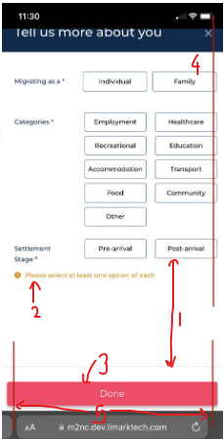 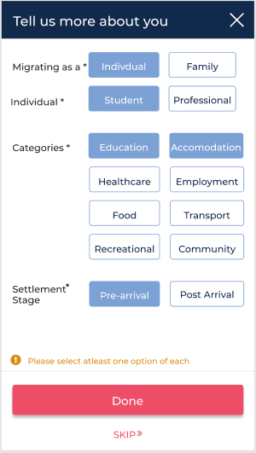

## **Login**

1. The heading and close icon are not inline with the text fields(The margins are bit high)

2. The ‘Forgot password’ text is not inline with input fields from the right side. It should move a bit to right

close icon is not vertically centered in the header

3. The button effect in Login button is not there

***Actual Behavior Expected Behavior***

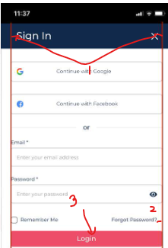 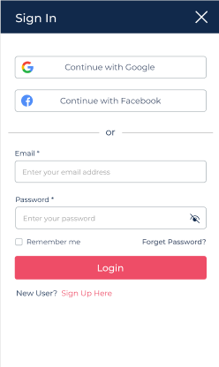

## **Signup**

1. The heading and close icon are not inline with the text fields(The margins are bit high)

2. When the Signup button is disabled, font color of the labels are incorrect

3. The button effect in Signup button is not there

***Actual Behavior Expected Behavior***

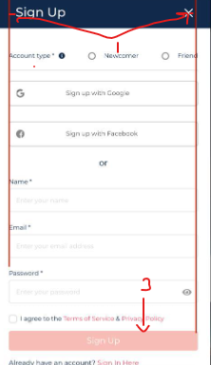 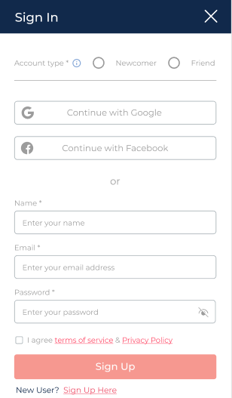

## **Forgot Password**

1. The heading and close icon are not inline with the text fields(The margins are bit less)

2. The ‘Back to login’ option is not inline with the input field

3. The button effect is not there

***Actual Behavior Expected Behavior***

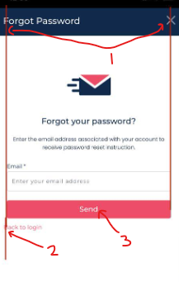 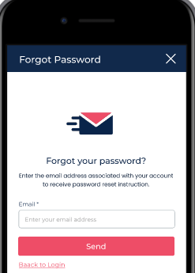

## **Reset Password**

1. The gap above the logo is very high (Take it to the level as same as in Forgot password screen)

2. The button effect is not there

3. The letter ‘P’ should be simple

***Actual Behavior Expected Behavior***

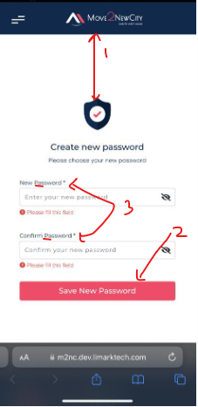 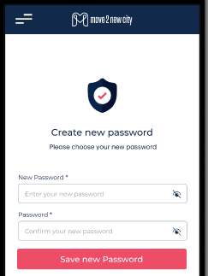

## **Ask a question confirmation modal**

1. The height of the modal is less(It should be opened on the entire screen)

***Actual Behavior Expected Behavior***

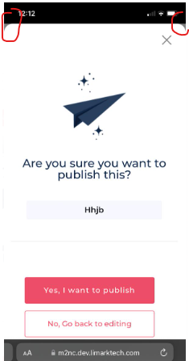 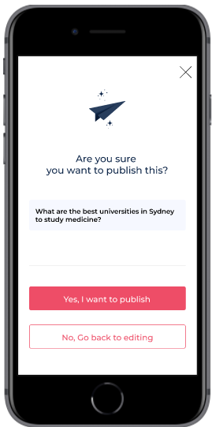

2. The left and right margins are high

3. The right margin is not equal to the left margin

4. The below marked gap above the ‘Yes, I want to publish’ button is bit high

5. The height of the buttons should be checked

***Actual Behavior Expected Behavior***

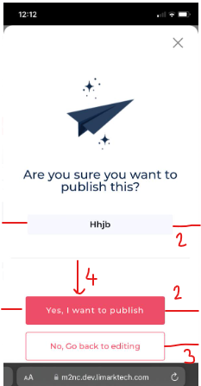 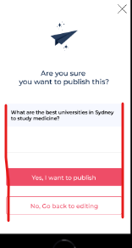

## **Threads (When there are no threads to show)**

1. The below marked gap is high

2. The gap between the close icon and edge of the section is high

3. The color of Search icon is wrong

4. The icon marked below is not inline with other content from the right side

***Actual Behavior Expected Behavior***

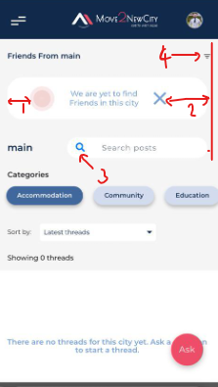 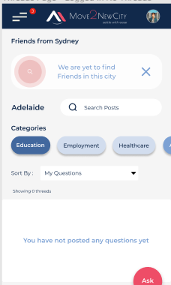

## **Threads**

1. The text from left hand side are not inline

2. The date in which the question or answer is posted should move to right hand corner keeping the same margin space as in left side

3. The color of Search icon is wrong

***Actual Behavior Expected Behavior***

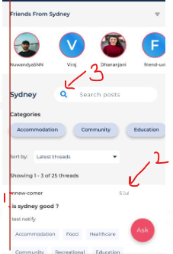 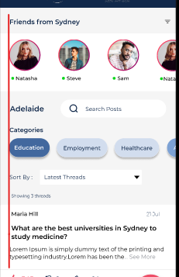

4. The gap below the categories of the question is bit high (Keep the same gap as marked in blue color)

5. The color of the voting icons and text is incorrect

6. When the comment box is opened, the separation line below the voting icons is not there

7. The ‘Send’ text should move to right

8. The width of comment box is less (Width should be increased so that the same margin from right is there as in left side of comment box)

***Actual Behavior Expected Behavior***

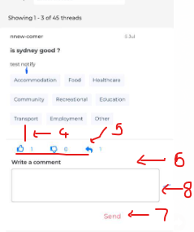 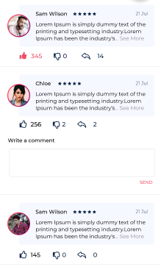

9. The image seems to be stretched horizontally

***Actual Behavior Expected Behavior***

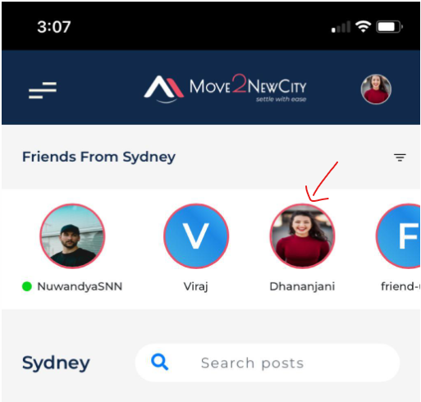 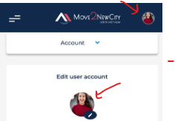

## **Become a friend**

1. The button effect is not there in ‘Become a friend’ button

2.Some words are unnecessarily capitalized

***Actual Behavior***

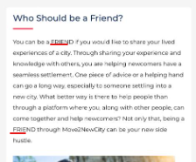 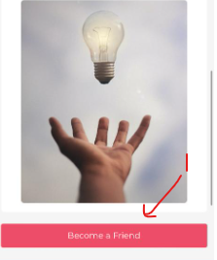

## **Reply to a question confirmation modal**

1. The height of the modal is less(It should be opened on the entire screen)

***Actual Behavior Expected Behavior***

 

2. The left and right margins are high

3. The right margin is not equal to the left margin

4. The below marked gap above the ‘Yes, I want to publish’ button is bit high

5. The height of the buttons should be checked

***Actual Behavior Expected Behavior***

 

## **Schedule a call**

1. The ‘About’ heading is missing

2. The username is below the profile image

3. The text ’Offline’ is not aligned properly

4. Even there are no anymore content to show, ‘see more’ option is shown

***Actual Behavior Expected Behavior***

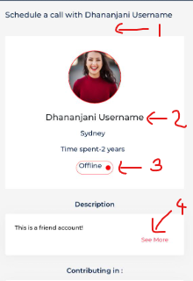 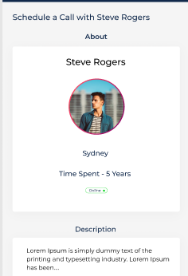

5. The below marked gaps are incorrect

***Actual Behavior Expected Behavior***

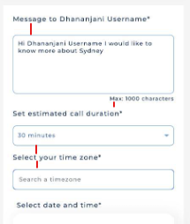 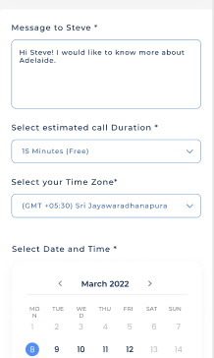

6. When the message field is clicked, a separate border is appearing

7. When the call duration and timezone fields are clicked, the border thickness should be increased

***Actual Behavior Expected Behavior***

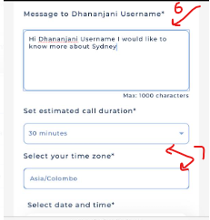 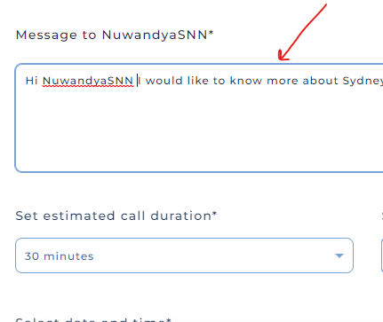

8. The ‘Choose available time slot’ text is not vertically centered

9. The position of the separation line is incorrect and also it touches the right edge of the section

10. The button effect is not there in ‘Schedule a call’ button

11. The color of separation lines is incorrect and they touch the 2 edges(length is high)

***Actual Behavior Expected Behavior***

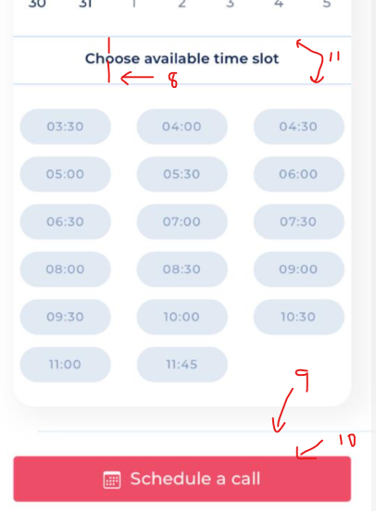 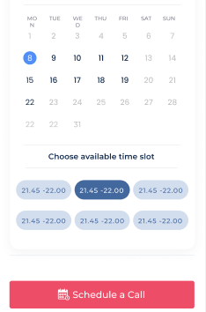

## **Scheduled Calls**

1. The heading is incorrect. It should be changed as ‘Scheduled calls’

2. The below marked gaps are incorrect

3. The white colored line is not there as in Figma

***Actual Behavior Expected Behavior***

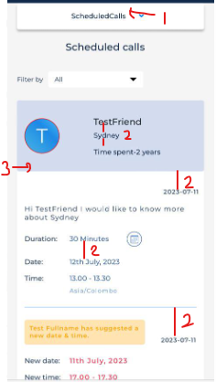 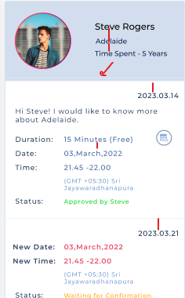

7. Margins are incorrect, Not equal from both sides and content is not inline

***Actual Behavior Expected Behavior***

