Individual Assignment : Developing a Comprehensive Marketing Plan
Course: IDC 2203 - Principles and Practices of Marketing
Assignment Title: Marketing Plan for a New Product
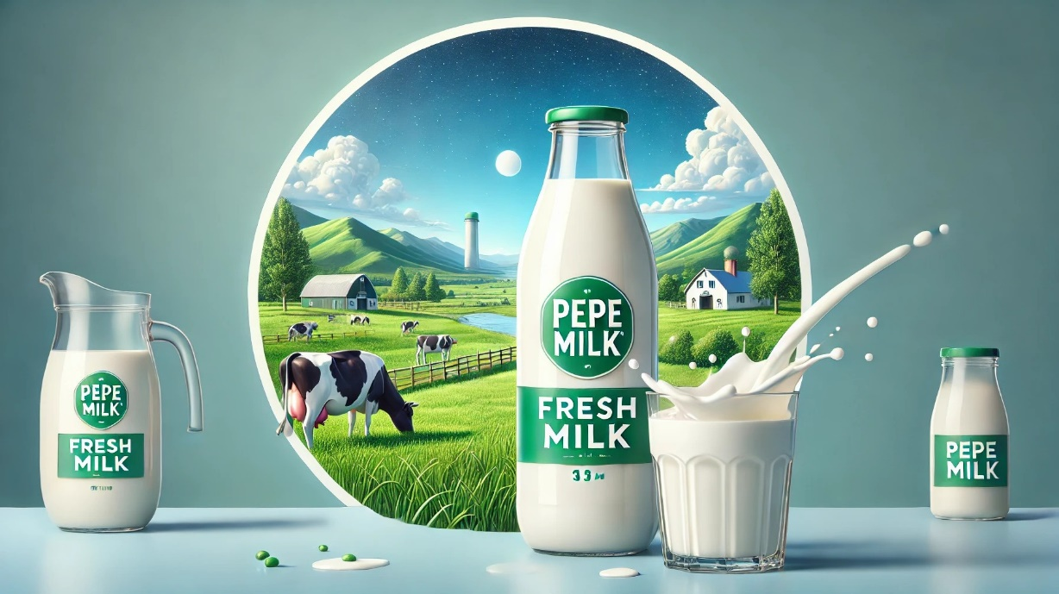
comprehensive marketing plan for a milk product
PEPEMILK
February 4, 2025

- M.A.N.K.WAnigasekara - ASP/2021/088 – 5446
(physical department)
- P.S.K.S.Dharmaratne – ASB/2021/144 – 5357
(Biological Department)

- PRODUCT DEVELOPMENT & BRANDING
Product Concept
PepeMilk is a premium organic dairy product made from 100% pure cow’s milk. It is carefully sourced from organic farms, ensuring that the milk is free from artificial additives, hormones, and preservatives. Fortified with essential nutrients such as calcium, vitamin D, and probiotics, PepeMilk supports strong bones, digestive health, and overall well-being. Designed for health-conscious consumers, it caters to families, fitness enthusiasts, and individuals seeking a natural and nutritious alternative to regular milk.

Brand Elements
- Brand Name: PepeMilk
The name PepeMilk combines a friendly, approachable feel ("Pepe") with a direct reference to milk, making it memorable, simple, and easy to recognize. It reflects purity, freshness, and premium quality.

- Tagline: “Pure. Healthy. Delicious.”
This tagline highlights the three key attributes of PepeMilk:
- Pure – Made from 100% organic cow’s milk with no additives.
- Healthy – Fortified with essential nutrients for overall wellness.
- Delicious – Offers a rich, creamy taste that consumers love.

- Slogan: “Nourish Your Life with Every Sip.”
This slogan emphasizes the health benefits of PepeMilk, reinforcing its role as a daily essential for a healthy and active lifestyle. It conveys a message of care, well-being, and natural nourishment in every sip.

- Color Palette:
- Blue – Represents trust, freshness, and reliability, assuring customers of the product’s quality.
- White – Symbolizes purity and simplicity, reflecting the clean, unprocessed nature of PepeMilk.
- Green – Signifies nature, health, and organic origins, reinforcing the brand’s commitment to sustainability.

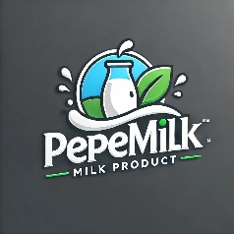
- Logo:

- Brand Identity:
PepeMilk embodies a premium, organic, and family-friendly brand identity. It appeals to health-conscious individuals, parents, and fitness enthusiasts who value quality and nutrition. The brand maintains a trustworthy and approachable tone, promoting a healthy lifestyle through wholesome dairy choices.

- STP (SEGMENTATION, TARGETING, AND POSITIONING)

Market Segments
PepeMilk is segmented based on the following criteria:
- Demographic
- Families & Children – Parents seeking a nutritious, safe milk option for their children.
- Elderly Individuals – Older consumers who need calcium and vitamin D for bone health.
- Fitness Enthusiasts – Individuals who prefer organic, protein-rich milk for muscle recovery.

- Geographic:
- Urban & Suburban Areas – Targeting middle-to-upper-income households that value organic products.
- Supermarkets & Health Stores – Available in premium retail locations where health-conscious consumers shop.

- Psychographic:
- Health-Conscious Individuals – Consumers who prioritize natural and organic food choices.
- Organic Product Seekers – Those who avoid artificial additives and preservatives in their diet.

- Behavioral:
- Loyal Milk Consumers – Regular buyers who consume milk as part of their daily routine.
- Customers Looking for Nutritional Benefits – Those who seek added probiotics, vitamins, and minerals in their dairy products.

Target Market
PepeMilk’s primary target market consists of:
- Health-conscious consumers who prioritize organic and nutrient-rich foods.
- Parents looking for a safe and nutritious milk option for their children.
- Individuals seeking high-quality dairy alternatives with added health benefits.

Positioning Strategy
PepeMilk is positioned as a premium, nutrient-rich milk product that promotes overall health and wellness.

Key Positioning Elements:
- Purity – 100% organic cow’s milk, free from hormones and additives.
- Nutrition – Fortified with calcium, vitamin D, and probiotics for optimal health.
- Sustainability – Sourced from eco-friendly, ethical farms that prioritize animal welfare..

Brand Messaging:
- “PepeMilk: A Pure, Healthy, and Delicious Choice for Every Family.”
- “Nourish Your Life with Every Sip – 100% Organic, 100% Wholesome.”

- TARGET AUDIENCE ANALYSIS

- Age Group: 5-65 years
PepeMilk caters to a wide age range, ensuring nutritional benefits for different life stages:
- Children (5-12 years): Supports growth and development with calcium and vitamin D.
- Teenagers & Young Adults (13-25 years): Provides energy and essential nutrients for active lifestyles.
- Adults (26-45 years): Appeals to fitness-conscious individuals and working professionals.
- Middle-aged & Elderly (46-65 years): Helps maintain bone strength and digestive health.

- Income Level: Middle to high-income households
PepeMilk is positioned as a premium product, making it attractive to consumers who are:
- Willing to pay extra for organic, high-quality dairy.
- Shopping in supermarkets, health stores, and premium grocery outlets.
- Prioritizing nutrition, purity, and long-term health benefits over price.

- Lifestyle: Health-conscious, fitness-oriented, family-oriented
- Health-Conscious Consumers: Focus on organic and clean eating, avoiding artificial additives.
- Fitness-Oriented Individuals: Seek protein-rich, probiotic-enhanced milk for muscle recovery and gut health.
- Family-Oriented Consumers: Parents and caregivers looking for a safe, nutritious choice for children and elders.

- Buying Behavior: Prefers high-quality, organic, and fortified dairy products
- Brand-Loyal Consumers: Prefer trusted, premium brands over generic milk products.
- Ingredient-Conscious Buyers: Check for organic certification, added nutrients, and sustainability.
- Frequent Buyers: Regularly purchase milk as a daily essential for drinking, cooking, or making beverages.

- MARKETING MIX(4Ps)

Product
- Features: Organic, rich in calcium & vitamin D, lactose-free variant available
- Organic: Made from 100% organic cow’s milk, ensuring purity and natural goodness.
- Nutrient-Rich: Fortified with calcium, vitamin D, and probiotics, offering additional health benefits.
- Lactose-Free Variant: Available for lactose-intolerant customers without compromising on taste and nutrition.

- Benefits: Supports bone health, improves digestion, and boosts immunity
- Supports Bone Health: Calcium and vitamin D are crucial for strengthening bones and teeth.
- Improves Digestion: Probiotics aid in gut health and digestion.
- Boosts Immunity: The added nutrients and probiotics help maintain a strong immune system.

- Differentiation: Fortified with probiotics, sustainable farming methods
- Fortified with Probiotics: Distinguishes PepeMilk as a functional dairy product.
- Sustainable Farming: Committed to ethical, eco-friendly farming practices that align with organic values.

Price (LKR)
- Pricing Strategy: Premium Pricing with value-for-money positioning to reflect the high quality and organic certification of the product.
- Justification:
- Higher Nutritional Value: Fortified with added nutrients for superior health benefits.
- Superior Quality: Sourced from organic farms, ensuring no hormones or additives.
- Organic Certification: Offers consumers peace of mind regarding the product’s authenticity and quality.

Product Size | Price (LKR)
500ml Bottle | 450 LKR
1L Bottle | 850 LKR
1.5L Family Pack | 1200 LKR
200ml Small Pack | 250 LKR

Place
Distribution Channels:
- Supermarkets & Grocery Stores: Widely available in retail chains, making it easy for consumers to purchase.
- Online Platforms: Available on e-commerce platforms, catering to the growing trend of online shopping.
- Direct Farm-to-Consumer Sales: A sustainable distribution model that emphasizes freshness and traceability.

Promotion
- Advertising:
- Social Media Ads: Targeted campaigns on platforms like Facebook, Instagram, and YouTube to reach health-conscious audiences.
- TV Commercials: Showcase the brand’s premium quality and nutritional benefits on national TV networks.
- Influencer Partnerships: Collaborations with health and wellness influencers to increase brand awareness and credibility.

- Digital Marketing:
- SEO (Search Engine Optimization): Ensuring that PepeMilk ranks highly on search engines for terms like “organic milk” and “fortified milk”.
- Email Marketing: Regular updates on new product launches, discounts, and health tips sent to subscribers.
- Social Media Engagement: Building a community through consistent posts, contests, and interactive content.

- Public Relations:
- Health Campaigns: Partnering with nutritionists and health experts to promote the wellness benefits of PepeMilk.
- Partnerships with Health Organizations: Collaborating with health bodies to enhance credibility and reinforce the product’s health benefits.

- Sales Promotion:
- Discount Offers: Periodic sales events and discounts to drive purchases.
- Free Samples: Offering small, free samples in health stores or supermarkets to encourage trial.
- Subscription Plans: Discounted subscription models for regular deliveries, appealing to loyal customers.

- SITUATIONAL & COMPETITIVE ANALYSIS

SWOT Analysis
- Strengths:
- High-Quality, Organic Product – 100% natural, free from additives and hormones.
- Health Benefits – Fortified with calcium, vitamin D, and probiotics for better nutrition.
- Strong Branding – Premium positioning with trustworthy and health-focused messaging.

- Weaknesses:
- Higher Price Compared to Regular Milk – May limit affordability for some consumers.
- Limited Initial Distribution – Availability restricted to select supermarkets and online platforms.

- Opportunities:
- Growing Demand for Organic Dairy – Consumers are shifting towards healthier, natural alternatives.
- Potential Global Expansion – Expanding into international organic food markets can drive growth.

- Threats:
- Competition from Established Dairy Brands – Major players like Nestlé and local dairy giants dominate the market.
- Fluctuating Milk Prices – Supply chain costs and economic instability may impact profitability.

PESTEL Analysis
- Political:
- Government Dairy Regulations – Compliance with food safety standards and organic certification.
- Subsidies & Policies – Support for sustainable dairy farming can benefit PepeMilk.

- Economic:
- Inflation & Rising Dairy Farming Costs – Higher production expenses may affect pricing.
- Consumer Spending Power – Premium pricing targets middle-to-high-income groups.

- Social:
- Rising Health Consciousness – Demand for organic, lactose-free, and fortified milk is increasing.
- Preference for Sustainable Brands – Eco-conscious consumers favor ethical dairy sourcing.

- Technological:
- Advancements in Dairy Processing – Smart packaging, extended shelf life, and improved preservation methods enhance product appeal.
- E-commerce Growth – Online sales channels offer direct-to-consumer opportunities.

- Environmental:
- Sustainability Concerns – Consumers prefer eco-friendly packaging and ethical farming practices.
- Carbon Footprint Awareness – Need for low-impact production and renewable energy use.

- Legal:
- Compliance with Food Safety Laws – Must meet dairy industry health standards.
- Labeling & Organic Certification Rules – Transparent product claims are essential.

Porter’s Five Forces Model
- Industry Rivalry: High
Competing with major brands like Nestlé and local dairy producers.
Strong competition on pricing, branding, and distribution reach.

- Threat of New Entrants: Medium
High regulatory barriers for organic dairy certification.
Branding and marketing costs can deter small-scale competitors

- .Bargaining Power of Buyers: Medium
Consumers demand quality and nutrition, but price sensitivity remains a factor.
Competitive pricing and subscription models can help retain customers

- Bargaining Power of Suppliers: Medium
Dependent on dairy farmers for organic milk supply.
Establishing direct partnerships with farms can reduce risks.

- Threat of Substitutes: High
Plant-Based Milk Alternatives (almond, soy, oat) gaining popularity.
Need to emphasize nutritional superiority over non-dairy alternatives.

- MVP (MINIMUM VIABLE PRODUCT) DEVELOPMENT

We have created a landing page showcasing the product’s features, nutritional benefits, and purchase options. The page also includes a promotional video and customer testimonials.

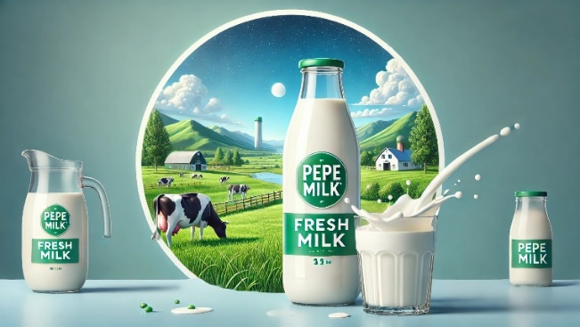
Click the image and it will go to the page:

- MARKETING OBJECTIVES (SMART GOALS)

- Increase Brand Awareness – Grow PepeMilk’s social media presence by achieving 50,000 followers across platforms (Facebook, Instagram, and Twitter) within 6 months through targeted advertising, influencer collaborations, and engaging content.

- Boost Sales – Sell 10,000 units within the first 3 months post-launch by implementing introductory discounts, bundle offers, and strategic promotions across supermarkets and online stores.

- Retail Expansion – Secure placement in 100+ retail stores within the first year, focusing on supermarkets, health stores, and specialty organic shops through strong B2B partnerships and distributor networks.

- Customer Engagement – Maintain an average rating of 4.5+ stars on online platforms by ensuring high product quality, responsive customer service, and engaging loyalty programs to encourage positive reviews and repeat purchases

- MARKETING STRATEGIES AND TACTICS

Strategies
- Leverage Social Media & Influencer Marketing – Use targeted ads, engaging content, and collaborations with health & fitness influencers to boost brand visibility.

- Offer Free Samples in Key Retail Locations – Introduce PepeMilk to new customers through tasting stations in supermarkets, health stores, and cafes.

- Build Strong Retail Partnerships – Work with large supermarket chains, organic grocery stores, and specialty health retailers to expand availability

Tactics
- Launch a Digital Campaign – Create social media ads and video content highlighting PepeMilk’s nutritional benefits, targeting parents and health-conscious consumers.

- Organize In-Store Promotions – Run discounts, bundle offers, and tasting events in retail stores to encourage trial and repeat purchases.

- Partner with Gyms & Wellness Brands – Cross-promote PepeMilk with fitness centers, nutritionists, and wellness brands, offering exclusive discounts and co-branded promotions.

- BUDGET & IMPLEMENTATION TIMELINE (LKR)

Budget Plan (Estimated in LKR)
- Production Costs: 16,000,000 LKR (Raw materials, manufacturing, packaging)

- Marketing & Advertising: 9,500,000 LKR (Digital ads, influencer marketing, sampling campaigns)

- Distribution & Logistics: 6,500,000 LKR (Retail partnerships, transportation, warehousing)

- Total Estimated Budget: 32,000,000 LKR

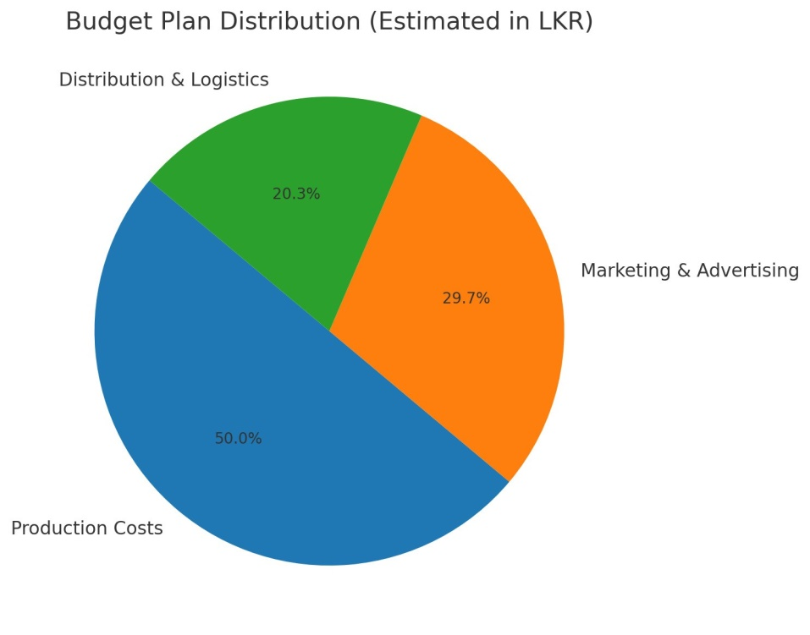

Implementation Timeline (Gantt Chart )

Task | Month 1 | Month 2 | Month 3 | Month 4 | Month 5 | Month 6
Product Development | *** | ***
Branding & Packaging Design | *** | ***
Market Research & Targeting | ** | *
Pricing Strategy Finalization | *
Website & Social Media Setup | * | ** | **
Pre-Launch Advertising (Teasers & Awareness) |  | *** | **
Production & Quality Testing |  | ** | * | *
Distribution Channel Partnerships |  |  | ** | *
Soft Launch (Limited Availability) |  |  | ** | ***
Main Launch & Promotions |  |  |  | *** | **
Advertising & Digital Marketing |  |  |  | *** | **
Customer Feedback & Adjustments |  |  |  |  | *** | **
Evaluation & Performance Analysis |  |  |  |  | ** | *

Legend:
- *** = High priority, intensive work
- ** = Medium effort
- * = Light effort

- EVALUATION AND CONTROL

Key Performance Indicators (KPIs)
- Sales Growth – Track monthly revenue and units sold to measure demand and profitability.

- Customer Engagement – Monitor social media interactions, website traffic, and customer reviews to assess brand awareness and satisfaction.

- Market Penetration – Measure the number of retail stores and online platforms carrying PepeMilk to evaluate distribution success.

Control Mechanisms
- Regular Market Research & Customer Feedback – Conduct surveys, online reviews analysis, and competitor benchmarking to identify areas for improvement.

- Adjusting Pricing & Marketing Strategies – Optimize pricing models, promotional campaigns, and ad spending based on sales data and consumer trends.

