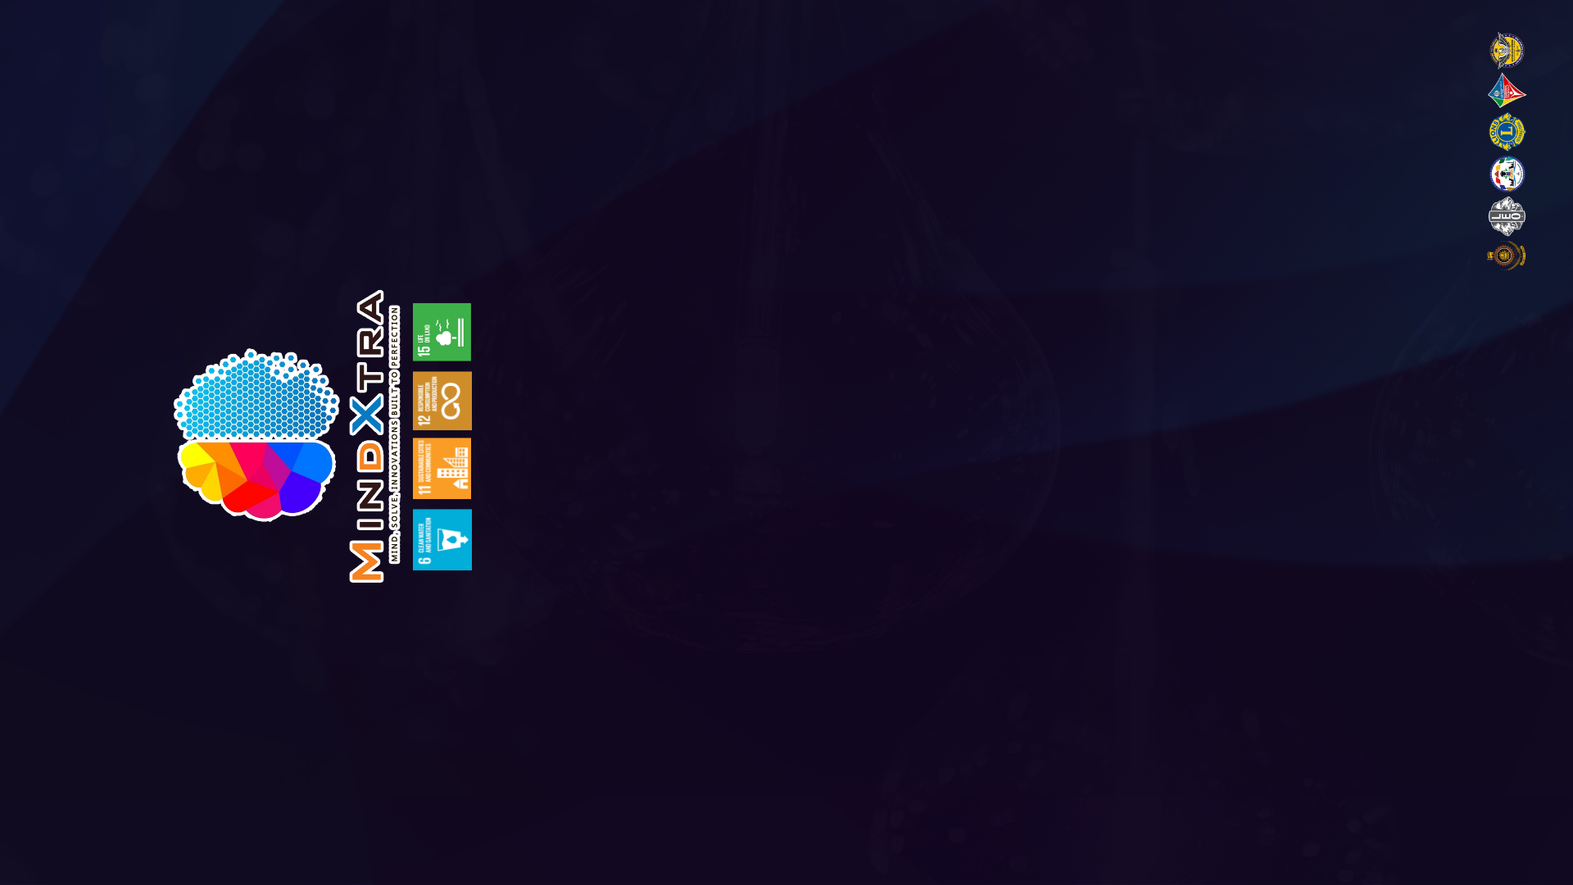

PROJECT PROPOSAL

Organized by Leo Club of University Of Moratuwa

ABOUT YOUR PROJECT

1.Tick the intended area of your project.

| Water purification |  |
| --- | --- |
| Human-Elephant conflict |  |
| Upcycling |  |

2.What is the specified issue that you have identified in one of the above intended areas?

………………………………………………………………………………………………………………………………………………………………………………………………………………………………………………………………………………………………………………………………………………………………………………………………....

3.What is the solution you are providing for the above mentioned problem.

…………………………………………………………………………………………………………………………………………………………………………………………………………………………………………………………………………………………………………………………………………………………………………………………………

4.Mention the key advantages of the solution.

…………………………………………………………………………………………………………………………………………………………………………………………………………………………………………………………………………………………………………………………………………………………………………………………………

5.State the beneficiaries of your solution.

……………………………………………………………………………………………………………………………………………………………………………………………………………………………………....

6.Explain the novelty of your solution.

………………………………………………………………………………………………………………………………………………………………………………………………………………………………………………………………………………………………………………………………………………………………………………………………………………………………………………………………………………

7.Mention the objectives you are going to achieve from your solution.

……………………………………………………………………………………………………………………………………………………………………………………………………………………………………………………………………………………………………………………………………………………………………………………………….

8.How do you think that your solution will achieve the sustainable goals?

…………………………………………………………………………………………………………………………………………………………………………………………………………………………………………………………………………………………………………………....

9.SWOT analysis based on your solution.

| **Strengths**  **(that would help your innovative idea)**  ………………………………………………………………………………………………………………………………………………………………………………………………………………………………………………………………………………………………………………………………………………………………………………………………………………………………………... | **Weaknesses**  **(that would be obstacles in your way)**  …………………………………………………………………………………………………………………………………………………………………………………………………………………………………………………………………………………………………………………………………………………………………………………………………………….. |
| --- | --- |
| **Opportunities**  **(would be opened by your innovative idea)**  ………………………………………………………………………………………………………………………………………………………………………………………………………………………………………………………………………………………………………………………………………………………………………………………………………………………………………... | **Threats**  **(you will have to face while engaging in the project)**  ……………………………………………………………………………………………………………………………………………………………………………………………………………………………………………………………………………………………………………………………………………………………………………………………........................ |

10.What development tools/platforms will be used to develop your innovative idea?(optional)

……………………………………………………………………………………………………………………………………………………………………………………………………………………………………....

11.Have you already started on this project or is it still a concept?

……………………………………………………………………………

12.If you have already started working on the project,state the progress so far?

……………………………………………………………………………

…………………………………………………………………………………………………………………………………………………………

13. State the plan of implementation of your proposed solution.

…………………………………………………………………………………………………………………………………………………………………………………………………………………………………………………………………………………………………………………………………………………………………………………………………

14.Mention the estimated time durations that will take for the following steps.

| Survey |  |
| --- | --- |
| Prototype release |  |
| Implementation |  |

15.Give us your approximate budget in implementing the project.

……………………………………………………………………………………………………………………………………………………………………………………………………………………………………………………………………………………………………………………………………………………………………………………………………………………………………………………………………………………………………………………………………………………………………………………………………………………………………………………………………………………………………………………………………………………………………………………………………

16.Are there any special requirements you expect from MindXtra?

………………………………………………………………………………………………………………………………………………………....

17.Verification of the information

I hereby verify that the above mentioned information is all true and complete to the best of my knowledge.

………………………………

Authorized signatory

Name-................................

Date-..................................

*PLEASE UPLOAD YOUR PROPOSAL IN A PDF FORMAT