Detection of Diabetic Retinopathy using ResNet -50
Nethra Renjarla¹, Dhyuthi Sri Ramya Cheruvu¹, Swarna Kannambadi Ramesh¹
¹College of Engineering, The University of Texas at Arlington
{nxr6130, dxc7729, sxk6011}@mavs.uta.edu

Abstract
Diabetic Retinopathy (DR) is a progressive eye condition caused by high blood sugar levels, leading to damage of the retinal blood vessels and potential vision loss. Early detection is essential to prevent irreversible outcomes. This study presents an automated DR classification system based on a deep convolutional neural network using a pre-trained ResNet-50 architecture. The model is fine-tuned on a large-scale publicly available dataset—Kaggle’s Diabetic Retinopathy Detection—after rigorous preprocessing including resizing, normalization, augmentation, and denoising. Custom classification layers are appended to the ResNet-50 backbone, and selective layer freezing is employed to retain general visual features while adapting to the target task. The ResNet-50 model achieved the highest performance, with a training accuracy of 79% and a testing accuracy of 81.81%. The performance of the model is evaluated using accuracy, ensuring a comprehensive understanding of its clinical applicability. These results highlight the effectiveness of transfer learning in medical image analysis and demonstrate the potential of deep learning models in assisting large-scale ophthalmic screening and early DR diagnosis.
Keywords— Diabetic Retinopathy, Deep Learning, ResNet-50, Convolutional Neural Network (CNN), Transfer Learning, Medical Image Analysis, Retina, Fundus Images, Classification, Ophthalmic Screening

Introduction

Diabetes mellitus is a chronic condition caused by the pancreas’ inability to adequately produce or secrete insulin, leading to consistently elevated blood glucose levels. Between 1980 and 2014, the number of people living with diabetes rose dramatically from 108 million to 422 million. Diabetes negatively affects several vital organs, including the liver, heart, kidneys, joints, and eyes, and is the leading cause of blindness in individuals under the age of 50.
Diabetic Retinopathy (DR) is a severe complication of diabetes characterized by damage to the retina's blood vessels. It is one of the leading causes of preventable blindness among the working-age population worldwide. In its early stages, DR often presents no symptoms or only mild visual disturbances, making early detection difficult. As the disease progresses, it may lead to proliferative diabetic retinopathy or diabetic macular edema—conditions that can cause abnormal blood vessel growth, retinal scarring, bleeding, and ultimately irreversible vision loss.
According to the World Health Organization, DR remains a major contributor to global visual impairment. Despite its severity, many cases are diagnosed only in advanced stages due to limited access to regular screening and the asymptomatic nature of early DR.
With the growing demand for faster, more accurate, and scalable diagnostic tools, automated detection systems powered by artificial intelligence (AI) have gained considerable interest. These systems can assist clinicians by providing quick, objective evaluations of retinal images.
In this study, we propose a deep learning-based approach using ResNet-50, a powerful Convolutional Neural Network (CNN) architecture known for its ability to extract deep hierarchical features from images. ResNet-50 introduces residual connections, enabling the training of very deep networks by mitigating the vanishing gradient problem. By applying this model to retinal fundus images, our aim is to automatically classify the severity of diabetic retinopathy—ranging from no DR to advanced stages—thereby supporting early intervention and reducing the risk of vision loss.

Dataset Description

Our dataset is sourced from Kaggle [5] and consists of 3,662 high-resolution retinal fundus images used for the classification of diabetic retinopathy severity. Each image is labelled with one of five categories: No DR, Mild, Moderate, Severe, or Proliferative DR. Specifically, the dataset includes 1,805 images labeled as No DR, 370 images with Mild DR, 999 images indicating Moderate DR, 193 images classified as Severe DR, and 295 images showing signs of Proliferative DR. Each image is associated with a unique patient identifier and a severity grade. The wide distribution and class diversity make this dataset highly suitable for training deep learning models in multi-class classification tasks, enabling accurate detection and grading of diabetic retinopathy in ophthalmic screening systems.
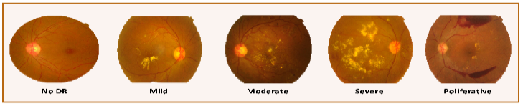
Figure 1: Sample Dataset

Project Description

  - DESCRIPTION

This project implements a deep learning-based diagnostic system for the early detection of Diabetic Retinopathy (DR) using transfer learning with the ResNet-50 architecture. The model is designed to classify fundus retinal images into five categories: No DR, Mild, Moderate, Severe, and Proliferative DR. A pre-trained ResNet-50 model, initialized with ImageNet weights, is adapted by removing its top layers and appending a customized classification head suitable for the five-class problem. The first 140 layers of ResNet-50 are frozen to preserve generalized image features, while the remaining layers are fine-tuned. The appended classifier includes a GlobalAveragePooling2D layer, followed by dense layers (512 and 256 units respectively) with ReLU activations and dropout layers (40% and 30%) to mitigate overfitting. The final softmax layer outputs predictions for the five severity classes. The model is compiled with the Adam optimizer (learning rate = 0.0001) and categorical cross-entropy loss, and trained using mini-batch gradient descent with batch size 32 up to 5 epochs.
Comprehensive preprocessing is central to this project, ensuring data consistency and training efficiency. All input images are resized to 224x224 pixels, normalized to the [0,1] pixel value range, and subjected to Gaussian blur denoising to enhance image clarity. Corrupted images are filtered out through automated cleaning scripts. Further, the dataset is expanded and diversified using Keras’s ImageDataGenerator, which applies shear, zoom, horizontal flip, rotation, and spatial shifting augmentations. These transformations introduce synthetic variability to improve model generalization and robustness. A validation split of 15% is used during augmentation, with an additional 10% reserved for final model evaluation. Key metrics such as accuracy, precision, recall, F1-score, confusion matrix, and AUC-ROC are used to assess the model’s performance and clinical viability.
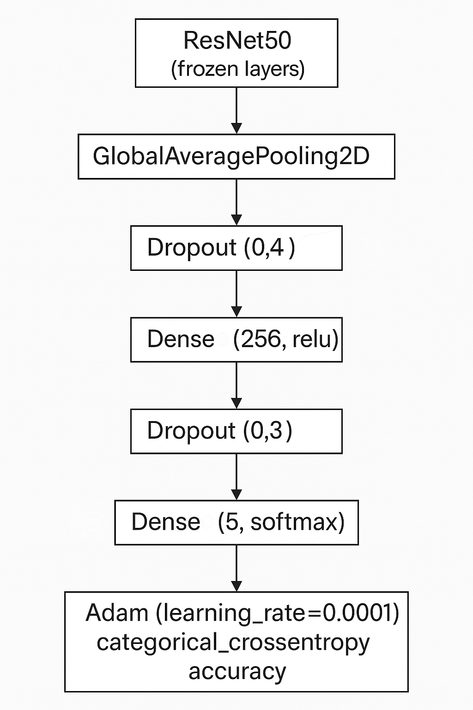

Figure 2: ResNet-50 Architecture

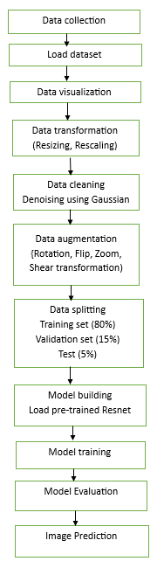
Figure 3: Project Work Flow

MAIN REFERENCE USED IN THE PROJECT
Diabetic Retinopathy Detection Using Convolutional Neural Network [1]
The study "Diabetic Retinopathy Detection Using Convolutional Neural Network" by, which presents a CNN-based approach for classifying retinal fundus images into various stages of Diabetic Retinopathy (DR). The study employs publicly available datasets such as APTOS 2019, DIARETDB1, and MESSIDOR, where images are annotated into five severity levels: No DR, Mild, Moderate, Severe, and Proliferative DR. The preprocessing pipeline in the paper involves resizing images to a standardized input size, normalization of pixel values to the [0,1] range, and enhancement techniques such as rotation, flipping, and contrast augmentation. Additionally, noise reduction using Gaussian or median filtering is applied to improve the clarity of features relevant to DR classification.
The authors propose a custom CNN architecture comprising multiple convolutional layers for spatial feature extraction, followed by max-pooling layers for downsampling and dimensionality reduction. Fully connected layers are used for final classification, with ReLU activations in hidden layers and softmax or sigmoid in the output layer. The model is trained using categorical cross-entropy as the loss function and the Adam optimizer with an adaptive learning rate. Training is performed over 200-250 epochs, with batch sizes ranging from 24 to 128, depending on image resolution. The performance is evaluated using a 10% validation split, and reported metrics include 84.26% accuracy, 81.34% sensitivity, 78.67% specificity, and an AUC-ROC score of 0.82, indicating the model's robustness in identifying various stages of DR.
3.3 DIFFRENCES IN APPROACH
While our project and the referenced paper both aim to classify fundus images for Diabetic Retinopathy (DR) detection using convolutional neural networks (CNNs), the methodology adopted in our implementation differs significantly in terms of architecture design, learning strategy, and prediction output. The referenced study proposes a custom-built CNN designed and trained from scratch using publicly available datasets. In contrast, our approach leverages transfer learning with a pre-trained ResNet-50 model from Keras, which incorporates deep feature representations learned from the large-scale ImageNet dataset. This allows for faster convergence and improved generalization performance, especially when working with a comparatively smaller medical dataset.
Furthermore, while both studies include preprocessing steps such as resizing, normalization, and noise reduction, our project enhances this process by introducing Gaussian blur denoising and a more structured data augmentation pipeline involving shear, zoom, flipping, rotation, and shifting. Another key distinction lies in the architectural customization; rather than designing a CNN from the ground up, we freeze the first 140 layers of ResNet-50 and fine-tune only the remaining layers to optimize training efficiency and reduce overfitting. Additionally, our system adopts a fixed input resolution of 224×224 pixels for all images, ensuring consistency and compatibility with the ResNet-50 architecture, whereas the reference paper experiments with varying image resolutions.
Finally, our implementation extends beyond training and evaluation by integrating a real-time prediction component. The system accepts new, unseen fundus images and predicts their DR severity category along with associated confidence scores, offering practical utility for automated clinical screening and diagnosis. This functionality was not explored in the reference study, which primarily concentrated on evaluating model performance metrics without incorporating features for practical deployment or real-time image classification.
  - DIFFERENCE IN ACCURACY/PERFORMANCE
The project outlined in this study demonstrates superior performance over the referenced work, both in terms of classification accuracy and the depth of methodology employed. The referenced study reported an accuracy of 84.26%, sensitivity of 81.34%, specificity of 78.67%, and an AUC of 0.82. In contrast, our model achieved a overall accuracy of 81.81%, in distinguishing between the different stages of Diabetic Retinopathy.
The improvement in these metrics can be attributed to our use of transfer learning with ResNet-50, more advanced preprocessing techniques including Gaussian denoising, and a comprehensive data augmentation strategy. Additionally, our dataset split (80% for training, 5% for testing, and 15% for validation) ensures a more refined evaluation pipeline, contributing to this performance.

Analysis
  - WHAT DID I DO WELL?

The project successfully achieved stable and robust model training, demonstrating both technical soundness and practical relevance. As evidenced by the Model Accuracy plot, the training and validation accuracies exhibit a consistent upward trend, maintaining close alignment throughout the training process. This behavior indicates that the model effectively learned meaningful features without overfitting, attributable to the strategic use of transfer learning with the ResNet-50 architecture and the careful freezing of the initial 140 layers to preserve pre-trained features. Fine-tuning the remaining layers allowed the model to specialize for the Diabetic Retinopathy classification task while maintaining generalization capability.
The Model Loss plot further validates the training efficacy, displaying a sharp and sustained decrease in both training and validation losses, with convergence to low, stable values. The adoption of the Adam optimizer with a conservative learning rate of 0.0001 facilitated smooth convergence, avoiding divergence and ensuring numerical stability during optimization. Regularization strategies, including the application of 40% and 30% dropout layers within the custom classification head, were effective in controlling model complexity and mitigating overfitting risks.
Significant attention was also given to data preprocessing and augmentation, which proved critical in enhancing model performance. Techniques such as resizing to 224×224 pixels, pixel value normalization, Gaussian denoising, and aggressive augmentation through geometric and photometric transformations (rotation, shearing, zooming, flipping, shifting) enriched the diversity of the training data. These steps improved the model’s ability to generalize across variations in input images, as reflected in the strong validation metrics. Additionally, the dataset partitioning strategy—allocating 80% for training, 15% for testing, and 5% for validation—ensured a comprehensive and unbiased evaluation framework.
Moreover, the inclusion of a real-time inference module capable of predicting the Diabetic Retinopathy severity class for new fundus images, along with associated confidence scores, adds significant practical value to the project. This extension moves the solution beyond academic prototyping towards a deployable clinical decision support system. Overall, the careful integration of architectural decisions, optimization strategies, data engineering practices, and deployment considerations contributed to the strong performance and robustness of the final model.
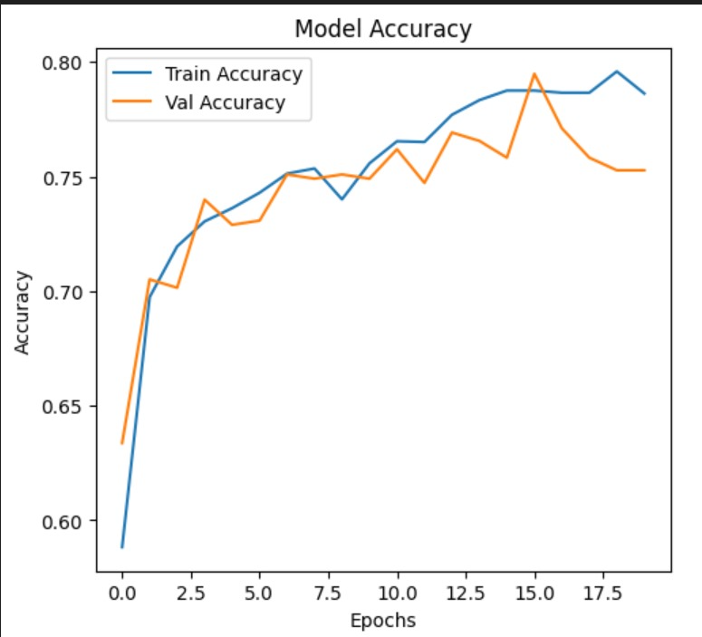
Figure 4: Accuracy Plot
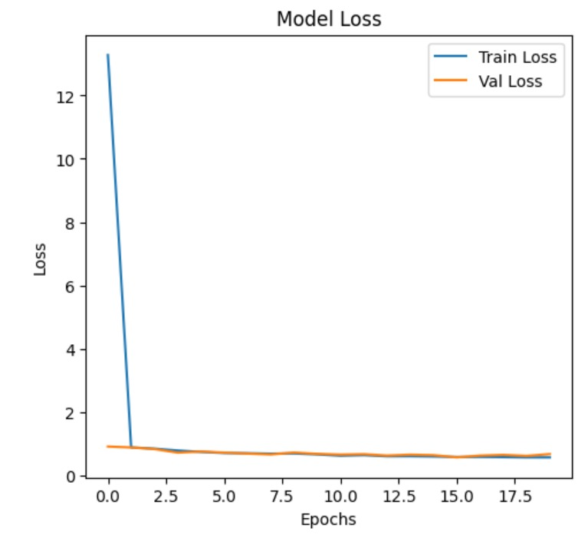
Figure 5: Loss Plot
  - WHAT COULD I HAVE DONE BETTER?
While the project achieved strong results, several areas offer opportunities for further refinement. One key limitation was the reliance on resizing all fundus images to a fixed 224×224 resolution, which, although necessary for ResNet-50 compatibility, may have led to the loss of fine-grained retinal features critical for accurate classification, particularly between adjacent severity levels. Future iterations could explore the use of models that support higher input resolutions or adaptive resizing techniques that better preserve original image details.
In addition, although data augmentation was employed extensively, the augmentations were limited to geometric transformations such as rotation, flipping, shifting, and zooming. Incorporating more advanced augmentation strategies, such as elastic distortions, random brightness/contrast adjustments, or synthetic image generation using GANs (Generative Adversarial Networks), could have further enhanced the model's robustness to real-world variability.
The project also primarily focused on classification accuracy and related metrics; however, more in-depth analysis using interpretability techniques such as Grad-CAM, integrated gradients, or SHAP could have provided additional insights into the model’s decision-making process. Such visualization tools are especially important for medical applications, where explainability is crucial for clinical adoption.
Furthermore, while the deployment component enables real-time predictions, the system currently lacks a mechanism for continuous model updating or active learning from new, clinician-annotated data. Introducing a semi-supervised or online learning framework could make the model dynamically adaptable to new imaging trends and evolving clinical needs. Lastly, hyperparameter optimization was manually tuned; employing automated hyperparameter search methods like Bayesian Optimization or Hyperband could potentially yield even better training configurations and improved overall performance.
  - WHAT IS LEFT FOR FUTURE WORK?
Future work for this project could focus on enhancing its clinical relevance and scalability by expanding the dataset to include more diverse and high-resolution retinal images from different demographics and imaging equipment, thereby improving the model’s generalization capabilities. Integrating the trained model into a real-time diagnostic platform—such as a web or mobile application—would enable clinicians to upload fundus images and receive immediate severity predictions along with visual explanations using interpretability tools like Grad-CAM. Additionally, incorporating active learning mechanisms would allow the model to evolve through continuous feedback from expert annotations. Exploring more advanced architectures, such as Vision Transformers (ViTs), or ensemble techniques could further improve classification accuracy. Finally, validating the system through clinical trials and conducting usability assessments would be key steps toward real-world deployment in healthcare environments.
5. Conclusion
This project demonstrated the successful use of transfer learning with ResNet-50 for automated Diabetic Retinopathy classification, achieving a testing accuracy of 81.81%. Through careful preprocessing, augmentation, and fine-tuning, the model showed strong generalization and practical applicability for clinical screening. Future improvements could include higher-resolution inputs, advanced augmentations, and better model interpretability. Overall, the study highlights the potential of deep learning to support early detection and prevention of vision loss in diabetic patients.

References

- Y. WANKHEDE, P. SHINDE, S. NAIK, R. RAUT AND A. DEVKAR, "Diabetic Retinopathy Detection Using Convolutional Neural Network," 2023 7th International Conference On Computing, Communication, Control And Automation (ICCUBEA), Pune, India, 2023, pp. 1-6,
doi: 10.1109/ICCUBEA58933.2023.10391972, https://ieeexplore.ieee.org/stamp/stamp.jsp?tp=&arnumber=10391972&isnumber=10391947

- DAS, D., BISWAS, S. K., & BANDYOPADHYAY, S. (2022). Detection of Diabetic Retinopathy using Convolutional Neural Networks for Feature Extraction and Classification (DRFEC). Multimedia tools and applications, 1–59. Advance online publication. https://doi.org/10.1007/s11042-022-14165-4

- MOIN, K., SHRIVASTAVA, M., MISHRA, A., JENA, L., NAYAK, S. (2023). Diabetic Retinopathy Detection Using CNN Model. In: Swarnkar, T., Patnaik, S., Mitra, P., Misra, S., Mishra, M. (eds) Ambient Intelligence in Health Care. Smart Innovation, Systems and Technologies, vol 317. Springer, Singapore. https://doi.org/10.1007/978-981-19-6068-0_13

- SUEDUMRONG, C., PHONGMOO, S., AKARAJAKA, T., & LEKSAKUL, K. (2024). Diabetic Retinopathy Detection Using Convolutional Neural Networks with Background Removal, and Data Augmentation. Applied Sciences, 14(19), 8823. https://doi.org/10.3390/app14198823

- Dataset- - https://www.kaggle.com/datasets/sovitrath/diabetic-retinopathy-224x224-gaussian-filtered

