DAY 10
LINUX FILES & PERMISSIONS

Linux Fundamentals for Cybersecurity

Assignment Code | DAY10-LINUX-FILES
Total Marks | 20
Submission Format | PDF
Student Name | ________________________________
Date | ________________________________

Objective
To understand Linux directories, common file-management commands, file permissions, ownership, and important filesystem locations. This assignment explains how these concepts help protect files and maintain system security.

Submission note
The following pages contain model answers to all 20 theory questions. Review the answers and express them in your own words before submission. No practical screenshot requirements were included in the assignment details provided.

PART A — LINUX FILES & PERMISSIONS THEORY
1. What is a Linux directory?
A Linux directory is a location used to organize and store files and other directories. Directories form a hierarchical structure that starts from the root directory (/).
- What does mkdir do?
The mkdir command means “make directory.” It creates a new directory. For example, mkdir projects creates a directory named projects in the current location.
- What does touch do?
The touch command creates an empty file if the specified file does not exist. If the file already exists, it updates its access and modification timestamps without changing its contents.
- What does cat do?
The cat command displays the contents of a text file in the terminal. It can also combine and print the contents of multiple files.
- What does cp do?
The cp command copies files or directories from one location to another. For example, cp notes.txt backup.txt creates a copy named backup.txt.
- What does mv do?
The mv command moves files or directories to another location. It is also used to rename files and directories.
- What does rm do?
The rm command removes files. With suitable options it can also remove directories. It should be used carefully because removed files may not be easy to recover.
- What does ls -l display?
The ls -l command displays a detailed listing. It commonly shows file type and permissions, link count, owner, group, file size, modification time, and file or directory name.
- Explain r, w and x permissions.
r (read) allows reading a file or listing a directory's contents. w (write) allows changing a file or modifying directory entries. x (execute) allows running an executable file or entering/traversing a directory, subject to other permissions and system rules.
- Explain user, group and others.
Linux permissions are commonly set for three classes. user means the file's owner, group means users who belong to the file's assigned group, and others means all other users on the system.
- What does chmod do?
The chmod command changes the permission settings of files and directories. Permissions can be specified symbolically, such as u+x, or numerically, such as 755.
- What does chmod 755 represent?
The mode 755 gives the owner read, write, and execute permissions (7); the group read and execute permissions (5); and others read and execute permissions (5). In symbolic form, this is commonly rwxr-xr-x.
- What does chmod 644 represent?
The mode 644 gives the owner read and write permissions (6), while the group and others receive read-only permissions (4). In symbolic form, it is rw-r--r--.
- What is file ownership?
File ownership identifies the user account and group associated with a file or directory. Ownership helps the operating system decide which permission rules apply to users accessing that item.
- What is the purpose of /etc?
The /etc directory stores system-wide configuration files. Examples include settings for services, users, networking, and other operating-system components.
- What is the purpose of /home?
The /home directory normally contains the personal home directories of regular users. These directories store user documents, downloads, personal configuration files, and other user data.
- What is commonly stored under /var?
The /var directory stores variable data that changes during system operation. Common examples include log files, caches, mail data, spool files, and application or service data.
- Why should rm be used carefully?
The rm command can permanently remove files or directories, and recovery may be difficult. Before using it, users should check the path and filename carefully and avoid running broad or unfamiliar removal commands.
- Why are Linux permissions important?
Linux permissions help control who can read, modify, or execute files and who can access directories. They protect private information, prevent unauthorized changes, and support secure multi-user system operation.
- How can incorrect permissions create a security risk?
Incorrect permissions may allow unauthorized users to read confidential files, change important data, or execute files they should not control. For example, giving everyone write access to a sensitive configuration file could let an attacker alter system settings.

PART B — COMMAND & PERMISSION REFERENCE
This reference summarizes the main commands and permission modes covered in the assignment. Example names are illustrative; use a practice directory and files on your own Linux machine or authorized virtual machine.
Command | Purpose | Example
mkdir | Create a directory | mkdir practice
touch | Create an empty file or update timestamps | touch notes.txt
cat | Display file contents | cat notes.txt
cp | Copy a file or directory | cp notes.txt notes-copy.txt
mv | Move or rename an item | mv notes.txt old-notes.txt
rm | Remove a file | rm old-notes.txt
ls -l | Show detailed file information | ls -l
chmod | Change permissions | chmod 644 notes.txt
Permission number breakdown
Number | Permission | Meaning
4 | r | Read
2 | w | Write
1 | x | Execute
7 | rwx | 4 + 2 + 1
5 | r-x | 4 + 1
6 | rw- | 4 + 2
In a numeric mode such as 755 or 644, each digit represents permissions for owner, group, and others respectively.

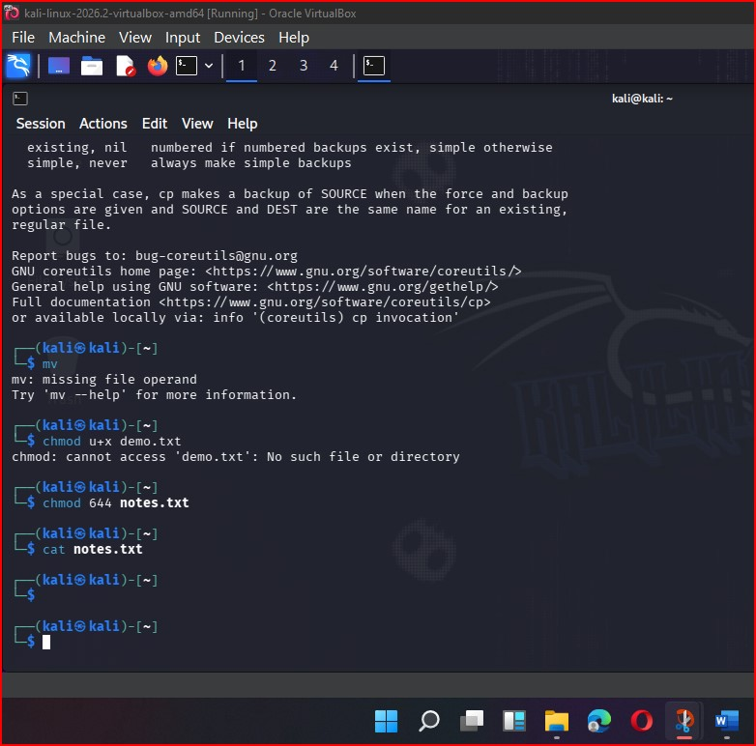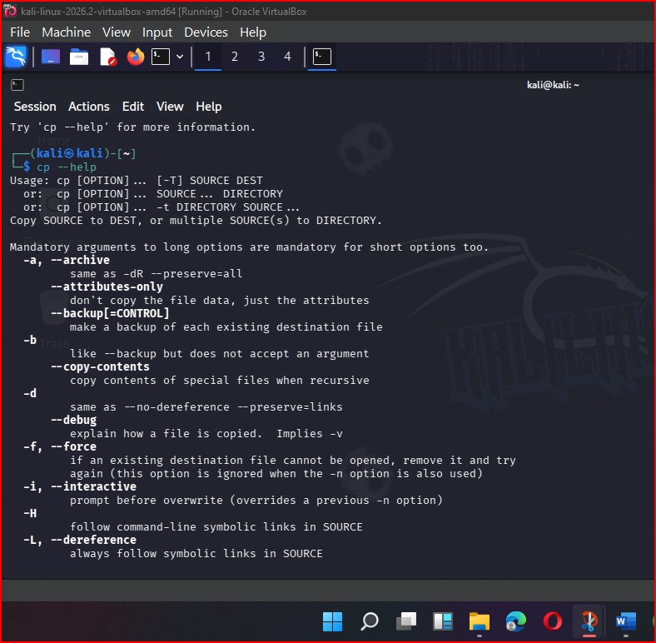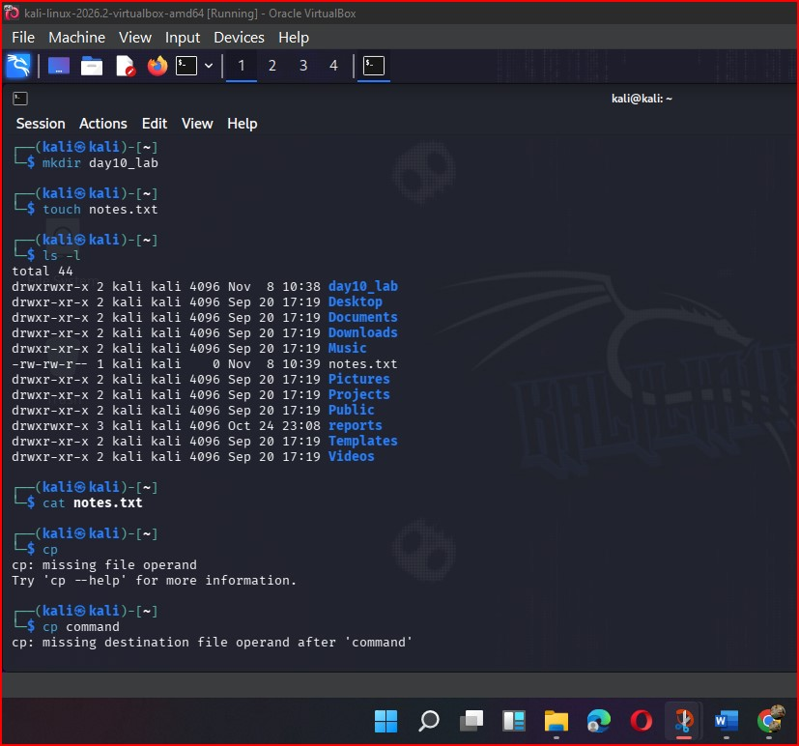

PART C — CONCLUSION
Through this assignment, I learned how Linux organizes files and directories, how common commands are used to create, view, copy, move, and remove files, and how permissions and ownership control access. I also learned the purpose of important system directories such as /etc, /home, and /var. These concepts are essential for protecting information and maintaining secure Linux systems.
Safety and responsible use
Practice file-management and permission commands only in a directory you own or in an authorized lab environment. Check paths and permission settings before making changes. Use extra caution with removal commands and never modify files on systems without permission.

End of Assignment — DAY10-LINUX-FILES

