DAY 09 LINUX BASICS
Networking Fundamentals for Cybersecurity

Assignment Code | DAY09-LINUX-BASICS
Total Marks | 20
Submission Format | PDF
Student Name | ________________________________
Date | ________________________________

Objective
To understand the Linux operating system, basic terminal commands, directory navigation, file paths, and the importance of Linux in cybersecurity. The practical section records basic commands run on the student's own Linux machine or virtual machine.

Submission note
This document contains model answers and spaces for practical evidence. Run the listed commands on your own Linux system or VM and insert your own screenshots in the marked spaces before submitting. Do not use screenshots from another person's machine.

PART A — LINUX THEORY
- What is Linux?
Linux is a free and open-source, Unix-like operating system kernel. It manages computer hardware and system resources. Complete operating systems are built by combining the Linux kernel with system tools and applications.
- What is a Linux distribution?
A Linux distribution (distro) is a complete operating system built around the Linux kernel. It includes software, package management tools, utilities, and often a desktop environment.
- Name four Linux distributions.
Four examples are Ubuntu, Debian, Fedora, and Kali Linux.
- What is Kali Linux?
Kali Linux is a Debian-based Linux distribution designed mainly for cybersecurity work, including penetration testing, security auditing, digital forensics, and security research. It includes many security tools.
- What is a terminal?
A terminal is a text-based interface used to interact with the operating system by entering commands. It allows users to manage files, navigate directories, and run programs.
- What does the whoami command do?
The whoami command displays the username of the account currently running the terminal session.
- What does hostname display?
The hostname command displays the system's host name, which is the name used to identify the computer on a network.
- What does pwd mean?
pwd means “print working directory.” It displays the full path of the directory in which the terminal is currently working.
- What is the purpose of ls?
The ls command lists files and directories in the current directory, or in a directory specified after the command.
- Explain the difference between ls, ls -l and ls -a.
ls shows the usual visible entries. ls -l displays a detailed, long-format listing with permissions, ownership, size, and modification time. ls -a includes hidden entries whose names begin with a dot (.), as well as the special . and .. entries.
- What does cd do?
The cd command means “change directory.” It moves the terminal's current working location to another directory.
- What does cd .. do?
The command cd .. moves one level up, from the current directory to its parent directory.
- What does cd ~ do?
The command cd ~ changes the current directory to the home directory of the logged-in user.
- What does cd / do?
The command cd / changes the current directory to the filesystem's root directory.
- What is the Linux root directory?
The root directory, written as /, is the top-level directory of the Linux filesystem. Other directories and files are organized below it in a single directory tree.
- What is the difference between the root directory and the root user?
The root directory (/) is the top of the filesystem hierarchy. The root user is the system's administrative account, which has extensive privileges. They are different concepts: one is a location and the other is a user account.
- What is an absolute path?
An absolute path gives the complete location of a file or directory starting from the root directory (/). For example, /home/student/Documents. It identifies the same location regardless of the current directory.
- What is a relative path?
A relative path describes a location from the current working directory rather than starting at /. For example, Documents/notes.txt refers to a location under the current directory.
- How are hidden Linux files commonly identified?
Hidden files and directories commonly have names that begin with a dot (.). For example, .bashrc. They are usually omitted from a normal ls listing and can be displayed with ls -a.
- Why are Linux skills important for cybersecurity?
Many servers, cloud systems, security tools, and network services run on Linux. Knowing Linux helps cybersecurity professionals navigate systems, inspect files and permissions, understand processes and logs, use security tools, and perform authorized testing in a controlled lab.

PART B — COMMAND UNDERSTANDING
The following table summarizes the commands required for this assignment. These are basic navigation and identification commands; they do not intentionally modify or delete files.
Command | Purpose | Example / result
whoami | Shows the current logged-in username. | student
hostname | Displays the computer's host name. | linux-vm
pwd | Prints the current working directory. | /home/student
ls | Lists visible files and directories. | Documents Downloads
ls -l | Shows a detailed listing, including permissions and ownersh | ip.-rw-r--r-- ... notes.txt
ls -a | Shows all entries, including hidden dotfiles. | .bashrc .profile
cd / | Moves to the filesystem root directory. | /
cd ~ | Moves to the current user's home directory. | /home/student
Suggested practical sequence
Open a terminal and run each command separately. Record the output and capture a clear screenshot showing the command and its result. For directory navigation, run pwd before and after cd / and cd ~ to show the location change.
whoami hostname pwd ls ls -l ls -a cd / pwd cd ~ pwd

PART C — PRACTICAL SCREENSHOTS
Insert screenshots captured from your own Linux system or virtual machine. Make sure the terminal text is readable and the command is visible in each screenshot. You may combine related commands in one screenshot if all commands and outputs can be read clearly.

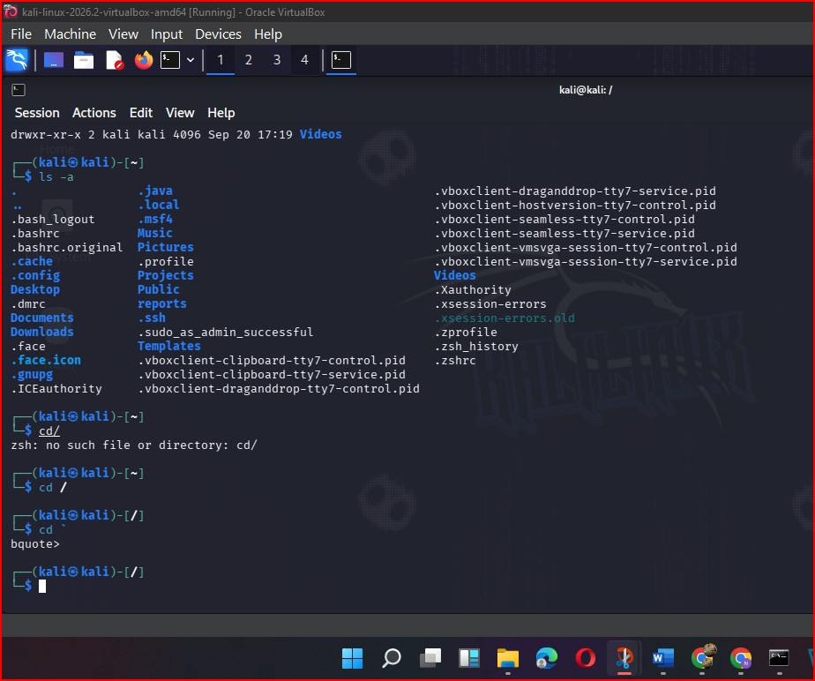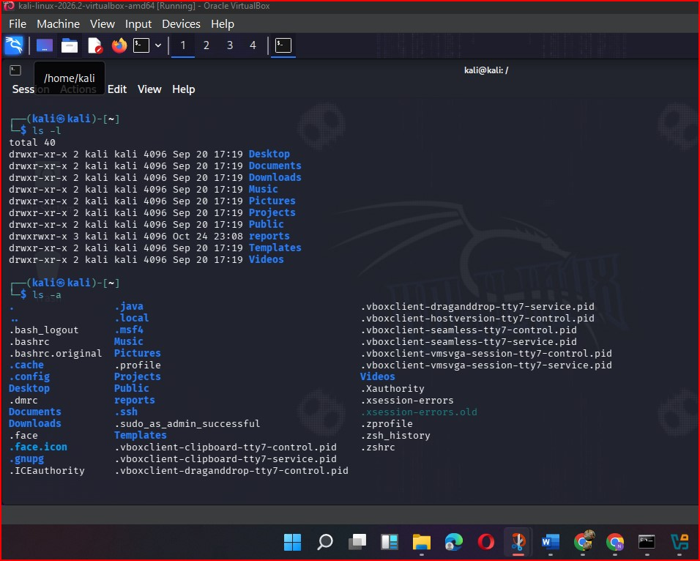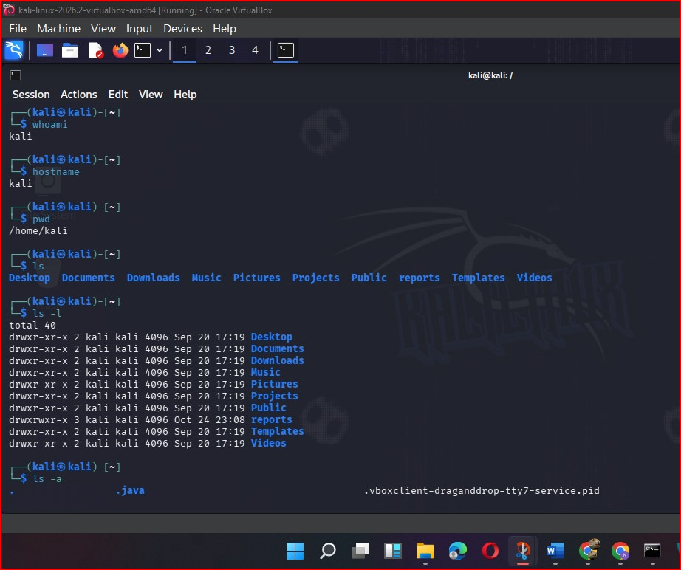
Screenshot 1 — whoami and hostname
Run: whoami and hostname
PASTE YOUR OWN TERMINAL SCREENSHOT HERE
Screenshot 2 — pwd and ls
Run: pwd and ls
PASTE YOUR OWN TERMINAL SCREENSHOT HERE
Screenshot 3 — ls -l and ls -a
Run: ls -l and ls -a
PASTE YOUR OWN TERMINAL SCREENSHOT HERE
Screenshot 4 — cd /
Run: cd / followed by pwd
PASTE YOUR OWN TERMINAL SCREENSHOT HERE
Screenshot 5 — cd ~
Run: cd ~ followed by pwd
PASTE YOUR OWN TERMINAL SCREENSHOT HERE

PART D — CONCLUSION
Through this assignment, I learned the basics of Linux, the role of Linux distributions, and how to use the terminal for identifying the current user and host name, checking the working directory, listing files, and navigating the filesystem. These foundational skills are useful for working with Linux-based servers and cybersecurity tools in authorized lab environments.
Safety and privacy
All practical commands in this assignment are intended for use on your own computer or authorized lab VM. The exercises use basic identification and navigation only. Do not run commands on external systems or include personal information in screenshots.

End of Assignment — DAY09-LINUX-BASICS

