**1.c program to write multiple lines in a text file?**

#include <stdio.h>

int main ()

{

FILE * fptr;

int i,n;

char str[100]; //number of strings

char fname[20]="Nethra.txt"; //creating a file

char str1;

printf("\n\n Write multiple lines in a text file and read the file :\n");

printf(" Input the number of lines : ");

scanf("%d", &n);

printf("\n The lines are :\n");

fptr = fopen (fname,"w");

for(i = 0; i < n+1;i++) // to interate number of lines

{

fgets(str, sizeof str, stdin); //to get number of strings

fputs(str, fptr);

}

fclose (fptr);

fptr = fopen (fname, "r"); //reading a Nethra.txt file

printf("\n The content of the file %s is :\n",fname);

str1 = fgetc(fptr);

while (str1 != EOF)

{

printf ("%c", str1); //accept character by character

str1 = fgetc(fptr);

}

printf("\n\n");

fclose (fptr);

return 0;

}

**o/p :**

Write multiple lines in a text file and read the file :

Input the number of lines : 2

The lines are :

Hi this is nethra

welcome to JKtech family.

The content of the file Nethra.txt is :

Hi this is nethra

welcome to JKtech family.

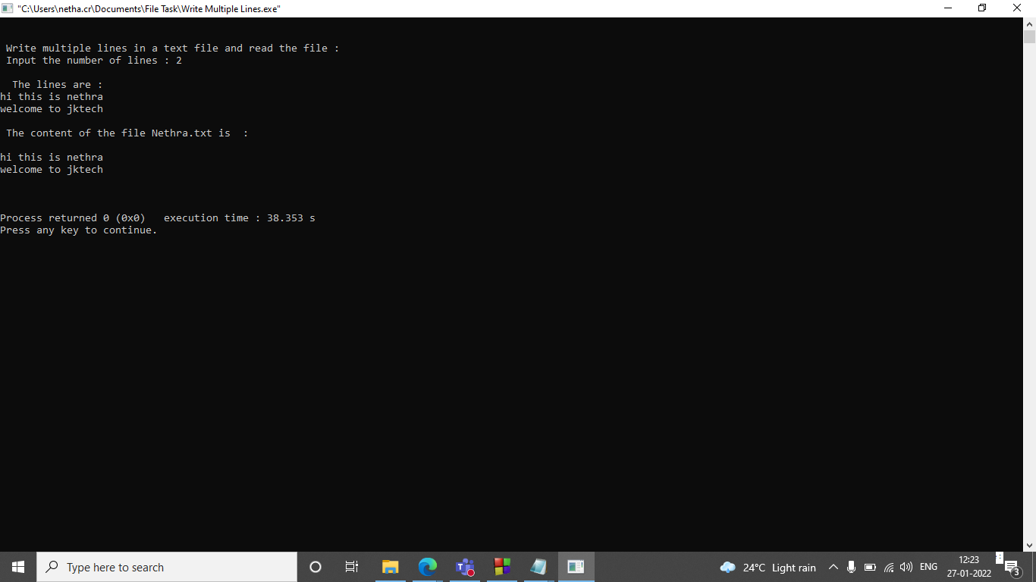

**2.write a c program to count a number of words and character in a file?**

#include <stdio.h>

#include <stdlib.h>

int main(){

FILE * file;

char ch;

int characters, words;

file=fopen("Demo","w"); // opening a Demo file

printf("enter the text:\n");

while((ch = getchar())!=EOF){

putc(ch,file);

}

fclose(file);

file = fopen("Demo", "r"); //file in read mode

if (file == NULL)

{

printf("\nUnable to open file.\n");

exit(1);

}

characters = words =0;

while ((ch = fgetc(file)) != EOF){

characters++;

if (ch == ' ' || ch == '\t' || ch == '\n' || ch == '\0')

words++;

}

if (characters > 0){

words++;

}

printf("\n");

printf("Total characters = %d\n", characters);

printf("Total words = %d\n", words);

fclose(file);

return 0;

}

**o/p:**

enter the text:

Hi this nethra welcome to jktech.

^Z

Total characters = 34

Total words = 7

Process returned 0 (0x0) execution time : 97.149 s

Press any key to continue.

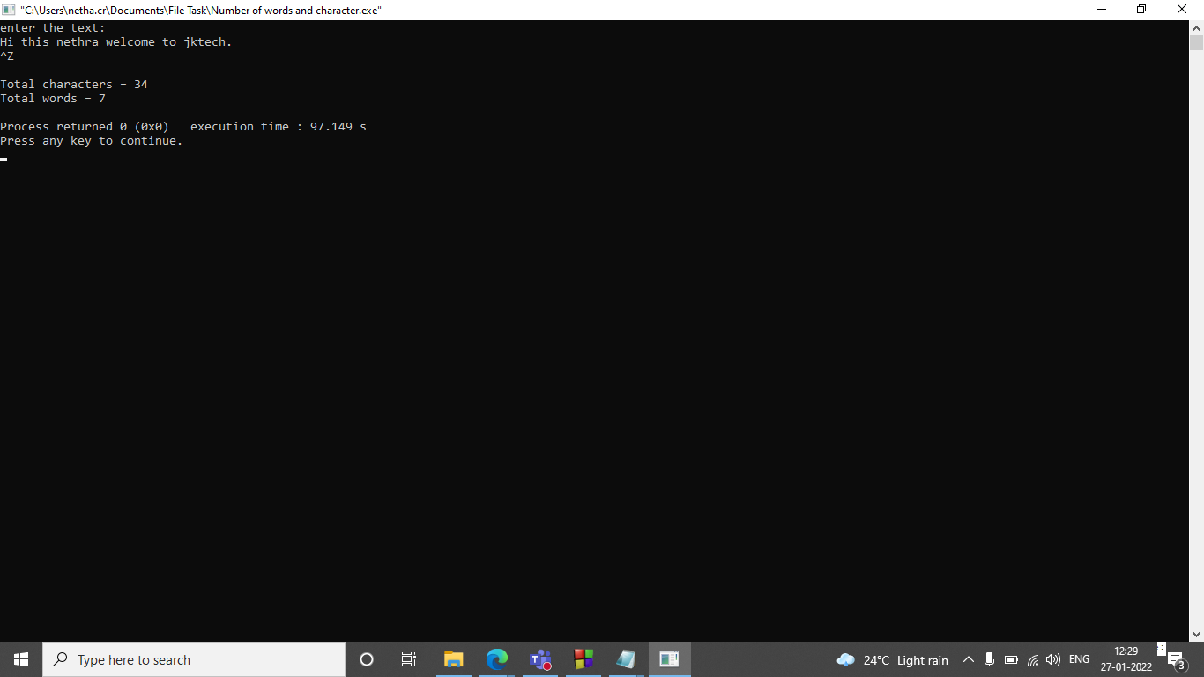

**3.Merge two files and write it in a new file?**

#include<stdio.h>

#include<stdlib.h>

int main()

{

FILE *fp1=fopen("file1.txt","r");

FILE *fp2=fopen("file2.txt","r");

FILE *fp3=fopen("file3.txt","w");

char c;

if(fp1==NULL||fp2==NULL||fp3==NULL)

{

puts("files are not able to open\n");

exit(0);

}

while((c=fgetc(fp1))!=EOF) //copying contect of first file into a file3.txt//c is a structured programming language .

fputc(c,fp3);

while((c=fgetc(fp2))!=EOF) //copying content of second file into a file3.txt//hi this is nethra.

fputc(c,fp3);

printf("merger file1 and file2 into file3");

fclose(fp1);

fclose(fp2);

fclose(fp3);

return 0;

}

**o/p:**

merger file1 and file2 into file3

Process returned 0 (0x0) execution time : 0.061 s

Press any key to continue.

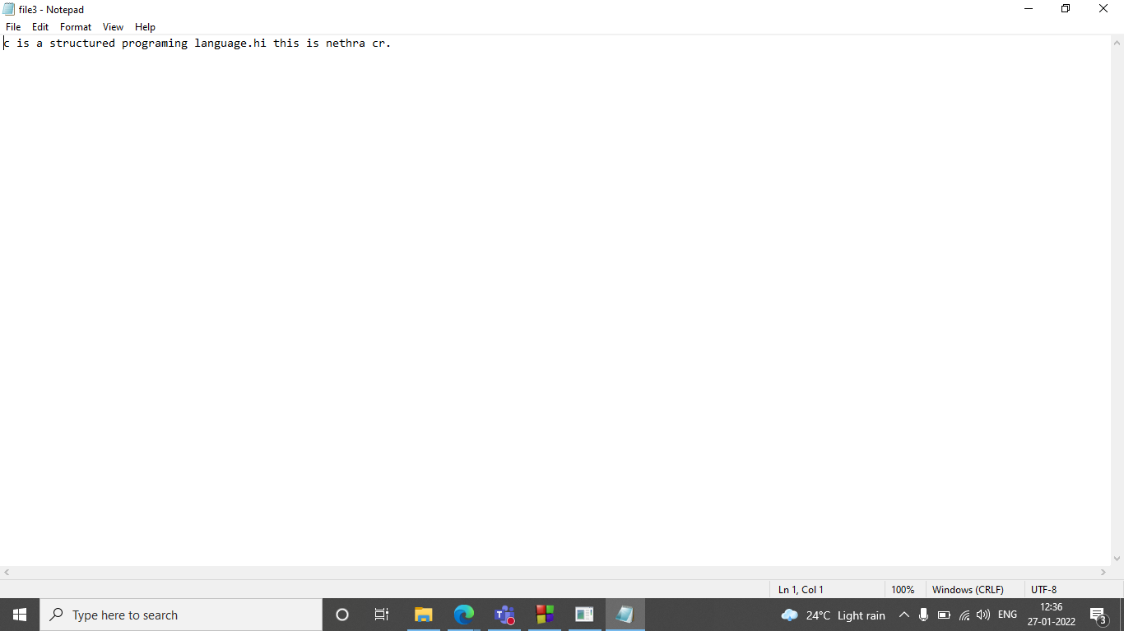

**4.write a c program to remove a file from the disk?**

#include<stdio.h>

int main()

{

if (remove("Nethra1.txt") == 0)

printf("Deleted successfully");

else

printf("Unable to delete the file");

return 0;

}

**o/p:**

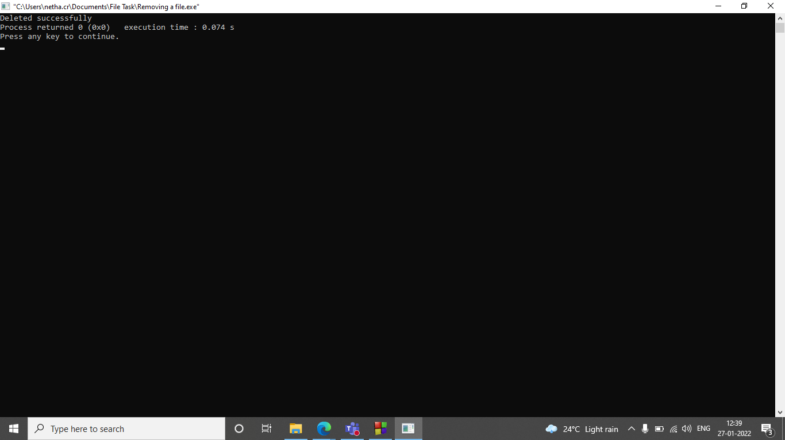

**5. write a c program to create and store information in a text file?**

#include <stdio.h>

#include <stdlib.h>

struct employeeDetailes

{

int Id;

int salary;

char Name[30];

char destination[30];

};

int main()

{

int n;

struct employeeDetailes emp;

FILE *fptr;

if ((fptr = fopen("EmployeeDetailes.txt","w")) == NULL)

{

printf("Error! opening file");

// Program exits if the file pointer returns NULL.

exit(1);

}

printf("Enter a employee detailes:\n");

for(n = 1; n < 3; ++n)

{

printf("\nEmployeeName::");

scanf("%s",&emp.Name);

printf("\nEmployeeId::");

scanf("%d",&emp.Id);

printf("\nEmployeeSalary::");

scanf("%d",&emp.salary);

printf("\nDestination::");

scanf("%s",&emp.destination);

{

fwrite(&emp, sizeof(struct employeeDetailes),1, fptr);

}

fclose(fptr);

}

printf("Employee Detailes are:\n");

fptr = fopen("D:\\EmployeeDetailes.txt","a");

for(n = 1; n < 3; ++n)

{

fread(&emp, sizeof(struct employeeDetailes), 1, fptr);

printf("Name: %s\nId: %d\nsalary: %d\ndestination:%s\n", emp.Name, emp.Id, emp.salary,emp.destination);

}

fclose(fptr);

return 0;

}

o/p:

Enter a employee detailes:

EmployeeName::nethra

EmployeeId::1

EmployeeSalary::200000

Destination::associate

EmployeeName::abc

EmployeeId::2

EmployeeSalary::240000

Destination::manager

Employee Detailes are:

Name: abc

Id: 2

salary: 240000

destination:manager

Name: abc

Id: 2

salary: 240000

destination:manager

