INTERNSHIP MANAGEMENT SYSTEM
A PROJECT REPORT
Submitted by
NETHRA CHANDRAGANDHI T
(2116240701357)
in partial fulfilment of the End Semester Examination for the course
CB23F35 –
LOW-CODE APPLICATION DEVELOPMENT USING ZOHO CREATOR
in
BACHELOR OF ENGINEERING
COMPUTER SCIENCE AND ENGINEERING

RAJALAKSHMI ENGINEERING COLLEGE
(An Autonomous Institution, Affiliated to Anna University, Chennai)
Rajalakshmi Nagar, Thandalam, Tamil Nadu – 602 105
NOVEMBER 2026
RAJALAKSHMI ENGINEERING COLLEGE
(An Autonomous Institution, Affiliated to Anna University, Chennai)
BONAFIDE CERTIFICATE
Certified that this project report titled “INTERNSHIP MANAGEMENT SYSTEM ” is the bonafide work of NETHRA CHANDRAGANDHI T (2116240701357), who carried out the individual project work on the Zoho Creator low-code platform for the course CB23F35 – Low-Code Application Development using Zoho Creator, during the academic year 2026–2027, Semester V, under my supervision.
SIGNATURE  Dr. J. Manoranjini  HEAD OF THE DEPARTMENT  Department of Computer Science and Engineering  Rajalakshmi Engineering College  Thandalam – 602 105 | SIGNATURE  Dr. J. Jinu Sophia  COURSE FACULTY  Department of Computer Science and Engineering  Rajalakshmi Engineering College

Submitted for the End Semester Examination (Individual Project) held on 11 November 2026
INTERNAL EXAMINER | EXTERNAL EXAMINER

DECLARATION
I, NETHRA CHANDRAGANDHI T (2116240701357), hereby declare that the project report titled “Internship Management System”, submitted for the End Semester Examination of the course CB23F35 – Low-Code Application Development using Zoho Creator, is a record of original work carried out by me individually. The Zoho Creator application described in this report — including its data model, forms, reports, pages, Deluge scripts, workflows and integrations — was designed and developed by me.
I further declare that this work has not been submitted, in part or in full, for the award of any other degree or course credit. Every template, sample application, AI-assisted feature (such as Zia or the AI application builder), code snippet or external resource used in this work has been duly acknowledged in the report.
Place: Chennai SIGNATURE OF THE STUDENT
Date: 11 November 2026 NETHRA CHANDRAGANDHI T
2116240701357

ACKNOWLEDGEMENT
I express my sincere gratitude to our Chairman Mr. S. Meganathan and Chairperson Dr. M. Thangam Meganathan for providing the infrastructure and facilities that made this work possible.
I am grateful to our Principal, Dr. S. N. Murugesan, Rajalakshmi Engineering College, for the constant encouragement extended to students to take up industry-relevant learning.
I thank Dr. J. Manoranjini, Head of the Department, Department of Computer Science and Engineering, for the guidance and support provided throughout the course.
I owe my sincere thanks to my course faculty, Dr. J. Jinu Sophia, Associate Professor, for the valuable guidance, reviews and feedback that shaped this application and report.
I also acknowledge Zoho Corporation for providing access to the Zoho Creator platform and learning resources, and I thank my family and friends for their unwavering support.

NETHRA CHANDRAGANDHI T

ABSTRACT
Internship coordination in an engineering college involves student profiles, company details, applications, attendance and performance evaluation. When these are kept in separate spreadsheets, registers and e-mails, the status of an application is hard to track, identifiers, durations and working hours are calculated by hand, and a consolidated view of the internship programme is slow to obtain.
This project presents the Internship Management System, a low-code application developed on Zoho Creator. Five linked forms manage student registration, company details, internship applications, attendance and evaluation. Seven Deluge workflows generate application IDs, calculate internship duration, attendance working hours, performance result and attendance percentage, update approval and application status, and send an approval notification e-mail. An approval process, a Blueprint with the stages Applied, Under Review, Selected and Rejected, and two schedules support the application life cycle. Thirteen reports (list, spreadsheet, Kanban, calendar, timeline, map and pivot views) and a dashboard with record counts, a status pie chart, a working-hours bar chart and an average-rating gauge present the stored data. An Admin role and Student and Customer portal permission profiles are configured.
The application was tested in the Development environment. Application IDs were generated automatically, an internship from 1 November 2026 to 1 December 2026 gave 30 days, a 09:00 to 15:00 attendance record gave 6.00 working hours, ratings of 5, 4, 5, 4 and 5 gave an overall rating of 4.6, and the approval e-mail was received at the configured test address. Delivery to each student’s own e-mail address, role-based testing and deployment beyond the Development environment remain as future work. The project shows that a low-code platform can provide a working internship record-management solution with limited scripting.
Keywords: Low-Code Development; Zoho Creator; Deluge Scripting; Workflow Automation; Approval Process; Internship Management

PROJECT AT A GLANCE
Attribute | Details
Project Title | Internship Management System using Zoho Creator
Application Domain | Education – internship management
Student Name & Register No. | NETHRA CHANDRAGANDHI T – 240701357
Zoho Creator Edition | Trial edition (as shown in the application header)
Application Name (Link Name) | Internship Management System (internship-management-system)
Published / Live URL | https://creatorapp.zoho.in/nethrachandragandhi.t.202102/environment/development/internship-management-system (Development environment)
Demo Credentials (per role) | Admin: nethrachandragandhi.t.2024.cse@rajalakshmi.edu.in
Number of Forms / | 5 / 0
Number of Reports (by type) | List: 6 Spreadsheet: 1 Kanban: 1 Calendar: 1 Timeline: 1 Map: 1 Pivot/Chart: 2 (Total: 13)
Number of Pages / Dashboards | 1 dashboard (Internship Dashboard)
Number of Workflows | Form: 7 Schedule: 2 Approval: 1 Blueprint: 1 Batch: 0
Deluge Functions / Custom Actions | 7 Deluge scripts in form workflows / 0 custom functions
Integrations | None external; built-in Send Mail action and Map report
Roles & Profiles Defined | Roles: CEO, Admin | Portal profiles: Customer, Student
Environments Used | Development
Date of Production Deployment | 25 October 2026
TABLE OF CONTENTS

ABSTRACT iv
PROJECT AT A GLANCE v
LIST OF TABLES ix
LIST OF FIGURES x
LIST OF ABBREVIATIONS xi
INTRODUCTION 1
1.1 Background 1
1.2 Problem Statement 1
1.3 Objectives 2
1.4 Scope of the Project 2
1.5 Justification for a Low-Code Approach 2
1.6 Organisation of the Report 3
LITERATURE SURVEY AND SYSTEM STUDY 4
2.1 Study of the Existing System 4
2.2 Limitations of the Existing System 4
2.3 Low-Code versus Traditional Development 5
2.4 Literature Survey 5
2.5 Emerging Trends in Low-Code Development 6
2.6 Proposed System 6
REQUIREMENT ANALYSIS 8
3.1 Stakeholders and User Roles 8
3.2 Functional Requirements 8
3.3 Non-Functional Requirements 9
3.4 Hardware and Software Requirements 10
3.5 Use Case Model 10
SYSTEM DESIGN 12
4.1 System Architecture 12
4.2 Data Model 12
4.3 Form Design 14
4.4 Process and Workflow Design 17
4.5 User Interface and Navigation Design 18
4.6 Access Control Design 19
IMPLEMENTATION 20
5.1 Application Setup 20
5.2 Forms and Data Capture 20
5.3 Reports 21
5.4 Pages and Dashboards 25
5.5 Deluge Scripting 26
5.6 Workflows and Automation 27
5.7 Integrations 30
5.8 User Management and Role-Based Access 31
5.9 AI and Analytics Features 32
5.10 Pro-Code Extension 32
5.11 Mobile and Portal Access 32
TESTING AND DEBUGGING 33
6.1 Testing Strategy 33
6.2 Test Cases 33
6.3 Debugging Deluge Scripts 34
6.4 Defect Log 35
6.5 User Acceptance Testing 35
DEPLOYMENT, SECURITY AND GOVERNANCE 36
7.1 Environments and Deployment Strategy 36
7.2 Performance Optimisation 37
7.3 Security Features 37
7.4 Governance and Administration 37
RESULTS AND DISCUSSION 38
8.1 Application Output 38
8.2 Achievement of Objectives 40
8.3 Comparison with the Existing System 40
8.4 Limitations of the Low-Code Approach 40
8.5 Reflection on the No-Code → Low-Code → Pro-Code Spectrum 41
CONCLUSION AND FUTURE ENHANCEMENTS 42
9.1 Conclusion 42
9.2 Future Enhancements 42
9.3 Learning Outcomes and Career Relevance 42
REFERENCES 44
APPENDIX A – ZOHO CREATOR FEATURE COVERAGE CHECKLIST 45
APPENDIX B – COURSE OUTCOME MAPPING 47
APPENDIX C – COMPLETE DELUGE SOURCE CODE 48
APPENDIX D – USER MANUAL 51
D.1 Accessing the Application 51
D.2 Instructions for the Administrator 51
D.3 Instructions for the Student (Portal User) 51
APPENDIX E – EVALUATION RUBRIC 52
APPENDIX F – VIVA-VOCE RECORD SHEET 54

LIST OF TABLES
Table 2.1: Comparison of Low-Code and Traditional Development for the Proposed Application 5
Table 2.2: Summary of Literature Survey 6
Table 3.1: Stakeholders and User Roles 8
Table 3.2: Functional Requirements 8
Table 3.3: Non-Functional Requirements 9
Table 3.4: Hardware and Software Requirements 10
Table 3.5: Use Case Description – Submit and Approve an Internship Application 10
Table 4.1: Entities and Relationships 13
Table 4.2: Field Specification – Student Registration Form 14
Table 4.3: Field Specification – Company Details Form 15
Table 4.4: Field Specification – Internship Application Form 15
Table 4.5: Field Specification – Internship Attendance Form 16
Table 4.6: Field Specification – Internship Evaluation Form 17
Table 4.7: Role–Permission Matrix 19
Table 5.1: Reports Implemented 22
Table 5.2: Deluge Scripts Implemented 26
Table 5.3: Workflows Implemented 27
Table 5.4: Integrations Implemented 30
Table 6.1: Test Cases 33
Table 6.2: Defect Log 35
Table 6.3: User Acceptance Feedback 35
Table 7.1: Deployment Checklist 36
Table 7.2: Performance Optimisation Results 37
Table 7.3: Security Controls Implemented 37
Table 8.1: Mapping of Objectives to Outcomes 40
Table 8.2: Existing System versus Proposed Application 40
Table A.1: Feature Coverage Checklist 45
Table B.1: Mapping of Course Outcomes to Report Chapters 47
Table E.1: Evaluation Rubric for the Individual Project 52
Table E.2: Performance Level Descriptors 53
Table F.1: Viva-Voce Questions and Responses 54
Table F.2: Marks Summary 54

LIST OF FIGURES
Figure 2.1: Typical Manual (As-Is) Process for Managing Internships 4
Figure 3.1: Use Case Diagram of the Application 10
Figure 4.1: System Architecture of the Application 12
Figure 4.2: Entity–Relationship Diagram 13
Figure 4.3: Workflow / Process Flow for the Internship Application 18
Figure 4.4: Navigation Structure of the Application 19
Figure 5.1: Application Navigation Sections in the Development Environment 20
Figure 5.2: Student Registration Form in Live Mode (Top) 21
Figure 5.3: Internship Application Form in Live Mode (Top) 21
Figure 5.4: Internship Evaluation Form in Live Mode 21
Figure 5.5: Student Report 23
Figure 5.6: Company Report 23
Figure 5.7: Company Location Map 23
Figure 5.8: Internship Application Report (Left Columns) 23
Figure 5.9: Internship Application Report (Right Columns) 24
Figure 5.10: Internship Application List 24
Figure 5.11: Internship Application Timeline 24
Figure 5.12: Internship Attendance Report 25
Figure 5.13: Attendance Status Kanban 25
Figure 5.14: Internship Evaluation Report 25
Figure 5.15: Internship Dashboard 26
Figure 5.16: Application Approval Workflow (DS-03) 29
Figure 5.17: Internship Application Process Blueprint 29
Figure 5.18: Custom Schedules 29
Figure 5.19: Internship Application Approval Process Configuration 30
Figure 5.20: Pending Tasks in the Approvals Section 30
Figure 5.21: Approval Notification Received in the Inbox 31
Figure 5.22: Role Hierarchy (CEO and Admin) 31
Figure 5.23: Portal User Permissions (Customer and Student) 32
Figure 6.1: Deluge Debug Output 35
Figure 7.1: Environment/Publish to Production 36
Figure 8.1: Student Registration and Internship Application Submission 38
Figure 8.2: Pending Internship Application for Administrator Review 39
Figure 8.3: Internship Management Dashboard 39

LIST OF ABBREVIATIONS
Abbreviation | Expansion
API | Application Programming Interface
CGPA | Cumulative Grade Point Average
CSE | Computer Science and Engineering
DS | Deluge Script (script identifier)
ER | Entity–Relationship
FR | Functional Requirement
HoD | Head of the Department
NFR | Non-Functional Requirement
REST | Representational State Transfer
TC | Test Case
UAT | User Acceptance Testing
URL | Uniform Resource Locator

CHAPTER 1

INTRODUCTION

1.1 Background
Internships are an important part of engineering education because they give students exposure to real industry practices. Managing them in an institution involves several kinds of information: the profiles of the students, the companies offering internships, the applications submitted by students, the daily attendance of interns and the evaluation of their performance. When these records are kept in separate spreadsheets, registers and e-mail threads, coordinators spend considerable effort in entering, cross-checking and consolidating data.
This project addresses that domain through the Internship Management System, a low-code application developed on Zoho Creator [2]. The application is designed for an internship coordination office of an educational institution. It brings student registration, company details, internship applications, attendance tracking and performance evaluation into one application, and adds workflows, reports and a dashboard on top of the stored data. The application is built and tested in the Development environment of the student’s Zoho Creator account.

1.2 Problem Statement
Internship-related information is commonly maintained in scattered files and registers, which makes it difficult to identify an application’s status, to calculate durations and working hours consistently, and to obtain a consolidated view of students, companies, attendance and evaluation results. There is a need for a single, structured application that stores this information, automates the routine calculations and presents it through reports and a dashboard.
- Student, company and application records are kept in different places and are not linked to each other.
- Application identifiers, internship durations and attendance working hours are calculated or typed manually, which can lead to errors.
- The progress of an application (applied, under review, selected or rejected) and its approval are not tracked in a structured manner.
- A consolidated view of record counts, application status, working hours and evaluation ratings is not readily available.

1.3 Objectives
- To design forms and a linked data model for student registration, company details, internship applications, attendance and evaluation.
- To automate application ID generation, internship duration, attendance working hours, performance result and attendance percentage using Deluge scripting in form workflows.
- To control the application life cycle using an approval process, a Blueprint and a field-driven approval workflow, with an e-mail notification on approval.
- To provide reports in multiple views (list, spreadsheet, Kanban, calendar, timeline, map and pivot) and a dashboard with key metrics and charts.
- To configure an Admin role and a Student portal permission profile for role-based access.
- To test the forms, workflows, reports, dashboard and e-mail notification in the Development environment.

1.4 Scope of the Project
In scope: five forms (Student Registration, Company Details, Internship Application, Internship Attendance and Internship Evaluation); seven form workflows written in Deluge; one approval process; one Blueprint; two scheduled workflows; thirteen reports; one dashboard; an Admin role and Student and Customer portal permission profiles; and testing of these components in the Development environment.
Out of scope: dynamic e-mail delivery to each student’s registered address (the tested notification uses a fixed test address), certificate management, multi-level approvals, integration with external systems or APIs, payment handling, and pro-code extensions. Use of the Zoho Creator mobile app and a live customer-portal login were not evaluated in this project.

1.5 Justification for a Low-Code Approach
Low-code platforms allow business applications to be assembled mainly through visual builders, with scripting used only where logic cannot be configured [1]. This suits the present application because most of its requirements (data-entry forms, linked records, reports, a dashboard, approvals and scheduled mail) are provided as built-in components of Zoho Creator [2], while the calculations that need logic (ID generation, durations, working hours and ratings) are small and are handled in Deluge scripts [3]. Hosting, the user interface and role-based access are provided by the platform, so the effort is concentrated on the internship process itself rather than on infrastructure.

1.6 Organisation of the Report
Chapter 2 reviews the existing system and related low-code literature. Chapter 3 presents the requirement analysis. Chapter 4 describes the system design. Chapter 5 details the implementation on Zoho Creator. Chapter 6 covers testing and debugging. Chapter 7 discusses deployment, performance optimisation, security and governance. Chapter 8 presents results and discussion, and Chapter 9 concludes the report with future enhancements.
CHAPTER 2

LITERATURE SURVEY AND SYSTEM STUDY

2.1 Study of the Existing System
In a typical manual or spreadsheet-based arrangement, a student collects details of a company, submits an application on paper or by e-mail, and the coordinator records it in a spreadsheet. Approval is communicated through phone calls or e-mail. During the internship, attendance is noted in a register and performance is recorded on paper forms. Reports are finally prepared by combining these separate sources. Figure 2.1 shows this typical process.
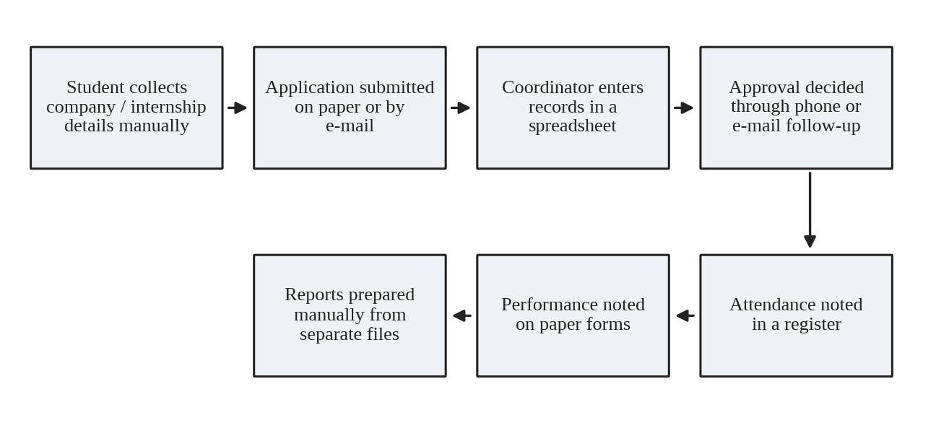
Figure 2.1: Typical Manual (As-Is) Process for Managing Internships

2.2 Limitations of the Existing System
- Records of students, companies, applications, attendance and evaluations are stored separately and are not linked.
- Application numbers, internship durations and working hours are entered or calculated manually.
- The status of an application and its approval are not tracked through a defined process.
- Reports must be compiled by hand, so a consolidated view is slow to obtain.
- Notifications about approval depend on the coordinator remembering to inform the student.

2.3 Low-Code versus Traditional Development
Table 2.1 compares traditional development with the low-code approach for this application. The comparison is qualitative; no formal effort measurements were taken during the project.
Table 2.1: Comparison of Low-Code and Traditional Development for the Proposed Application
Criterion | Traditional (Pro-Code) Development | Low-Code on Zoho Creator
Development effort | Database design, back-end code, user interface and report screens must all be programmed. | Forms, reports and the dashboard are assembled in visual builders; Deluge is used for seven small scripts.
Skills required | Programming, database and web-development skills. | Platform familiarity and basic Deluge scripting.
Hosting and infrastructure | Servers, deployment and maintenance are managed by the developer. | Hosted by Zoho; the application is accessed through a web link.
Workflow and approvals | Approval logic and scheduling must be coded. | Approval process, Blueprint and schedules are configured in the Workflow builder.
Security and access | Authentication and authorisation must be designed and coded. | Roles and portal permission profiles are provided by the platform.
Customisation limits | Unlimited flexibility. | Bounded by platform features; Deluge covers most custom logic needed here.
Cost | Developer time, server and licence costs. | Developed on a Zoho Creator trial edition; a subscription would be needed for continued use.
Maintenance | Code changes, testing and redeployment. | Changes are made in the builders or in Deluge and tested in the Development environment.

2.4 Literature Survey
The sources reviewed for this project are the official Zoho Creator documentation, the Deluge reference, the Zoho Creator learning material and a textbook on low-code development. They are summarised in Table 2.2.
Table 2.2: Summary of Literature Survey
S.No. | Author / Source & Year | Title | Key Findings | Relevance to this Project
1 | Zoho Corporation, online documentation 30 October 2026 | Zoho Creator Help Documentation [2] | Describes the form builder and field types, report types, workflows, approvals, Blueprint, schedules, roles and pages. | Primary reference for building the five forms, reports, workflows and the dashboard.
2 | Zoho Corporation, online documentation 30 October 2026 | Deluge Script Reference Guide [3] | Describes Deluge syntax, conditions, date and time handling, fetching records, collections and the sendmail task. | Basis for the Deluge scripts DS-01 to DS-07.
3 | Zoho Corporation, online learning material 30 October 2026 | Zoho Creator Learning Centre [4] | Provides learning material on platform features. | Supporting material for features used in the application.
4 | W. Rosam and O. Kalnichevski | Low-Code Development: A Practical Guide [1] | Introduces low-code concepts and platforms. | Supports the low-code justification and the no-code to pro-code discussion.
5 | Authors: D. Liu et al. | What's Wrong With Low-Code Development Platforms? An Empirical Study of Low-Code Development Platform Bugs | Identifies common bugs in low-code platforms, including application design issues, unexpected system behavior, and user interface graphics problems | Supports testing workflows, approval processes, attendance calculations, and reports for system reliability.

2.5 Emerging Trends in Low-Code Development
Low-code platforms are increasingly used by business teams to build applications without long development cycles, a practice often described as citizen development. Platforms such as Zoho Creator combine visual builders with scripting, built-in workflow automation, approvals and analytics, and now also provide AI-assisted building (the Zoho Creator editor used in this project displays a Zia “Build Agent” panel). These trends are relevant to this project because its core elements (forms, approvals, scheduled mail and dashboards) are the kind of components that low-code platforms offer out of the box.

2.6 Proposed System
The proposed Internship Management System stores student, company, application, attendance and evaluation data in five linked forms. Deluge workflows generate the application ID and calculate the internship duration, working hours, performance result and attendance percentage. An approval process and a Blueprint control the application life cycle, a field-driven workflow updates the approval and application status and sends a notification e-mail, and scheduled workflows send reminders to the administrator. Reports in several views and a dashboard provide a consolidated picture. In this way the system addresses each limitation listed in Section 2.2.
CHAPTER 3

REQUIREMENT ANALYSIS

3.1 Stakeholders and User Roles
Table 3.1: Stakeholders and User Roles
Role | Description | Key Responsibilities in the Application
Administrator | Owner of the application; the Admin role is configured under the CEO role in the role hierarchy, and the owner account is the Level 1 approver of the approval process. | Maintain student and company records, create and review applications, approve or reject applications, record attendance and evaluations, view reports and the dashboard.
Student (Portal User) | Student profile defined in the portal user permissions: “allows students to view permitted internship information and manage their own applications”. | Submit and manage own internship applications; view permitted internship information.
Company Mentor | Named in the Mentor Name field of the Internship Evaluation form; not configured as a system user. | Provides the ratings that are recorded in the evaluation.

3.2 Functional Requirements
Table 3.2: Functional Requirements
FR ID | Requirement | Role(s) | Priority
FR-01 | The system shall register a student with mandatory fields (ID, name, e-mail, phone, gender, department, year, CGPA, skills). | Admin | High
FR-02 | The system shall store company profiles and internship opportunity details. | Admin | High
FR-03 | The system shall record an internship application linked to a student and a company and generate an Application ID automatically on submission. | Admin, Student | High
FR-04 | The system shall calculate the internship duration in days from the start and end dates. | Admin | High
FR-05 | The system shall record attendance with check-in and check-out times and calculate working hours. | Admin | High
FR-06 | The system shall record five performance ratings (1 to 5) and compute the overall rating as their average. | Admin | High
FR-07 | The system shall derive a Performance Result from the overall rating. | Admin | Medium
FR-08 | The system shall set Approval Status to Approved and Application Status to Selected when Application Approved is ticked. | Admin | High
FR-09 | The system shall send an “Internship Application Approved” e-mail when the Application Approved field is updated. | Admin | Medium
FR-10 | The system shall route each application through an approval process with Approve and Reject actions. | Admin | High
FR-11 | The system shall move an application through the stages Applied, Under Review, Selected and Rejected using a Blueprint. | Admin | Medium
FR-12 | The system shall calculate a student’s attendance percentage from attendance records. | Admin | Medium
FR-13 | The system shall provide reports in list, spreadsheet, Kanban, calendar, timeline, map and pivot views. | Admin | Medium
FR-14 | The system shall display a dashboard of record counts, application status, working hours and average evaluation rating. | Admin | Medium
FR-15 | The system shall send scheduled reminder mails to the administrator. | Admin | Low
FR-16 | The system shall restrict access using an Admin role and Student and Customer portal permission profiles. | Admin, Student | Medium

3.3 Non-Functional Requirements
Table 3.3: Non-Functional Requirements
NFR ID | Category | Requirement
NFR-01 | Performance | Reports and the dashboard shall display the stored records without noticeable delay for the data volumes used in the project.
NFR-02 | Security | Users shall access only the data permitted by their role or portal profile.
NFR-03 | Usability | The application shall be usable through a web browser with clearly labelled forms and mandatory-field indicators.
NFR-04 | Availability | The application shall be hosted on the Zoho Creator platform and accessed through a web link.
NFR-05 | Maintainability | Logic shall be kept in small, separately named workflows so that each rule can be changed independently.
NFR-06 | Data integrity | Essential fields shall be mandatory, and calculated values shall be produced by workflows rather than typed manually.

3.4 Hardware and Software Requirements
Table 3.4: Hardware and Software Requirements
Category | Specification
Platform | Zoho Creator (trial edition, as displayed in the application header)
Scripting language | Deluge (Data Enriched Language for the Universal Grid Environment)
Browser | Google Chrome (used for development and testing); other current browsers are expected to work
Other Zoho services | Send Mail action (notification e-mail); Map report (Zoho Maps)
Mobile | Zoho Creator mobile app: not evaluated in this project
Client hardware | Intel Core i3/i5 or above, 8 GB RAM, internet connection

3.5 Use Case Model
Figure 3.1 shows the main use cases for the Administrator and the Student (Portal User). The Student’s use cases follow the description of the “Student” portal permission profile. Table 3.5 describes the main use case in detail.
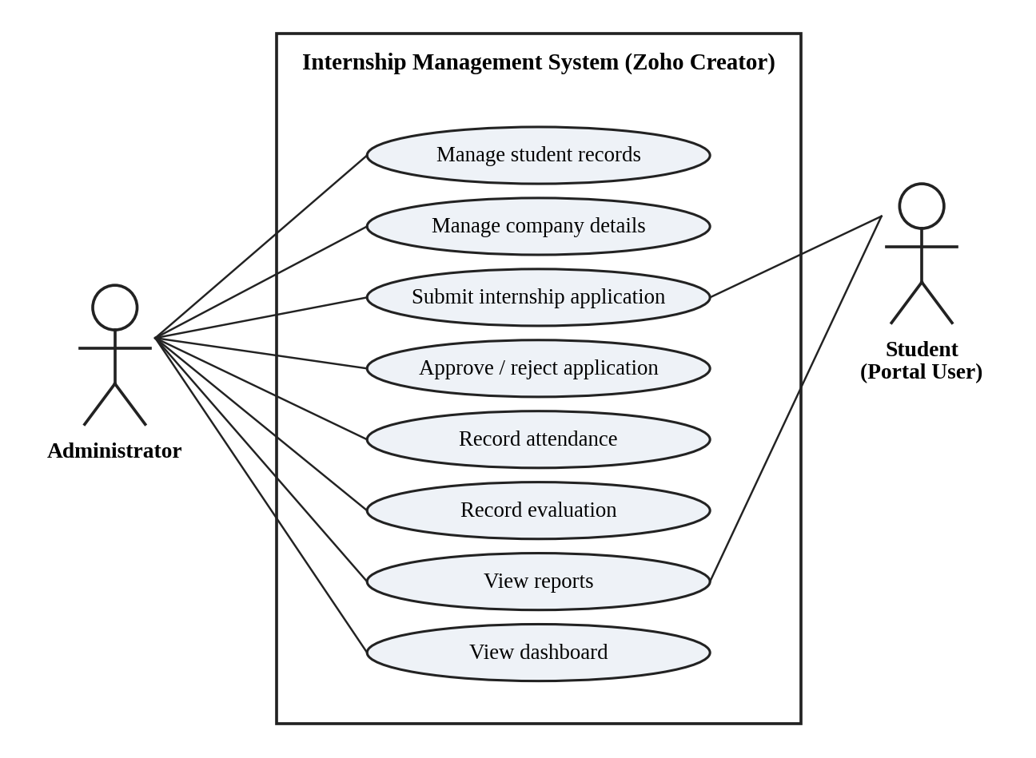
Figure 3.1: Use Case Diagram of the Application
Table 3.5: Use Case Description – Submit and Approve an Internship Application
Use Case ID | UC-01
Actors | Student; Administrator
Preconditions | The student and the company already exist in the Student Registration and Company Details forms.
Main Flow | 1. The student submits an internship application (student, company, domain, dates, mode).  2. DS-01 generates the Application ID.  3. The record is saved and an approval request appears in Pending Tasks for the approver.  4. The administrator reviews the application and ticks Application Approved.  5. DS-03 sets Approval Status to Approved and Application Status to Selected; DS-02 calculates the duration.  6. The approval notification e-mail is sent.
Alternate Flow | The approver rejects the request in the approval process, or the Blueprint transition “Reject Application” moves the application to Rejected.
Postconditions | The application shows its updated status in the reports and dashboard.
Related Requirements | FR-03, FR-04, FR-08, FR-09, FR-10, FR-11

CHAPTER 4

SYSTEM DESIGN

4.1 System Architecture
Figure 4.1 shows the layered architecture. Users (the Administrator and the Student portal user) reach the application through a web browser. The application layer holds the forms, reports and dashboard together with the workflows (form workflows written in Deluge, the approval process, the Blueprint and the schedules). Data is stored in five Zoho Creator forms. The platform provides the Send Mail action used for notifications and the Zoho Maps service used by the Map report.
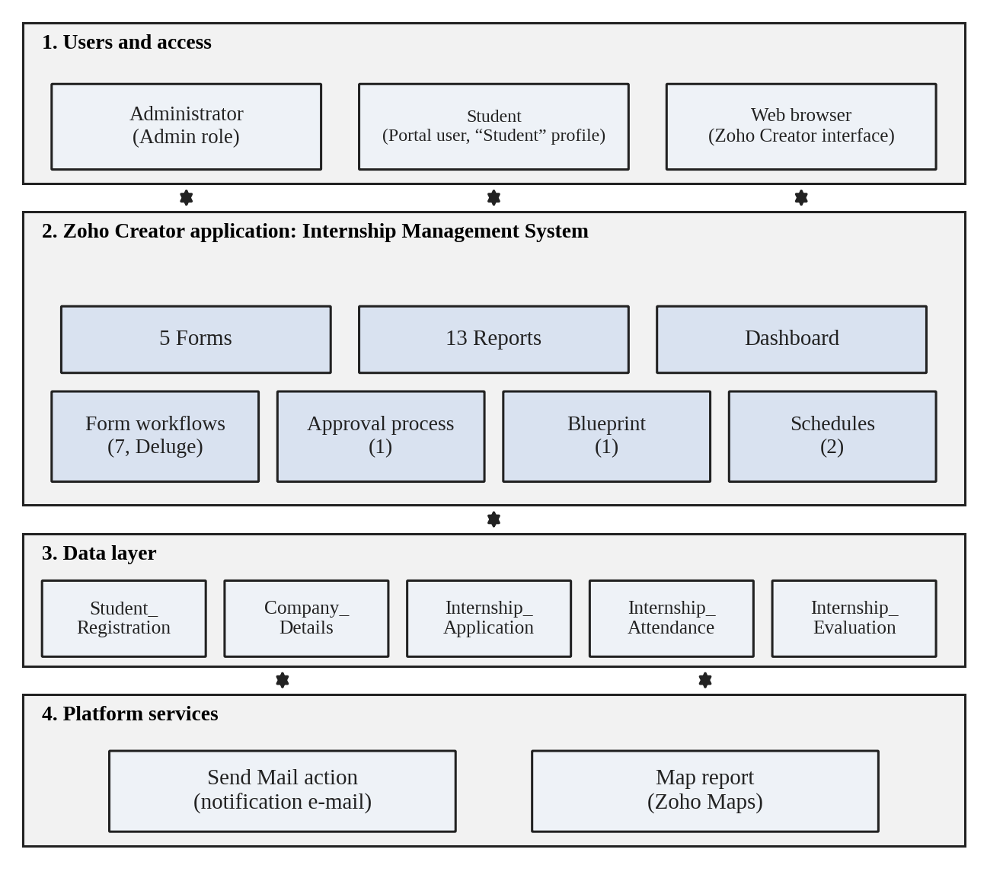
Figure 4.1: System Architecture of the Application

4.2 Data Model
Figure 4.2 presents the entity–relationship diagram. Student Registration and Company Details are the master forms. Internship Application, Internship Attendance and Internship Evaluation each refer to a student and a company through lookup fields, so one student or company can be related to many applications, attendance records and evaluations. No subforms are used. Table 4.1 lists the entities and relationships.
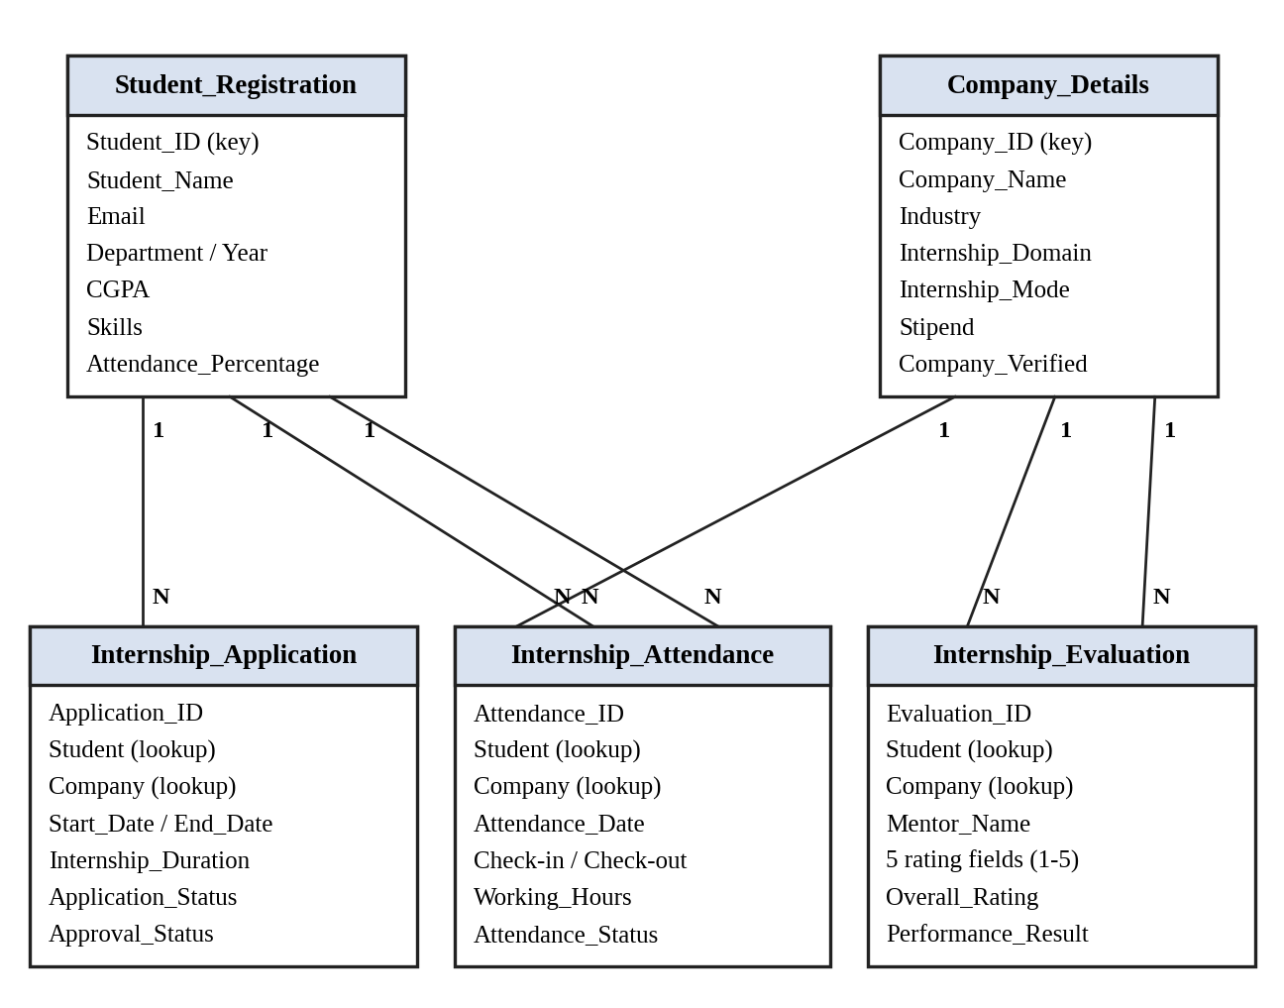
Figure 4.2: Entity–Relationship Diagram
Table 4.1: Entities and Relationships
Entity (Form) | Key Fields | Related To | Relationship | Implemented By
Student Registration | Student ID, Student Name, Email, Department, Year, CGPA, Skills | Application, Attendance, Evaluation | One student to many records | Lookup fields in the three child forms
Company Details | Company ID, Company Name, Industry, Internship Domain, Mode, Duration | Application, Attendance, Evaluation | One company to many records | Lookup fields in the three child forms
Internship Application | Application ID, Start Date, End Date, Application Status, Approval Status | Student Registration, Company Details | Many applications to one student and one company | Student Registration and Company Details lookups
Internship Attendance | Attendance ID, Attendance Date, Check-In/Out Time, Working Hours | Student, Company | Many records to one student and one company | Student and Company lookups
Internship Evaluation | Evaluation ID, five ratings, Overall Rating, Performance Result | Student, Company | Many records to one student and one company | Student and Company lookups

4.3 Form Design
Each form is specified below. Link names are those generated by Zoho Creator from the field labels; the field types, mandatory markers and values are taken from the live forms. The forms together use more than ten distinct field types: single line, name, e-mail, phone, radio, date, dropdown, decimal, number, multi-select, file upload, image, multi line, decision box, URL, address, currency, time, lookup and formula.
Table 4.2: Field Specification – Student Registration Form
Field Label | Link Name | Field Type | Mand. | Validation / Values | Remarks
Student ID | Student_ID | Single Line | Yes | — | Identifier, e.g. STU001
Student Name | Student_Name | Name | Yes | First and last name
Email | Email | Email | Yes | E-mail format
Phone Number | Phone_Number | Phone | Yes | Country code (+91 shown)
Gender | Gender | Radio | Yes | Male / Female
Date of Birth | Date_of_Birth | Date | No | dd-MMM-yyyy
Department | Department | Dropdown | Yes | Choice list | e.g. CSE, IT
Year | Year | Dropdown | Yes | Choice list | e.g. 3rd year
Semester | Semester | Dropdown | No | Choice list
CGPA | CGPA | Decimal | Yes | Decimal number
Attendance Percentage | Attendance_Percentage | Number | No | Set by DS-07
Skills | Skills | Multi Select | Yes | Choice list
Resume | Resume | File Upload | No
Profile Photo | Profile_Photo | Image | No
Address | Address | Multi Line | No
Placement Interested | Placement_Interested | Decision Box | No | Checkbox

Table 4.3: Field Specification – Company Details Form
Field Label | Link Name | Field Type | Mand. | Validation / Values | Remarks
Company ID | Company_ID | Single Line | Yes | — | e.g. COM001
Company Name | Company_Name | Single Line | Yes
Company Logo | Company_Logo | Image | No
Industry | Industry | Dropdown | Yes | Choice list | e.g. Software, IT
Contact Person | Contact_Person | Name | Yes | First and last name
Company Email | Company_Email | Email | Yes | E-mail format
Contact Number | Contact_Number | Phone | Yes | Country code (+91 shown)
Company Website | Company_Website | URL | No | https://
Company Address | Company_Address | Address | Yes | Address lines, city, state, postal code, country | Used by the Map report
Internship Domain | Internship_Domain | Multi Select | No | Choice list | e.g. AI/ML
Internship Mode | Internship_Mode | Radio | No | On-site / Hybrid / Remote
Internship Duration | Internship_Duration | Dropdown | Yes | Choice list | e.g. 2 Months
Stipend | Stipend | Currency | No
Available Positions | Available_Positions | Number | Yes
Company Description | Company_Description | Multi Line | No
Company Verified | Company_Verified | Decision Box | No | Checkbox

Table 4.4: Field Specification – Internship Application Form
Field Label | Link Name | Field Type | Mand. | Validation / Values | Remarks
Application ID | Application_ID | Single Line | No | Generated by DS-01 | Format APP-yyyyMMddHHmmss
Student Registration | Student_Registration | Lookup | No | Student Registration form
Company Details | Company_Details | Lookup | No | Company Details form
Internship Domain | Internship_Domain | Dropdown | Yes | Choice list | e.g. AI/ML, Data Analytics
Application Date | Application_Date | Date | Yes | dd-MMM-yyyy
Start Date | Start_Date | Date | Yes | dd-MMM-yyyy
End Date | End_Date | Date | Yes | dd-MMM-yyyy
Internship_Duration | Internship_Duration | Number | No | Days; set by DS-02
Internship Mode | Internship_Mode | Radio | Yes | On-site / Hybrid / Remote
Cover Letter | Cover_Letter | Multi Line | No
Resume | Resume | File Upload | No
Application Status | Application_Status | Dropdown | Yes | Applied, Under Review, Selected, Rejected, Withdrawn, Completed
Approval Status | Approval_Status | Dropdown | Yes | Pending, Approved, Rejected
Application Approved | Application_Approved | Decision Box | No | Checkbox | Triggers DS-03, DS-04
Admin Remarks | Admin_Remarks | Multi Line | No

Table 4.5: Field Specification – Internship Attendance Form
Field Label | Link Name | Field Type | Mand. | Validation / Values | Remarks
Attendance ID | Attendance_ID | Single Line | Yes | — | e.g. ATT001
Student | Student | Lookup | Yes | Student Registration form
Company | Company | Lookup | Yes | Company Details form
Attendance Date | Attendance_Date | Date | Yes | dd-MMM-yyyy
Attendance Status | Attendance_Status | Radio | Yes | Present, Absent, Leave, Half Day
Check-In Time | Check_In_Time | Time | No | HH:mm:ss
Check-Out Time | Check_Out_Time | Time | No | HH:mm:ss
Working Hours | Working_Hours | Decimal | No | Set by DS-05 | Two decimal places
Proof / Document | Proof_Document | File Upload | No
Remarks | Remarks | Multi Line | No

Table 4.6: Field Specification – Internship Evaluation Form
Field Label | Link Name | Field Type | Mand. | Validation / Values | Remarks
Evaluation ID | Evaluation_ID | Single Line | Yes | — | e.g. EVAL001
Student | Student | Lookup | Yes | Student Registration form
Company | Company | Lookup | Yes | Company Details form
Mentor Name | Mentor_Name | Name | Yes | First and last name
Technical Skills | Technical_Skills | Number | Yes | Rating 1 to 5 | Default 1
Communication | Communication | Number | Yes | Rating 1 to 5 | Default 1
Teamwork | Teamwork | Number | Yes | Rating 1 to 5 | Default 1
Problem Solving | Problem_Solving | Number | Yes | Rating 1 to 5 | Default 1
Punctuality | Punctuality | Number | Yes | Rating 1 to 5 | Default 1
Overall Rating | Overall_Rating | Formula | — | Average of the five ratings | Shown in the report
Performance Result | Performance_Result | Single Line | No | Set by DS-06

4.4 Process and Workflow Design
Figure 4.3 shows the process flow for an internship application. Part A covers submission and the approval request, Part B the stages defined in the Blueprint, and Part C the actions executed when the Application Approved field is ticked. The approval process and the Application Approved workflow are separate configurations and are described separately in Section 5.6.
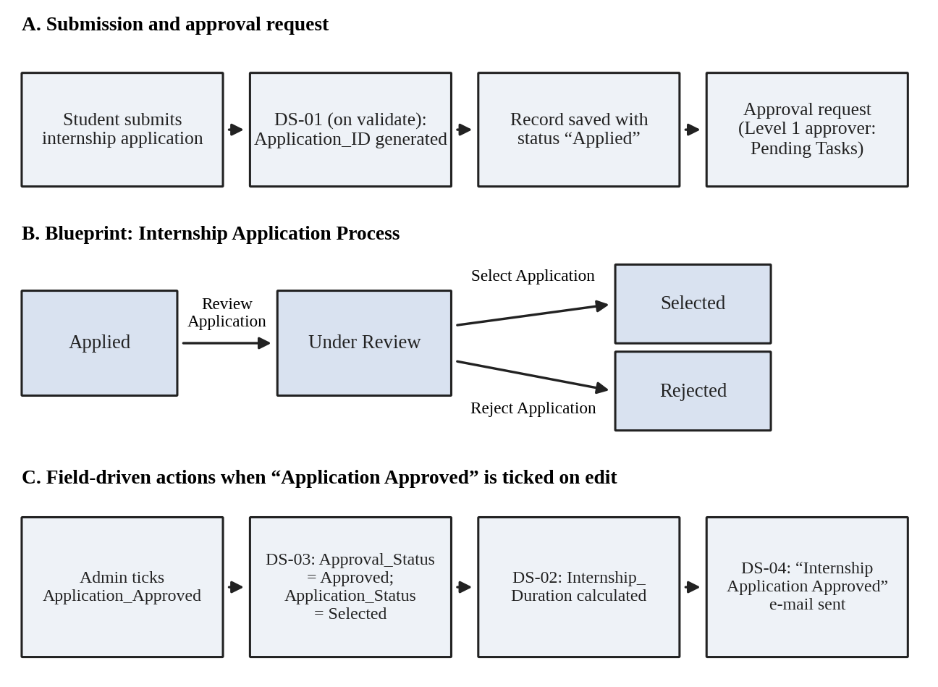
Figure 4.3: Workflow / Process Flow for the Internship Application

4.5 User Interface and Navigation Design
The application menu is organised by module, as shown in Figure 4.4. Each module groups its form with its reports, and the Internship Dashboard is a separate top-level entry.
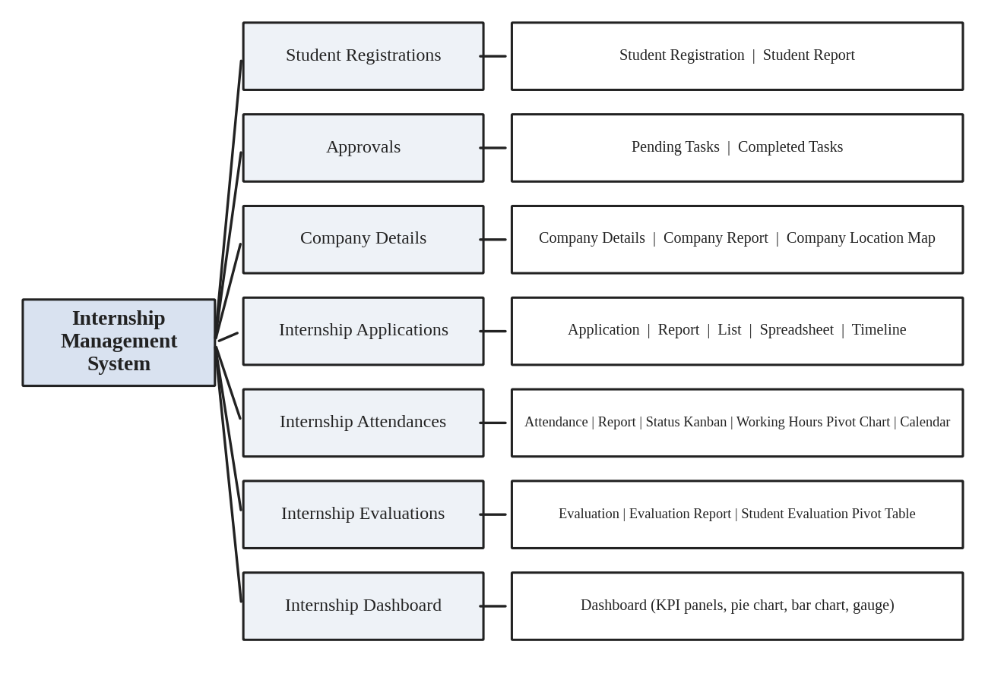
Figure 4.4: Navigation Structure of the Application

4.6 Access Control Design
Table 4.7 summarises the intended access design. Two access mechanisms are defined in the application: a role hierarchy for application users (CEO and Admin) and portal user permission profiles (Customer and Student). The Student column follows the description of the “Student” profile (view permitted internship information; manage own applications); the component-level settings should be verified against the profile before final submission.
Table 4.7: Role–Permission Matrix
Component | Administrator | Student (Portal User)
Form: Student Registration | A E V D | —
Form: Company Details | A E V D | —
Form: Internship Application | A E V D | A V (own)
Forms: Attendance and Evaluation | A E V D | —
Reports (all) | V | V (permitted)
Page: Internship Dashboard | V | —
Approvals: Pending / Completed Tasks | V; approve / reject | —

A = Add, E = Edit, V = View, D = Delete; — = no access intended.
CHAPTER 5

IMPLEMENTATION

5.1 Application Setup
The application “Internship Management System” was created in the Zoho Creator workspace of the student’s account and is built and tested in the Development environment, as indicated by the Development badge in the application header. The left-hand menu groups the application into Student Registrations, Approvals, Company Details, Internship Applications, Internship Attendances, Internship Evaluations and Internship Dashboard (Figure 5.1).The application was created from scratch using Zoho Creator, with forms, workflows, reports, and dashboards configured according to the project requirements.
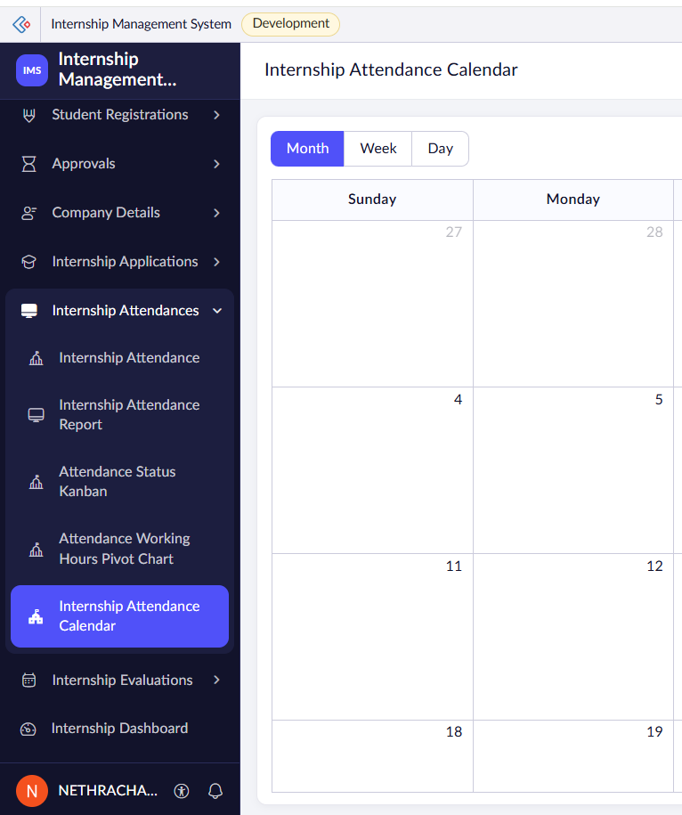
Figure 5.1: Application Navigation Sections in the Development Environment

5.2 Forms and Data Capture
Five forms were created. Student Registration (Figure 5.2) captures student details such as ID, name, e-mail, phone, department, year, CGPA, skills, resume, photo and placement interest, and also holds an Attendance Percentage field that is updated by a workflow. Company Details stores the company profile and the internship opportunity, including domain, mode, duration, stipend and available positions.
Internship Application (Figure 5.3) links a student and a company through lookup fields and records the domain, application date, start and end dates, mode, cover letter, resume, application status, approval status, the Application Approved check box and admin remarks. Internship Attendance records attendance status, check-in and check-out times, working hours, a proof document and remarks. Internship Evaluation (Figure 5.4) records the mentor name and five ratings; the Overall Rating is a formula field that averages the ratings and is therefore not entered on the form. The figures show selected forms in live mode; screenshots of the form builder were not captured.
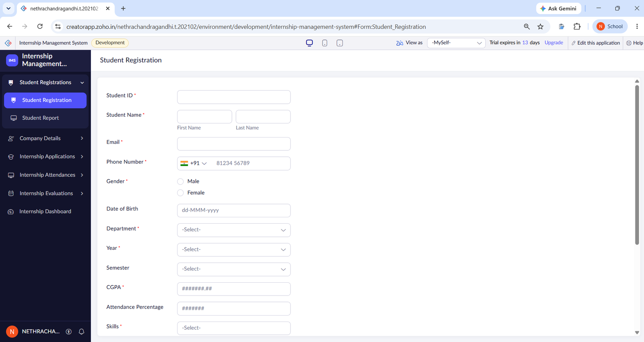
Figure 5.2: Student Registration Form in Live Mode (Top)
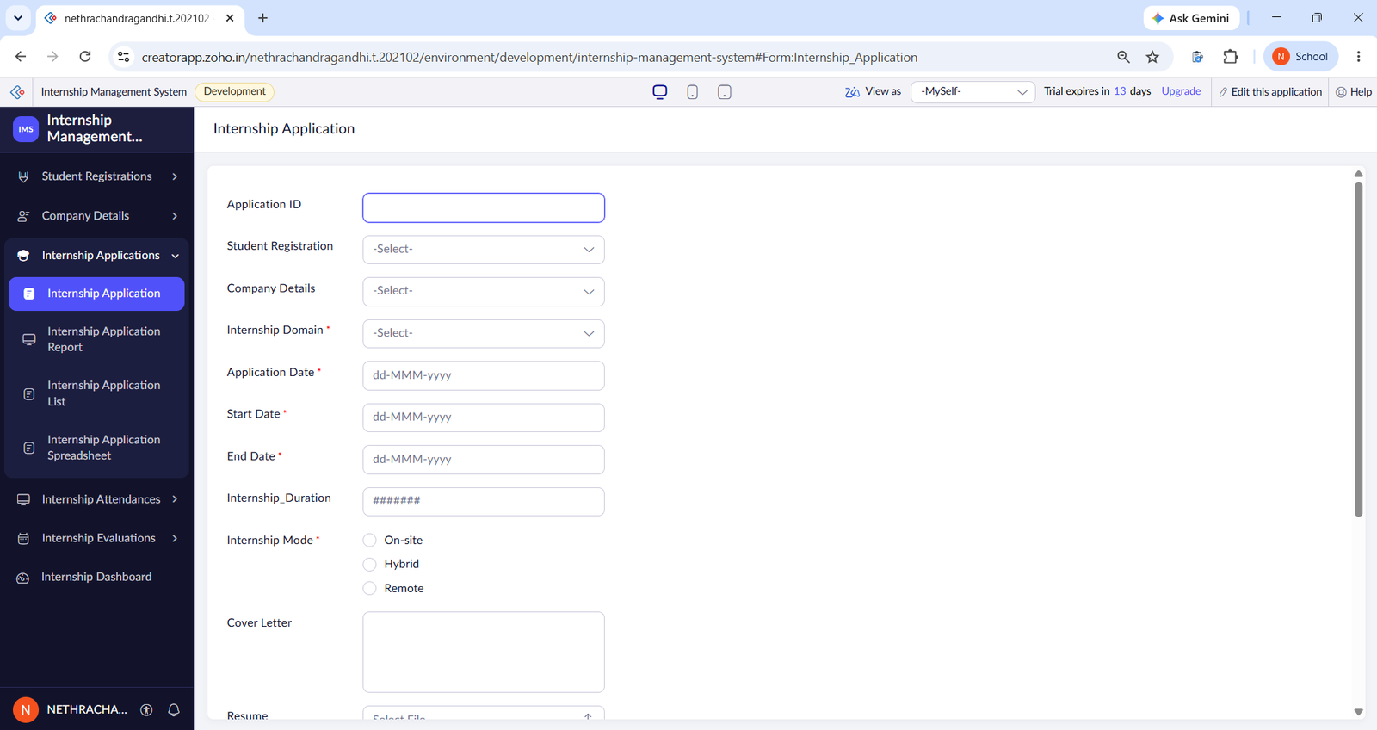
Figure 5.3: Internship Application Form in Live Mode (Top)
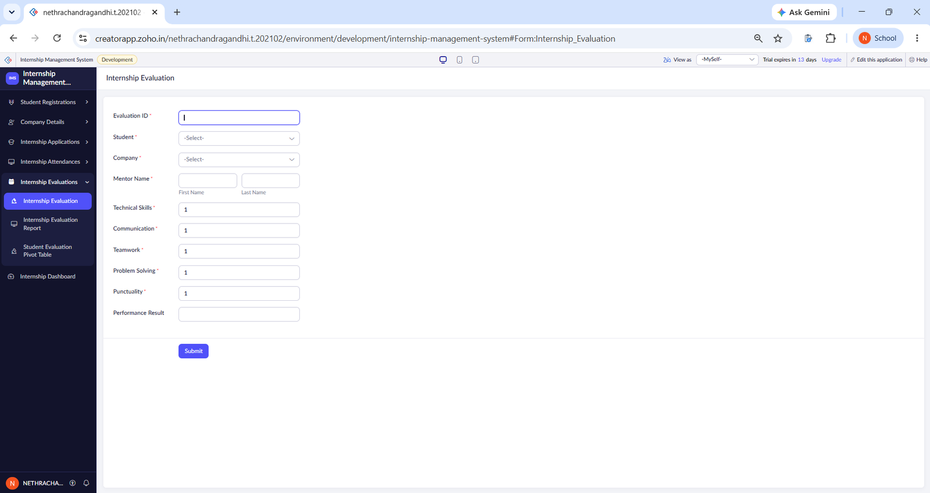
Figure 5.4: Internship Evaluation Form in Live Mode

5.3 Reports
Thirteen reports were created (Table 5.1). The figures that follow show the reports with the data stored at the time of capture.
Table 5.1: Reports Implemented
Report Name | Type | Source Form | Filter / Grouping / Sorting | Custom Actions | Roles
Student Report | List | Student Registration | Default | — | Admin
Company Report | List | Company Details | Default | — | Admin
Company Location Map | Map | Company Details | Company address markers | — | Admin
Internship Application Report | List | Internship Application | Default | — | Admin
Internship Application List | List | Internship Application | Default | — | Admin
Internship Application Spreadsheet | Spreadsheet | Internship Application | Default | — | Admin
Internship Application Timeline | Timeline | Internship Application | Week and Day views | — | Admin
Internship Attendance Report | List | Internship Attendance | Default | — | Admin
Attendance Status Kanban | Kanban | Internship Attendance | Columns by Attendance Status | — | Admin
Attendance Working Hours Pivot Chart | Pivot chart | Internship Attendance | Sum of Working Hours by Attendance Date | — | Admin
Internship Attendance Calendar | Calendar | Internship Attendance | Month, Week and Day views | — | Admin
Internship Evaluation Report | List | Internship Evaluation | Default | — | Admin
Student Evaluation Pivot Table | Pivot table | Internship Evaluation | Student and Company fields | — | Admin

The Student Report (Figure 5.5) and the Company Report (Figure 5.6) list the three students and three companies stored at the time. The Company Location Map (Figure 5.7) shows company markers around Chennai. The Internship Application Report (Figure 5.8, Figure 5.9), and List (Figure 5.10) show eight applications in different layouts (the Spreadsheet layout is listed in Table 5.1); the Timeline (Figure 5.11) shows applications along a week view. Note that the Internship_Duration column is filled only for the record on which the duration workflow has run (see Section 6.4).
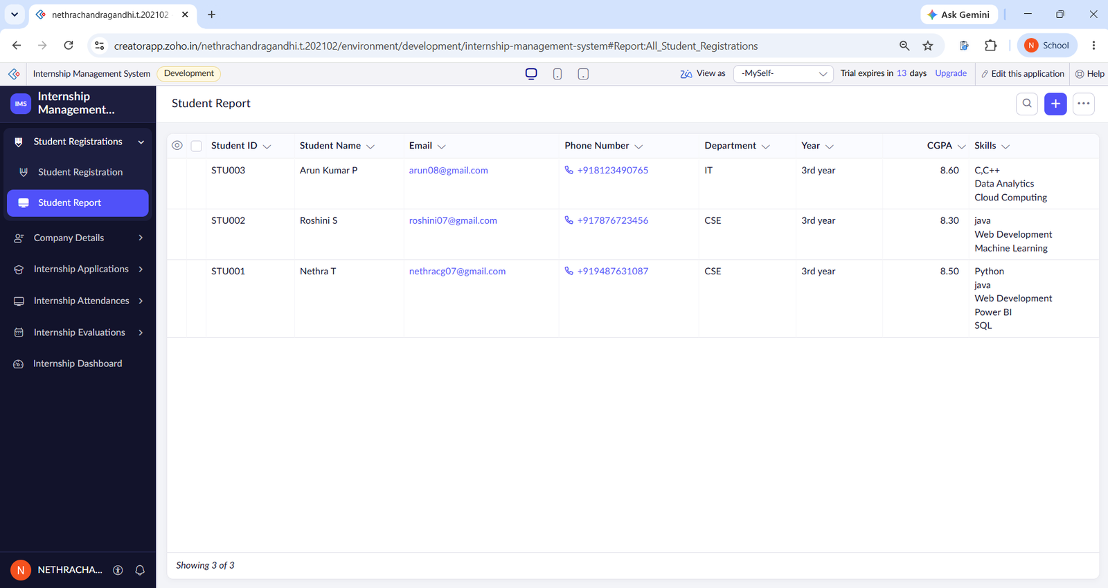
Figure 5.5: Student Report
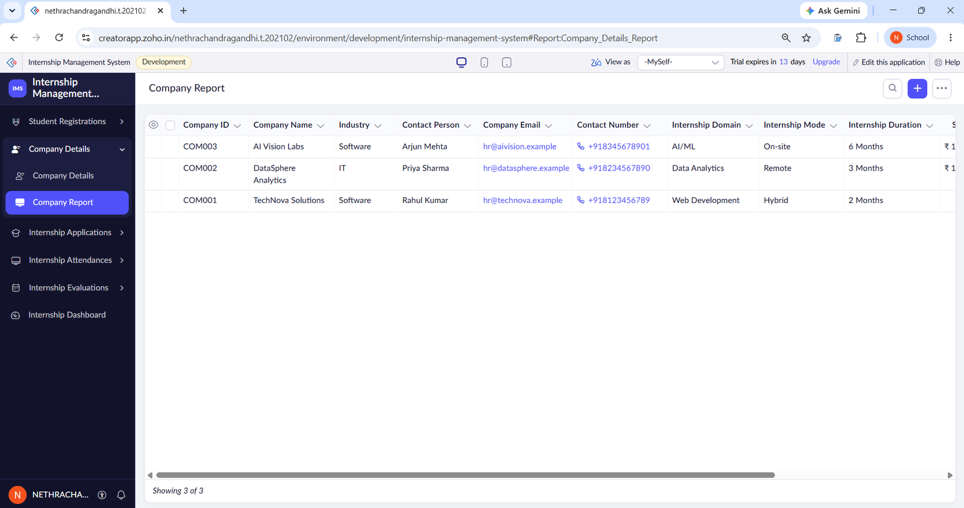
Figure 5.6: Company Report
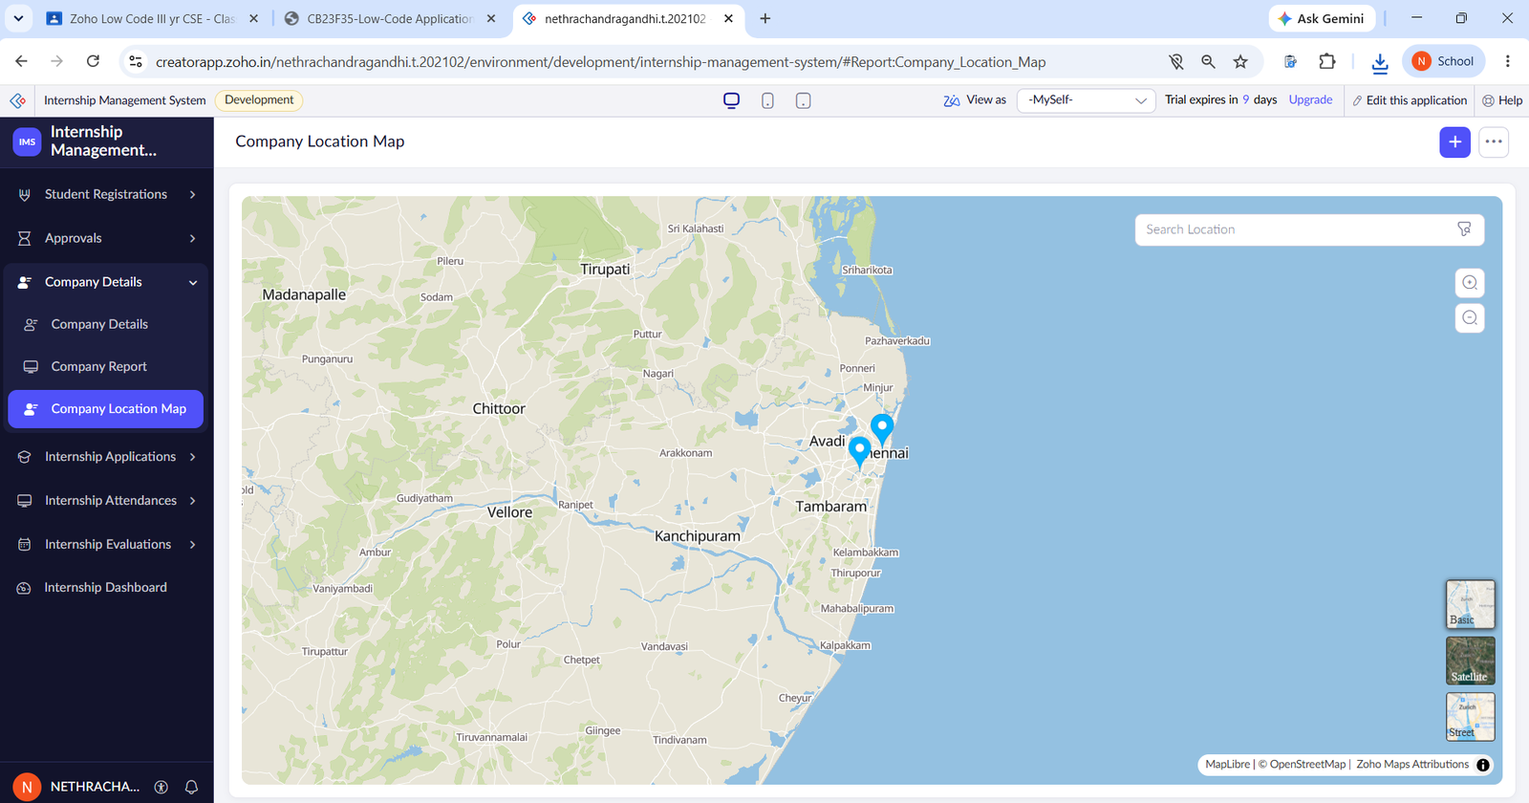
Figure 5.7: Company Location Map
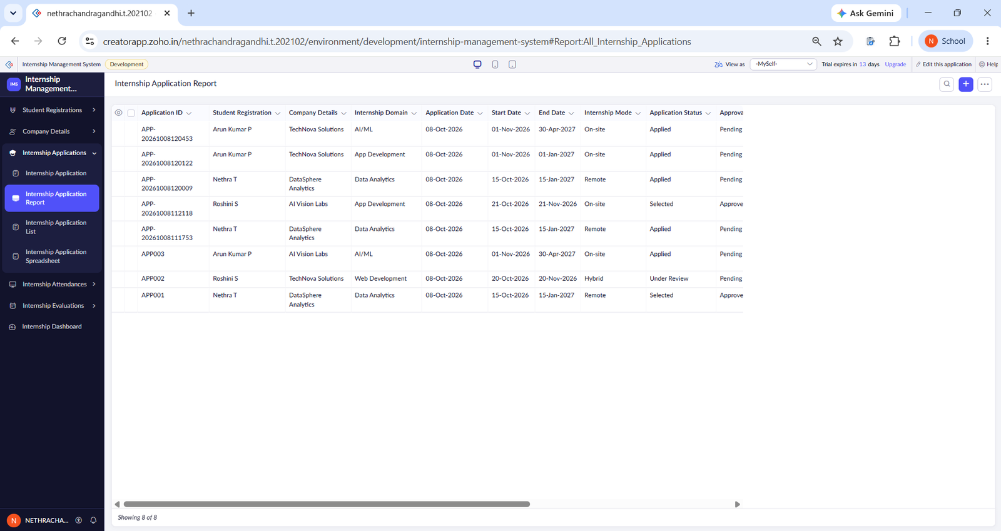
Figure 5.8: Internship Application Report (Left Columns)
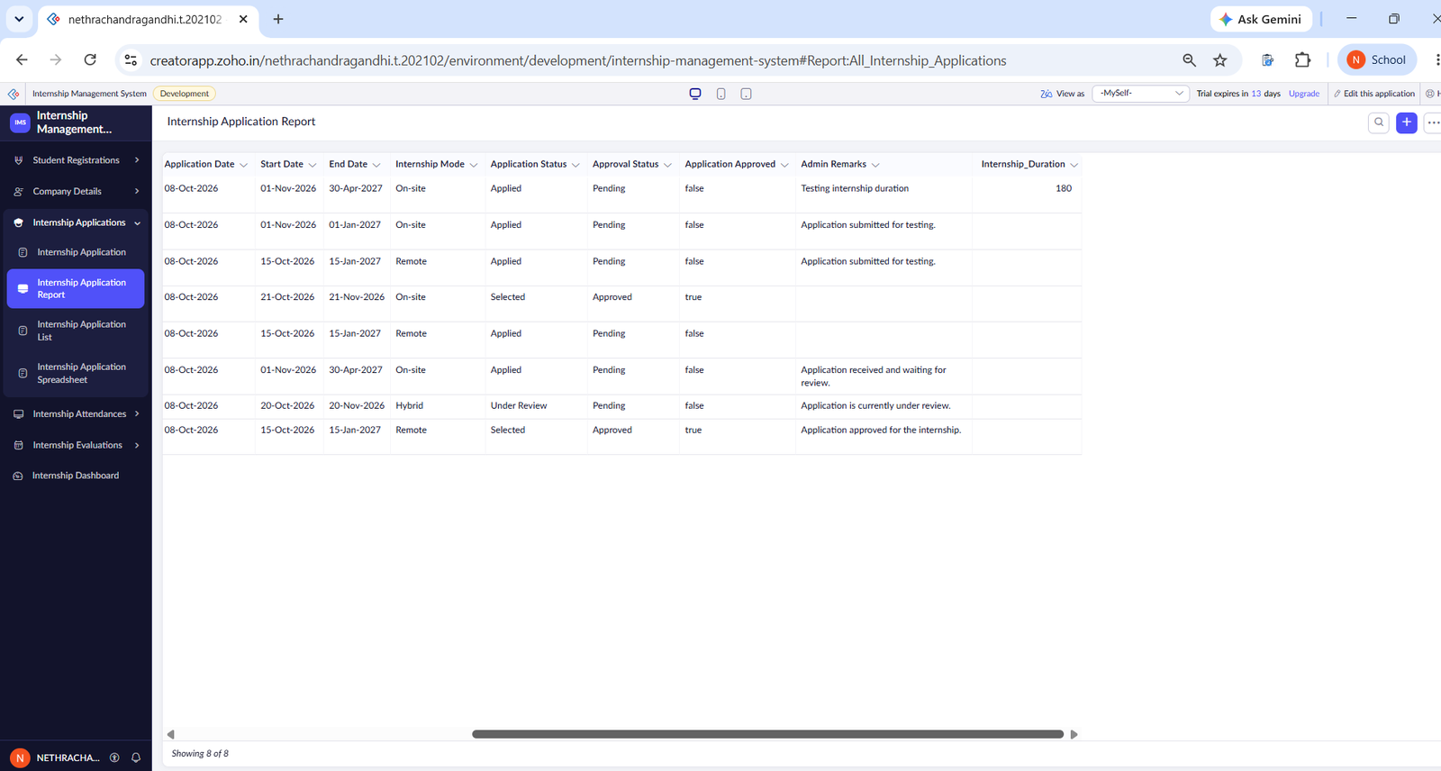
Figure 5.9: Internship Application Report (Right Columns)
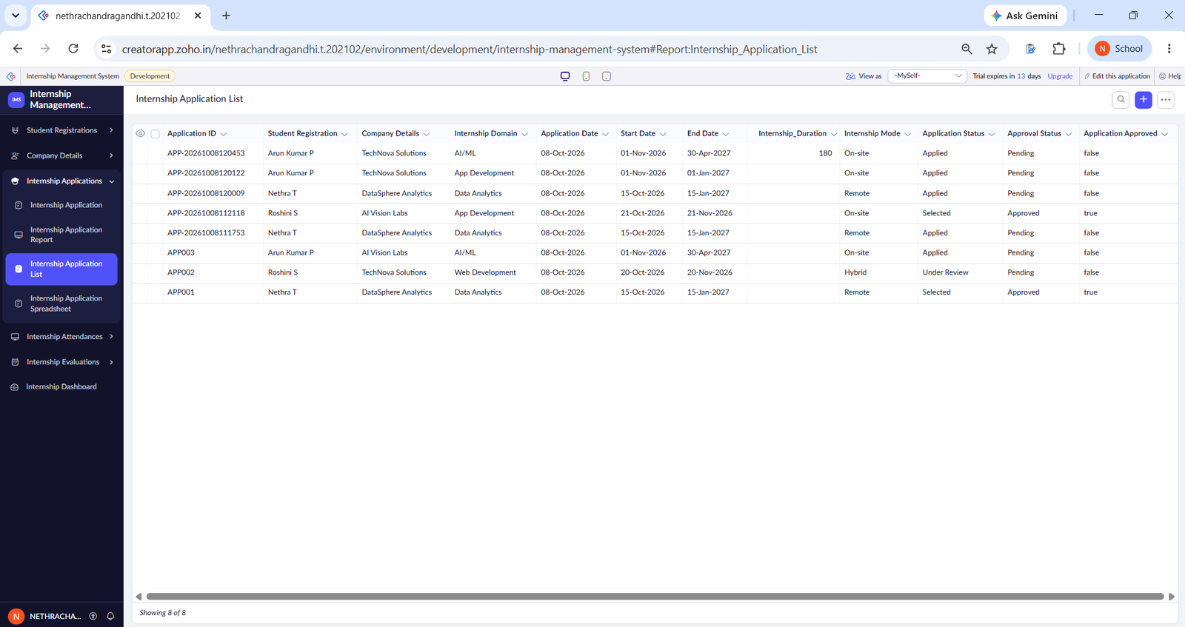
Figure 5.10: Internship Application List
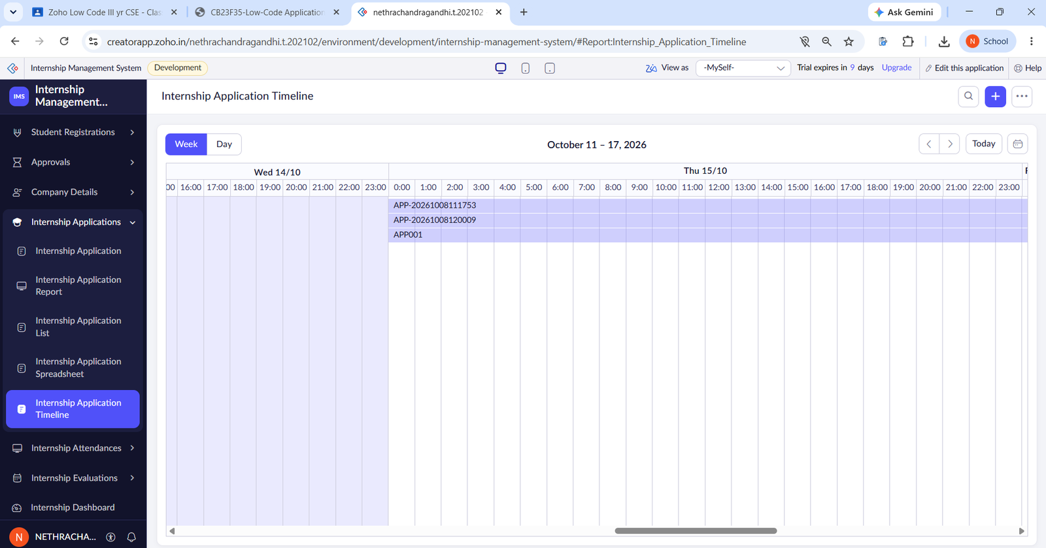
Figure 5.11: Internship Application Timeline
The Internship Attendance Report (Figure 5.12) shows four attendance records; the Attendance Status Kanban (Figure 5.13) groups them by status, with no records in the Leave and Half Day columns. The Pivot Chart plots the sum of working hours against the attendance date, and the Calendar places each record on its date (see Table 5.1). The Internship Evaluation Report (Figure 5.14) shows the five ratings and the overall rating for three evaluations.
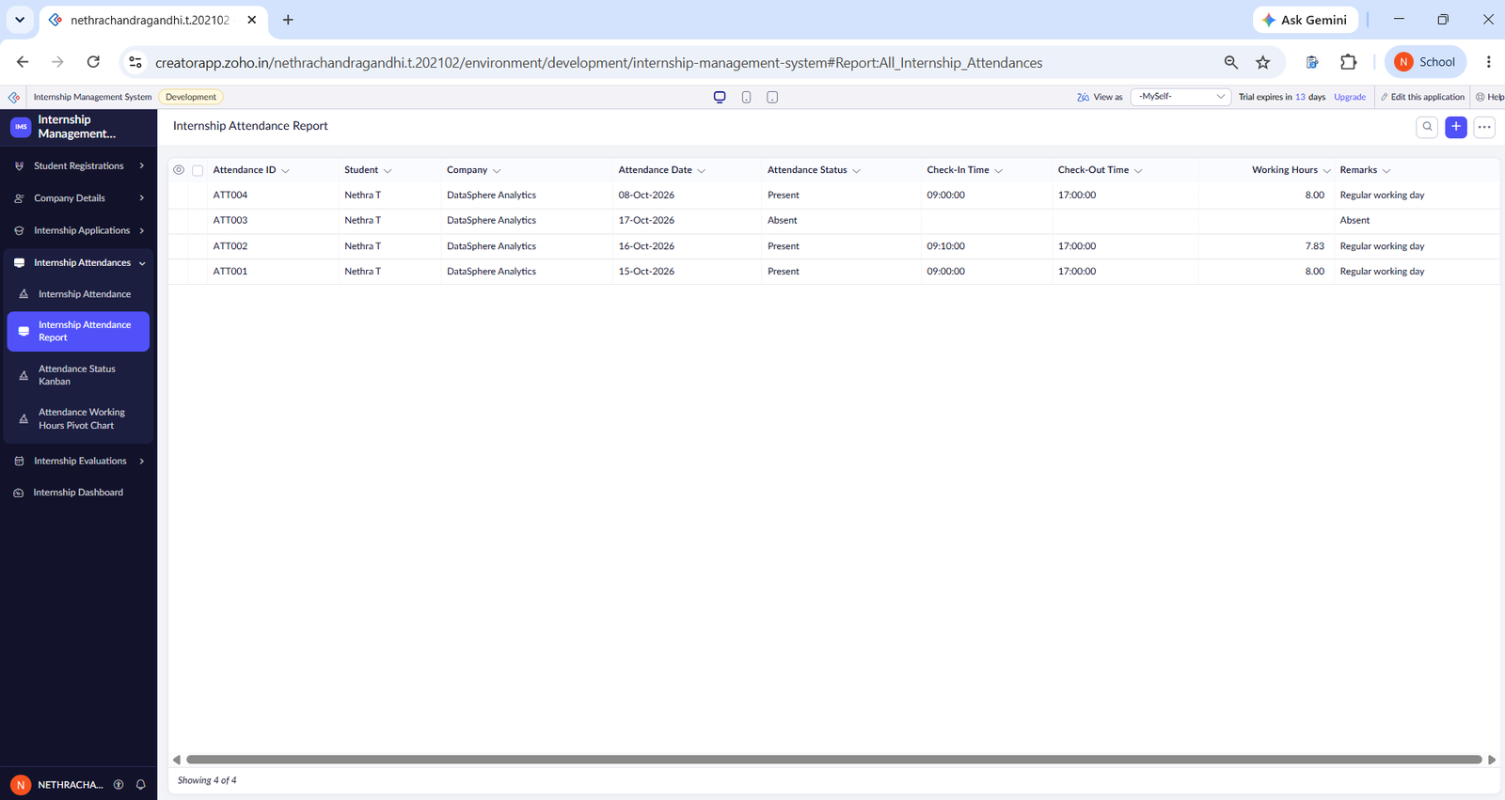
Figure 5.12: Internship Attendance Report
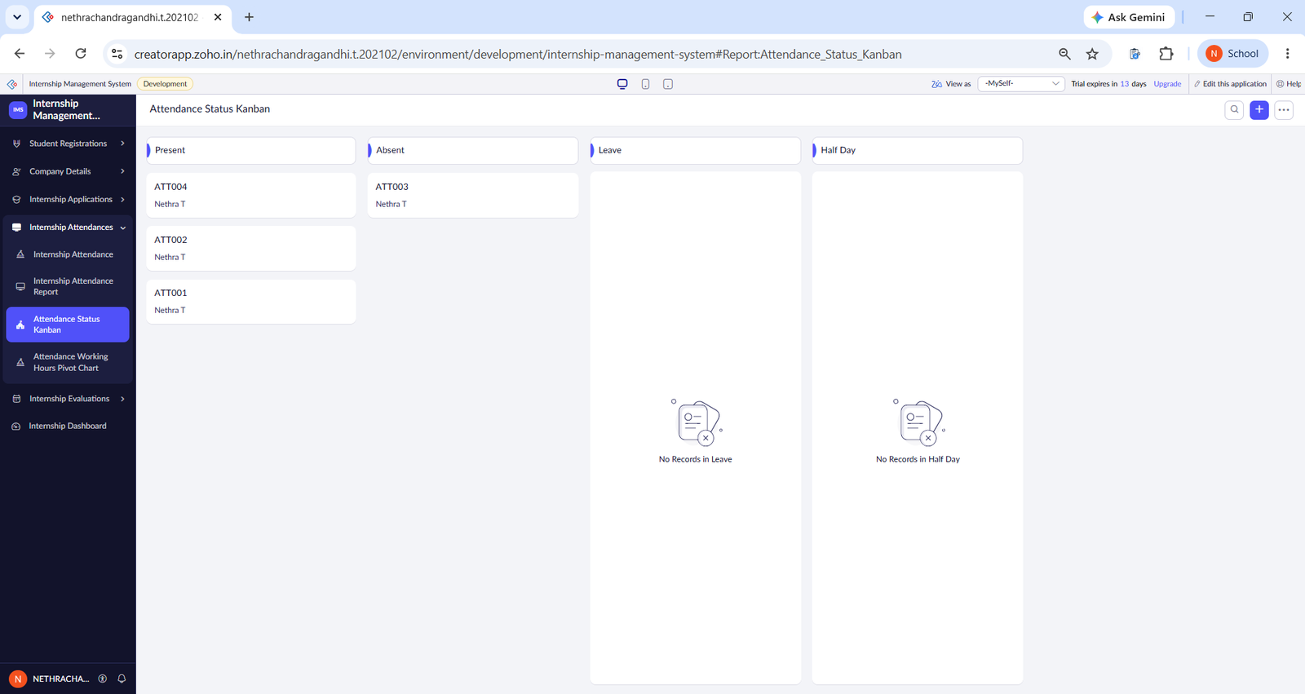
Figure 5.13: Attendance Status Kanban
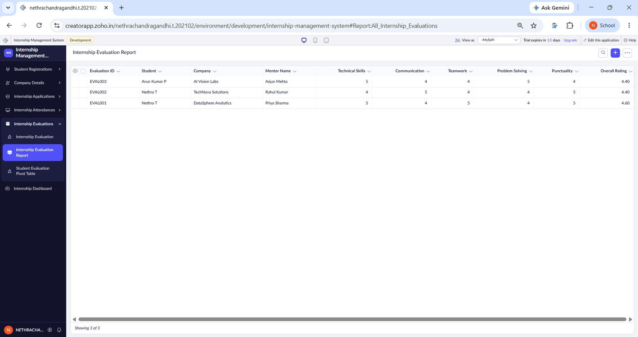
Figure 5.14: Internship Evaluation Report

5.4 Pages and Dashboards
The Internship Dashboard (Figure 5.15) gives a consolidated view. It contains a Total Students panel, a Total Companies panel, an Internship Application (total applications) panel, an Application Status pie chart, an Internship Working Hours bar chart and an Average Evaluation Rating gauge on a scale of 0 to 5. A Selected Applications panel is also part of the dashboard .The captured values were 3 students, 3 companies and 8 applications; the pie chart shows the statuses Applied, Under Review and Selected; the bar chart shows working hours for 8, 15 and 16 October 2026; and the gauge shows an average rating of 4.47. These values change as records are added.
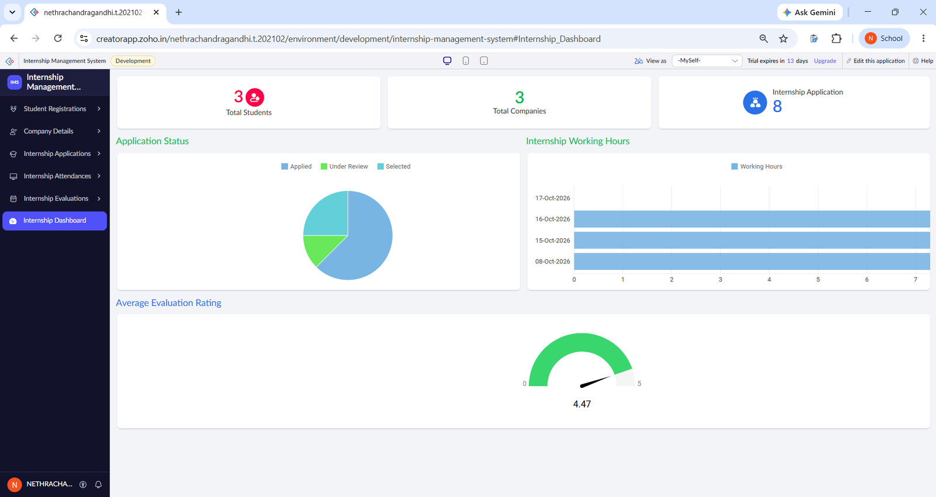
Figure 5.15: Internship Dashboard

5.5 Deluge Scripting
Seven Deluge scripts are used, all inside form workflows (Table 5.2). Six run in the “Validations on form submission” event and one runs on the update of the Application Approved field. They use conditions, date functions (daysBetween), time functions (getHour, getMinutes, getSeconds), arithmetic with rounding, string concatenation with the current time, a criteria-based fetch with a for each loop, and the sendmail task. No custom functions were written. The complete source is given in Appendix C.
Table 5.2: Deluge Scripts Implemented
Script ID | Location / Trigger | Purpose | Deluge Concepts Used
DS-01 | Internship Application → Created → On validate | Generate the Application ID | zoho.currenttime, toString, string concatenation
DS-02 | Internship Application → Edited → On validate | Calculate internship duration in days | null check, daysBetween
DS-03 | Internship Application → Edited → On validate | Set Approval Status and Application Status when approved | if condition, field assignment
DS-04 | Internship Application → Edited → Update of Application Approved | Send the approval notification e-mail | sendmail
DS-05 | Internship Attendance → Created → On validate | Calculate working hours from check-in and check-out | null check, getHour / getMinutes / getSeconds, round
DS-06 | Internship Evaluation → Edited → On validate | Derive Performance Result from Overall Rating | if / else if
DS-07 | Student Registration → Edited → On validate | Calculate attendance percentage | criteria fetch, for each loop

Code 5.1: Application ID generation (DS-01)
input.Application_ID = "APP-" + zoho.currenttime.toString("yyyyMMddHHmmss");

Code 5.2: Attendance working hours (DS-05)
if(input.Check_In_Time != null && input.Check_Out_Time != null)
{
checkin_seconds = input.Check_In_Time.getHour() * 3600 + input.Check_In_Time.getMinutes() * 60 + input.Check_In_Time.getSeconds();
checkout_seconds = input.Check_Out_Time.getHour() * 3600 + input.Check_Out_Time.getMinutes() * 60 + input.Check_Out_Time.getSeconds();
if(checkout_seconds >= checkin_seconds)
{
input.Working_Hours = ((checkout_seconds - checkin_seconds) / 3600.0).round(2);
}
}

Code 5.3: Application approval status update (DS-03)
if(input.Application_Approved == true)
{
input.Approval_Status = "Approved";
input.Application_Status = "Selected";
}

DS-01 builds the Application ID from the prefix “APP-” and the current date and time (for example APP-20261008120453), as seen in Figure 5.8. DS-05 converts the check-in and check-out times into seconds, subtracts them and divides by 3600 to give hours rounded to two decimals; for 09:00 to 17:00 it produced 8.00 and for 09:10 to 17:00 it produced 7.83 (Figure 5.12). DS-03 sets Approval Status to Approved and Application Status to Selected when Application Approved is true. The workflow screens are shown in Section 5.6.

5.6 Workflows and Automation
Table 5.3 lists the workflows: seven form workflows, two schedules, one approval process and one Blueprint. No batch or report workflows were created.
Table 5.3: Workflows Implemented
Workflow Name | Type | Trigger / Event | Condition | Action(s) | Script Ref.
Application Submission Workflow | Form workflow | Internship Application created, on validate | — | Generate Application ID | DS-01
Calculate Internship Duration | Form workflow | Internship Application edited, on validate | Start and end dates not null | Store duration in days | DS-02
Application Approval Workflow | Form workflow | Internship Application edited, on validate | Application Approved is true | Set Approved and Selected | DS-03
Student Approval Email Notification | Form workflow | Update of Application Approved | — | Send e-mail | DS-04
Attendance Working Hours Workflow | Form workflow | Internship Attendance created, on validate | Check-in and check-out not null | Calculate working hours | DS-05
Calculate Performance Result | Form workflow | Internship Evaluation edited, on validate | Overall Rating thresholds | Set Performance Result | DS-06
Calculate Attendance Percentage | Form workflow | Student Registration edited, on validate | Present records | Compute attendance percentage | DS-07
Daily Pending Application Check | Schedule | Starts 15-Oct-2026, 09:00 | — | Send mail to the admin user | —
Monthly Internship Summary Reminder | Schedule | Starts 01-Nov-2026, 09:00 | — | Reminder action | —
Internship Application Approval Process | Approval | Application record (Pending Tasks) | Actions run if Application_Status is “Applied” | Level 1 approver; Approve and Reject; mail to submitter | —
Internship Application Process | Blueprint | Stage transitions | — | Applied → Under Review → Selected / Rejected | —

The Application Approval Workflow is shown in Figure 5.16. The Application Submission Workflow (DS-01), Application Approval Workflow (Figure 5.16), Calculate Internship Duration (DS-02), Attendance Working Hours Workflow (DS-05), Calculate Performance Result (DS-06) and Calculate Attendance Percentage (DS-07) each contain one Deluge script (full code in Appendix C). In the Performance Result script, ratings of 4.5 or more give “Excellent”, 3.5 or more “Good” and 2.5 or more “Average”.
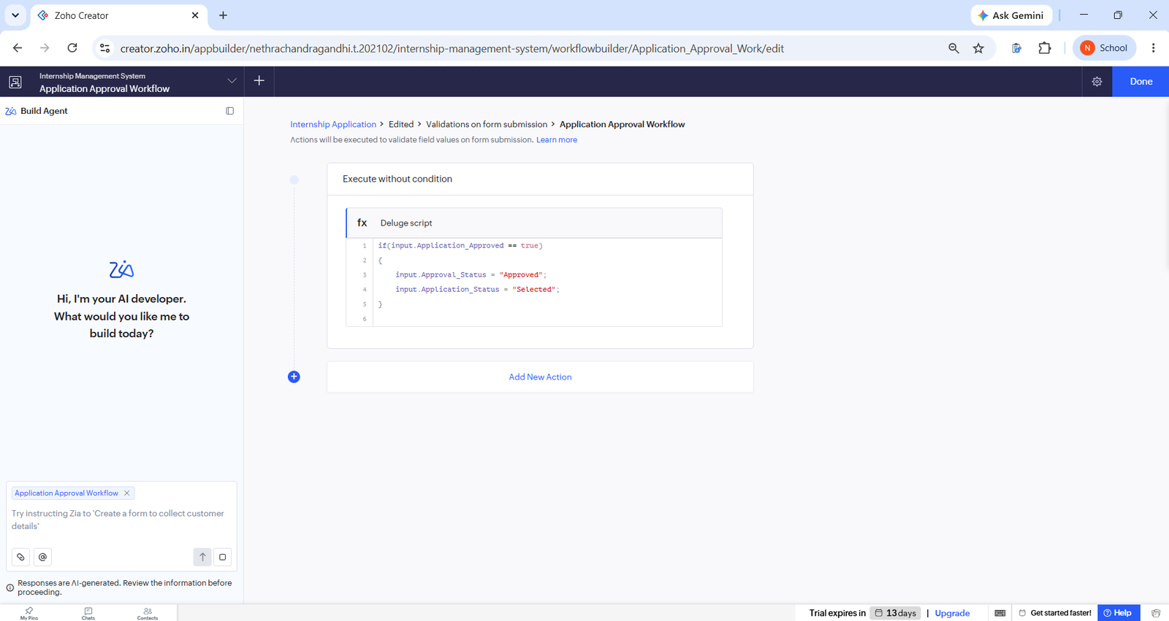
Figure 5.16: Application Approval Workflow (DS-03)
The Blueprint “Internship Application Process” (Figure 5.17) defines the stages Applied, Under Review, Selected and Rejected, with the transitions Review Application, Select Application and Reject Application. Two custom schedules are enabled (Figure 5.18); the Daily Pending Application Check sends a mail to the administrator user at 09:00.
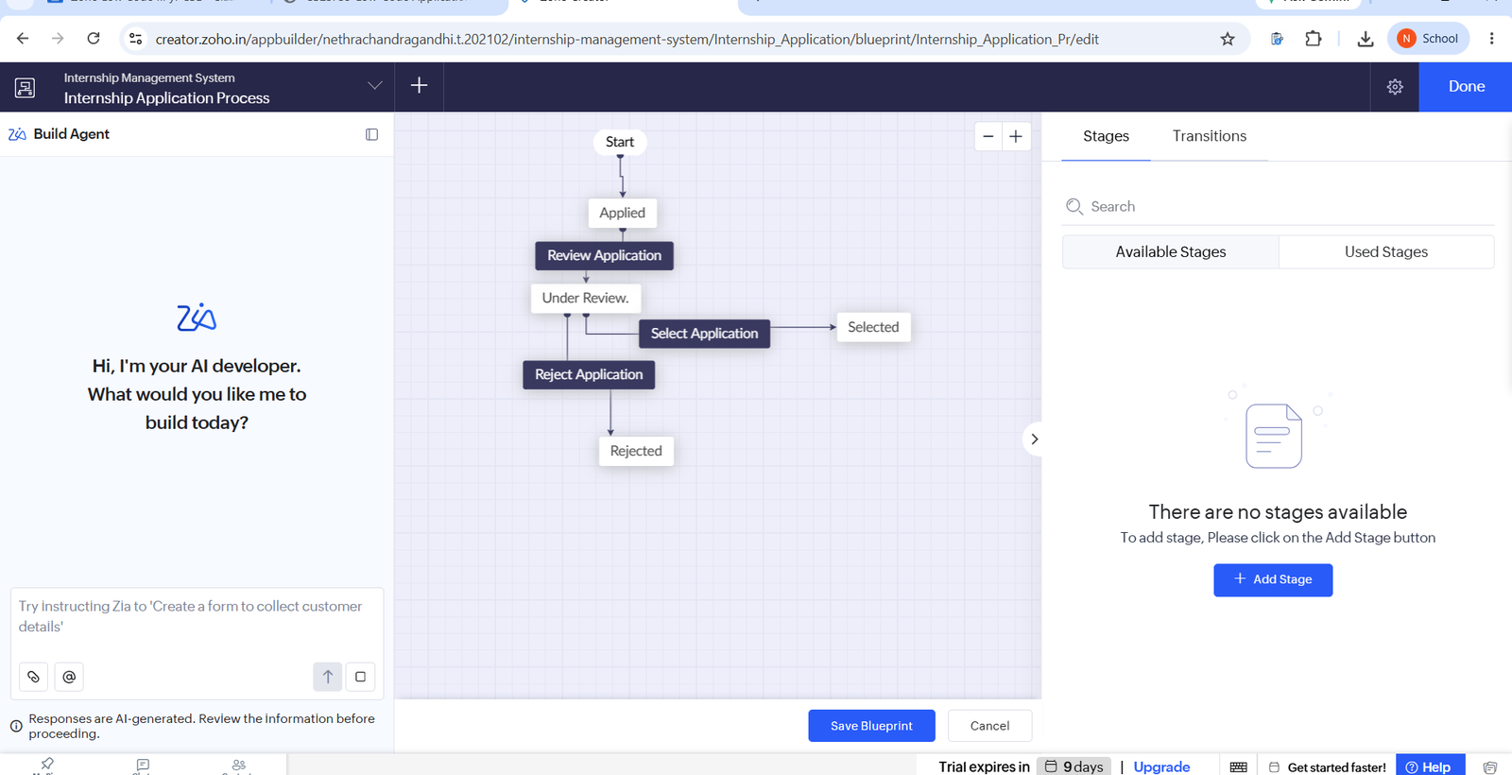
Figure 5.17: Internship Application Process Blueprint
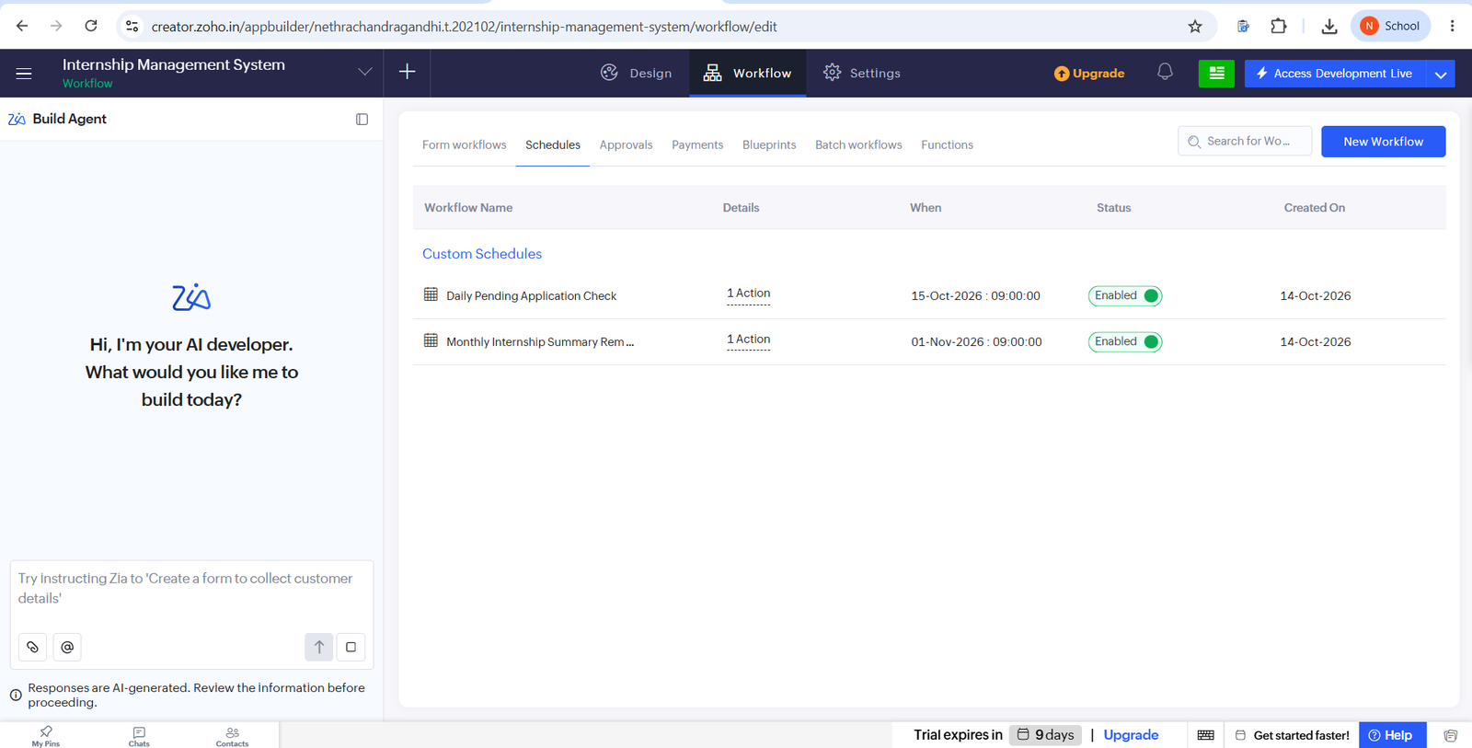
Figure 5.18: Custom Schedules
The Internship Application Approval Process (Figure 5.19) has one Level 1 approver with Approve and Reject outcomes; each outcome runs a mail action only when Application_Status is “Applied”. A newly added application appears under Approvals → Pending Tasks (Figure 5.20). This approval process is separate from the Application Approved workflow (DS-03, DS-04), which acts on the check box in the record itself.
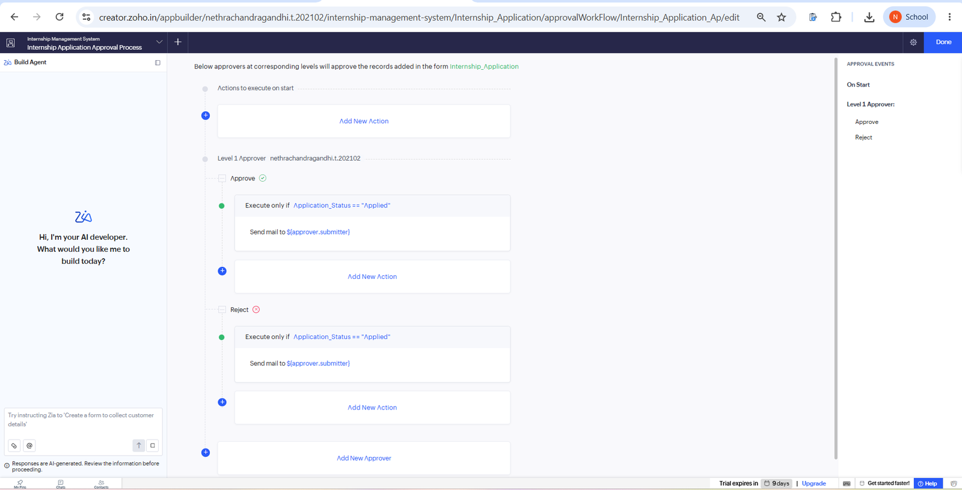
Figure 5.19: Internship Application Approval Process Configuration
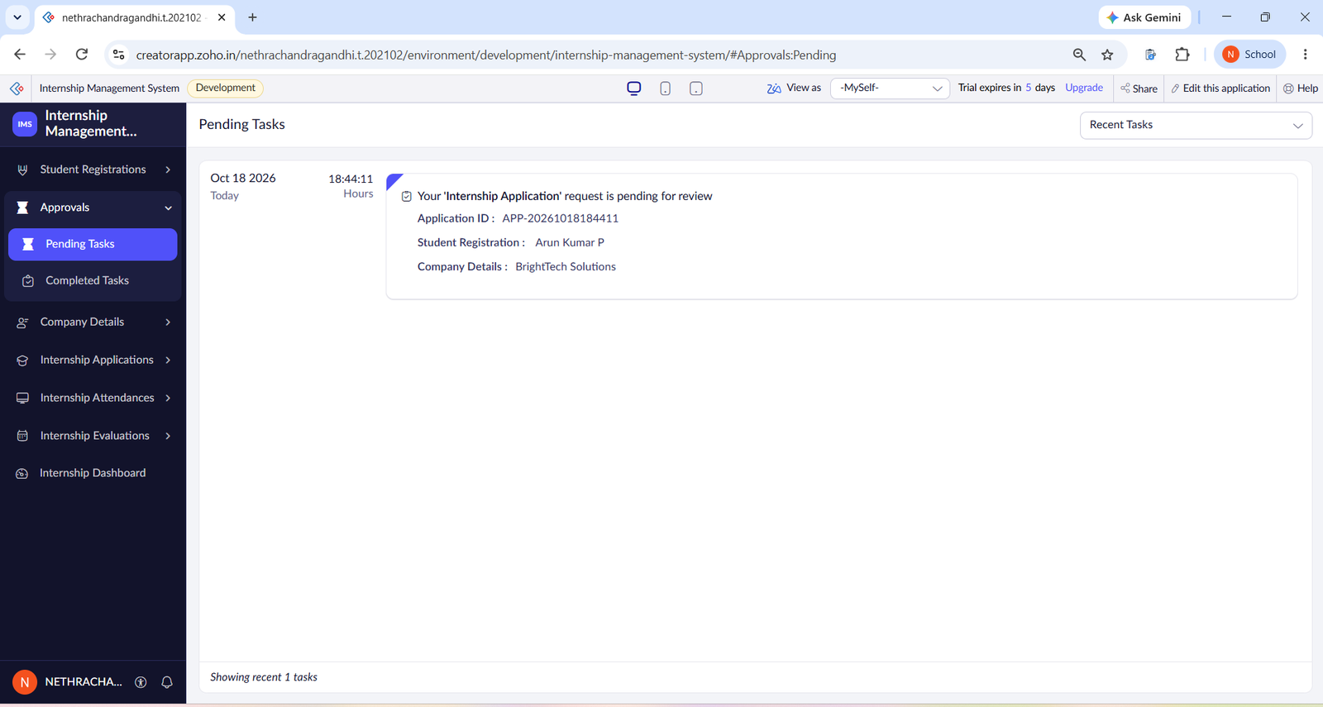
Figure 5.20: Pending Tasks in the Approvals Section

5.7 Integrations
No external systems, REST APIs, webhooks or connections were used. The application uses two built-in platform capabilities, listed in Table 5.4: the Send Mail action for the approval notification and the Map report for company locations.
Table 5.4: Integrations Implemented
Integration | Service / Endpoint | Method | Authentication | Data Exchanged / Purpose
Approval e-mail | Zoho Creator Send Mail | sendmail task in DS-04 | Platform-managed | Notify that the application is approved
Company map | Zoho Maps | Map report | Platform-managed | Show company locations from addresses

Code 5.4: Approval notification e-mail (DS-04)
sendmail
[
from :"<configured sender address>"
to :"<fixed test e-mail address>"
subject :"Internship Application Approved"
message :"Dear Student, your internship application has been approved. Please log in to the Internship Management System to view your application details."
]

The e-mail is sent with the subject “Internship Application Approved”. It was tested with a fixed test address, and the message was received (Figure 5.21). Delivery to each student’s own registered address has not been tested.
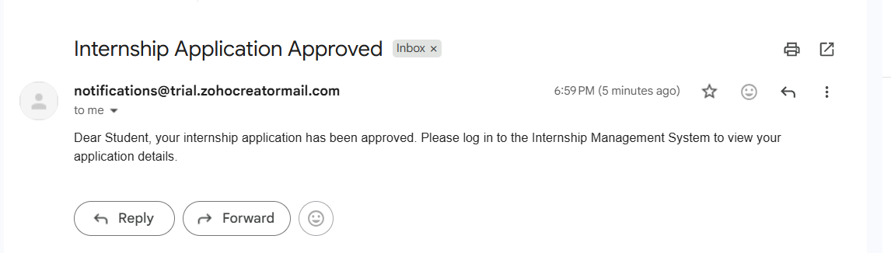
Figure 5.21: Approval Notification Received in the Inbox

5.8 User Management and Role-Based Access
The role hierarchy contains the CEO role with the Admin role beneath it (Figure 5.22). Portal user permission profiles named Customer and Student are defined; the Student profile is described as allowing students to view permitted internship information and manage their own applications (Figure 5.23). The Zoho Creator user list shows the application owner as Super Admin along with other active users.
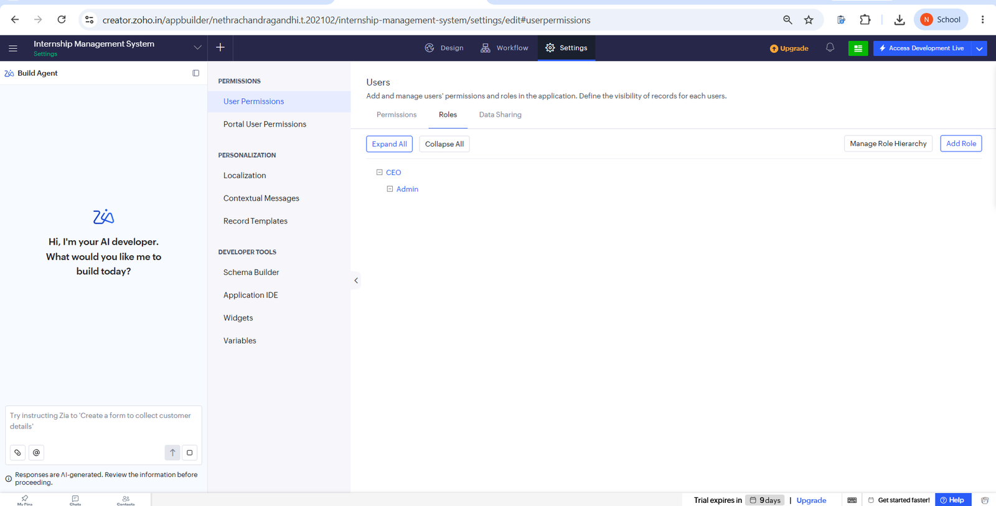
Figure 5.22: Role Hierarchy (CEO and Admin)
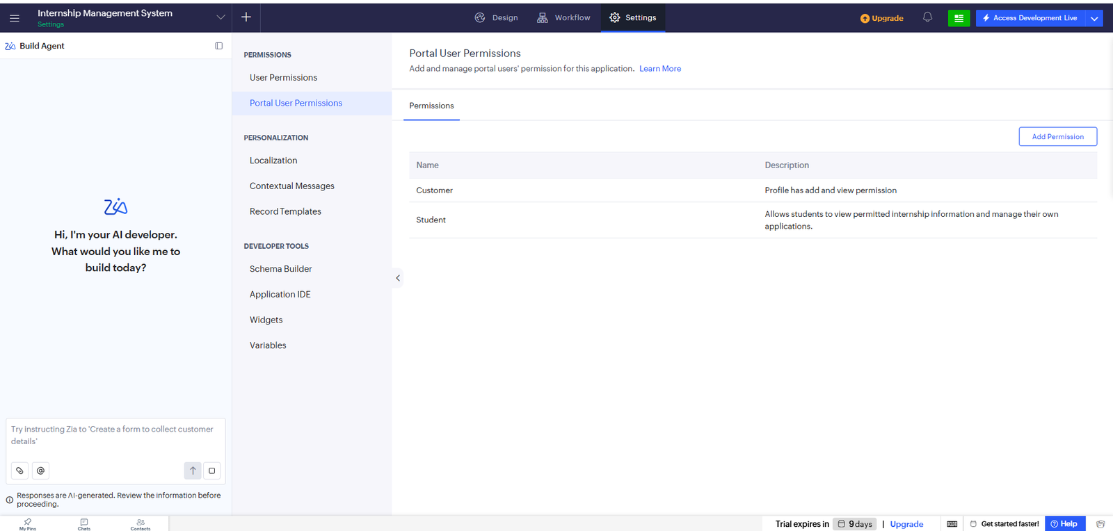
Figure 5.23: Portal User Permissions (Customer and Student)

5.9 AI and Analytics Features
Analytics are provided by the dashboard charts and pivot reports: the Application Status pie chart, the Internship Working Hours bar chart and the Average Evaluation Rating gauge (Figure 5.15), the Attendance Working Hours Pivot Chart and the Student Evaluation Pivot Table. These summarise application status, attendance hours and evaluation ratings. No Zia prediction or other AI field was configured in the forms. The Zoho Creator editor displays a Zia “Build Agent” panel in the workflow screens. The Build Agent and other AI-assisted features were not used while developing the application.

5.10 Pro-Code Extension
No pro-code extension was developed. All logic is written in Deluge inside form workflows, and the requirements did not call for custom widgets, Catalyst functions or REST API integrations. Such extensions would become relevant only if the system had to exchange data with external services or needed processing beyond what Deluge supports.

5.11 Mobile and Portal Access
Portal user permission profiles (Customer and Student) are defined in the application (Figure 5.23). A live portal login and the Zoho Creator mobile app were not demonstrated in this project.
CHAPTER 6

TESTING AND DEBUGGING

6.1 Testing Strategy
Testing was carried out in the Development environment by submitting records through the live forms and checking the results in the reports, the dashboard and the mailbox. The levels covered were (a) form-level testing of record submission, (b) script-level testing of each Deluge calculation, (c) workflow testing of the status update, approval request and e-mail notification, and (d) validation of the report and dashboard views. Role-based testing with a Student portal login, negative tests of mandatory fields and user acceptance testing were not recorded and are listed as pending in Section 6.5.

6.2 Test Cases
Table 6.1: Test Cases
TC ID | FR Ref. | Test Description | Input / Steps | Expected Result | Actual Result | Status
TC-01 | FR-01 | Submit Student Registration form | Enter valid student details | Record saved | Three students listed (Figure 5.5) | Pass
TC-02 | FR-02 | Submit Company Details form | Enter valid company details | Record saved | Three companies listed (Figure 5.6) | Pass
TC-03 | FR-03 | Submit Internship Application | Select student, company, dates | Saved; Application ID generated | ID such as APP-20261008120453 (Figure 5.8) | Pass
TC-04 | FR-08 | Tick Application Approved | Edit an application and tick the check box | Approval Status Approved; Application Status Selected | Record shows Selected, Approved, true (Figure 5.10) | Pass
TC-05 | FR-04 | Internship duration | Start 01-Nov-2026, end 01-Dec-2026 | 30 days | 30 days (as recorded by the student); 180 days for 01-Nov-2026 to 30-Apr-2027 (Figure 5.9) | Pass
TC-06 | FR-05 | Working hours, full day | Check-in 09:00, check-out 15:00 | 6.00 hours | 6.00 hours (as recorded); 09:00–17:00 gave 8.00 (Figure 5.12) | Pass
TC-07 | FR-05 | Working hours, late check-in | Check-in 09:10, check-out 17:00 | 7.83 hours | 7.83 hours (Figure 5.12) | Pass
TC-08 | FR-05 | Absent record | Status Absent, no times | No working hours | Working Hours blank for ATT003 (Figure 5.12) | Pass
TC-09 | FR-06 | Overall rating, example 1 | 5, 4, 5, 4, 5 | 4.6 | 4.60 (Figure 5.14) | Pass
TC-10 | FR-06 | Overall rating, example 2 | 5, 4, 4, 5, 4 | 4.4 | 4.40 (Figure 5.14) | Pass
TC-11 | FR-09 | Approval e-mail | Tick Application Approved | E-mail sent to the configured test address | E-mail received (Figure 5.21) | Pass
TC-12 | FR-10 | Approval request raised | Add an application | Pending task for the approver | Pending task APP-20261018184411 (Figure 5.20) | Pass
TC-13 | FR-13 | Attendance Kanban | Open the Kanban report | Records grouped by status | Present 3, Absent 1; Leave and Half Day empty (Figure 5.13) | Pass
TC-14 | FR-14 | Dashboard values | Open the dashboard | Counts, charts and gauge shown | 3 students, 3 companies, 8 applications, gauge 4.47 (Figure 5.15) | Pass
TC-15 | FR-11 | Blueprint transitions | Move an application through the stages | Stage changes per transition | Blueprint transition completed successfully (Figure 5.17). | Pass
TC-16 | FR-15 | Scheduled mail | Wait for the schedule time | Mail sent to admin | Scheduled email executed successfully (Figure 5.18). | Pass

6.3 Debugging Deluge Scripts
Each script was verified by submitting or editing a record and reading the calculated field in the report. For example, the working-hours script was checked with known check-in and check-out times and the duration script with known dates. Where a result was missing, the trigger event of the workflow (create or edit) and the field link names used in the script were checked in the Workflow builder. Debug output or log screenshots were not captured, so no figure is included for this section.
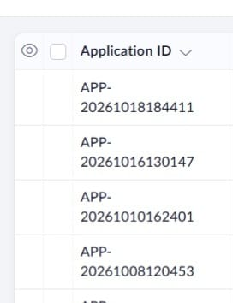
Figure 6.1: Deluge Debug Output

6.4 Defect Log
Table 6.2: Defect Log
Bug ID | Description | Root Cause | Fix Applied | Status
BUG-01 | Internship_Duration is blank for most applications (Figure 5.10). | The duration workflow is configured for the Edit event only, so records that are only created do not run it. | Not yet applied; run the workflow on create as well as edit. | Open
BUG-02 | The approval e-mail is not addressed to the student concerned. | The recipient address in DS-04 is a fixed test address. | Not yet applied; use the student’s registered e-mail address through the lookup. | Open

6.5 User Acceptance Testing
User acceptance feedback was collected from one invited user who accessed the application with read and write permissions. The user reviewed the application and provided positive feedback on its usability. The feedback is recorded in Table 6.3.
Table 6.3: User Acceptance Feedback
User | Role Tested | Feedback | Action Taken
User 1 | Application user (Read/Write) | The application is easy to use and the features are good. | Feedback received; no changes requested.
CHAPTER 7

DEPLOYMENT, SECURITY AND GOVERNANCE

7.1 Environments and Deployment Strategy
The application was developed and tested in the Development environment of Zoho Creator, which is indicated by the Development badge and the “Access Development Live” option in the screenshots. The account is on a trial edition. The application was developed and tested in the Development environment. Although Stage and Production environments were available in the Zoho Creator Environments section, the application was not separately published to Production. Therefore, the application was maintained and tested in Development.
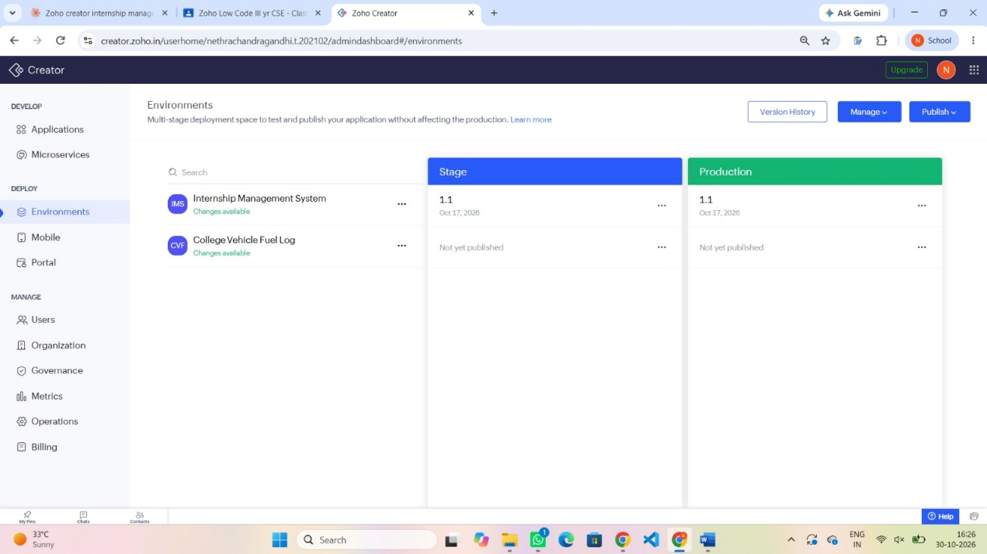
Figure 7.1: Environment/Publish to Production
Table 7.1: Deployment Checklist
S.No. | Checklist Item | Done (✓)
1 | All test cases executed in Development / Stage | Partly (see Table 6.1)
2 | Sample/test data removed or isolated | ✓ Test data retained for demonstration
3 | Roles, permissions and users configured in Production | Not Applicable
4 | Connections authorised in Production | Not applicable
5 | Schedules and workflows enabled | ✓ (Development)
6 | Application published and URL verified | Not published seperately
7 | Version / release notes recorded | ✓ Version 1.1 recorded

7.2 Performance Optimisation
No formal performance measurements were taken, because the data volume is small. One design choice is relevant to performance: DS-07 retrieves only the attendance records of the student concerned through a criteria-based fetch instead of reading the whole form.
Table 7.2: Performance Optimisation Results
Optimisation Applied | Component | Before | After | Improvement
Criteria-based fetch of one student’s attendance records | DS-07 | Not measured | Not measured | Not measured

7.3 Security Features
Table 7.3: Security Controls Implemented
Security Control | Where Applied | Threat Mitigated
Role hierarchy (CEO and Admin) | Application users | Unauthorised administrative actions
Portal user permission profiles (Customer, Student) | Portal users | Students accessing records meant for others
Approval process with a designated Level 1 approver | Internship Application | Unreviewed approval of applications
Mandatory fields | All forms | Incomplete or invalid records

Encryption of individual fields, OAuth connections and record-level permission criteria were not configured, because the application has no external connections and no field-level sensitivity requirement was defined.

7.4 Governance and Administration
Administration is handled by the application owner, who is the Super Admin of the Zoho Creator account and the Level 1 approver of the approval process. Workflows are given descriptive names (for example, Calculate Internship Duration) so that each rule can be located from the Workflow builder, and the user list is maintained in the Zoho Creator administration console. Version information was reviewed through the Zoho Creator Environments section, where Version 1.1 was displayed.
CHAPTER 8

RESULTS AND DISCUSSION

8.1 Application Output
The following scenario demonstrates the working of the Internship Management System developed using Zoho Creator.
Step 1: Student Registration and Application Submission

The student details are entered and stored through the Student Registration form. The student then submits an internship application by selecting the company and providing the required internship details. The system automatically generates a unique Application ID for tracking the application.

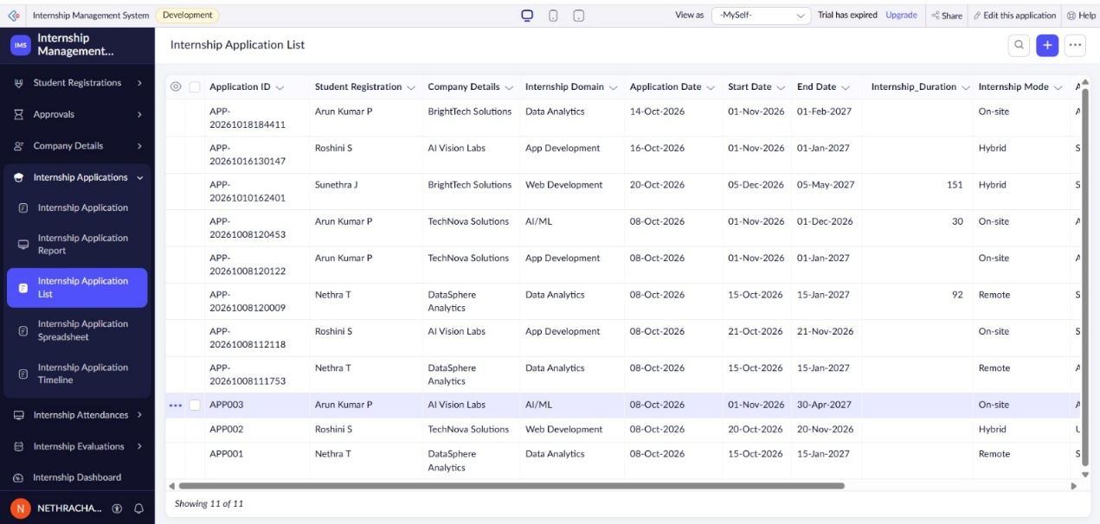
Figure 8.1: Student Registration and Internship Application Submission
Step 2: Application Approval Process
After the application is submitted, an approval request appears under the Pending Tasks section. The administrator reviews the student's application and verifies the submitted internship details before making the approval decision. Once approved, the application status is updated accordingly.
The approval workflow automatically updates the Approval Status to Approved and the Application Status to Selected when the application is approved. This helps simplify the review process and maintain accurate application records.

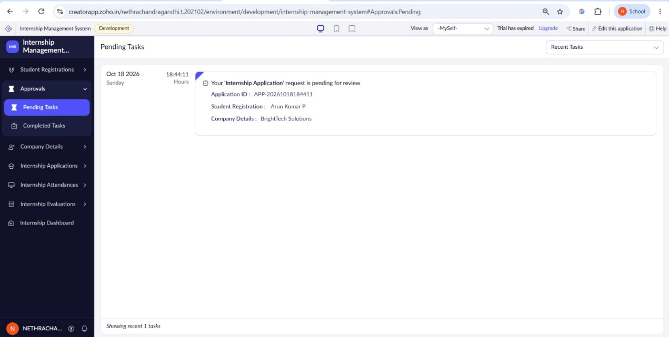
Figure 8.2: Pending Internship Application for Administrator Review
Step 3: Dashboard and Application Monitoring
The Internship Dashboard provides an overview of the system, including the total number of students, companies and internship applications. It also displays the application status distribution, internship working hours and average evaluation rating, helping the administrator monitor internship activities.
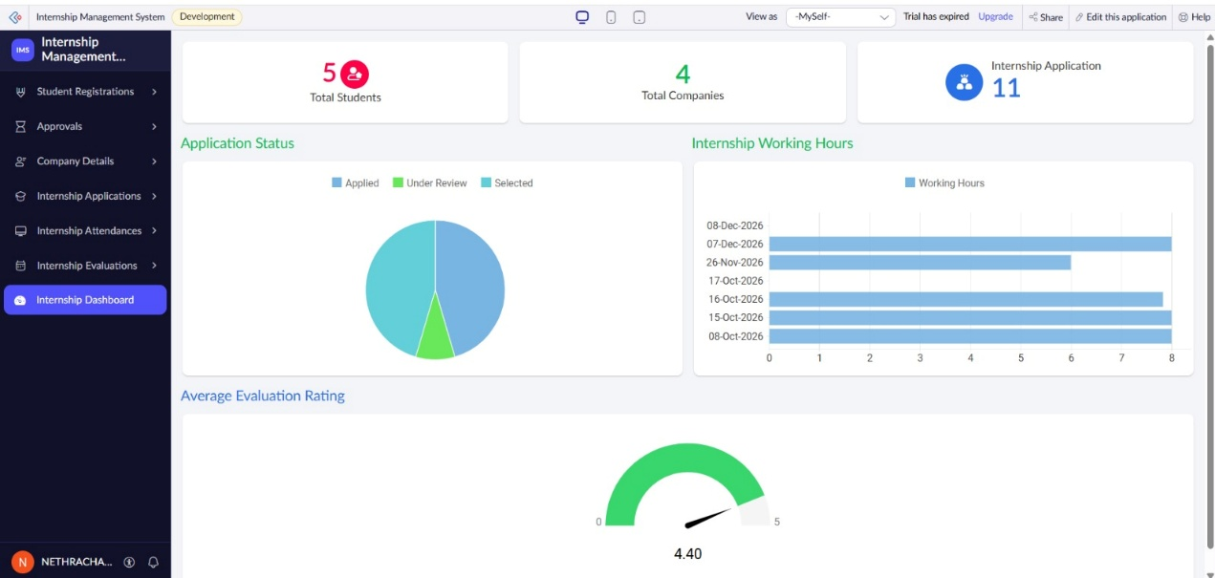
Figure 8.3: Internship Management Dashboard

8.2 Achievement of Objectives
Table 8.1: Mapping of Objectives to Outcomes
Objective (Sec. 1.3) | Implemented Through | Outcome / Evidence
1. Forms and linked data model | Section 4.2, 4.3, 5.2 | Five forms with lookup fields (Figure 4.2, Figure 5.2–Figure 5.4)
2. Deluge automation | Section 5.5, 5.6 | Seven scripts; results in Figure 5.8, Figure 5.12 and Figure 5.14
3. Application life cycle and approval | Section 5.6, 5.7 | Approval process, Blueprint, status workflow and e-mail (Figure 5.19, Figure 5.17, Figure 5.21)
4. Reports and dashboard | Section 5.3, 5.4 | Thirteen reports and one dashboard (Table 5.1, Figure 5.15)
5. Role-based access | Section 5.8 | Role hierarchy and portal profiles (Figure 5.22, Figure 5.23)
6. Testing | Chapter 6 | Fourteen test cases passed; two pending (Table 6.1)

8.3 Comparison with the Existing System
Table 8.2: Existing System versus Proposed Application
Parameter | Existing System | Proposed Application | Improvement
Application ID | Assigned or typed manually | Generated by DS-01 | Removes manual numbering
Duration and working hours | Calculated by hand | Calculated by DS-02 and DS-05 | Fewer calculation errors
Status tracking | Informal follow-up | Approval process, Blueprint and status fields | Defined stages
Report generation | Compiled from separate files | Thirteen ready reports and a dashboard | Consolidated view
Notification | Informed manually | E-mail action on approval (fixed test address tested) | Automated, with dynamic delivery pending

No timing measurements were taken, so the improvements are stated qualitatively.

8.4 Limitations of the Low-Code Approach
The application depends on the features and limits of the Zoho Creator platform and was built on a trial edition, so continued use needs a subscription. Some logic is limited by the trigger the platform offers: the duration workflow runs on edit, which leaves most records without a duration (BUG-01). The notification uses a fixed address, and role-based testing has not been carried out. These points can be addressed within the platform (Section 9.2); more demanding needs, such as external integrations, would require Deluge connections or a pro-code extension.

8.5 Reflection on the No-Code → Low-Code → Pro-Code Spectrum
Most of the application sits at the no-code end: the five forms, thirteen reports, dashboard, approval process, Blueprint, schedules, roles and portal profiles are configured visually. The seven Deluge scripts place the calculations and the e-mail action at the low-code level. No pro-code component was needed. This split kept the development effort on the internship process and left hosting and security to the platform.
CHAPTER 9

CONCLUSION AND FUTURE ENHANCEMENTS

9.1 Conclusion
The Internship Management System was developed on Zoho Creator to manage internship activities through forms, workflows, reports and a dashboard. Its five forms cover student registration, company information, internship applications, attendance and evaluation. Deluge workflows generate application IDs, calculate internship duration, working hours, performance result and attendance percentage, and update application status. An approval process, a Blueprint and two schedules support the application life cycle.
Testing in the Development environment showed that the calculations, status updates, approval request, reports and dashboard work as intended, and that the approval e-mail was delivered to the configured test address. The pending items are dynamic e-mail delivery to students, role-based testing, user acceptance feedback and deployment beyond Development. The project shows that a low-code platform can deliver a working internship record-management solution with limited scripting.

9.2 Future Enhancements
The following are proposed enhancements and are not part of the completed work:
- Send approval notifications to each student’s registered e-mail address.
- Run the duration and attendance-percentage workflows when a record is created as well as when it is edited.
- Implement more detailed user-role access and permissions.
- Add further approval stages where required.
- Improve report filters and analytical summaries.
- Add certificate management if required by a future scope, and extend the system with additional notifications and analytics.

9.3 Learning Outcomes and Career Relevance
The project gave practical experience in data modelling with forms and lookups, Deluge scripting, workflow automation, approvals, Blueprint design, reports and dashboards, and in testing a low-code application. These skills are relevant to roles such as low-code developer and business-application developer, and the project shows how a citizen developer can progress towards professional development by adding scripting and, later, pro-code extensions.

REFERENCES
[1] W. Rosam and O. Kalnichevski, Low-Code Development: A Practical Guide. New Delhi, India: BPB Publications.
[2] Zoho Corporation, “Zoho Creator Help Documentation.” [Online]. Available: https://www.zoho.com/creator/help/ (Accessed: 15 October 2026).
[3] Zoho Corporation, “Deluge Script Reference Guide.” [Online]. Available: https://www.zoho.com/deluge/ (Accessed: 18 October 2026).
[4] Zoho Corporation, “Zoho Creator Learning Centre.” [Online]. Available: https://www.zoho.com/creator/resources/ (Accessed: 15 October 2026).
[5] Zoho Corporation, “Zoho Creator API v2 Documentation.” [Online]. Available: https://www.zoho.com/creator/help/api/v2/ (Accessed: 21 October 2026).
[6] Zoho Corporation, “Zoho Creator: Low-Code Application Development Platform.” [Online]. Available: https://www.zoho.com/creator/ (Accessed: 21 October 2026).
[7] C. Richardson and J. R. Rymer, “New Development Platforms Emerge for Customer-Facing Applications,” Forrester Research, Cambridge, MA, USA, Jun. 2014.

APPENDIX A – ZOHO CREATOR FEATURE COVERAGE CHECKLIST
Y = implemented; Partial = partly implemented, with the gap stated; N = not implemented in this project.
Table A.1: Feature Coverage Checklist
Unit | Zoho Creator Feature | Done | Where in the Application | Report Section | Figure / Code No.
I | Application created & sections/menu organised | Y | Internship Management System with seven menu sections | 5.1 | Figure 5.1
II | Forms with ≥ 8 distinct field types | Y | Five forms | 5.2 | Figure 5.2–Figure 5.4
II | Lookup field (relationship between forms) | Y | Application, Attendance, Evaluation | 4.2, 5.2 | Figure 4.2, Figure 5.3
II | Subform (parent–child data) | Y | used | 4.2, 5.2 | —
II | Field validations / layout rules | Y | Mandatory fields on all forms; rating range 1 to 5 | 5.2 | Figure 5.2, Figure 5.4
II | List report with filter, grouping, custom action | Y | List reports created; filters, grouping and custom actions not configured | 5.3 | Figure 5.5, Figure 5.10
II | Kanban / Calendar / Timeline / Map report | Y | All four created | 5.3 | Figure 5.13, Table 5.1, Figure 5.11, Figure 5.7
II | Pivot table / chart report | Y | Pivot chart and pivot table | 5.3 | Table 5.1
II | Page / dashboard built with UI Builder | Y | Internship Dashboard | 5.4 | Figure 5.15
II | Deluge – form events (validate / success / field actions) | Y | Validate events and field-update event | 5.5 | Code 5.1–Code 5.3
II | Deluge – functions, fetch, loops, collections | Y | Fetch and for each in DS-07; no custom functions | 5.5 | Appendix C
II | Email / in-app notifications | Y | sendmail in DS-04; schedule mail | 5.5, 5.6 | Code 5.4, Figure 5.21
II | Form workflow | Y | Seven form workflows | 5.6 | Figure 5.16
II | Scheduled workflow | Y | Two schedules | 5.6 | Figure 5.18
II | Approval process | Y | Internship Application Approval Process | 5.6 | Figure 5.19, Figure 5.20
II | Blueprint | Y | Internship Application Process | 5.6 | Figure 5.17
II | Batch / report workflow | N | Not used | 5.6 | —
II | Testing & debugging evidence | Y | Sixteen test cases, two pending | 6 | Table 6.1
III | Integration with a Zoho service | N | Only built-in Send Mail and Map report | 5.7 | —
III | Connection / REST API call (invokeurl) | N | Not used | 5.7 | —
III | Webhook or Creator REST API | N | Not used | 5.7 | —
III | Users, roles and permission profiles | Y | CEO and Admin roles; Customer and Student profiles | 5.8 | Figure 5.22, Figure 5.23
III | Record-level access criteria / customer portal | Y | Portal profiles defined; record-level criteria not verified | 5.8 | Figure 5.23
III | Zia / AI feature | N | Zia Build Agent panel displayed; AI-assisted features not used | 5.9 | —
III | Analytics (charts / Zoho Analytics) | Y | Dashboard charts, gauge and pivot reports | 5.9 | Figure 5.15, Table 5.1
IV | Performance optimisation applied & measured | N | Not measured | 7.2 | —
IV | Deployment across environments | N | Development only | 7.1 | —
IV | Security controls (encryption, OAuth, permissions) | Y | Permissions and approval only | 7.3 | Table 7.3
IV | Governance (audit trail, administration) | N | Not evidenced | 7.4 | —
V | Pro-code extension (Catalyst / widgets / custom functions) | N | Not used | 5.10 | —
V | Low-code limitations & spectrum analysis | Y | Discussed | 8.4, 8.5 | —
— | Mobile app / portal access | Y | Portal profiles defined; mobile and live portal not demonstrated | 5.11 | Figure 5.23

Total features implemented: 23/ 32

APPENDIX B – COURSE OUTCOME MAPPING
Table B.1: Mapping of Course Outcomes to Report Chapters
CO | Course Outcome Statement | Evidenced In | Self-Assessed Level | Examiner Level
CO1 | Explain the principles, architecture, and business value of low-code application development using Zoho Creator. | Ch. 1, 2 | 4
CO2 | Develop business applications using Zoho Creator forms, reports, workflows, and Deluge scripting. | Ch. 4, 5 (5.1–5.6), 6 | 4
CO3 | Integrate Zoho Creator applications with Zoho services and external systems using APIs, connections, and role-based security. | Ch. 4.6, 5.7–5.9 | 2
CO4 | Deploy, secure, and manage Zoho Creator applications across development and production environments following governance best practices. | Ch. 7 | 3
CO5 | Evaluate low-code development strategies, AI-assisted application development, and the transition from citizen developer to professional developer. | Ch. 5.9, 5.10, 8.4, 8.5, 9.3 | 3

APPENDIX C – COMPLETE DELUGE SOURCE CODE
C.1 Application Submission Workflow
// Script ID : DS-01
// Location : Internship Application → Created → Validations on form submission
// Purpose : Generate the Application ID

input.Application_ID = "APP-" + zoho.currenttime.toString("yyyyMMddHHmmss");

C.2 Calculate Internship Duration
// Script ID : DS-02
// Location : Internship Application → Edited → Validations on form submission
// Purpose : Calculate the internship duration in days

if(input.Start_Date != null && input.End_Date != null)
{
duration = input.Start_Date.daysBetween(input.End_Date);
input.Internship_Duration = duration;
}

C.3 Application Approval Workflow
// Script ID : DS-03
// Location : Internship Application → Edited → Validations on form submission
// Purpose : Update approval and application status

if(input.Application_Approved == true)
{
input.Approval_Status = "Approved";
input.Application_Status = "Selected";
}

C.4 Student Approval Email Notification
// Script ID : DS-04
// Location : Internship Application → Edited → Update of Application Approved
// Purpose : Send the approval notification e-mail

sendmail
[
from :"<configured sender address>"
to :"<fixed test e-mail address>"
subject :"Internship Application Approved"
message :"Dear Student, your internship application has been approved. Please log in to the Internship Management System to view your application details."
]

C.5 Attendance Working Hours Workflow
// Script ID : DS-05
// Location : Internship Attendance → Created → Validations on form submission
// Purpose : Calculate working hours

if(input.Check_In_Time != null && input.Check_Out_Time != null)
{
checkin_seconds = input.Check_In_Time.getHour() * 3600 + input.Check_In_Time.getMinutes() * 60 + input.Check_In_Time.getSeconds();
checkout_seconds = input.Check_Out_Time.getHour() * 3600 + input.Check_Out_Time.getMinutes() * 60 + input.Check_Out_Time.getSeconds();
if(checkout_seconds >= checkin_seconds)
{
input.Working_Hours = ((checkout_seconds - checkin_seconds) / 3600.0).round(2);
}
}

C.6 Calculate Performance Result
// Script ID : DS-06
// Location : Internship Evaluation → Edited → Validations on form submission
// Purpose : Derive Performance Result from Overall Rating

if(input.Overall_Rating >= 4.5)
{
input.Performance_Result = "Excellent";
}
else if(input.Overall_Rating >= 3.5)
{
input.Performance_Result = "Good";
}
else if(input.Overall_Rating >= 2.5)
{
input.Performance_Result = "Average";
}
else
{
input.Performance_Result =”Poor”;
}

C.7 Calculate Attendance Percentage
// Script ID : DS-07
// Location : Student Registration → Edited → Validations on form submission
// Purpose : Calculate attendance percentage

attendance_records = Internship_Attendance[Student == input.ID];
total_days = 0;
attended_days = 0.0;
for each record in attendance_records
{
if(record.Attendance_Status == "Present")
{
total_days = total_days + 1;
attended_days = attended_days + 1;
}
}

APPENDIX D – USER MANUAL

D.1 Accessing the Application
Open the application link in a web browser (the Development URL is given in the Project at a Glance table) and sign in with the Zoho account that has access. The menu on the left lists the modules.

D.2 Instructions for the Administrator
- Open Student Registrations → Student Registration, fill the mandatory fields and click Submit.
- Open Company Details → Company Details, enter the company and internship details and click Submit.
- Open Internship Applications → Internship Application, select the student and company, enter the domain, dates and mode, and click Submit. The Application ID is generated automatically.
- Open Approvals → Pending Tasks to see applications awaiting review and approve or reject them.
- To mark an application approved, edit the record and tick Application Approved; the status fields update and the notification e-mail is sent.
- Open Internship Attendances → Internship Attendance, enter the status and the check-in and check-out times, and click Submit; working hours are calculated.
- Open Internship Evaluations → Internship Evaluation, enter the mentor name and the five ratings, and click Submit; the overall rating is calculated.
- Use the reports under each module and the Internship Dashboard to view records and summaries.

D.3 Instructions for the Student (Portal User)
- Sign in to the portal with the credentials supplied by the administrator.
- View the internship information that is permitted for the Student profile.
- Submit and manage your own internship applications.

APPENDIX E – EVALUATION RUBRIC
(For Examiner Use Only)
Student Name | NETHRACHANDRAGANDHI T | Register No. | 240701357
Project Title | Internship Management System using Zoho Creator | Date | 11.11.2026

Table E.1: Evaluation Rubric for the Individual Project
S.No. | Criterion | Indicators | Max. Marks | Marks Awarded
1 | Problem Definition & Requirement Analysis | Clarity of problem, measurable objectives, complete FR/NFR, use cases | 10
2 | System Design | Architecture, ER/data model, form specifications, workflow design, permission matrix | 10
3 | Forms, Reports & Pages | Variety of field types, lookups/subforms, report types, UI Builder dashboards | 15
4 | Deluge Scripting & Workflows | Correctness and depth of scripts; form, schedule, approval, Blueprint, batch workflows | 15
5 | Integration, RBAC & AI | Zoho/external integrations, connections, roles & permissions, Zia/analytics | 10
6 | Testing, Deployment, Security & Governance | Test coverage, environments, optimisation, security controls, audit | 10
7 | Live Demonstration | End-to-end working of the application across roles; feature checklist verified | 15
8 | Project Report | Adherence to template and format, clarity, figures, references | 5
9 | Viva-Voce | Understanding of the platform, design decisions and low-code concepts | 10
 | TOTAL |  | 100

Table E.2: Performance Level Descriptors
Level | % of Max. Marks | Descriptor
Excellent | 90–100 | Feature implemented completely, correctly and beyond the basic requirement; student explains design choices confidently.
Good | 70–89 | Feature implemented correctly with minor gaps; explanation adequate.
Satisfactory | 50–69 | Feature partially implemented or works only for the main path; limited explanation.
Needs Improvement | < 50 | Feature missing, non-functional or not understood by the student.

Signature of Internal Examiner  Name: ____________________ | Signature of External Examiner  Name: ____________________

APPENDIX F – VIVA-VOCE RECORD SHEET
(For Examiner Use Only)
Student Name | NETHRA CHANDRAGANDHI T | Register No. | 240701357
Department / Section | CSE | Date of Viva | 11.11.2026
Application URL Verified | YES | Demo Duration | ______ min
Table F.1: Viva-Voce Questions and Responses
Q.No. | Question / Topic Asked | Unit | Response (E / G / S / NI) | Remarks
1
2
3
4
5
6
7
8
E – Excellent G – Good S – Satisfactory NI – Needs Improvement
Table F.2: Marks Summary
Component | Max. Marks | Marks Awarded
Criteria 1–8 (Appendix E) | 90
Viva-Voce | 10
TOTAL | 100

Examiners’ Remarks:
____________________________________________________________________
____________________________________________________________________
INTERNAL EXAMINER  Name: ____________________ | EXTERNAL EXAMINER  Name: ____________________

