Inpatient & Outpatient Healthcare Dashboard
Professional project documentation for an interactive Power BI dashboard designed to analyze hospital waitlists, inpatient admissions, outpatient visits, and day-case activities.

1. Executive Summary
This dashboard provides healthcare administrators and analysts with a unified view of patient activity across multiple specialties, age groups, and waiting-time bands. It enables quick monitoring of case volumes, trends, and operational performance.

2. Business Objectives
- Monitor Inpatient, Outpatient and Day Case volumes.
- Track waiting list trends over time.
- Analyze patient distribution by specialty and age profile.
- Support data-driven resource allocation and operational decisions.

3. Dashboard Architecture
The solution contains two pages: a Summary Dashboard for high-level insights and a Detail View for drill-down analysis.

4. Summary Dashboard
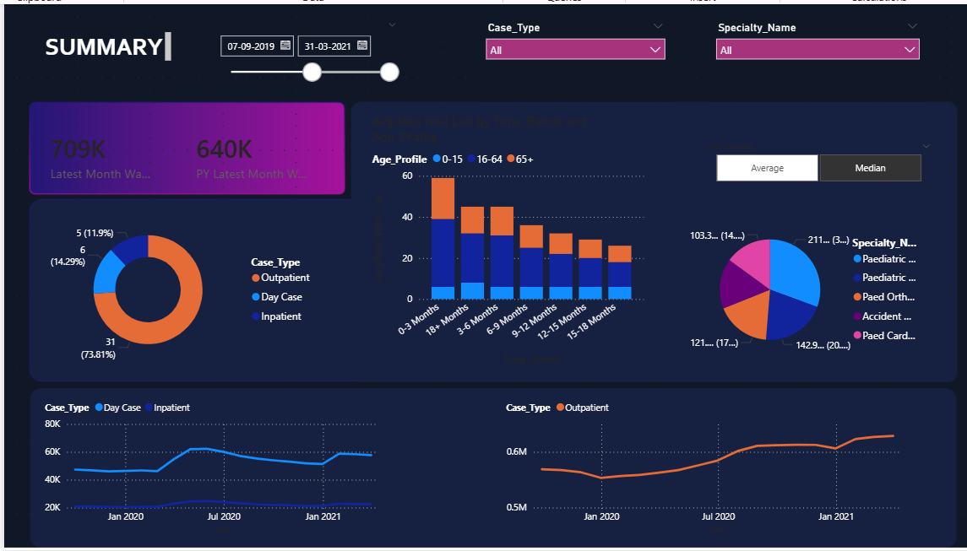
The Summary Dashboard highlights KPIs, case-type distribution, specialty analysis, age profile trends, and monthly trend lines. Interactive slicers allow users to filter by date, case type, and specialty.

Key Visuals
- KPI Cards: Latest Month Wait List and Previous Year Wait List.
- Donut Chart: Distribution of Inpatient, Outpatient and Day Case.
- Stacked Column Chart: Average/Median wait list by Age Profile and Time Bands.
- Pie Chart: Specialty-wise patient distribution.
- Trend Lines: Monthly changes in case volumes.

5. Detail View Dashboard
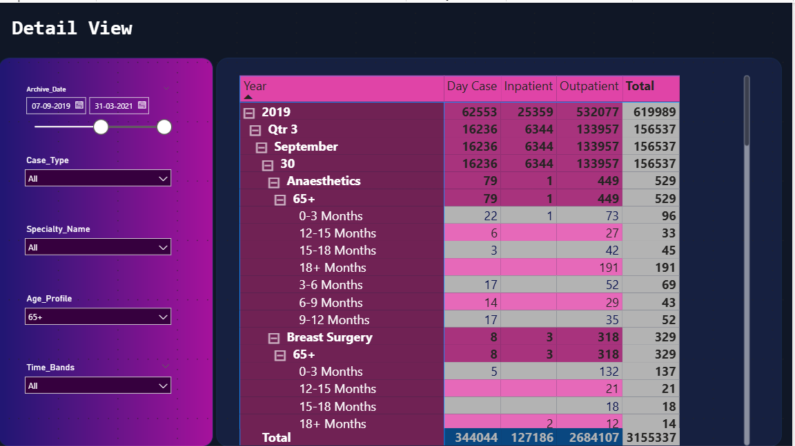
The Detail View offers drill-down analysis using a matrix visual with hierarchical navigation from Year to Quarter, Month, Specialty, Age Profile, and Time Bands.

Available Filters
- Archive Date
- Case Type
- Specialty Name
- Age Profile
- Time Bands

6. Data Model & Technologies
- Power BI for interactive visualizations
- Power Query for data transformation
- DAX for KPI calculations and measures
- Fact and Dimension tables for scalable data modeling

7. Business Impact
The dashboard improves visibility into healthcare operations, identifies high-demand specialties, tracks waiting periods, and supports better decision-making for hospital management.

8. Professional Notes
This project demonstrates skills in Power BI dashboard design, DAX, data modeling, healthcare analytics, KPI reporting, and interactive storytelling.

Prepared by: Nethra
Role: Aspiring Data Analyst

