Colombo Eats
A Restaurant Review Application for Android

Module: COMP50072
Assignment 2
Student Name: [PLACEHOLDER]
Student ID: CB016808
Date: [PLACEHOLDER]

Table of Contents

1. Introduction 1
2. Development Approach and Architecture 1
3. Application Walkthrough 3
4. Interface Design and Accessibility 13
5. Responsive Layout 15
6. Firebase Realtime Database 16
7. Location Services 18
8. Testing 21
9. Problems Encountered and Decisions Made 21
10. Limitations and Future Work 22
11. References 22
Appendix A: Manual Test Plan 23
Appendix B: Firebase Realtime Database Security Rules 27

(Right-click this area and choose Update Field, or press F9, to build the table of contents.)

1. Introduction
Colombo Eats is a restaurant review app I built for Android with Flutter. It is meant for people in Colombo deciding where to eat, and for the people who run those restaurants. There is no single dominant local review app for the city; most existing options are general map or delivery apps with reviews added as an afterthought. This app puts reviewing at the centre instead.
The code recognises three kinds of user. A signed-in person can browse every restaurant and post their own review. A person who owns a restaurant can add it themselves, with a description, a photo and a location, and manage it afterwards. A signed-out visitor can do neither: main.dart gates the whole app behind Firebase authentication, so there is no way to browse or review without an account first.

2. Development Approach and Architecture
The app is built with Flutter 3.47.0 and Dart 3.13.0, targeting Android. I chose Flutter because it compiles one Dart codebase to a native Android binary (REF-01), which meant I did not need a second language or a separate build system for the coursework. The obvious cost is that it will not run on iOS without platform work I have not done.
lib/ is organised by feature rather than by type. main.dart starts Firebase and decides between the login screen and the main app. theme/ holds the single seed colour the whole palette comes from. models/ has Restaurant and Review, the two record types stored in the database. services/ wraps every Firebase and GPS call so screens never talk to Firebase directly. utils/ has one function, ratingsByRestaurant, which turns a list of reviews into an average. shared_widgets/ holds the card and image widgets used on more than one screen. screens/ is split into a subfolder per feature: auth, home, restaurants, my_reviews, my_restaurants and profile (Figure 1).
State management is setState throughout, and navigation is Navigator.push and Navigator.pop, with no Provider, Riverpod, Bloc or go_router anywhere in the project. This was a deliberate limit. I wanted to be able to explain every part of the app from memory in a viva, and a state management package would have meant defending someone else's abstraction rather than my own decisions.
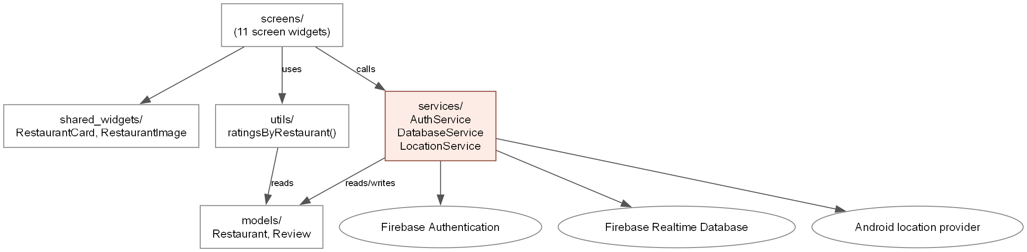
Figure 1: lib/ folder structure and how the layers depend on each other.

3. Application Walkthrough
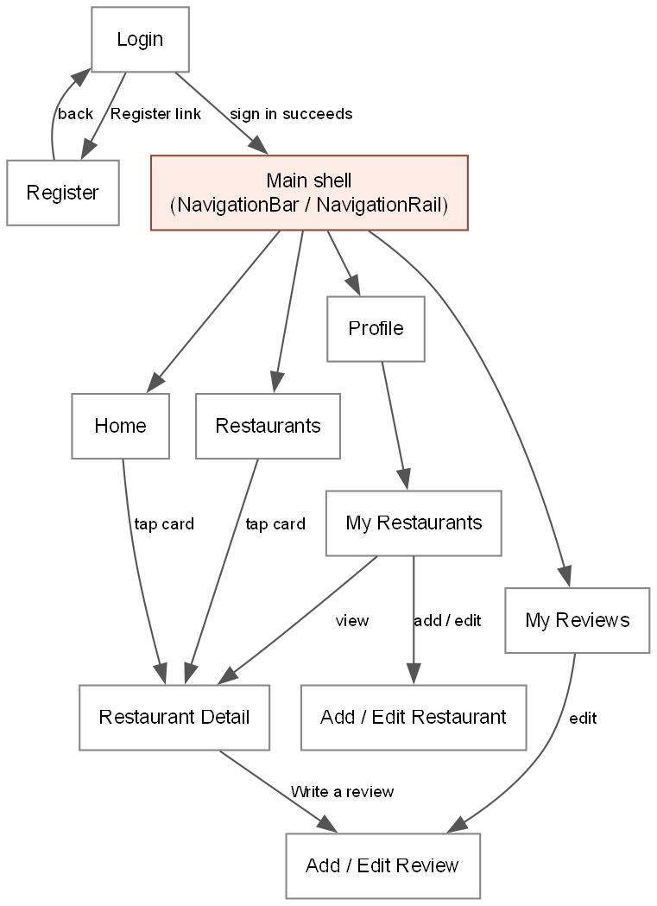
Figure 2: navigation map, showing every screen and how a user reaches it.
Login is the first screen a signed-out user sees, or the app opens straight past it if a session was already saved on the device. It checks the email format and asks for a password of at least six characters before it will call Firebase, and shows a plain sentence rather than a raw error code when sign-in fails.

Figure 3: Login screen. [SCREENSHOT TO BE INSERTED: login.png]
Register collects a name, email, password and a confirmation field, creates the account, and writes the entered name onto it as a display name so later reviews can show who wrote them.

Figure 4: Register screen. [SCREENSHOT TO BE INSERTED: register.png]
Home lists the four highest-rated restaurants, ranked by the live average from their reviews rather than a stored number. A restaurant with no reviews has nothing to rank by and sorts last.

Figure 5: Home tab. [SCREENSHOT TO BE INSERTED: home.png]
Restaurants is the full list, with a slider to filter by minimum rating and a button that reads the device's GPS position and sorts by distance from it. The layout itself changes with orientation, covered in section 5.
 | 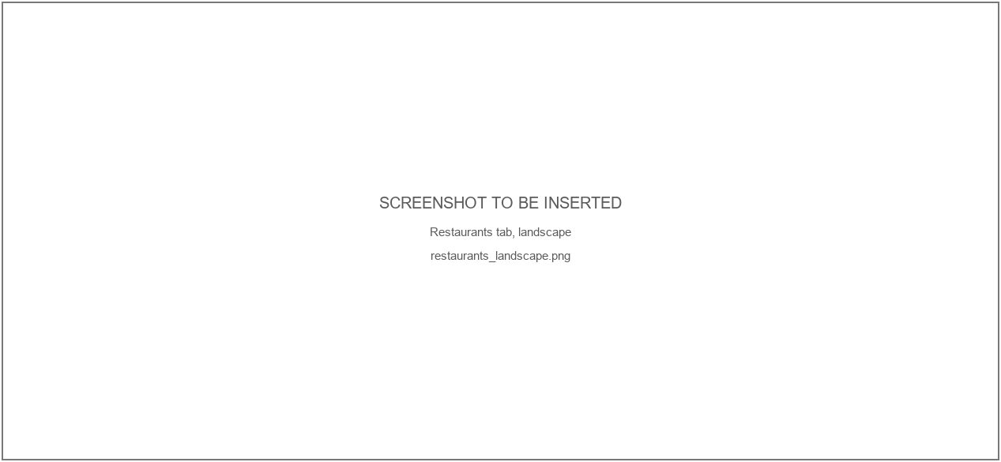
Figures 6 and 7: Restaurants tab, portrait and landscape. [SCREENSHOT TO BE INSERTED: restaurants_portrait.png, restaurants_landscape.png]
Restaurant Detail shows the description, price range, popular dishes and the underlying reviews, none of which appear on the card. If the signed-in account owns the restaurant, the review button is replaced with a banner instead, explained fully in section 6.

Figure 8: Restaurant Detail screen. [SCREENSHOT TO BE INSERTED: restaurant_detail.png]
Write a Review is one form used for creating and editing, with four field types: a slider for the rating, a dropdown for the meal, a date picker with no future dates allowed, and a text box for the comment capped at 400 characters.

Figure 9: Add/edit review form. [SCREENSHOT TO BE INSERTED: add_review.png]
My Reviews lists every review the signed-in account has written, with edit and delete on each behind a confirmation dialog.

Figure 10: My Reviews tab. [SCREENSHOT TO BE INSERTED: my_reviews.png]
My Restaurants, reached from Profile, lists the restaurants the signed-in account owns and is where a user adds a new one.

Figure 11: My Restaurants screen. [SCREENSHOT TO BE INSERTED: my_restaurants.png]
Add a Restaurant collects the name, cuisine, area, price, a photo link, dishes and a description, and has a button that fills latitude and longitude from a GPS fix rather than asking for typed coordinates. There is no rating field: an owner cannot score their own restaurant.

Figure 12: Add/edit restaurant form. [SCREENSHOT TO BE INSERTED: add_restaurant.png]
Profile shows the account's name and email, a count of reviews written, the average rating given, a link into My Restaurants, and sign out.

Figure 13: Profile tab. [SCREENSHOT TO BE INSERTED: profile.png]

4. Interface Design and Accessibility
The whole app uses Material 3 and generates both colour schemes from one seed colour, a deep orange, 0xFFBF360C, with ColorScheme.fromSeed (REF-02). themeMode is set to ThemeMode.system, so the app follows whatever light or dark setting is already on the phone.
I did not want to assume the seed colour produced readable text, so I wrote a script using the same ColorScheme.fromSeed call the app uses and measured the WCAG contrast ratio (REF-03) for eight foreground and background pairs, in both light and dark mode.
Table 1: measured WCAG contrast ratios, ColorScheme.fromSeed(0xFFBF360C)
Pair | Light mode | Dark mode | Threshold
onSurface / surface | 16.36 : 1 | 14.42 : 1 | 4.5 : 1
onSurfaceVariant / surface | 8.92 : 1 | 10.93 : 1 | 4.5 : 1
onPrimary / primary | 6.49 : 1 | 7.74 : 1 | 4.5 : 1
onPrimaryContainer / primaryContainer | 7.25 : 1 | 7.25 : 1 | 4.5 : 1
onSecondaryContainer / secondaryContainer | 7.23 : 1 | 7.23 : 1 | 4.5 : 1
onError / error | 6.46 : 1 | 7.72 : 1 | 4.5 : 1
onErrorContainer / errorContainer | 7.24 : 1 | 7.24 : 1 | 4.5 : 1
outline / surface | 4.28 : 1 | 5.84 : 1 | 3.0 : 1

Every pair cleared the 4.5:1 threshold recommended for normal text, and outline against surface, checked against the lower 3:1 threshold used for borders, cleared that too. The lowest of the sixteen ratios measured was outline against surface in light mode, at 4.28 to 1. I should be honest that this checks the theme's own numbers rather than how the screen looks in daylight, which I have not tested on a physical device.

Figure 14: Home tab, light and dark mode. [SCREENSHOT TO BE INSERTED: home.png, dark_home.png]
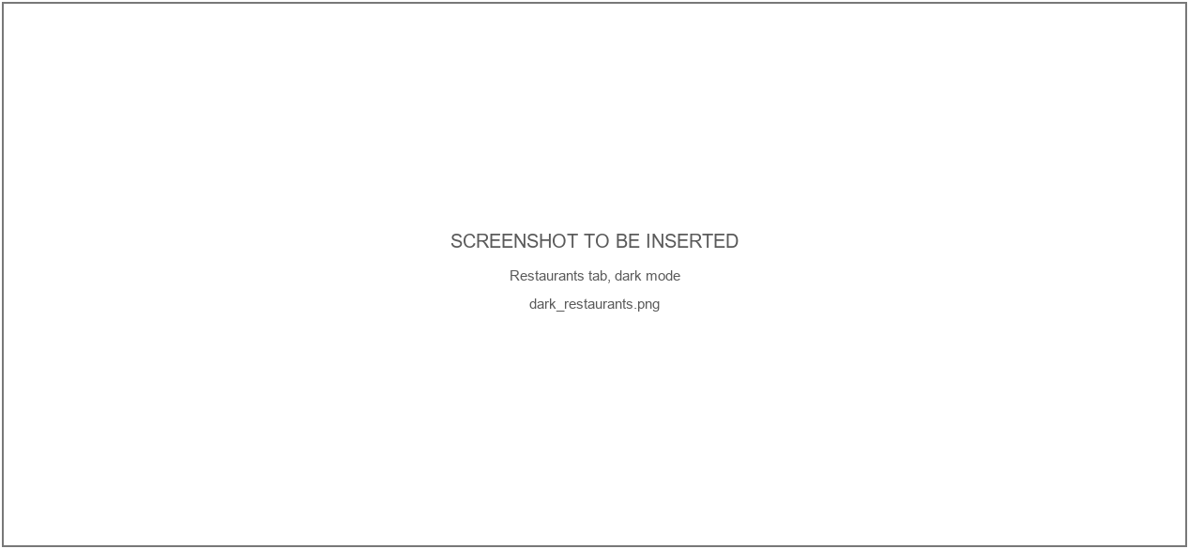
Figure 15: Restaurants tab, light and dark mode. [SCREENSHOT TO BE INSERTED: restaurants_landscape.png, dark_restaurants.png]

5. Responsive Layout
Two screens use OrientationBuilder to change layout on rotation. On Restaurants, portrait shows a single column of wide cards in a ListView.builder; landscape switches to a GridView.builder using a different, more compact card widget entirely, RestaurantGridCard rather than RestaurantCard. On Restaurant Detail, portrait stacks the photo above scrolling text in a Column; landscape puts the photo in a fixed panel on the left with the text scrolling on its own in a separate SingleChildScrollView on the right, which changes the structure rather than just the size.
Screen size is handled separately, with MediaQuery.of(context).size.shortestSide, and I want to describe accurately what it does: it changes the column count on the Restaurants grid, between one, two or three depending on width and orientation, and swaps the bottom NavigationBar for a side NavigationRail once shortestSide passes 600 logical pixels. It does not give the tablet a separate page design beyond that.
 |  |  | 
Figure 16: phone portrait, phone landscape, tablet portrait and tablet landscape compared. [SCREENSHOT TO BE INSERTED: restaurants_portrait.png, restaurants_landscape.png, tablet_portrait.png, tablet_landscape.png]

6. Firebase Realtime Database
All app data sits in one Firebase Realtime Database under two top-level nodes, restaurants and reviews. A restaurant record holds its name, cuisine, area, price range, an image URL, a description, an optional list of popular dishes, latitude, longitude, and an ownerId, empty for the eight restaurants I imported to seed the database and set to a Firebase Auth uid for anything a user adds.
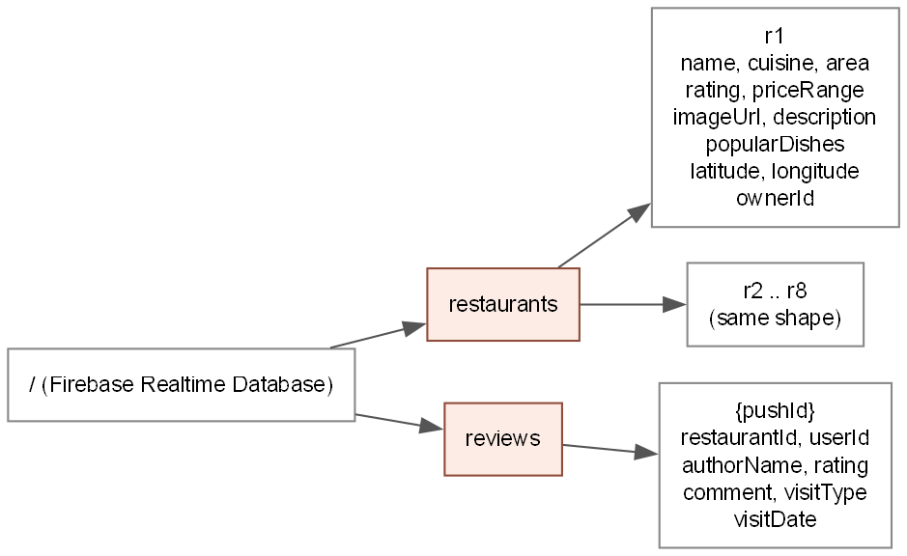
Figure 17: shape of the data under restaurants/ and reviews/.
I used the Realtime Database rather than Firestore because it was what the coursework covered, and I read every list through an .onValue stream (REF-05) rather than a one-off .get(), so a change made from the console or another device appears immediately with no manual refresh anywhere in the app.
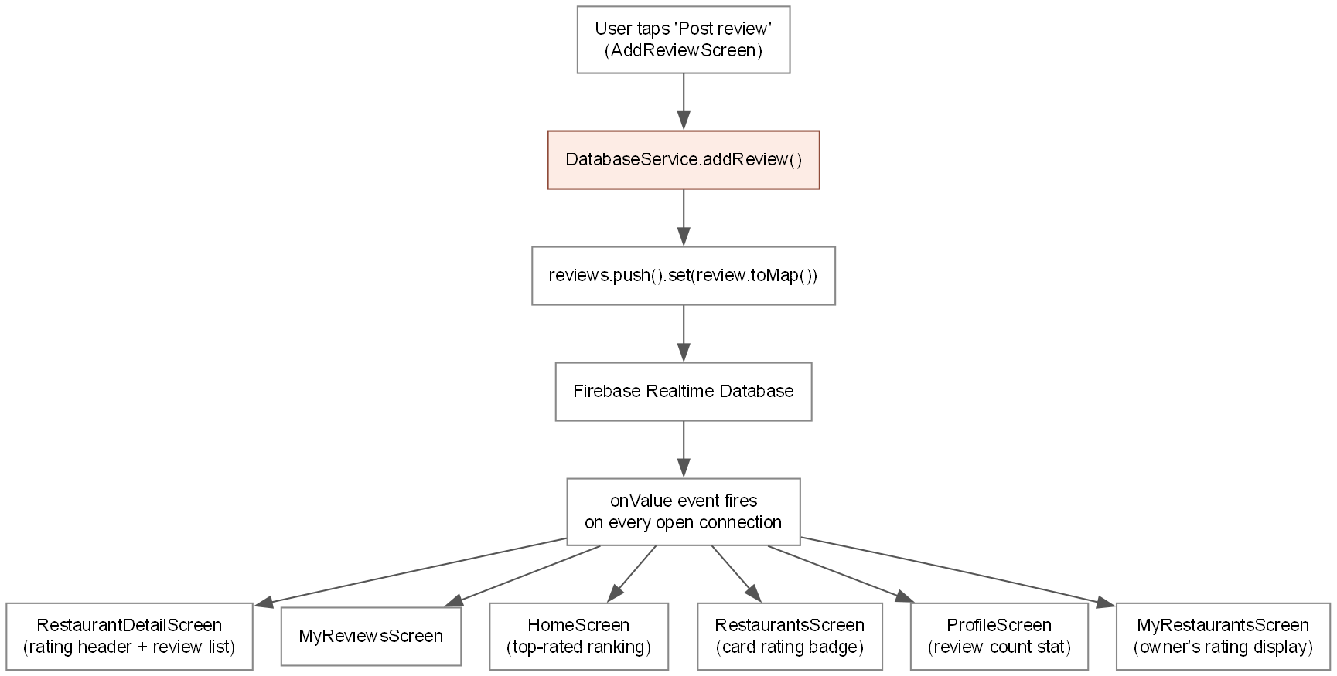
Figure 18: one write, from button press to every screen that updates because of it.
Table 2: the four CRUD operations, both entities, where each happens
Operation | Entity | Screen / widget | DatabaseService method
Create | Review | AddReviewScreen, Post review button | addReview()
Read | Review | RestaurantDetailScreen, review list | reviewsStream()
Update | Review | MyReviewsScreen, edit icon | updateReview()
Delete | Review | MyReviewsScreen, delete icon | deleteReview()
Create | Restaurant | AddRestaurantScreen, Add restaurant button | addRestaurant()
Read | Restaurant | RestaurantsScreen / HomeScreen list | restaurantsStream()
Update | Restaurant | MyRestaurantsScreen, edit icon | updateRestaurant()
Delete | Restaurant | MyRestaurantsScreen, delete icon | deleteRestaurant()


Figure 19: Firebase console showing the live restaurants and reviews nodes. [SCREENSHOT TO BE INSERTED: firebase_console.png]
The deployed rules (REF-04, Appendix B) refuse every read and write by default, then open both nodes to read for a signed-in user only. A restaurant can only be written by the uid in its own ownerId field, on creation and every update after, which stops one user editing or deleting somebody else's listing. A review can only be created if the writing uid matches its own userId and is not the ownerId of the restaurant being reviewed, which is what actually stops an owner reviewing their own place, not just the app hiding a button. The rating field has its own rule: it must be exactly zero on creation and cannot change on any update, which stops an owner setting or later raising their own score by writing to Firebase directly.

7. Location Services
GPS is used for two things. On Restaurants, tapping the compass icon reads the current position, sorts every restaurant by distance and shows a badge on each card. On Add Restaurant, a button fills latitude and longitude from the same read, so an owner can tag a restaurant by standing in it.
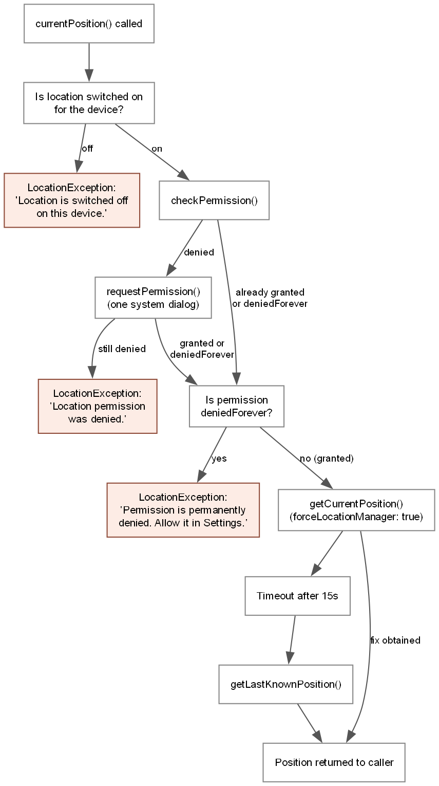
Figure 20: the three permission states LocationService checks, and the message shown for each.
LocationService.currentPosition() checks three states before reading anything: whether location is switched on, whether permission has been granted, asking once if not, and whether permission has been permanently denied, which needs a message pointing the user to Android's own Settings since the system dialog will not appear again (REF-07). Each state gets its own message rather than one generic failure.

Figure 21: the message shown when location permission is denied. [SCREENSHOT TO BE INSERTED: location_denied.png]
While building this I found the first tap after opening the app often reported a position kilometres from the real one, with a second tap then correct. Android's fused location provider was returning a cached fix it judged recent enough (REF-06). Setting forceLocationManager: true fixed it by forcing the read through Android's own LocationManager instead, at some cost in speed. One limitation stands: there is no way to type coordinates by hand, so a user who refuses location permission cannot add a restaurant, though they can still browse and review.

8. Testing
test/widget_test.dart has 14 unit tests, all synchronous and none touching Firebase. They check that Restaurant.fromMap and Review.fromMap parse a complete record, fall back safely when a field is missing, and handle a rating Firebase returns as a whole number. A second group checks ownership on Restaurant, including the case where a signed-out uid of an empty string must not be treated as owning a restaurant whose ownerId is also empty. A third group checks ratingsByRestaurant directly: an empty list gives an empty map, a restaurant with no reviews has no entry rather than a zero, and an average of 4.0, 4.0 and 5.0 rounds to 4.3.
Table 3: test coverage summary
Area | Automated (unit tests) | Manual (test plan rows)
Model parsing (Restaurant, Review) | 5 | 0
Ownership logic | 4 | 4 (section 5)
Live rating calculation | 5 | 1 (O4)
Authentication | 0 | 11 (section 1)
Navigation | 0 | 5 (section 2)
Review CRUD via UI | 0 | 12 (section 3)
Restaurant CRUD via UI | 0 | 6 (section 4)
Form validation | 0 | 8 (section 6)
GPS sensor | 0 | 6 (section 7)
Layout, theme, animation | 0 | 12 (section 8)
Total | 14 | 64

This is model and logic testing only. There is no widget testing and no integration testing anywhere in the project; nothing pumps a screen or taps a button inside a test. That was a scope decision given the time available. The manual test plan (Appendix A) is what covers screen behaviour, navigation, the Firebase rules and the sensor, run by hand on an emulator rather than automated.

9. Problems Encountered and Decisions Made
A few things did not work the first time.
Deleting a restaurant originally cascaded to delete every review about it, which I built before thinking it through. If an owner could remove reviews by deleting and recreating their restaurant, nothing stopped them wiping a bad one that way. I removed the cascade: DatabaseService.deleteRestaurant now only removes the restaurant, and reviews left pointing at one that no longer exists are filtered out in MyReviewsScreen instead.
A restaurant's rating was, for most of the project, a number stored on the record and set once at creation. It never changed when a new review came in, which I did not notice until I asked myself directly whether the number on screen would move after posting a review. It would not have. I replaced it with ratingsByRestaurant, computed live from the reviews stream on every screen that shows a rating.
The rules stopping an owner reviewing their own restaurant and setting their own rating sat in firebase/database_rules.json for a while before I deployed them with firebase deploy --only database. Until that command ran, the live database was still enforcing an older, looser rule set, so the add-restaurant feature accepted input in the UI while every write was silently rejected by Firebase underneath it.
The GPS bug from section 7 belongs here too. forceLocationManager was not something I knew to reach for; I found it after noticing the wrong-then-right pattern on two consecutive taps and searching for why Android's fused provider would behave that way.

10. Limitations and Future Work
Distance shown to the user is a straight line between two GPS points, not a walking or driving distance, so it understates how far a restaurant is if the road network is not direct. Nothing stops one account posting more than one review for the same restaurant. Adding a restaurant depends entirely on a GPS fix with no manual entry, so it cannot be done without granting location permission. Given more time I would add typed address entry as a fallback and some limit on repeat reviews, but neither exists now and I am not listing them as though they were planned features.

11. References
The reference list for this report will be inserted here once the sources named in docs/report/REFERENCES_NEEDED.md have been found and formatted in Harvard style.

Appendix A: Manual Test Plan
Carried out on an Android emulator (Pixel 6, API 34), Flutter 3.47.0, Dart 3.13.0, against the Firebase Realtime Database in asia-southeast1, debug build.

A.1 Authentication
ID | Steps | Expected | Actual | Pass/Fail
A1 | Register → fill all fields → Create account | Account created, app opens on Home tab
A2 | Enter nethusha.com → submit | Field error “Enter a valid email address”; nothing sent to Firebase
A3 | Enter 123 → submit | Field error “Password must be at least 6 characters”
A4 | Enter different confirm password | Field error “Passwords do not match”
A5 | Use an email already registered | Red bar: “An account already exists with that email”
A6 | Enter valid credentials → Sign in | Opens on Home tab
A7 | Enter valid email, wrong password | Red bar: “Email or password is incorrect”
A8 | Tap Sign in with both fields blank | Both fields show validation errors
A9 | Sign in → close app → reopen | Opens signed in, no login screen
A10 | Profile → Sign out → confirm | Returns to login screen
A11 | Profile → Sign out → Cancel | Stays signed in

A.2 Navigation
ID | Steps | Expected | Actual | Pass/Fail
N1 | Tap each destination in the bottom bar | Correct screen shown, icon fills in
N2 | Restaurants → tap any card | Detail screen opens with that restaurant
N3 | Detail → back arrow | Returns to the list, scroll position kept
N4 | Login → Register | Register screen opens
N5 | Register → back arrow | Returns to login

A.3 Firebase CRUD — reviews
ID | Steps | Expected | Actual | Pass/Fail
C1 | Open Restaurants tab | 8 restaurants load from Firebase
C2 | Detail → Write a review → fill → Post | Snackbar “Review posted”; appears under Reviews immediately
C3 | My Reviews tab | The new review is listed
C4 | My Reviews → edit icon → change rating → Save changes | Snackbar “Review updated”; new values shown
C5 | My Reviews → delete icon → Delete | Snackbar “Review deleted”; row disappears
C6 | Delete icon → Cancel | Review is not deleted
C7 | Add a review in the Firebase console while the app is open | Appears in the app without any refresh
C8 | Sign in as a second user, view a restaurant | Other users’ reviews visible but no edit/delete buttons on My Reviews
C9 | Open Restaurants on a cold start | Spinner shown before the list appears
C10 | Turn off emulator network → open Restaurants | “Could not load restaurants” message, no crash
C11 | Set the rating filter to 5.0 | “No restaurants match” message
C12 | Firebase console → Rules → Simulator → write to /reviews unauthenticated | Simulation denied

A.4 Firebase CRUD — restaurants
ID | Steps | Expected | Actual | Pass/Fail
R1 | Profile → My Restaurants → Add restaurant → fill form → Use my current location → Add restaurant | Snackbar “Restaurant added”; listing appears in the Restaurants tab with a “New” chip
R2 | My Restaurants → edit icon → change the name → Save changes | Snackbar “Restaurant updated”; new name shown everywhere the restaurant appears
R3 | My Restaurants → delete icon → Delete | Snackbar “Restaurant deleted”; listing disappears from Restaurants and Home; any reviews written about it are not deleted and simply stop being displayed
R4 | Add restaurant → leave the photo link blank → Add restaurant | Field error “Paste a photo link for your restaurant”
R5 | Add restaurant → type a description under 20 characters | Field error “Please write at least 20 characters”
R6 | Add restaurant → do not tap “Use my current location” → Add restaurant | Inline error: “Set the restaurant location before saving.” — save is blocked

A.5 Ownership rules
ID | Steps | Expected | Actual | Pass/Fail
O1 | Open a restaurant you added yourself | No “Write a review” floating button; a banner reads “This is your restaurant. Owners cannot review their own listings.”
O2 | While signed in as the owner, attempt a direct write to /reviews with restaurantId set to your own restaurant and userId set to your own uid | Write is rejected — PERMISSION_DENIED
O3 | While signed in as the owner, attempt a direct write to /restaurants/{yourId}/rating setting any value other than the current one | Write is rejected — PERMISSION_DENIED, both for a non-zero value on create and for any change on update
O4 | Note a restaurant’s current rating (or “New”) → post a review for it as a different account → return to the Restaurants list and detail page | The average and review count update immediately, with no app restart

A.6 Form validation
ID | Steps | Expected | Actual | Pass/Fail
F1 | Post review with blank comment | “Write a few words about your visit”
F2 | Enter Good as the comment | “Please write at least 10 characters”
F3 | Drag the rating slider from 1.0 to 5.0 | Value updates live next to the slider
F4 | Open the meal dropdown, choose Lunch | Selection shown in the field
F5 | Tap the date field, choose a past date | Date shown as e.g. “12 Aug 2026”
F6 | Open the date picker | Dates after today cannot be selected
F7 | Type past 400 characters in the review comment | Counter stops at 400
F8 | My Reviews → edit | Rating, meal and comment already filled in

A.7 Hardware sensor — GPS
ID | Steps | Expected | Actual | Pass/Fail
G1 | First tap of the location icon | Android permission dialog appears
G2 | Allow | Distance badges appear; list sorts nearest first
G3 | Deny | Red bar explaining distances will not show; no crash
G4 | Emulator settings → Location off → tap the icon | Message “Location is switched off on this device”
G5 | Set emulator to 6.9271, 79.8612 | Colombo 01–07 restaurants all within a few km
G6 | Tap the close icon on the location bar | Bar closes, distances stay

A.8 Layout, theme and animation
ID | Steps | Expected | Actual | Pass/Fail
L1 | Device Settings → Display → Dark theme | App recolours with no restart
L2 | Turn dark theme back off | App returns to light palette
L3 | Restaurants tab, upright | Single-column list of wide cards
L4 | Rotate | Two-column grid of compact cards
L5 | Run on a Pixel Tablet AVD, portrait | NavigationRail on the left instead of the bottom bar; two-column grid
L6 | Rotate the tablet | Three-column grid; NavigationRail remains
L7 | Open a restaurant upright | Photo on top, details underneath
L8 | Rotate | Photo on the left, details scroll on the right
L9 | Tap a card | Photo expands from the card into the detail screen
L10 | Tap the filter icon | Panel slides open rather than snapping
L11 | Break an imageUrl in Firebase | Grey box with a fork icon, no red error box
L12 | Set a restaurant name to 60 characters | Name truncates with an ellipsis, layout does not break

Total: 64 manual cases across 8 areas. Actual result, Pass/Fail and Date columns are completed by hand while testing on device and are not reproduced here in full; the source table with those columns lives in docs/TEST_PLAN.md.

Appendix B: Firebase Realtime Database Security Rules
The rules below are deployed to the live database and enforced by Firebase on every read and write, independent of the app's own UI.
{
"rules": {
".read": false,
".write": false,
"restaurants": {
".read": "auth != null",
"$restaurantId": {
".write": "auth != null && (!data.exists() ? newData.child('ownerId').val() === auth.uid : data.child('ownerId').val() === auth.uid)",
".validate": "newData.hasChildren(['ownerId', 'name', 'cuisine', 'area', 'description', 'imageUrl', 'latitude', 'longitude'])",
"ownerId": {
".validate": "newData.val() === auth.uid"
},
"name": {
".validate": "newData.isString() && newData.val().length >= 2 && newData.val().length <= 80"
},
"description": {
".validate": "newData.isString() && newData.val().length >= 20 && newData.val().length <= 400"
},
"rating": {
".validate": "newData.isNumber() && newData.val() >= 0 && newData.val() <= 5 && (!data.exists() ? newData.val() === 0 : newData.val() === data.val())"
},
"latitude": {
".validate": "newData.isNumber() && newData.val() >= -90 && newData.val() <= 90"
},
"longitude": {
".validate": "newData.isNumber() && newData.val() >= -180 && newData.val() <= 180"
}
}
},
"reviews": {
".read": "auth != null",
"$reviewId": {
".write": "auth != null && (!data.exists() ? (newData.child('userId').val() === auth.uid && root.child('restaurants').child(newData.child('restaurantId').val()).child('ownerId').val() !== auth.uid) : data.child('userId').val() === auth.uid)",
".validate": "newData.hasChildren(['restaurantId', 'userId', 'authorName', 'rating', 'comment', 'visitType', 'visitDate'])",
"rating": {
".validate": "newData.isNumber() && newData.val() >= 1 && newData.val() <= 5"
},
"comment": {
".validate": "newData.isString() && newData.val().length >= 10 && newData.val().length <= 400"
},
"userId": {
".validate": "newData.val() === auth.uid"
}
}
}
}
}

