word

## Solved crimes

Table 1

|  |  |  |  |  |  |
| --- | --- | --- | --- | --- | --- |
| crime.solved | victim.sex | victim.age | perpetrator.sex | perpetrator.age | record.source |
| Yes | Female | 19 | Male | 21 | FBI |
| Yes | Male | 29 | Male | 28 | FBI |
| Yes | Male | 40 | Male | 35 | FBI |
| Yes | Male | 26 | Female | 26 | FBI |
| Yes | Male | 34 | Male | 26 | FBI |
| Yes | Male | 48 | Male | 38 | FBI |
| Yes | Female | 0 | Male | 21 | FBI |
| Yes | Male | 0 | Female | 23 | FBI |
| Yes | Male | 30 | Male | 28 | FBI |
| Yes | Male | 57 | Male | 45 | FBI |

#### *This is a* **70.20%** *of all crimes*

## Solved crimes for people which was friends

Table 2

|  |  |  |  |  |  |
| --- | --- | --- | --- | --- | --- |
| victim.sex | victim.age | perpetrator.sex | perpetrator.age | perpetrator.race | relationship |
| Male | 26 | Male | 27 | White | Friend |
| Male | 27 | Male | 22 | White | Friend |
| Male | 20 | Male | 24 | White | Friend |
| Male | 22 | Male | 44 | White | Friend |
| Female | 18 | Male | 19 | White | Friend |
| Male | 42 | Male | 38 | White | Friend |
| Male | 36 | Male | 44 | Black | Friend |
| Male | 39 | Male | 57 | Unknown | Friend |
| Male | 45 | Male | 22 | White | Friend |
| Male | 37 | Male | 31 | Black | Friend |

## Solved crimes for people which was in relations

Table 3

|  |  |  |  |  |  |
| --- | --- | --- | --- | --- | --- |
| victim.sex | victim.age | perpetrator.sex | perpetrator.age | perpetrator.race | relationship |
| Female | 43 | Male | 47 | Native American/Alaska Native | Girlfriend |
| Male | 35 | Female | 29 | Native American/Alaska Native | Boyfriend |
| Female | 32 | Male | 50 | White | Girlfriend |
| Male | 32 | Female | 32 | White | Boyfriend |
| Male | 34 | Female | 22 | Black | Boyfriend |
| Male | 31 | Female | 29 | Black | Boyfriend |
| Male | 23 | Female | 22 | Black | Boyfriend |
| Male | 28 | Female | 22 | Black | Boyfriend |
| Female | 25 | Male | 27 | White | Girlfriend |
| Male | 32 | Female | 41 | Black | Boyfriend |

## Race-specified plot

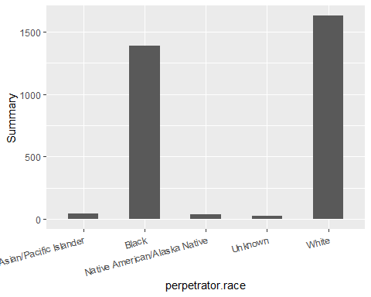

## Type-specified plot

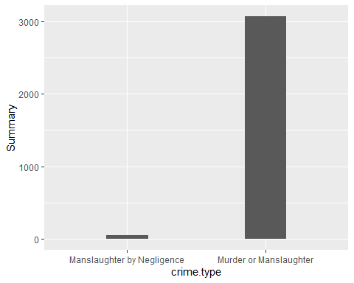

## Weapon-specified plot (TOP10)

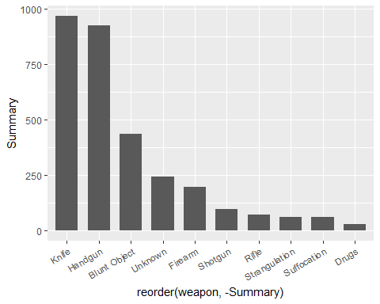

## Year/State-specified plot

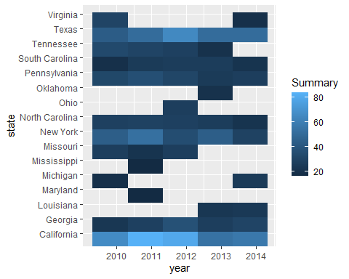

## Age-specified plot (jitter)

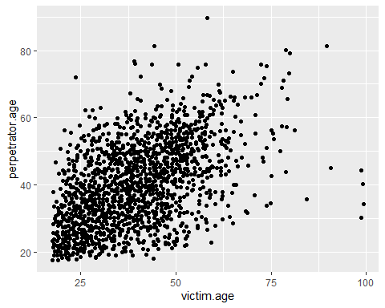

## Age-specified plot (gisto)

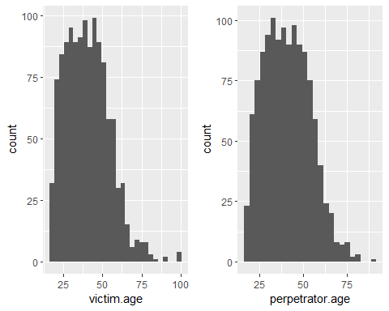

## Age-specified plot (correlation of ages)

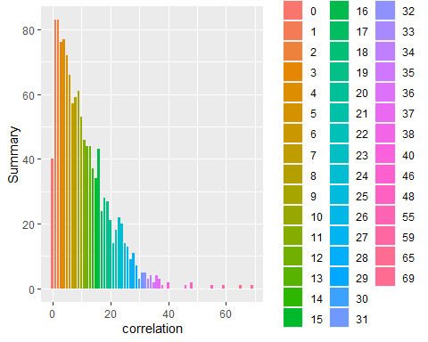

## State-specified plot (TOP5)

