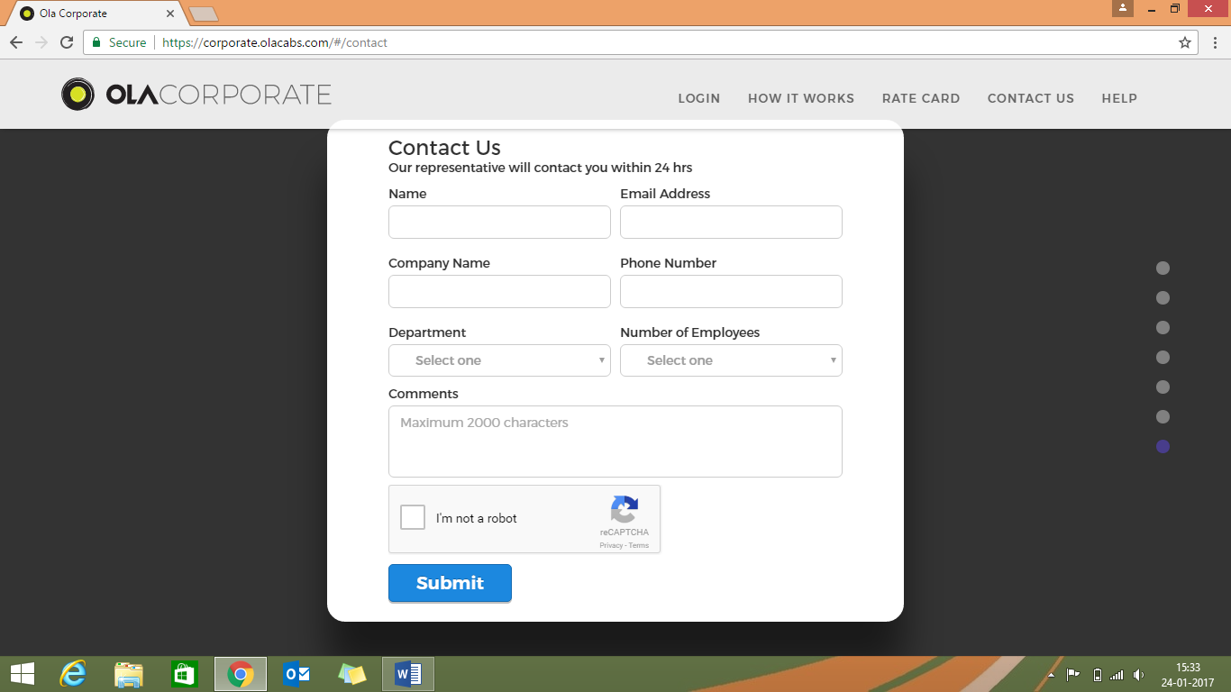

Test Cases

* 1. Name
     + Positive
       - Alignment
       - Enter alphabets
       - Enter up to 100 characters
       - Default text
       - Check validation message
       - Format of heading and validation message
     + Negative
       - Leave it blank
       - Enter numeric characters
       - Enter special characters
       - Enter alphanumeric characters
       - Enter more than 100 characters
       - Enter only white spaces
  2. Email Address
     + Positive
       - Alignment
       - Enter alphanumeric characters
       - Enter correct format
       - Default text
       - Check validation message
       - Format of heading and validation message
     + Negative
       - Leave it blank
       - Enter wrong format
       - Enter more than 30 characters
       - Enter white spaces
  3. Company Name
     + Positive
       - Alignment
       - Enter alphanumeric characters
       - Enter up to 20 characters
       - Default text
       - Check validation message
       - Format of heading and validation message
     + Negative
       - Leave it blank
       - Enter numeric characters
       - Enter special characters
       - Enter more than 20 characters
       - Enter white spaces
  4. Phone Number
     + Positive
       - Alignment
       - Enter numeric characters
       - Enter up to 10 characters
       - Default text
       - Check validation message
       - Format of heading and validation message
     + Negative
       - Leave it blank
       - Enter alphabets
       - Enter special characters
       - Enter alphanumeric characters
       - Enter more than 10 characters
       - Enter white spaces
  5. Department
     + Positive
       - Alignment of label
       - Alignment of drop down
       - Verify all options
       - Select one option
       - Format of options
       - Default text
       - Check validation message
       - Format of heading and validation message
     + Negative
       - Leave it blank
       - Select more than one option
  6. Number of Employees
     + Positive
       - Alignment of label
       - Alignment of drop down
       - Verify all options
       - Select one option
       - Format of options
       - Default text
       - Check validation message
       - Format of heading and validation message
     + Negative
       - Leave it blank
       - Select more than one option
  7. Comments
     + Positive
       - Alignment
       - Enter alphabets
       - Enter up to 2000 characters
       - Default text
       - Check validation message
       - Format of heading and validation message
     + Negative
       - Leave it blank
       - Enter numeric characters
       - Enter special characters
       - Enter alphanumeric characters
       - Enter more than 2000 characters
       - Enter white spaces
  8. Submit Button
     + Positive
       - Alignment of label
       - Alignment of button
       - Format of label
       - Check successful message
       - Check validation message
       - Format of validation message and successful message
       - Button shape
       - Button color
     + Negative
       - Click button with all fields empty
       - Click button with few fields empty