Acknowledgement

We would like to show our heartfelt gratitude to all those who have contributed to the successful completion of this project. We are deeply thankful to our project guide, Dr. Maitri Jhaveri, for her guidance, support, and encouragement throughout the development of the Blood Bank System. Her expertise and insights have been instrumental in shaping the project.

Furthermore, we extend our heartfelt gratitude to Dr. Jyoti Pareek, for her invaluable advice and constructive feedback.

We would also like to express our gratitude to the Head of the Department, Dr. Hiren Joshi, and faculty and staff of the Department of Computer Science, Gujarat University, for providing the necessary resources and support.

Index

|  |  |
| --- | --- |
| **Sr. No.** | **Contents** |
| 1 | Project profile |
| 2 | About the Project |
| 3 | System Engineering |
| 4 | System Design |
| 5 | System Testing |
| 6 | Sample Coding |
| 7 | Future Enhancements |
| 8 | Bibliography |

Project Profile

**Project Title:** Blood Bank System

**Aim:** To design and develop a Blood Bank System that facilitates efficient management of donor registrations, blood donations, hospital requests, and inventory tracking, ensuring a seamless and organized process.

**Software Used:**

* PHP (Backend)
* MySQL (Database)
* HTML/CSS (Frontend)
* XAMPP (Server Environment)

**Hardware Used:**

* Intel Core i5 or higher processor
* 8GB RAM (minimum)
* 500GB Hard Disk

**Team Size:** 4

**Team Members/Developed By:**

* Mahale Ruchita
* Makwana Keyuri
* Patel Netra

**Minimum Deployment Environment:**

**Hardware:**

* A computer with at least an Intel Core i3 processor
* 4GB RAM (minimum)
* 250GB Hard Disk

**Software:**

* Operating System: Windows 10 or Linux
* IDE: VS Code or any preferred text editor
* XAMPP Server
* PHP 7.4 or higher
* MySQL Server

About The Project

The Blood Bank System is an application designed to manage the operations of a blood bank effectively. This system allows administrators to register donors, register hospitals, record blood donations, manage hospital requests, track blood supply etc. It also facilitates hospitals in requesting blood and viewing responses. The system ensures efficient handling of blood donation history, blood expiry, and inventory for each blood type.

**Features:**

* Donor registration and management
* Hospital registration and management
* Blood donation tracking
* Hospital requests and responses
* Blood inventory management

Requirement Engineering

**System Overview:**

The Blood Bank System provides a platform for administrators and hospitals to manage blood donations and requests efficiently. Here Blood Bank admin can manage donor and hospital’s registration, can manage blood donation tracking. Hospitals are able to request and response the blood requests.

**Requirement Analysis and Feasibility Study:**

**Requirements:**

* User roles: Admin and Hospital
* Secure login and authentication
* Data entry and retrieval for donors and hospitals
* High availability and reliability
* User-friendly interface

**Feasibility:**

* Technically feasible with available tools
* Cost-effective
* Operationally viable

**Proposed System:**

1. **Objectives:**
   1. To automate the blood bank management process
   2. To maintain accurate and up-to-date record
   3. To ensure timely responses to hospital requests
2. **Hardware and Software Platforms:**
   1. Minimum Hardware Requirements:
      1. Processor: Intel i4 or higher
      2. RAM: 4GB
      3. Storage: 500GB
   2. Operating System: Windows 10
   3. Development Tools: HTML, CSS, JavaScript, PHP, MySQL

System Design

* ER Diagram

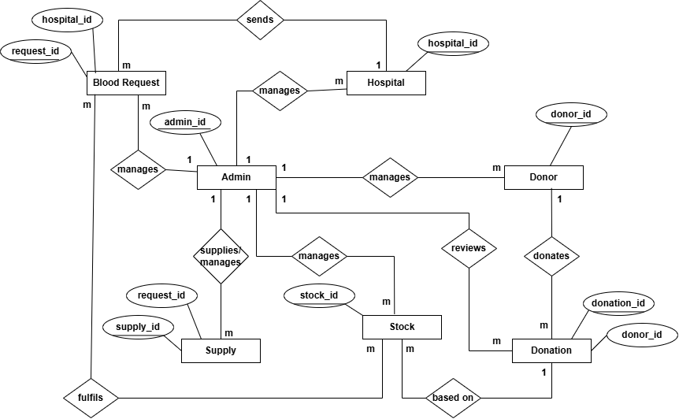

* Activity Diagram

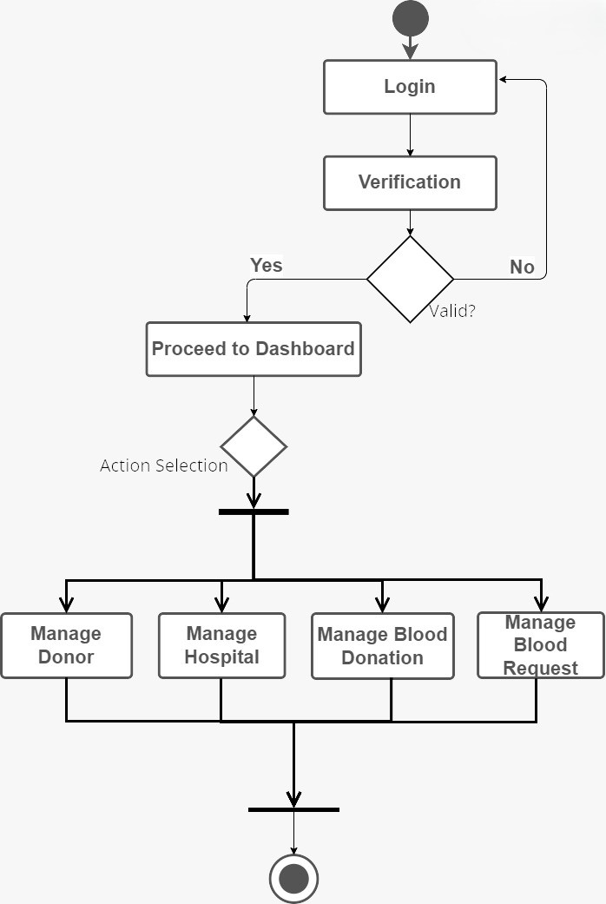

* Database Design

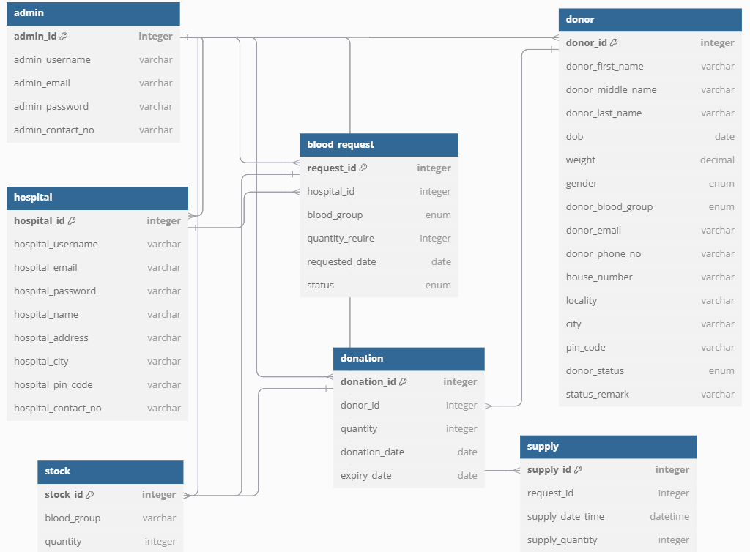

* Forms Design

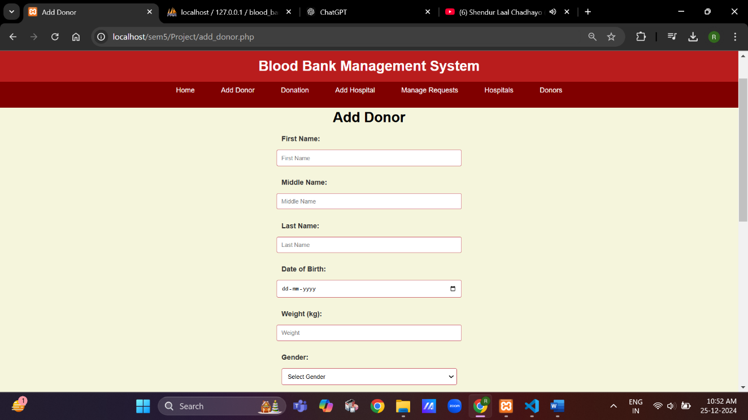

Fig. 1: Add a Donor

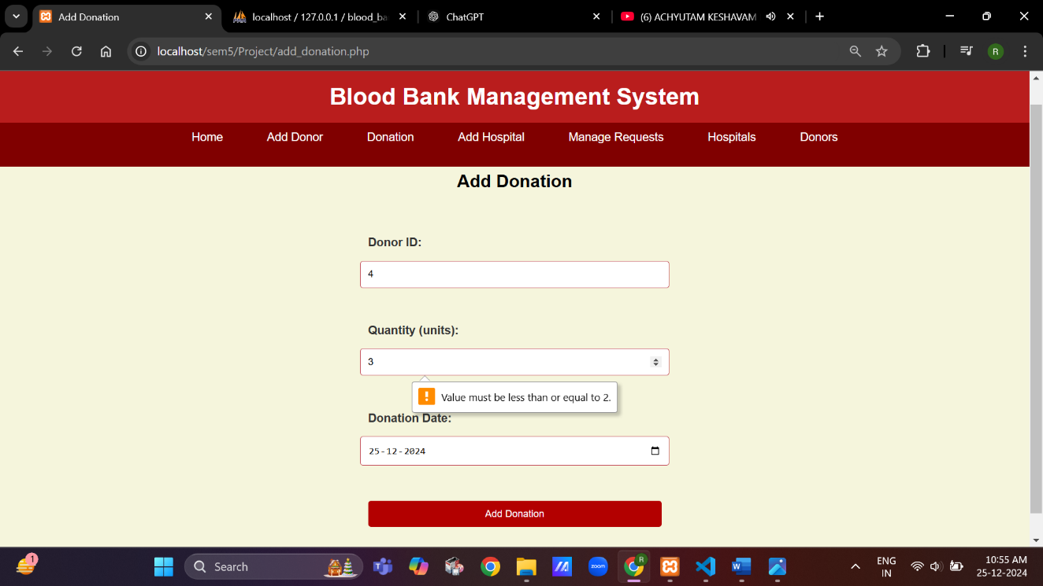

Fig. 2: Add donation data

* Reports Design

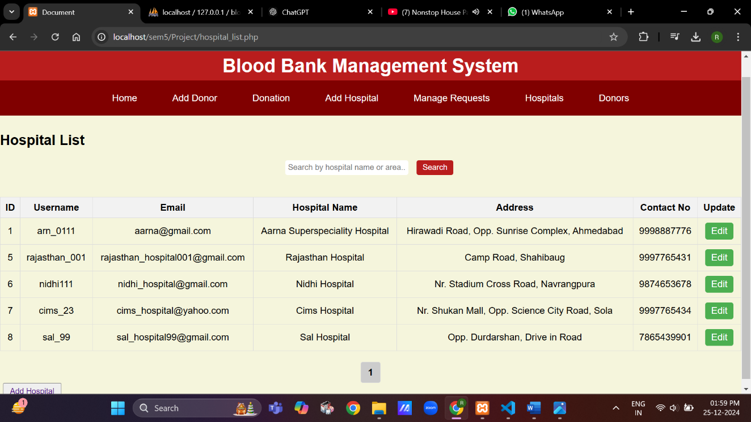

Fig. 3a: List of all the hospitals

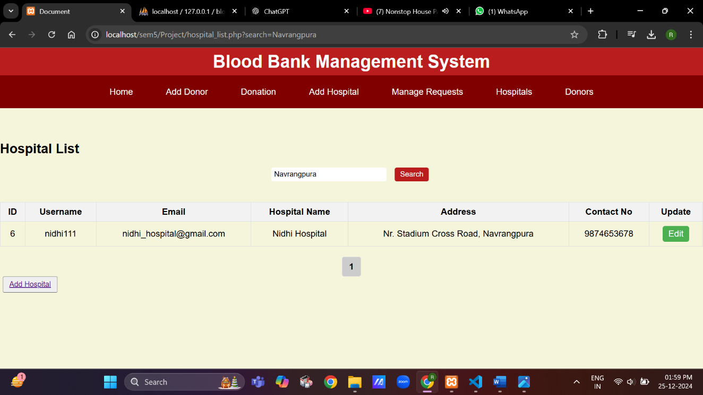

Fig. 3b: List of hospitals in “Navrangpura”

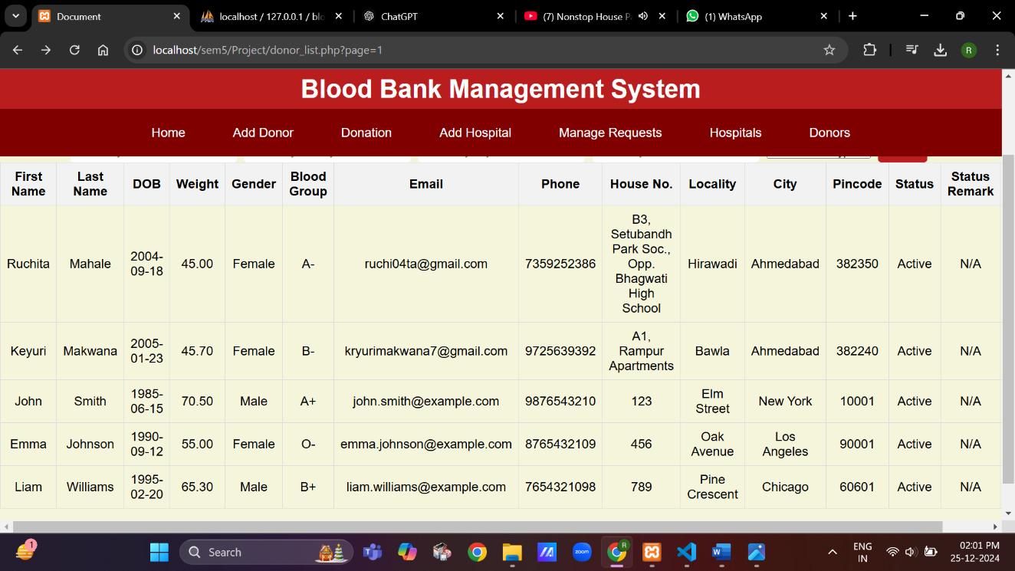

Fig. 4a: List of all the donors

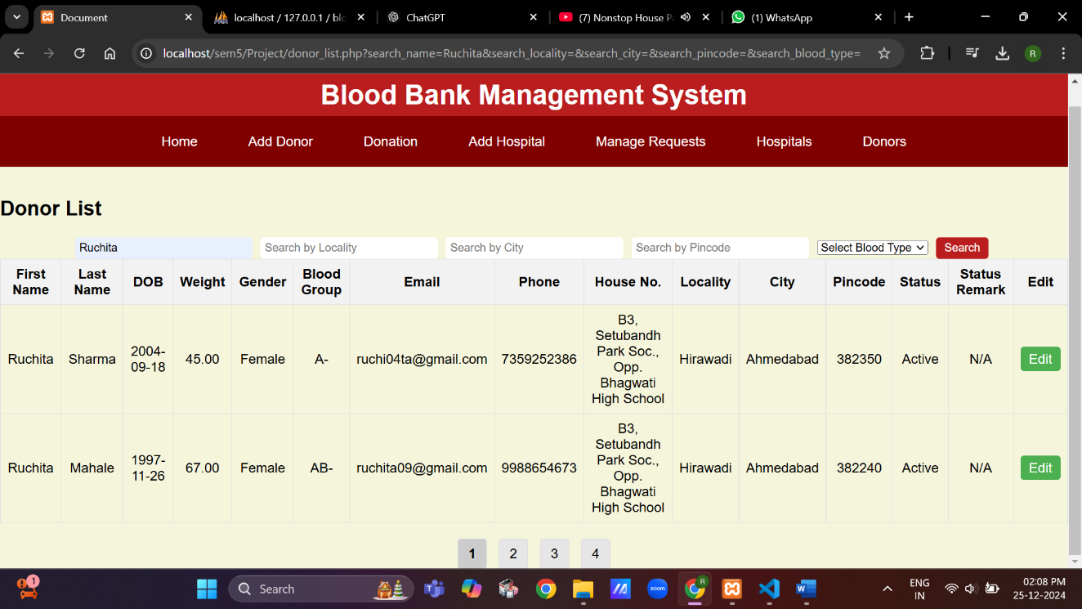

Fig. 4b: List of donors with name “Ruchita”

* System Security

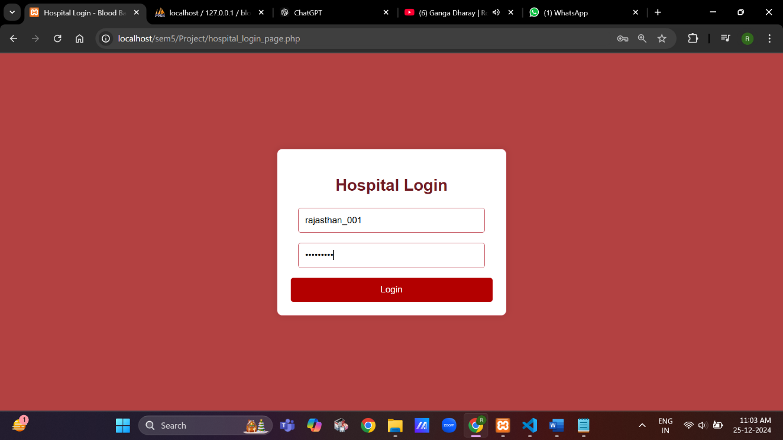

Fig. 5a: Entered data to login

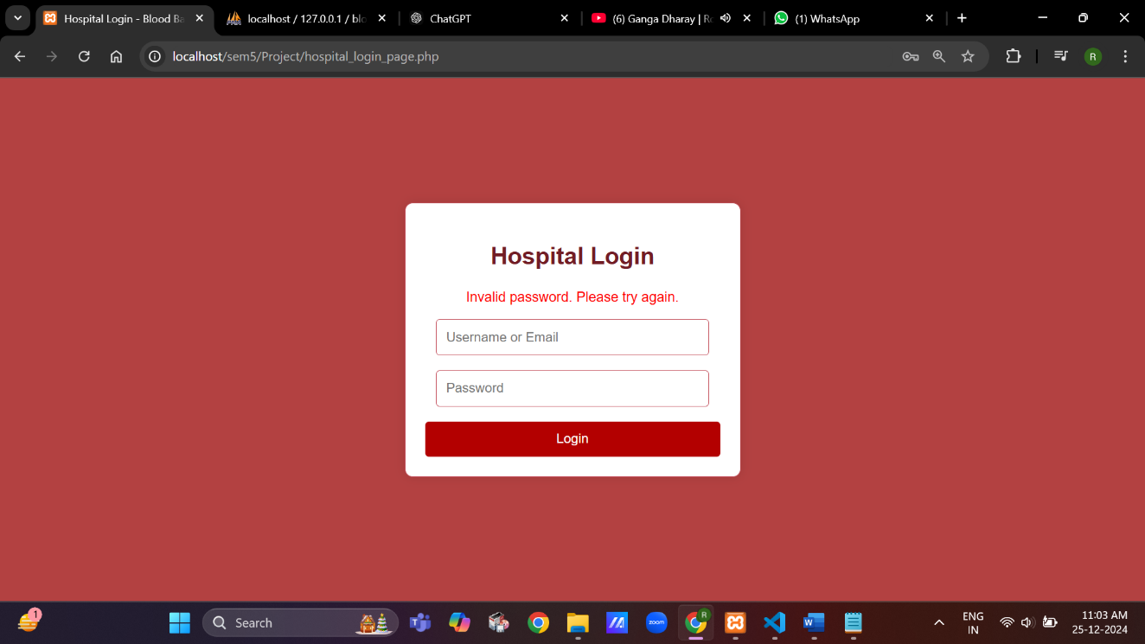

Fig. 5b: Error for entering incorrect data entered

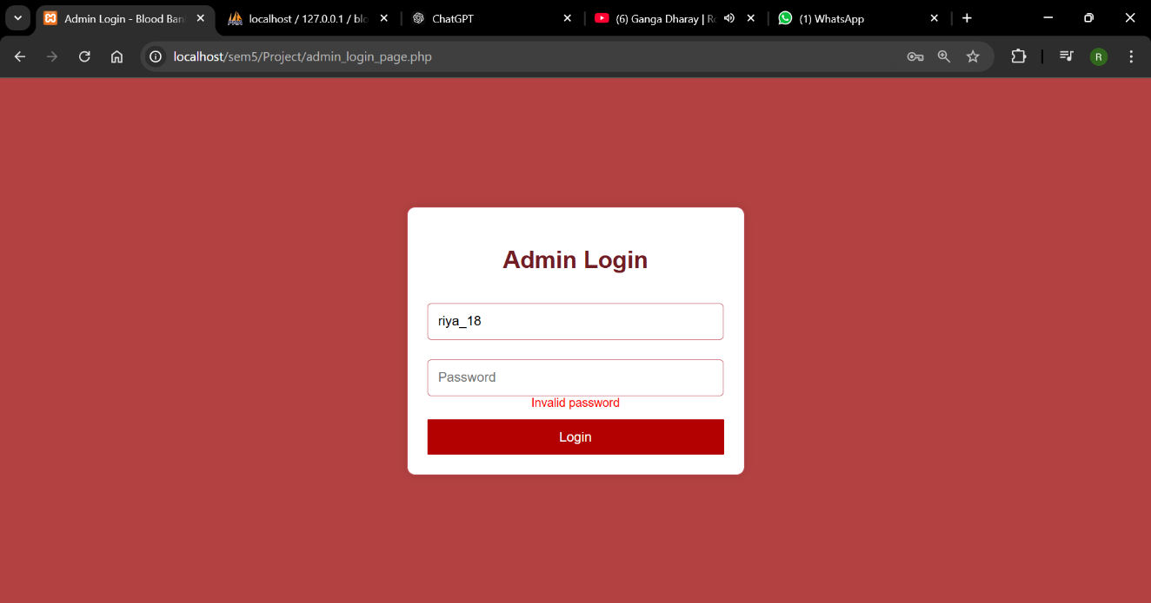

Fig. 6: Doesn’t allow to take any action without login

System Testing

|  |  |  |  |  |
| --- | --- | --- | --- | --- |
| Sr No. | Date | Exact Outcome | Expected Outcome | Status |
| 1. | 24-12-2024 | Blood donor added successfully | Blood donor is added to the database | Pass |
| 2. | 24-12-2024 | Blood donor with incomplete information (E.g. gender) | Error message indicating any missing information | Pass |
| 3. | 24-12-2024 | Searching for a donor by blood group | List of donors with matching blood group is displayed | Pass |
| 4. | 24-12-2024 | Adding a blood donation record with invalid blood group | Error message indicating invalid blood group | Pass |
| 5. | 24-12-2024 | Blood donation record added with valid date | Blood donation date is saved correctly in the database | Pass |
| 6. | 24-12-2024 | Hospital requests blood of type A+ | Blood of any type is issued from the bank if available | Pass |
| 7. | 24-12-2024 | Hospital requests blood when no stock is available | Error message indicating insufficient blood supply | Pass |
| 8. | 24-12-2024 | Hospital attempts to request a specific blood quantity exceeding available stock | Error message indicating insufficient quantity | Pass |

System Coding

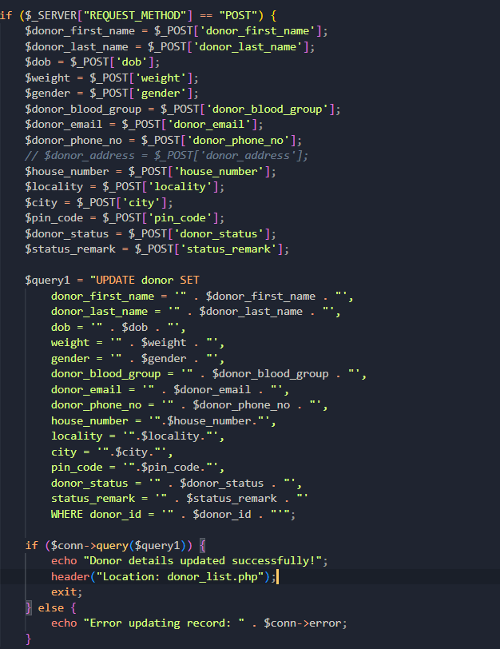

Fig. 7: Blood Bank/Admin Side:- Updating donor’s details

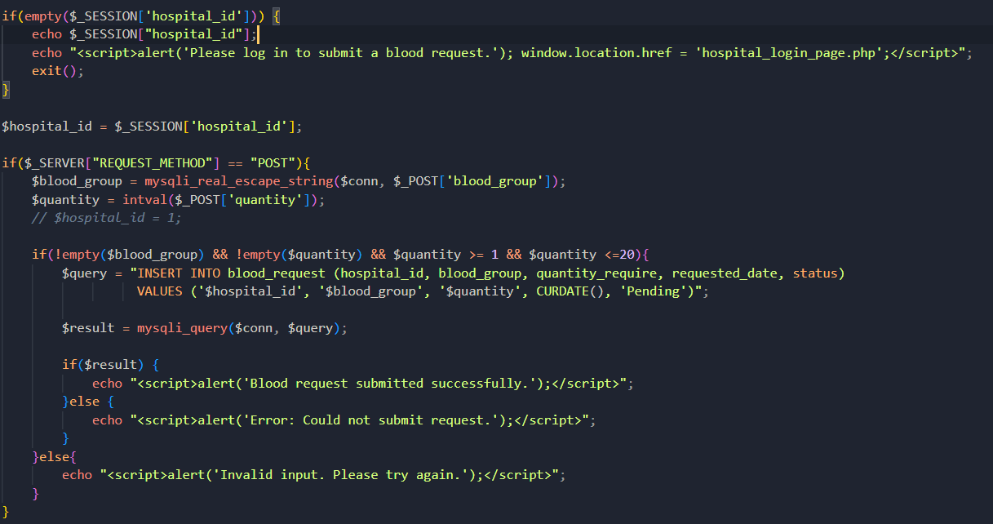

Fig. 8: Hospital Side:- Requesting blood from the Blood bank

Future Enhancements

* Integration with mobile applications for easy to use.
* Donors web page to see their donation history.
* Real time notifications for donor and hospitals.
* Laboratory Module**:** A dedicated module for managing laboratory tests related to blood donations, including compatibility testing and quality assurance.

Bibliography

**MySQL Database Documentation**

* Guidance and references from MySQL’s official documentation for creating and managing databases related to the Blood Bank System.

**Blood Bank System Research Articles**

* "Design and Implementation of a Blood Bank Management System" by Omkar Vilas Kamble, International Journal of Scientific Research in Engineering and Management.

**Stack Overflow**

* Online community forum for troubleshooting and learning best practices in web development.

**System Development Reference Books**

* Books on system engineering and software development methodologies to aid in designing, developing, and testing the project.
* Object-Oriented Modelling and Design with UML, Second Edition