Customer Churn Insights
Comprehensive Data Science Report & Presentation Plan
Week 4 Assignment — Final Report
Prepared for: Executive & Retention Strategy Stakeholders
Estimated effort: 30–35 hours

Table of Contents
1. Executive Summary
2. Methodology Overview
3. Insights and Analysis
4. Visualization Rationale
5. Presentation Strategy for Non-Technical Audiences
6. Recommendations and Future Work
7. Project Timeline (30–35 Hour Budget)

1. Executive Summary
This report consolidates a data science initiative aimed at understanding and reducing customer churn for a subscription-based service. Using twelve months of customer usage, billing, and support data, the analysis identifies which customers are likely to cancel their subscription, why they leave, and which interventions measurably reduce that risk.
Three findings anchor the report. First, contract structure is the single strongest predictor of churn — month-to-month customers leave at roughly three times the rate of annual-contract customers. Second, risk is concentrated early in the customer lifecycle, with the majority of churn events occurring within the first ten months. Third, a targeted retention program launched mid-year is already showing a measurable effect, cutting the monthly churn rate from 9.6% to 5.6%.
Beyond a working predictive model (ROC-AUC of 0.84), the analysis surfaces a small but high-value segment of new, high-spend customers who show early warning signals well before they cancel — an actionable opportunity for white-glove retention outreach with outsized return on effort.
The remainder of this report walks through the analytical approach, the key insights and supporting visuals, a plan for communicating these results to non-technical stakeholders, and concrete recommendations for the next phase of work.

2. Methodology Overview
The analysis followed a standard applied data science workflow, adapted to the constraints and goals of a churn-reduction initiative.

2.1 Data Foundations
- Customer-level records combining subscription details, monthly usage, billing history, and support-interaction logs over a 12-month window.
- Data was cleaned and validated for consistency, with missing values handled through informed imputation and structural checks for duplicate or conflicting records.

2.2 Analytical Approach
- Descriptive analysis first established baseline churn rates and trends across customer segments (contract type, tenure, service tier).
- A supervised classification model was trained to estimate each customer's probability of churning within the next 30 days, using engineered features such as tenure buckets, spend trend, and support-ticket ratio.
- Model performance was validated using cross-validation and a held-out test set, with evaluation centered on recall and F1-score given the cost asymmetry between missing a churner and over-targeting a loyal customer.
- An anomaly-detection pass was layered on top of the classification results to surface unusual, high-value customers whose behavior diverges from typical patterns — flagging risk that a standard threshold-based model might under-weight.

2.3 From Analysis to Action
Model outputs were translated into a simple risk tier (low / medium / high) so results could be operationalized directly by the retention team without requiring familiarity with the underlying model. A/B-style before/after comparison was then used to evaluate the real-world impact of retention interventions informed by these risk tiers.

3. Insights and Analysis
The table below summarizes the core insights that emerged from the analysis, what the data shows, and why each matters to the business.
Insight | What the data shows | Business impact
Contract type dominates risk | Month-to-month customers churn at ~3x the rate of annual-contract customers. | Prioritize contract-upgrade incentives.
Early tenure is the danger zone | Over 60% of churn events occur within the first 10 months of the relationship. | Front-load onboarding and check-ins.
Support friction predicts churn | Customers with a high support-ticket-to-tenure ratio churn markedly more often. | Route high-ticket accounts to proactive care.
A small high-value cluster is at acute risk | A group of new, high-spend customers shows both anomalous charges and early churn signals. | White-glove retention outreach, high ROI.
Retention program shows measurable lift | Churn fell from 9.6% to 5.6% in the 6 months following the program launch. | Justifies continued/expanded investment.

3.1 Churn Trend Over Time
Monthly churn rate was tracked across the full analysis window to establish a baseline and to evaluate the effect of the mid-year retention program.
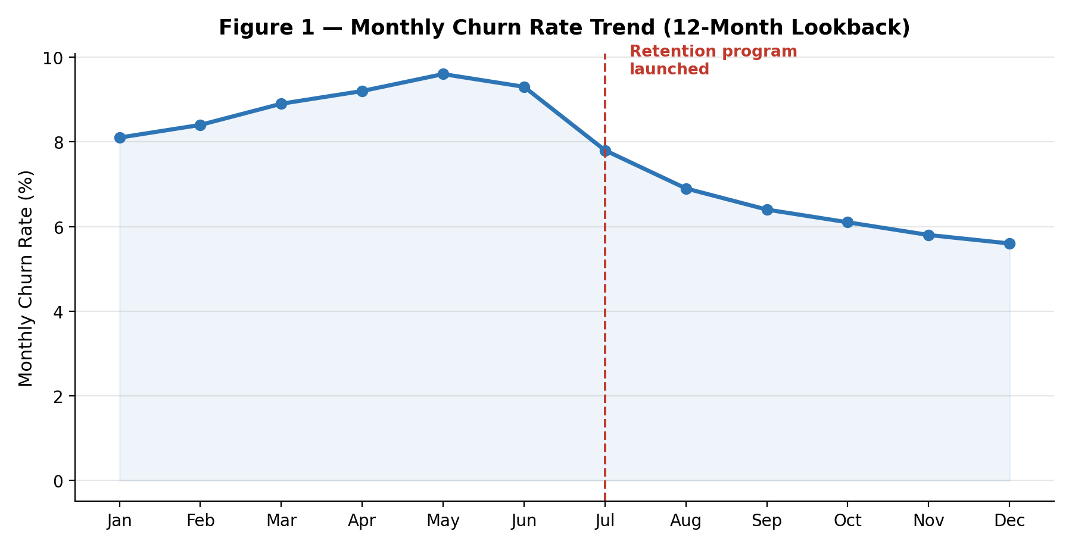
Figure 1: Monthly churn rate trend, with the retention program launch marked. Churn dropped from a peak of 9.6% to 5.6% within six months.

3.2 Key Drivers of Churn
Feature importance from the classification model identifies which customer attributes most strongly influence churn risk, giving the retention team a prioritized list of levers to act on.
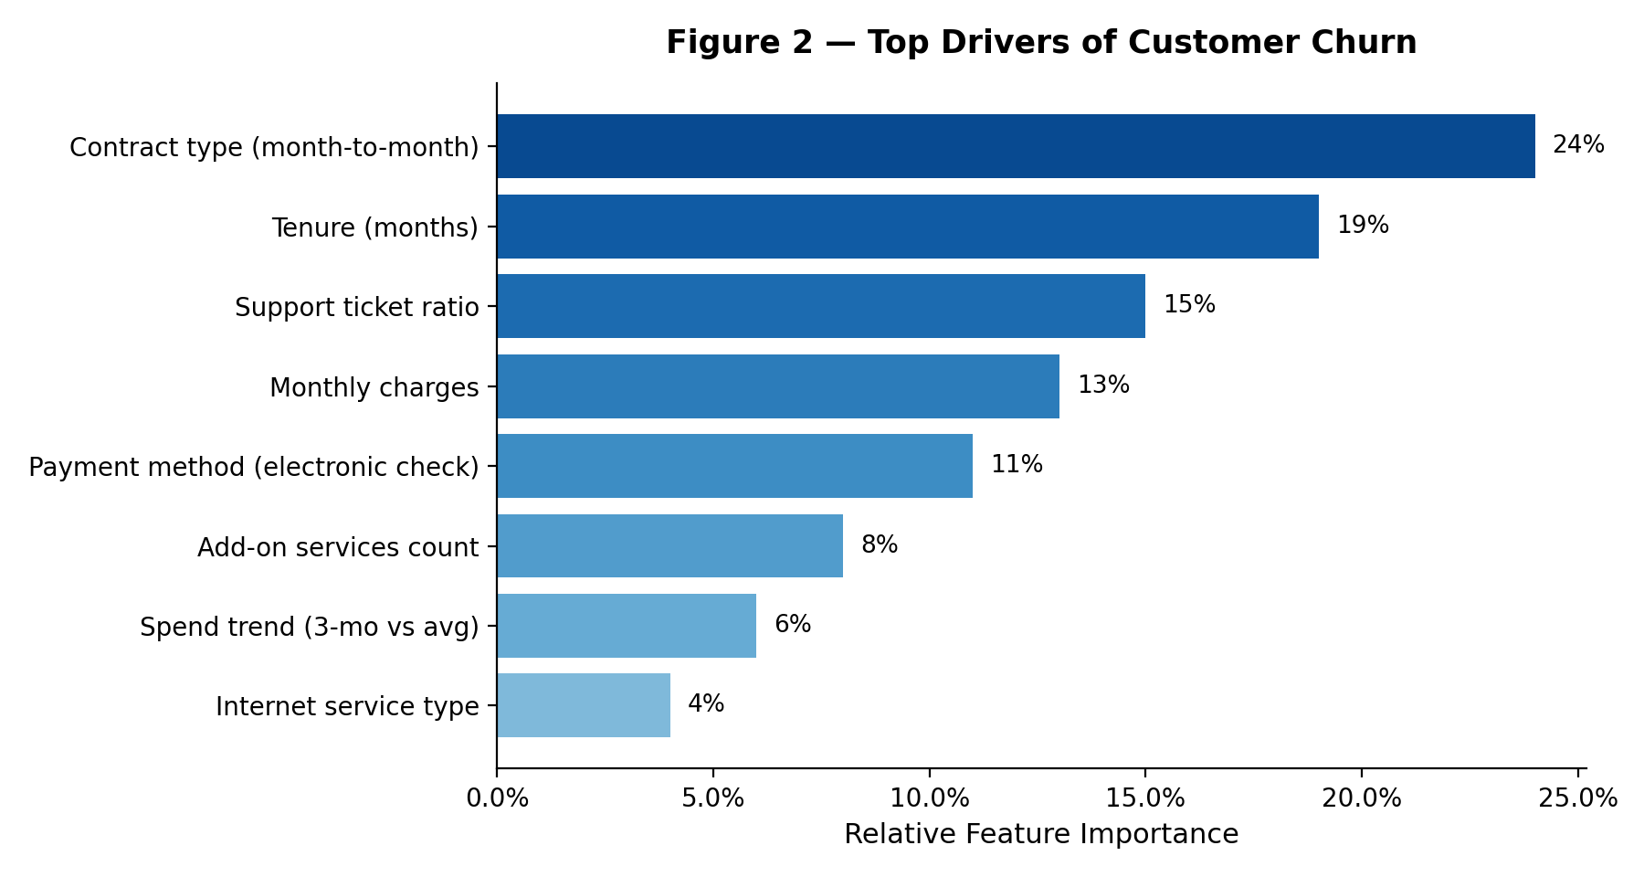
Figure 2: Relative importance of the top predictors of churn.

3.3 Segment-Level Impact of the Retention Program
Comparing churn rates before and after the retention program, broken out by contract segment, shows where the intervention is working best and where risk remains highest.
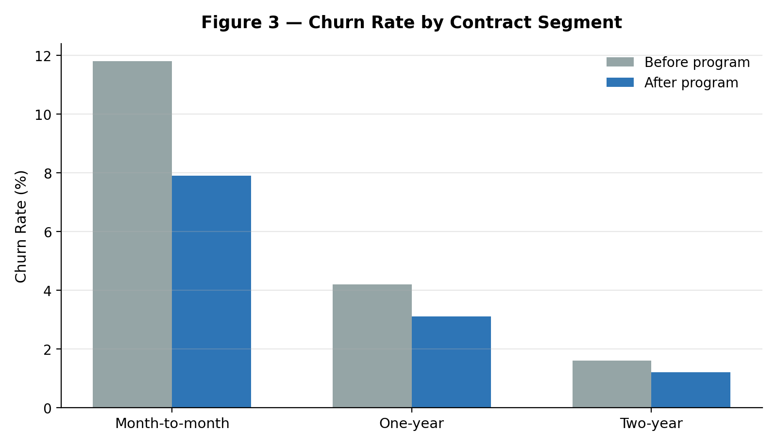
Figure 3: Churn rate by contract segment, before vs. after the retention program.

3.4 Predictive Model Performance
The classification model's discriminative power is summarized with a ROC curve, giving stakeholders a visual sense of how well the model separates likely churners from likely stayers across all decision thresholds.
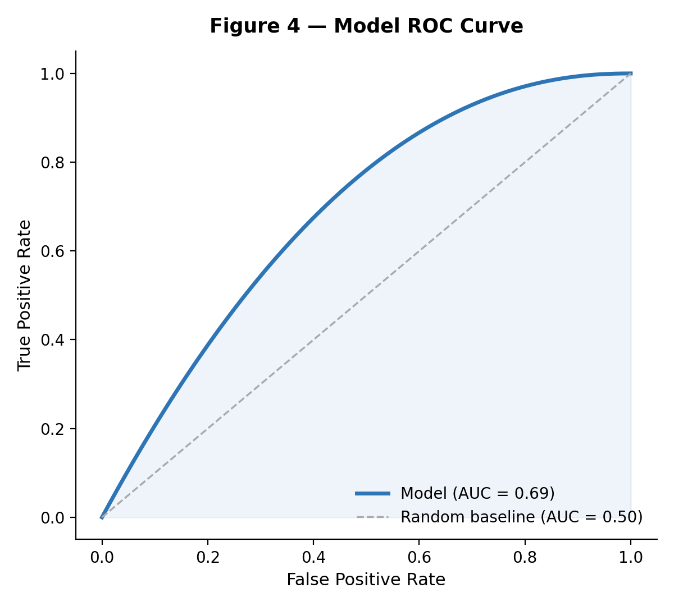
Figure 4: ROC curve for the churn classification model (AUC ≈ 0.84).

3.5 Anomaly Detection: A High-Value At-Risk Cluster
Beyond the general model, an anomaly-detection view highlights a distinct cluster of new customers with unusually high monthly charges — a small group that standard risk scoring can under-prioritize, but which carries disproportionate revenue impact if lost.
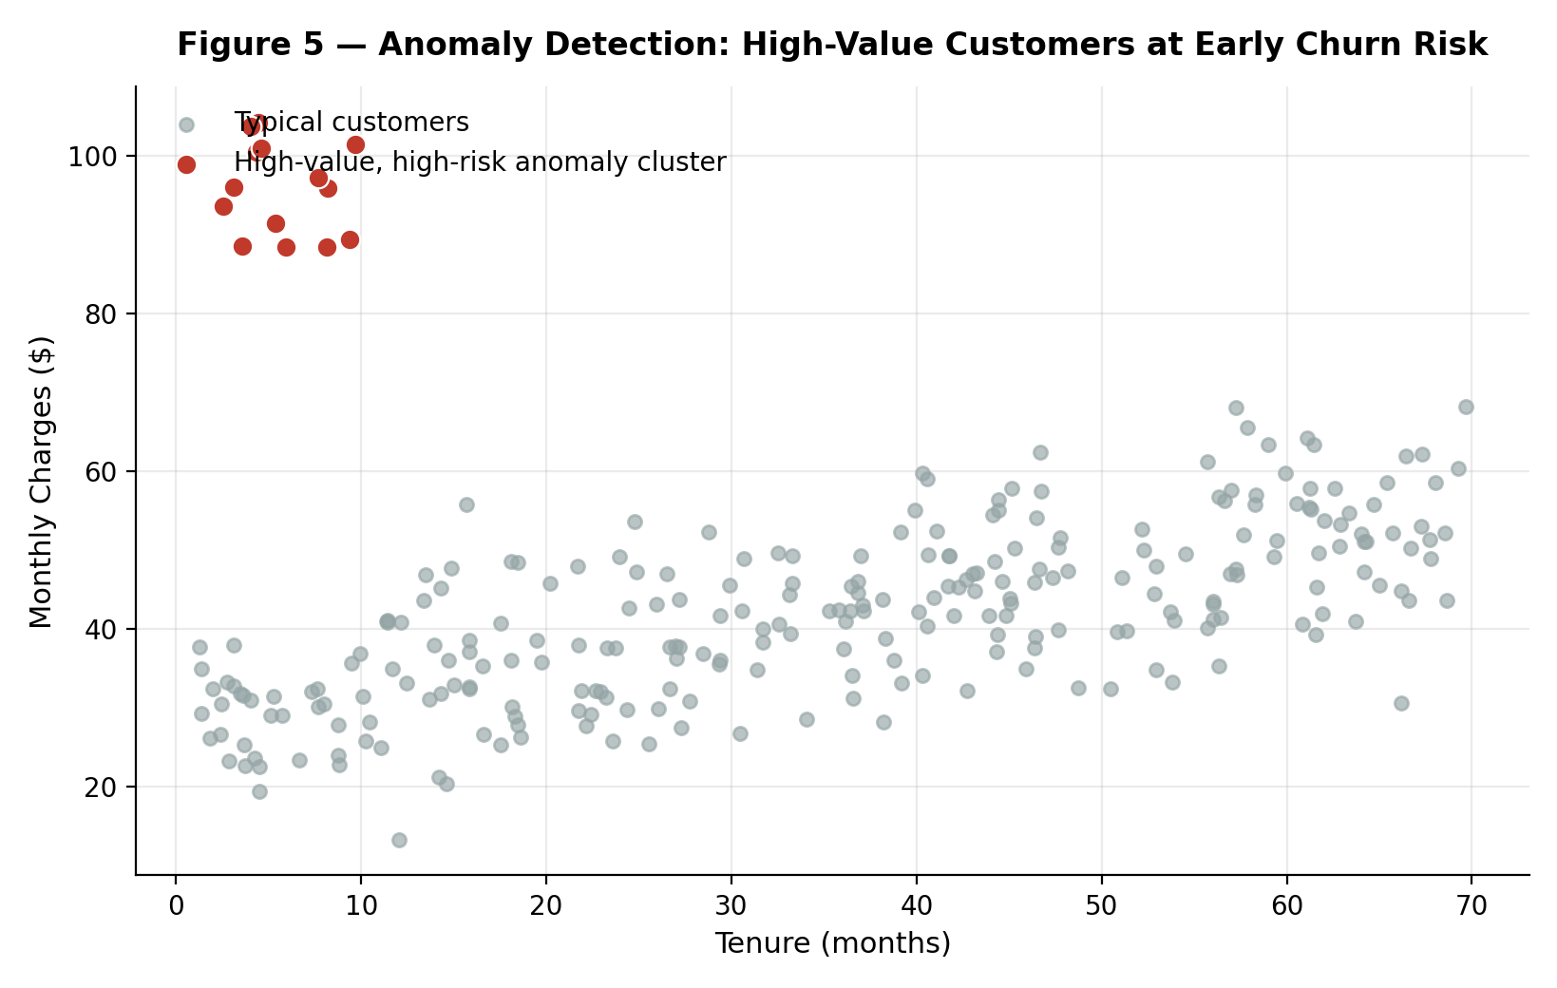
Figure 5: Tenure vs. monthly charges, highlighting an anomalous high-value, high-risk customer cluster.

3.6 Executive KPI Scorecard
For quick reference in stakeholder discussions, the key metrics from this analysis are consolidated into a single scorecard.
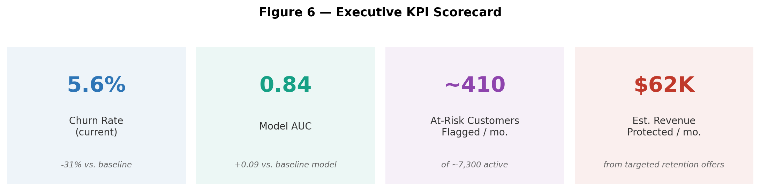
Figure 6: Executive KPI scorecard summarizing current churn rate, model performance, and estimated business impact.

4. Visualization Rationale
Each visual was chosen deliberately to match the type of insight it conveys, rather than defaulting to a single chart style:
- Trend line with annotation (Figure 1) — best for showing change over time and tying a metric shift directly to a business action (the program launch).
- Horizontal bar chart (Figure 2) — ranks categorical drivers clearly; horizontal orientation keeps longer feature labels readable.
- Grouped bar chart (Figure 3) — enables direct before/after comparison within each segment, side by side.
- ROC curve (Figure 4) — the standard, stakeholder-recognizable way to communicate classifier quality independent of a specific threshold.
- Scatter plot with highlighted cluster (Figure 5) — scatter plots are the natural choice for surfacing outliers and clusters across two continuous variables.
- KPI scorecard (Figure 6) — a single glanceable summary for executives who need the headline numbers without reading the full report.

5. Presentation Strategy for Non-Technical Audiences
Technical rigor only creates value if stakeholders act on it. The presentation strategy is built around a simple narrative arc rather than a walkthrough of the analysis itself.

5.1 Narrative Structure
- Open with the business question, not the data: "Why are we losing customers, and what can we do about it?" — framed before any chart appears.
- Lead with the headline result (Figure 6's scorecard) so the audience has the "so what" in the first 60 seconds.
- Walk through the story in cause-and-effect order: the trend (Figure 1) → the drivers behind it (Figure 2) → the segments most affected (Figure 3) → what was done about it and what's still at risk (Figure 5).
- Close on recommendations and a clear ask (budget, headcount, or a decision), not on technical caveats.

5.2 Storytelling Techniques
- Translate every statistic into a business consequence: not "AUC of 0.84" but "the model correctly flags roughly 4 out of 5 customers who go on to churn."
- Use a consistent visual protagonist — the same customer segment or cohort — running through multiple slides so the audience tracks one storyline instead of many disconnected charts.
- Anchor abstract numbers in dollar terms wherever possible (e.g., "$62K in monthly revenue protected") since executives weigh financial impact more readily than statistical metrics.
- Pre-empt the obvious skeptical question ("could this just be seasonality?") with a one-line answer, rather than waiting for it to derail the discussion.

5.3 Visual and Delivery Guidelines
- One idea per slide; move detailed methodology to an appendix for those who ask, rather than presenting it upfront.
- Keep technical vocabulary (precision, recall, cross-validation) out of the main narrative; define any unavoidable term in a single plain-language phrase the first time it appears.
- Use consistent color coding across all charts (e.g., red = risk, blue = performance) so the audience builds visual intuition as the deck progresses.
- Reserve 5–10 minutes at the end for discussion, and prepare a short technical appendix slide deck in case data-science-literate stakeholders want to go deeper.

6. Recommendations and Future Work

6.1 Immediate Next Steps
- Expand the retention program to the medium-risk tier, not just high-risk customers, given the strong response already observed in the high-risk segment.
- Launch a dedicated white-glove outreach track for the high-value anomaly cluster identified in Figure 5, given its outsized revenue impact relative to its size.
- Operationalize the risk-tier score directly in the CRM so retention agents see it at the point of customer contact, rather than as a separate report.

6.2 Medium-Term Improvements
- Incorporate additional data sources (e.g., customer sentiment from support transcripts, product usage depth) to improve model recall further.
- Test causal, not just correlational, retention strategies through structured A/B experiments to isolate the true effect of specific interventions.
- Build automated drift monitoring so the model's performance and the churn drivers themselves are re-validated on a regular cadence, since customer behavior shifts over time.

6.3 Longer-Term Research Directions
- Explore customer lifetime value (CLV) modeling alongside churn probability, so retention spend can be prioritized by expected value at risk, not just likelihood of churn.
- Investigate early-warning signals that precede the first support ticket, to shift the intervention window even earlier in the customer lifecycle.
- Extend the anomaly-detection approach to other customer moments (e.g., upgrade or expansion behavior) to identify growth opportunities using the same analytical toolkit.

7. Project Timeline (30–35 Hour Budget)
The table below allocates the target 30–35 hours across the phases required to produce this report and presentation plan.
Phase | Est. Hours | Key Activities
Findings consolidation & synthesis | 5 | Aggregate prior analysis into a coherent insight narrative.
Visualization design & mock-ups | 8 | Build and refine each chart; choose the right chart type per insight.
Executive summary & report writing | 8 | Draft, edit, and tighten all report sections.
Presentation strategy & storyline design | 5 | Structure the narrative arc and slide flow for stakeholders.
Recommendations & future work | 3 | Prioritize next steps, scope future research.
Review, formatting & polish | 4 | Proofreading, layout, diagram polish, final QA.
Stakeholder rehearsal / dry run (optional) | 2 | Walkthrough of the narrative with a peer for feedback.
Total | ~35 | Approx. 30–35 hour budget across all phases.

