Machine Learning Model
Development & Evaluation Plan
Week 3 Assignment — Conceptual Design Document
Use Case: Customer Churn Prediction for a Subscription-Based Telecom Service
Estimated effort: 30–35 hours

Table of Contents
1. Objective and Problem Definition
2. End-to-End Workflow Overview
3. Data Preprocessing
4. Model Selection and Training
5. Evaluation Metrics and Validation Strategy
6. Model Deployment (Optional Extension)
7. Project Timeline (30–35 Hour Budget)
8. Conclusion

1. Objective and Problem Definition
This document presents a detailed, phase-by-phase plan for developing and evaluating a machine learning model in Python. No code is executed as part of this exercise; instead, every phase of a real-world ML project lifecycle is planned, justified, and documented in enough depth to guide an actual implementation.

1.1 Hypothetical Problem
Problem statement: predict which customers of a subscription-based telecom service are likely to churn (cancel their subscription) within the next 30 days, so the retention team can intervene with targeted offers before the customer leaves.

1.2 Justification of the Problem and Approach
- Business relevance: acquiring a new customer typically costs 5–7x more than retaining an existing one, so even a modest improvement in churn detection has an outsized effect on revenue.
- Data availability: telecom providers routinely capture usage, billing, and support-interaction data, making this a realistic supervised learning problem with a clear binary label (churned / not churned).
- Machine learning fit: churn is driven by a mix of linear and non-linear relationships between tenure, usage patterns, pricing, and service quality — well suited to both interpretable and ensemble models, allowing a meaningful comparison.
- Actionability: a churn score can be directly wired into a CRM workflow to trigger retention campaigns, so the model output maps cleanly onto a business action.

1.3 Success Criteria
The project will be considered successful if the final model achieves a recall of at least 0.75 for the churn class (to minimize missed at-risk customers) while keeping precision above 0.55 (to keep retention-offer costs manageable), validated via stratified k-fold cross-validation and confirmed on a held-out test set.

2. End-to-End Workflow Overview
The diagram below summarizes the full pipeline this plan follows, from problem definition through deployment and monitoring. Each stage is detailed in the sections that follow.
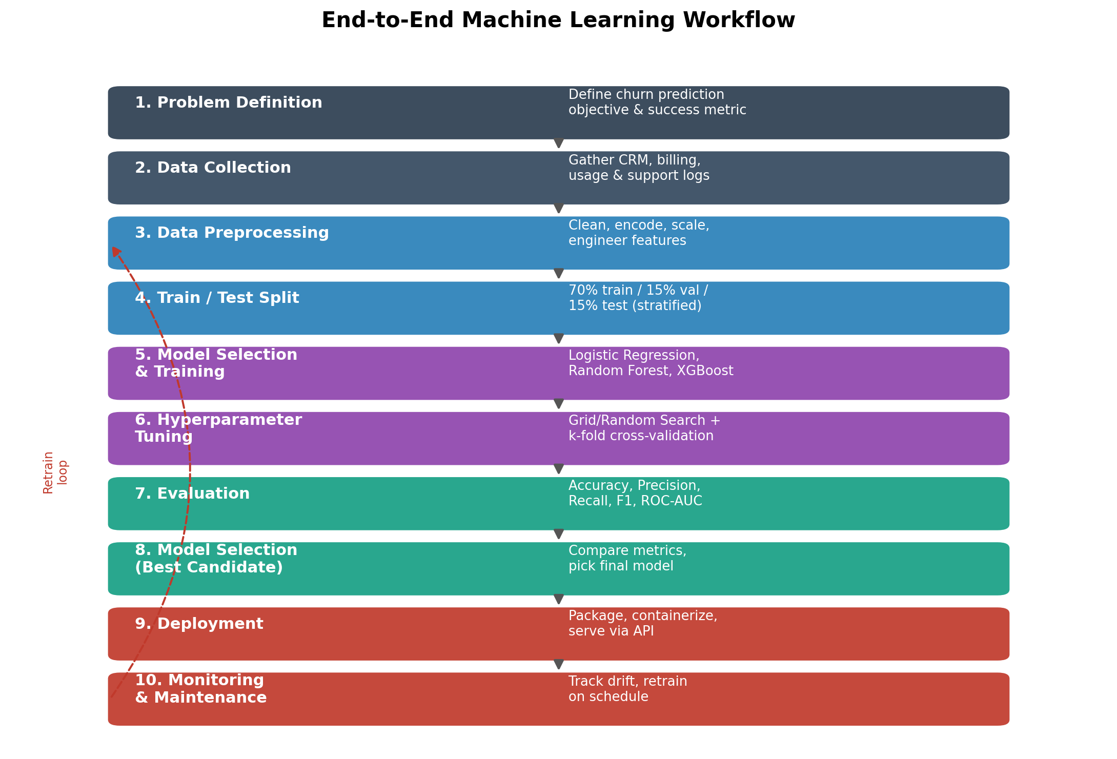
Figure 1: End-to-end machine learning workflow for the churn prediction project.

3. Data Preprocessing
Raw data from CRM, billing, and support systems is rarely model-ready. This phase transforms raw records into a clean, well-structured feature matrix.

3.1 Data Cleaning
- Handle missing values: impute numeric fields (e.g., monthly charges) with median values grouped by contract type; impute categorical fields with the mode or an explicit "Unknown" category.
- Remove duplicate customer records using customer ID as the deduplication key.
- Detect and treat outliers in continuous fields (e.g., tenure, total charges) using the IQR method or domain-based capping.
- Standardize inconsistent categorical labels (e.g., "Yes"/"y"/"1" all mapped to a single boolean representation).

3.2 Normalization and Scaling
- Apply StandardScaler (zero mean, unit variance) to continuous features for models sensitive to feature scale (logistic regression, SVM).
- Tree-based models (Random Forest, XGBoost) do not require scaling, but scaling is still applied consistently for pipeline simplicity and to keep the comparison fair.

3.3 Feature Engineering
- Derive tenure buckets (0–6, 7–12, 13–24, 24+ months) to capture non-linear lifecycle effects.
- Compute average monthly spend trend (last 3 months vs. historical average) as a proxy for dissatisfaction.
- Create a support-interaction ratio: number of support tickets divided by tenure in months.
- One-hot encode low-cardinality categorical variables (contract type, payment method); target/frequency-encode higher-cardinality fields.

3.4 Feature Selection
- Remove near-zero-variance features and features with correlation above 0.9 to reduce redundancy.
- Use mutual information score and tree-based feature importance to rank candidate features.
- Apply recursive feature elimination (RFE) with cross-validation to select the final feature subset for the baseline linear model.

3.5 Potential Challenges and Solutions
Challenge | Mitigation
Class imbalance (churners are a minority) | Use stratified sampling, class-weighting, or SMOTE oversampling during training only (never on validation/test data).
Data leakage | Fit all scalers/encoders on the training fold only, inside a scikit-learn Pipeline, and apply the same transform to validation/test data.
Missing/inconsistent historical records | Document imputation assumptions; add a missingness indicator flag as an extra feature where missingness itself may be informative.
High-cardinality categorical fields | Use target encoding with cross-validation folds to avoid leakage, or hash encoding for very high cardinality.

4. Model Selection and Training

4.1 Candidate Models
Several model families are proposed to compare interpretability, accuracy, and robustness trade-offs:
Model | Strengths | Weaknesses | Role in this plan
Logistic Regression | Fast, interpretable, good baseline, coefficients are explainable to stakeholders. | Assumes linear decision boundary; weaker on complex interactions. | Baseline model.
Decision Tree | Captures non-linear splits; easy to visualize. | Prone to overfitting; unstable to small data changes. | Interpretability check.
Random Forest | Ensemble reduces variance; handles non-linearity and mixed feature types well. | Slower to train; less interpretable than a single tree. | Strong candidate.
Gradient Boosting (XGBoost) | Typically highest accuracy on tabular data; handles missing values natively. | More hyperparameters to tune; can overfit if unchecked. | Primary candidate.
Support Vector Machine | Effective in high-dimensional space. | Slow on large datasets; sensitive to feature scaling. | Secondary comparison.

4.2 Chosen Model and Justification
Gradient Boosting (XGBoost) is proposed as the primary candidate, with Logistic Regression retained as an interpretable baseline for stakeholder communication. Gradient boosting is chosen because it consistently performs well on structured/tabular data of this kind, handles mixed numeric and categorical features effectively after encoding, and natively supports feature importance and SHAP-based explainability, which is important for a business-facing churn use case where the retention team needs to understand why a customer is flagged.

4.3 Training Process
- Split the dataset into training (70%), validation (15%), and test (15%) sets using stratified sampling on the churn label.
- Establish a naive baseline (majority-class predictor) to contextualize all subsequent model performance.
- Train each candidate model on the training set using a scikit-learn Pipeline that bundles preprocessing and the estimator.
- Track training and validation metrics after each run to detect overfitting (large train/validation gap) or underfitting (both scores low).
- Select the best-performing candidate based on cross-validated F1-score and ROC-AUC, then retrain it on the combined train+validation set before final testing.

4.4 Hyperparameter Tuning Strategy
- Grid Search: exhaustive search over a small, hand-picked grid for the logistic regression baseline (regularization strength C, penalty type).
- Randomized Search: for Random Forest and XGBoost, sample from distributions over max_depth, n_estimators, learning_rate, subsample, and min_child_weight — far more efficient than grid search over a large space.
- Bayesian Optimization (optional refinement): use a tool such as Optuna to more efficiently navigate the XGBoost hyperparameter space once a promising region is identified via randomized search.
- All tuning is performed with k-fold cross-validation on the training set only; the test set remains untouched until final evaluation.

5. Evaluation Metrics and Validation Strategy
Because churn is typically a minority class, accuracy alone would be misleading (a model that always predicts "no churn" could still score high on accuracy). A combination of metrics is therefore used:
Metric | Definition | When to prioritize it
Accuracy | Proportion of predictions that are correct. | Balanced classes; a quick, high-level sanity check only.
Precision | Of predicted churners, the fraction that actually churned. | Retention offers are costly — minimize false positives.
Recall (Sensitivity) | Of actual churners, the fraction correctly identified. | Missing a churner is costlier than a false alarm.
F1-Score | Harmonic mean of precision and recall. | Class imbalance and both error types matter.
ROC-AUC | Area under the ROC curve across all thresholds. | Comparing models independent of a chosen threshold.
PR-AUC | Area under the precision-recall curve. | Severe class imbalance (churners are the minority).
Confusion Matrix | Breakdown of TP, FP, TN, FN counts. | Diagnosing the specific type of errors the model makes.

5.1 Cross-Validation for Robust Performance
Stratified k-fold cross-validation (k = 5) is used throughout model selection and tuning. Stratification preserves the churn/non-churn ratio in every fold, which matters given the class imbalance. Each fold is used once as validation while the remaining folds train the model, and the reported metric is the mean (with standard deviation) across all folds — this reduces the risk that a single lucky or unlucky train/test split drives the model choice.
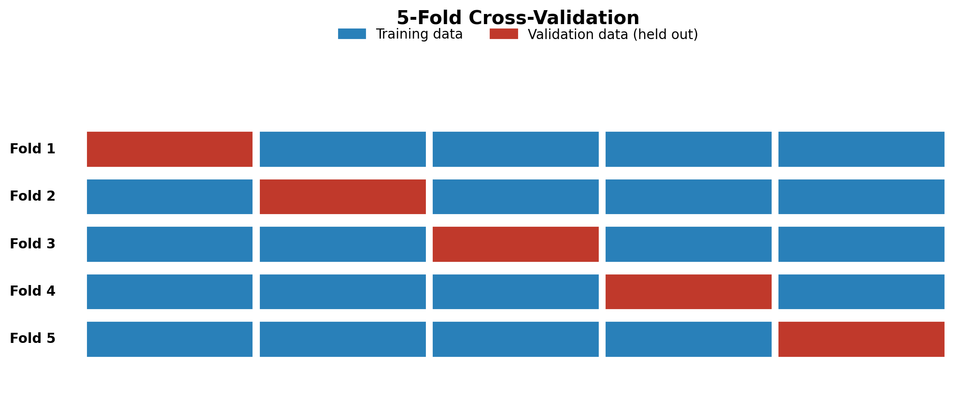
Figure 2: 5-fold cross-validation — each fold serves once as the held-out validation set.

5.2 Additional Validation Practices
- Learning curves: plot training vs. validation score against training set size to diagnose bias/variance issues.
- Calibration check: verify predicted probabilities are well-calibrated (reliability diagram) since the retention team may want a risk score, not just a class label.
- Threshold tuning: rather than using the default 0.5 cutoff, select the classification threshold that best balances precision and recall for the business cost of a false negative vs. a false positive.
- Final holdout test: the untouched 15% test set is scored exactly once, after model and hyperparameters are finalized, to give an unbiased estimate of real-world performance.

6. Model Deployment (Optional Extension)

6.1 Packaging
- Serialize the final pipeline (preprocessing + model) using joblib or pickle, versioned alongside the training code and feature list.
- Wrap the serialized model in a lightweight REST API (e.g., FastAPI) that accepts customer features and returns a churn probability and risk tier.

6.2 Maintenance and Monitoring
- Monitor input data drift (feature distributions) and prediction drift (churn rate over time) on a scheduled basis.
- Track live model performance against ground-truth churn outcomes as they become available, alerting if metrics degrade beyond a defined threshold.
- Establish a retraining cadence (e.g., quarterly) or a trigger-based retrain policy when drift or performance degradation is detected.
- Maintain a model registry with versioning so a previous model can be rolled back quickly if a new version underperforms in production.

6.3 Governance
- Log every prediction with its input features and model version for auditability.
- Periodically review the model for fairness across customer segments to avoid disproportionately targeting or overlooking any subgroup.

7. Project Timeline (30–35 Hour Budget)
The table below allocates the target 30–35 hours across the phases of this plan.
Phase | Est. Hours | Key Activities
Problem definition & scoping | 2 | Stakeholder framing, success metric, data availability check.
Data collection & exploration | 5 | Source consolidation, EDA, missing-value/outlier profiling.
Data preprocessing & feature engineering | 6 | Cleaning, encoding, scaling, feature creation/selection.
Model selection & baseline training | 5 | Train logistic regression, decision tree, ensemble baselines.
Hyperparameter tuning & cross-validation | 7 | Grid/random/Bayesian search, k-fold CV, model comparison.
Evaluation & error analysis | 4 | Metric computation, confusion matrix review, bias checks.
Documentation, diagrams & reporting | 4 | Write-up, flowcharts, final report assembly.
Deployment planning & review | 2 | Packaging plan, monitoring strategy, retraining policy.
Total | ~35 | Approx. 30–35 hour budget across all phases.

8. Conclusion
This plan lays out a complete, defensible path from problem framing to a production-ready churn model: a clearly justified business problem, a disciplined preprocessing strategy, a comparative model selection process anchored on gradient boosting, a rigorous cross-validated evaluation approach centered on recall and F1-score, and a concrete deployment and monitoring plan. Following this plan would give a full-scale implementation a strong, well-reasoned foundation.

