Steganography

Comp 8505 Assignment 2

Shane Spoor

Mat Siwoski

**Introduction** **3**

Constraints 3

**Design** **4**

Decode 4

Encode 5

**Testing** **6**

**Analysis of Image Differences** **8**

Before image encoded 8

After image encoded 9

# 

# 

# Introduction

The purpose of this assignment was to become familiar with Steganography and to design a simple LSB stego application. The basic application is command-line (bonus marks for UIs), with the appropriate switches to perform the various functions. The two main functions will be the embedding (hide) and the extraction functions. The filenames of the cover image, secret image, and output file will also be specified as part of the command line invocation of the program

## Constraints

* The image format for your application will be BMP.
* Provide a help function that will display all of the switches and command line arguments for your application.
* You are required to implement encryption (any cipher of your choice) as part of your application. Note that you will require 8 bytes in the cover image to hide a single byte of the secret image. Other data that will also need to be hidden is the filename, including the extension. This means that you will have calculate the file sizes of both images and ascertain that the cover file is large enough to hold all of the secret image data.
* Structure your application to have at least three separate modules as follows (names are arbitrary):
  + dcstego.x – the main function that will contain the general functionality such as parsing command line arguments, checking file sizes, file formats, etc.
  + dcimage.x - this module will contain all of the functions for the image processing and manipulation.
  + dcutils.x - this module will contain the two main functions for hiding and extracting the data.
* Depending on your platform and language you will also have to provide a means of building the application (makefile, project, etc) and a set of instructions.
* As part of your testing experiment with different cover images (large sections of solid colors, lots of colors, etc) to see if the stego image reveals any obvious artifacts.
* You are required to show all the data supporting the success (or lack thereof) of your data embedding scheme in your test document.

# Design

## Decode

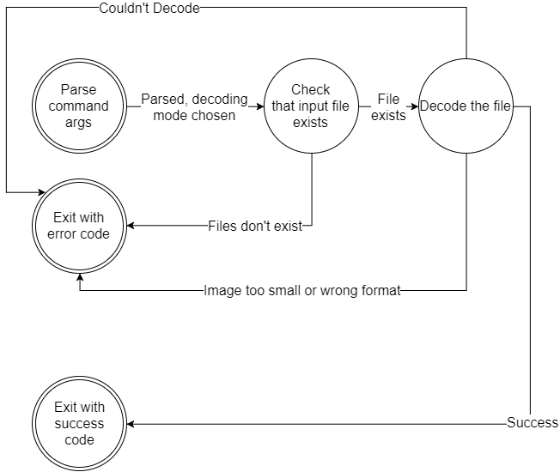

*Fig. 1: Decoder state transition diagram*

## 

## Encode8505Assn2Encode.png

*Fig. 2: Encoder state transition diagram*

# Testing

|  |  |  |
| --- | --- | --- |
| Test # | Test Description | Result |
| 1 | Encode file into image with correct format and sufficient size | Passed (Fig. 3) |
| 2 | Decode file from stego’d image | Passed (Fig. 4) |
| 3 | Display error message when non-existent files are specified | Passed (Fig. 5) |
| 4 | Display error message when invalid arguments are specified | Passed (Fig. 6) |
| 5 | Display usage information when -h option is specified | Passed (Fig. 7) |
| 6 | Encoded/decoded files are binary identical | Passed (Fig. 8) |
| saved stego image.png *Fig. 3: Encoding file into suitable image* | | |
| decoded.png *Fig. 4: Decoding file from stego’d image* | | |
| errordecode.png *Fig. 5: Checking for non-existent files* | | |
| encodeerror.png *Fig. 6: Checking for invalid arguments* | | |
| help.png *Fig. 7: Displaying help message* | | |
| cmp stegod files.png *Fig. 8: Verifying encoded/decode files are binary indentical* | | |

## 

# Analysis of Image Differences

Here is the analysis of the image before it had an image added to it using steganography and an image after it was added.

## Before image encoded

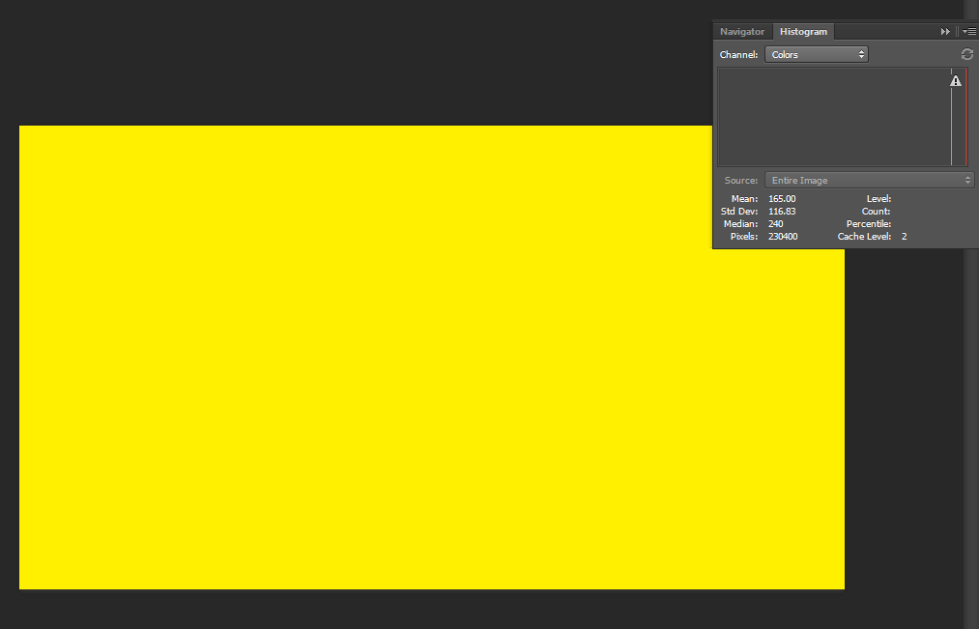

*Fig. 9: Image Histogram* 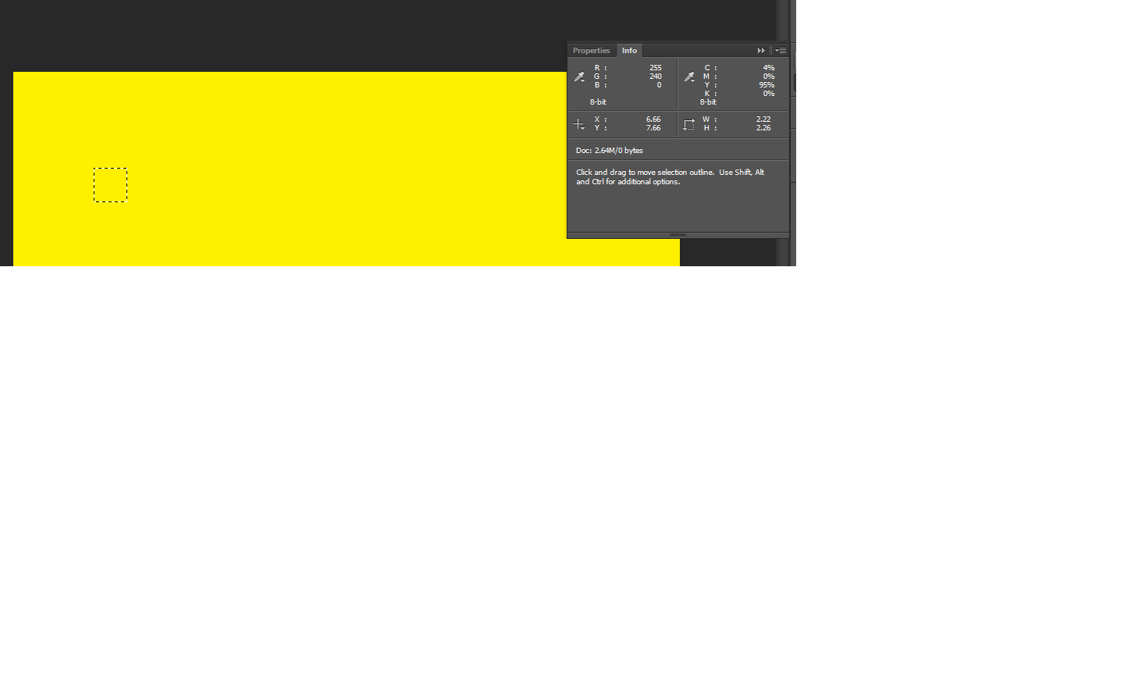

*Fig. 10: Image RGB*

Pixel size is 230400. The RGB value is 255, 240 and 0. Throughout the image, these values do not change. The median value is 240, and the mean is 165. Standard Deviation is 116.83.

## After image encoded

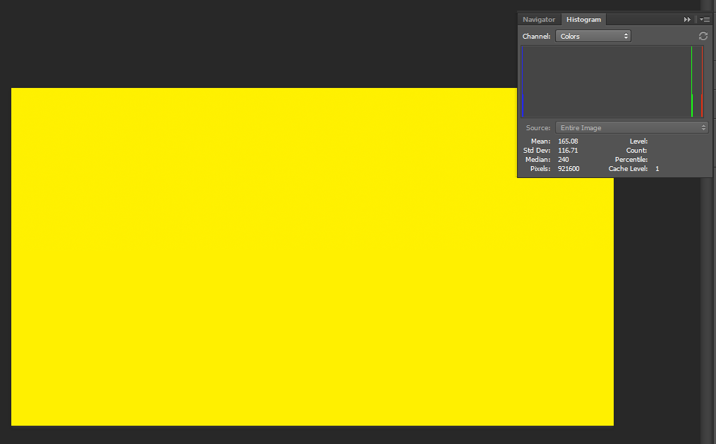

*Fig .11:Image Histogram*

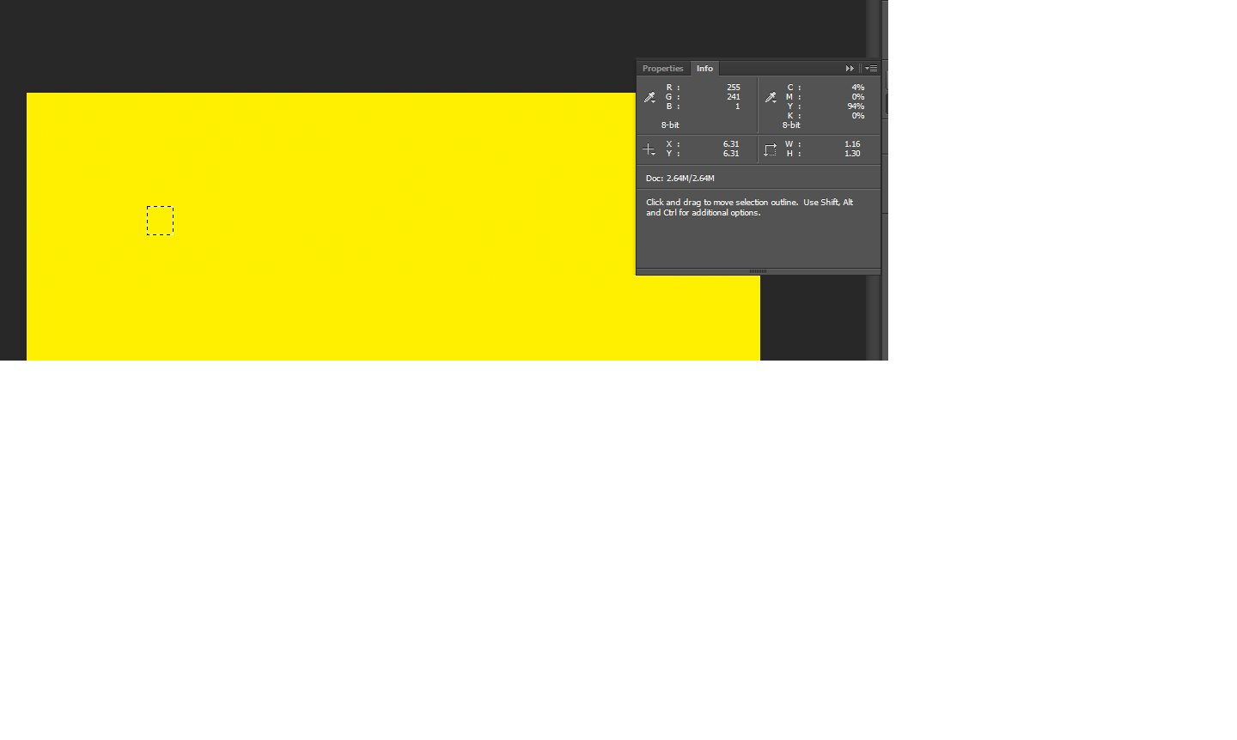

*Fig. 12: Image RGB*

The pixel size is 921600, which has grown from the original image’s pixel size of 230400. At the location in Fig. 12, the RGB values are 255, 241 and 1. This is different from the original images RGB value of 255, 240 and 0. The median value is 240, the same as the original image, and the mean is 165.08 versus the original size of 165. Standard Deviation is 116.71, which differs from the original images standard deviation of 116.83.

The most important point to get from this analysis is that to the naked eye, the image differences are undetectable..