**Client Tests**

|  |  |  |  |  |
| --- | --- | --- | --- | --- |
| **Test Number** | **Description** | **Tools Used** | **Expected Outcome** | **Result** |
| C1 | Client is given invalid directory | client | Client displays error message and exits | Passed (Figure 1) |
| C2 | Client is given directory with no read and/or write privileges | client | Client displays error message and exits | Passed (Figure 2) |
| C3 | Client can't connect to server | client | Client displays error message and exits | Passed (Figure 3) |
| C4 | Incorrect command is entered on client | client | Client displays command syntax and waits for next command | Passed (Figure 4) |
| C5 | User enters SEND command for existing file | client, server | Client sends file to server | Passed (Figure 5) |
| C6 | User enters SEND command for non-existent file | client | Client displays error message and waits for next command | Passed (Figure 6) |
| C7 | User enters GET command for file that exists on server | client, server | Client retrieves file | Passed (Figure 7) |
| C8 | User enters GET command for file that doesn't exist on server | client, server | Client displays returned server error message | Passed (Figure 8) |
| C9 | User types Ctrl + D | client | Client exits | Passed (Figure 9) |

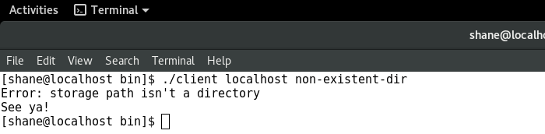

Figure : Client is given invalid directory

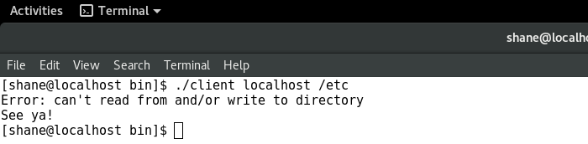

Figure : Client is given directory with no read and/or write privileges

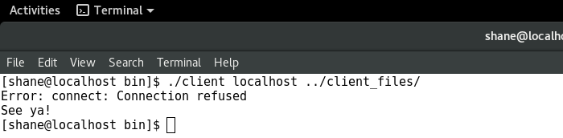

Figure : Client can't connect to server

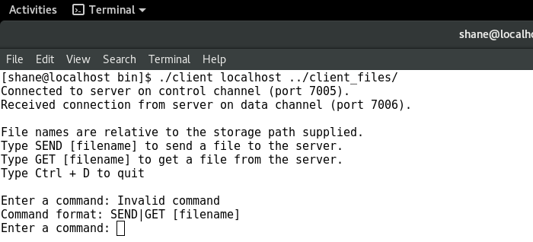

Figure : Incorrect command is entered on client

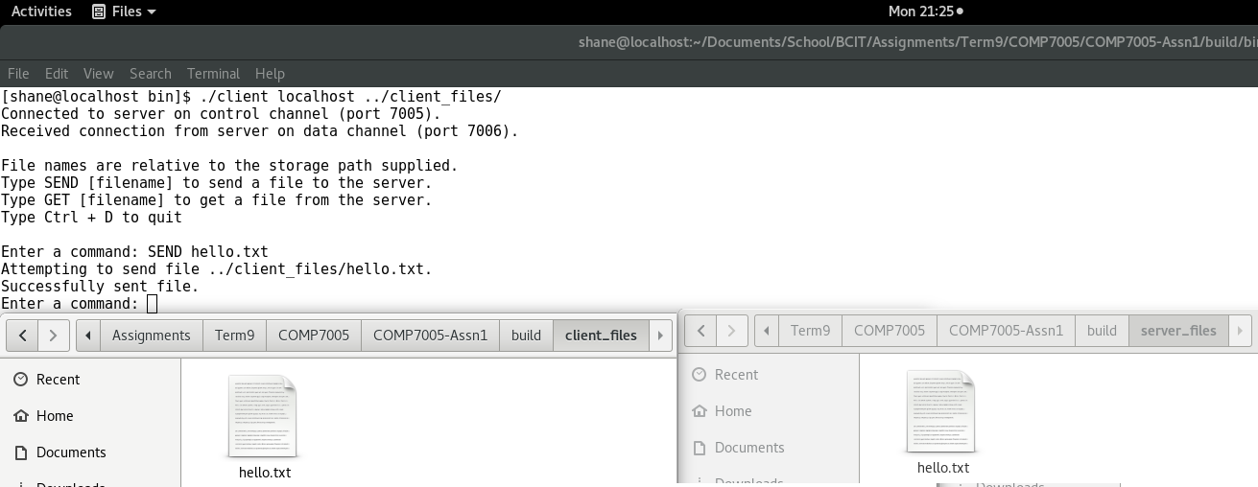

Figure : User enters SEND command for existing file

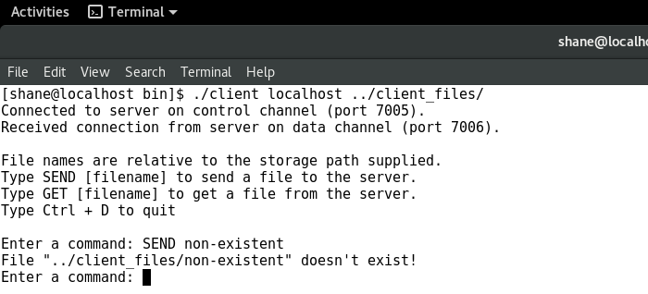

Figure : User enters SEND command for non-existent file

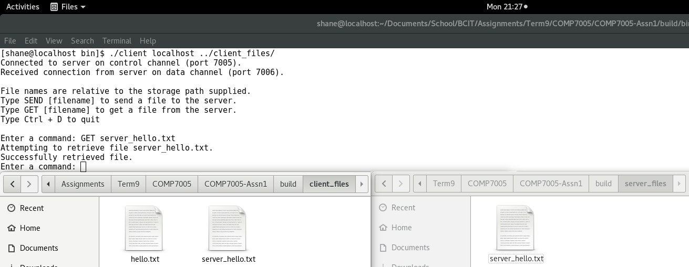

Figure : User enters GET command for file that exists on the server

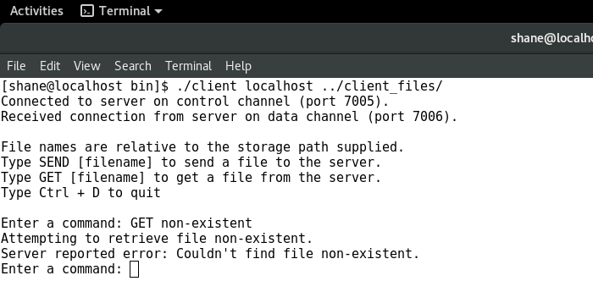

Figure : User enters GET command for file that doens't exist on the server

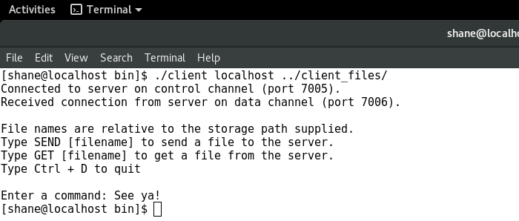

Figure : User enters Ctrl + D