**Server Tests**

|  |  |  |  |  |
| --- | --- | --- | --- | --- |
| **Test Number** | **Description** | **Tools Used** | **Expected Outcome** | **Result** |
| C1 | Server is given invalid directory | server | Server displays error and exits | Passed (Figure 1) |
| C2 | Server is given directory with no read and/or write privileges | server | Server displays error and exits | Passed (Figure 2) |
| C3 | Server receives client connection | server, client | Server accepts connection and waits for commands | Passed (Figure 3) |
| C4 | Server receives GET command for existing file | server, client | Server reads file and sends it back to client | Passed (Figure 4) |
| C5 | Server receives GET command for non-existent file | server, client | Server sends error back to client | Passed (Figure 5) |
| C6 | Server receives SEND command | server, client | Server opens the specified file and writes the contents sent by the client | Passed (Figure 6) |
| C7 | Client disconnects from server | client, server | Server logs disconnection message and waits for next client | Passed (Figure 7) |

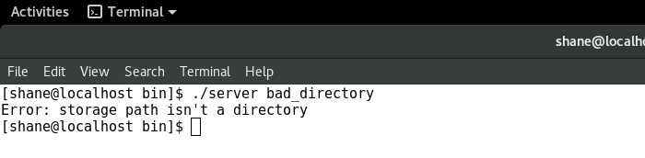

Figure : Server is given invalid directory

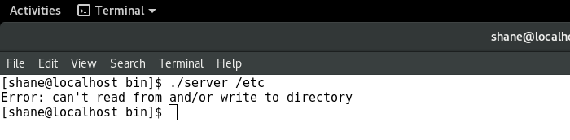

Figure : Server is given directory with no read and/or write permissions

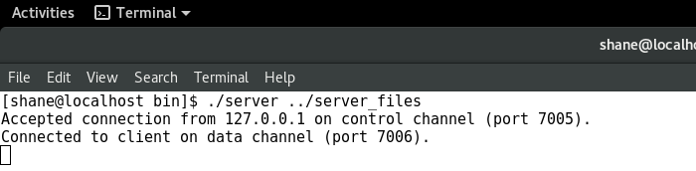

Figure : Server receives client connection

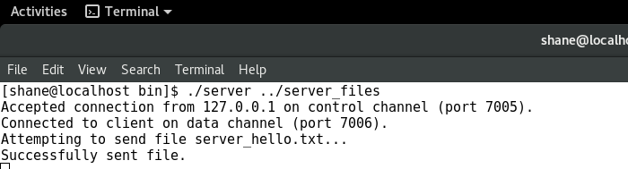

Figure : Server receives GET command for existing file

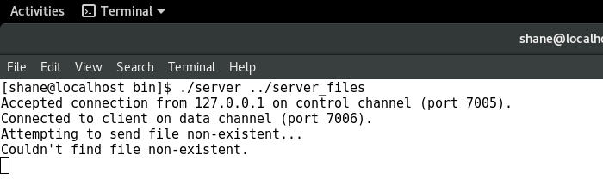

Figure : Server receives GET command for non-existent file

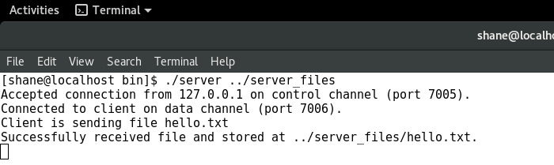

Figure : Server receives SEND command

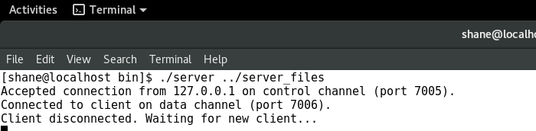

Figure : Client disconnects from server