Minutes of Meeting | July 2  2026
A stakeholder consultation meeting was conducted for the demonstration of the revised prototype of the Social Disability Management Information System (SDMIS) at the Women, Child, Senior Citizen & Divyangjan Welfare Department. The meeting included a detailed walkthrough of the updated prototype, showcasing the enhancements incorporated based on the feedback received during the previous demonstration. The session was followed by discussions on the proposed changes, module-wise functionalities, system workflow, user roles, and additional suggestions provided by the department for further refinement of the application.
Location: |  | Women, Child, Senior Citizen & Divyangjan Welfare Department
Date: |  | 02 July 2026
Time: |  | 12:00 PM – 1:00 PM
Attendees
- Officials and Staff of the Women, Child, Senior Citizen & Divyangjan Welfare Department
- Representative form Netspeq Solutions

Agenda of the Meeting
- Introduction to the Social Disability Management Information System (SDMIS)
- Demonstration of the proposed system workflow and prototype
- Discussion on user roles and module-wise functionality
- Collection of stakeholder feedback and suggested modifications
- Discussion on further improvements and next course of action

- The meeting commenced with a brief introduction to the Social Disability Management Information System (SDMIS), outlining the objectives of the project and its proposed workflow. The Netspeq Solutions team demonstrated the prototype module-wise, covering the functionalities of the Administrator, Inspector, Social Welfare Officer (SWO), and Headquarters (HQ) Officials.
- The meeting primarily focused on demonstrating the enhancements incorporated into the SDMIS prototype based on the suggestions and feedback received during the previous prototype demonstration. The revised modules were presented sequentially, and the department officials reviewed the implemented changes and provided additional observations and recommendations for further refinement.
- Form A –
a) Personal Information
- The department suggested that the applicant's age should continue to be calculated automatically based on the Date of Birth and should also update automatically with the passage of time.
- It was suggested that the existing Present Address field be replaced with Permanent Address.
- It was further suggested that the address section should include the following fields in sequence: District, Block, GPU, Ward
All the above fields should be provided as dropdown selections.
- The department recommended changing a field "Is Present Address same as Permanent Address?” to "Is Permanent Address same as Present Address?" (Yes/No). If No is selected, the system should display a separate field to put Present Address.
- The department suggested providing an Aadhaar upload facility. The development team informed that implementation of this feature requires further discussion considering security and data privacy policies.
d) Disability Information
- It was suggested that under Certificate Type, if Temporary is selected, an additional "Valid Till" field should be displayed and made mandatory.
- The "Any Other Benefits" field should support multiple entries through an Add More option.
- Social Welfare Officer (SWO)
The department requested that Social Welfare Officers (SWOs) should also be provided with permission to edit submitted application details whenever corrections are required.
- Reports
It was suggested that all printable reports and reports generated through the workflow should be kept simple, concise, and easy to understand for end users.

- Decision
All observations and suggestions provided by the department were noted by the Netspeq Solutions team. The proposed changes shall be reviewed for technical feasibility and incorporated into the subsequent version of the SDMIS prototype wherever applicable.

Note: It was discussed that the Disability Type and Services Receiving fields shall be configured as master lists. The respective lists of disability types and services shall be provided by the department, based on which the master data will be configured in the system.
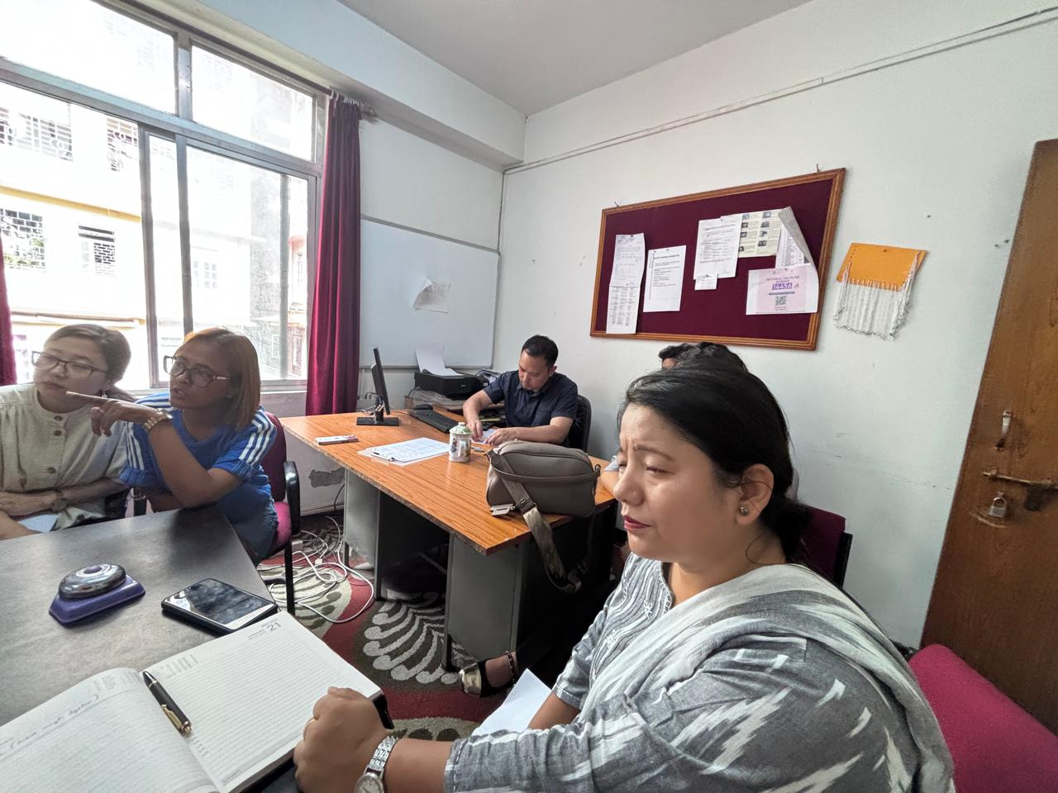
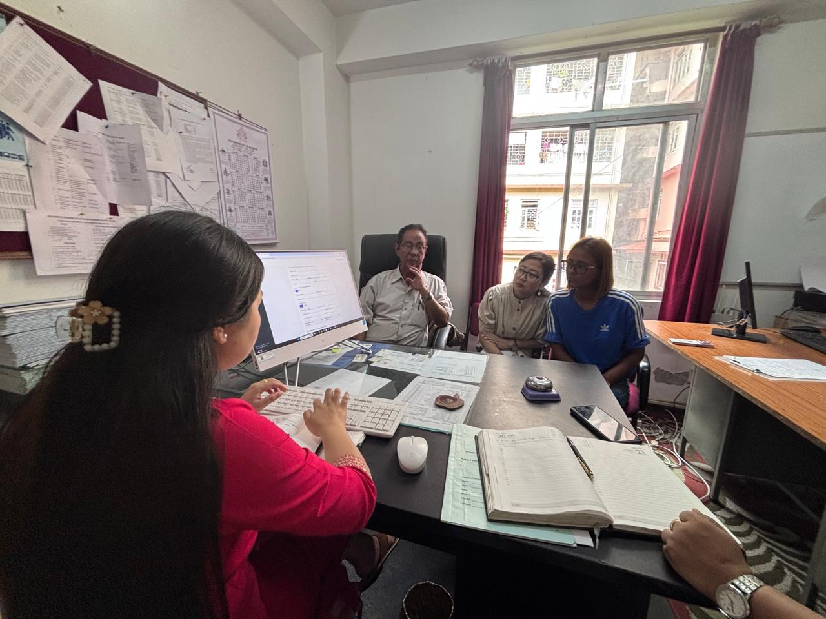
DEMONSTRATION IMAGES

