SDMIS

State Disability Management Information System

Women, Child, Senior Citizen & Divyangjan Welfare Department

- Workflow
- Survey Data Collection
Anganwadi workers conduct surveys across 58 designated zones and manually record information in department-issued survey booklets using:
- Form A: Certified Disability Cases
- Form B: Suspected or Probable Disability Cases
The completed survey forms are submitted for further processing.
- Data Entry by Inspectors
A total of 116 Inspectors is assigned across 58 zones, with two Inspectors designated for each zone. The Inspectors will be responsible for entering survey data into the web application on a zone-wise basis. The system will support two methods of data entry:
  - Inspectors will enter the details from Form A and Form B that have been collected and submitted by the Anganwadi Workers through physical survey booklets.
  - Inspectors will conduct field surveys and directly enter the details of Form A and Form B into the application during the survey process.
- Verification by SWO
The submitted records are reviewed by the respective Social Welfare Officer (SWO). The SWO verifies the accuracy and completeness of the data and either approves the records or returns them to the concerned inspector for correction.
- Monitoring by Headquarters (HQ)
Once verified, the data is made available to HQ officials for centralized monitoring. HQ oversees survey progress, data entry status, verification status, and generates consolidated reports for analysis and decision-making.
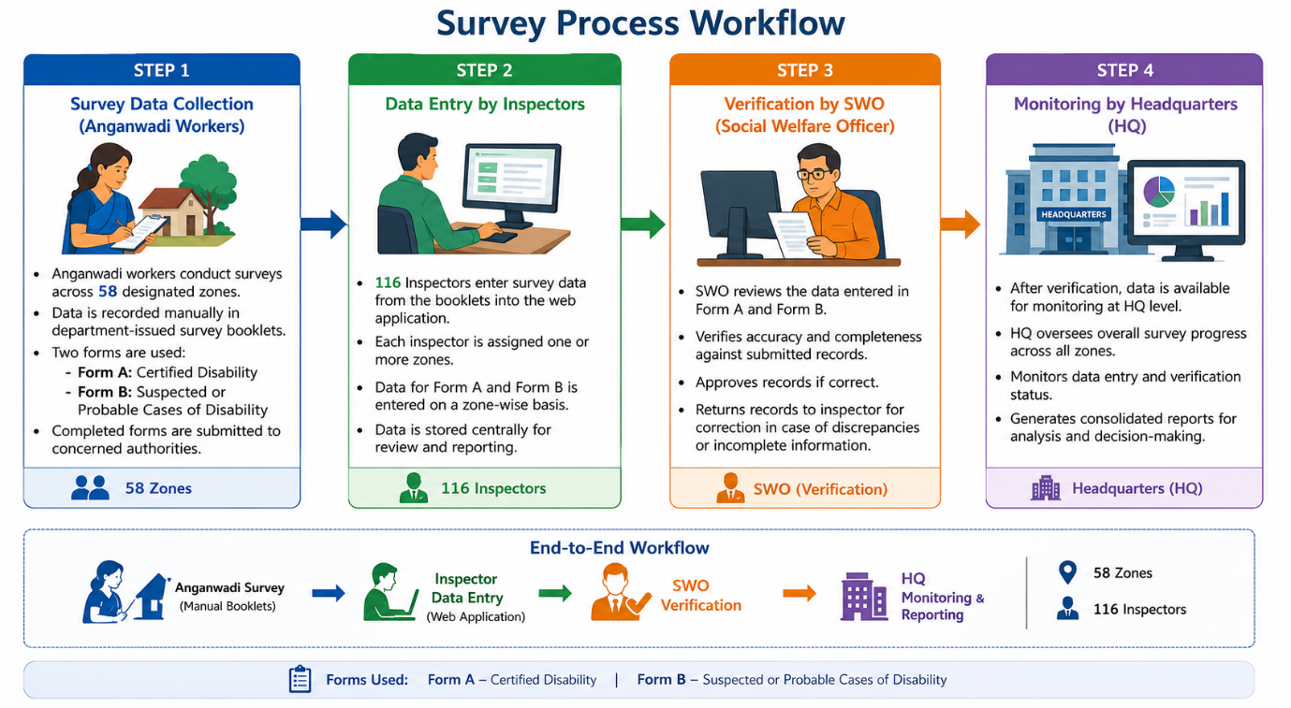
- Module Description
- Form A- Certified Disability Cases
Form A is used to capture details of beneficiaries who have already been identified and certified as Persons with Disabilities (PwDs) by the competent authority. These beneficiaries possess a valid Disability Certificate and, where applicable, a Unique Disability ID (UDID) Number. The form captures personal, educational, occupational, family, and disability-related information along with details of benefits, services, and aids/appliances availed by the beneficiary. The information collected through Form A is used to maintain a comprehensive database of certified disability cases for monitoring, planning, and delivery of welfare services.
- Step 1: Personal Information
Should be filled in with BLOCK LETTERS
This section captures the personal, demographic, contact, and residential details of the beneficiary. The information collected in this step serves as the primary identification and profiling data for the disability survey.
- Fields to be Captured
- Name (Mandatory)
- Father's Name / Mother's Name (Mandatory Age (Mandatory)
- Address (Mandatory)
- GPU (Mandatory)
- Ward Number (Mandatory)
- House Number (Optional)
- PIN Code (Mandatory)
- Contact Number (Mandatory)
- Additional Contact Person Name and Number (Mandatory)
- Aadhaar Number (Mandatory)
- Voter ID Number (Applicable for beneficiaries aged 18 years and above)
- Offsprings
- Total
- Male/Female
- Age
- Gender
Siblings
- Total
- Male/Female
- Age
- Gender
Multiple family member records can be added as required.
- Residency Status
If Local:
- COI Number / RC Number / Sikkim Subject Certificate Number can be entered if available.
- Application should proceed even if these documents are not available.
If Non-Local:
- At least one valid Identity Proof Number must be provided.
- Marital Status
- Passport Size Photograph

- Step 2: Qualification & Occupation Information
This section captures the educational, employment, and income details of the beneficiary.
- Fields to be Captured
- Education
Field Name | Field Type | Mandatory | Values / Options | Remarks
Education Qualification | Dropdown | Yes | Below 8, Class X, Class XII, Graduate, Post Graduate, Others | If "Others" is selected, Remarks field shall be displayed

- Institute/School
- Occupation
The Occupation field shall be displayed as a dropdown.
  - If Government Employee is selected:
Post Name shall be displayed and mandatory.
Type of Employment shall be displayed and mandatory.
If Others is selected in Type of Employment, a Remarks field shall be displayed and mandatory.
  - If Self Employed is selected:
Business Name shall be displayed and mandatory.
  - If Private Employee is selected:
No additional fields shall be displayed.
  - If Unemployed is selected:
No additional fields shall be displayed.

Field Name | Field Type | Mandatory | Values / Options | Remarks
Occupation | Dropdown | Yes | Government Employee, Private Employee, Self Employed, Unemployed | Select occupation type
Post Name | Text Box | Optional | Free Text | Mandatory when Occupation = Government Employee
Type of Employment | Dropdown | Optional | Regual, Contractual, Adoc, Others | Mandatory when Occupation = Government Employee
Employment Remarks | Text Box | Optional | Free Text | Mandatory when Type of Employment = Others
Business Name | Text Box | Optional | Free Text | Mandatory when Occupation = Self Employed
- Cumulative Annual Income
The Cumulative Annual Income field shall be displayed as a dropdown.
The user shall select one of the available income ranges:
- Below ₹50,000
- Below ₹1,00,000
- Above ₹1,00,000
Field Name | Field Type | Mandatory | Values / Options | Remarks
Cumulative Annual Income | Dropdown | Yes | Below ₹50,000  Above ₹50,000  Above ₹1,00,000 | Select annual income range

- Step 3. Family information
This section captures the beneficiary's household and family living conditions.
- Fields to be Captured
  - House Type
Field Name | Field Type | Mandatory | Values / Options | Remarks
House Type | Dropdown | Yes | Kutcha (Own), RCC (Own), Rented | Select house type
  - No. of Family (Numeric values only.)
  - Facilities at home
Field Name | Field Type | Mandatory | Values / Options | Remarks
Facilities at home | Dropdown | Yes | water  Toilet  Electricity  Accessibility | Availability of water facility at home  Availability of toilet facility at home  Availability of electricity at home

Field Name | Field Type | Mandatory | Values / Options | Remarks
Accessibility Facility | Text Box | No | Free Text | Details of accessibility provisions such as ramps, handrails, etc.
  - Language Spoken
- Step4. Disability Information
This section captures the beneficiary's disability details, certification information, medical condition, and benefits availed.

Fields to be Captured
- Disability Type
Field Name | Field Type | Mandatory | Values / Options | Remarks
Disability Type | Dropdown | Yes | Blindness, Low Vision, Hearing Impairment, etc  Others | Select others mention applicable disability type

- Disability Percentage
- Disability Certificate Number and Upload the Certificate image
- UDID Number (18 Digit with mixture of Alphabets and Numericals) In BOX TYPE
- Disability Certificate Issue Date
- Place of Issue
- Aids and Appliances Used/Required
Field Name | Field Type | Mandatory | Values / Options | Remarks
Aids and Appliances Used/Required | Multi-Select Dropdown | Yes | Wheelchair, Crutches, Walking Stick, Hearing Aid, Prosthetic Limb, Orthotic Device, Tricycle, White Cane, Braille Kit, Speech Aid Device, Walker, Special Footwear, Other | Multiple options can be selected
Other Aids/Appliances | Text Box | Conditional | Free Text | Mandatory if "Other" is selected

- Benefits Availed from Government Schemes
- Pension Receiving Status (Yes/No)
- Pension Receiving Since
- Associated Medical Problems (if any)
- Associated Medical Problems Since
- Services Currently Receiving
- Care Giver Name
- Relationship with Beneficiary
- Form B Suspected/Probable Disability Cases
Form B is used to capture details of individuals who are suspected or identified as probable cases of disability during the survey but have not yet been medically certified. These beneficiaries may not possess a Disability Certificate or UDID Number at the time of registration. The form captures personal, educational, occupational, family, and disability-related information to facilitate further assessment, verification, and certification by the concerned authorities. The information collected through Form B helps the department identify potential Persons with Disabilities (PwDs) and support their inclusion in the disability certification and welfare system.
The structure of Form B remains the same as Form A for:
- Step 1: Personal Information
- Step 2: Qualification & Occupation Information
- Step 3: Family Information
The only variation is in Step 4: Disability Information, where details related to certified disability such as Disability Percentage, Disability Certificate Number, UDID Number, Issue Date, and Place of Issue are not captured. Instead, the form records the suspected disability type and other supporting information required for further assessment and certification.
The information collected through Form B helps the department identify potential Persons with Disabilities (PwDs) and support their inclusion in the disability certification and welfare system.
- Reports
The Reports Module enables authorized users to generate and view survey reports based on the information captured in Form A (Certified Disability Cases) and Form B (Suspected/Probable Disability Cases).
The module shall provide various filtering options through dropdown selections to generate detailed and summary reports. Users shall be able to view, search, filter, and export reports for monitoring, analysis, and decision-making purposes.

Report Filters
Reports may be generated based on the following criteria:
- Form Type (Form A / Form B)
- Zone
- GPU
- Ward
- Gender
- Age Group
- Disability Type / Suspected Disability Type
- Education Qualification
- Occupation
- Annual Income Category
- House Type
- Marital Status
- Local / Non-Local Status
- Pension Receiving Status
- Benefits Availed
- Services Receiving

Report Features
- View Summary Reports
- View Detailed Beneficiary Reports
- Search Beneficiary Records
- Filter Records Using Multiple Criteria
- Export Reports to Excel and PDF
- View Zone-wise Statistics
- View Disability-wise Statistics
- View Gender-wise Statistics
- View Form A and Form B Comparative Reports
The reports shall assist SWO and HQ officials in monitoring survey progress, analyzing beneficiary data, and supporting departmental planning and decision-making.
- Form B to Form A - Conversion Process
Beneficiaries registered under Form B are identified as Suspected/Probable Disability Cases and do not possess a valid Disability Certificate or UDID Number at the time of registration.
After medical assessment and certification by the competent authority, if a beneficiary's disability is confirmed, the system shall allow the beneficiary record to be converted from Form B to Form A.

Business Rules
- The system shall provide an option to convert a verified Form B record into a Form A record.
- During conversion, all information captured in Step 1 (Personal Information), Step 2 (Qualification & Occupation Information), and Step 3 (Family Information) shall be retained.
- The Disability Information section shall be updated with the certified disability details, including Disability Type, Disability Percentage, Disability Certificate Number, and UDID Number.
- Upon successful conversion, the beneficiary record shall be removed from the active Form B records.
- The converted record shall be available under Form A as a Certified Disability Case.
- The system shall maintain an audit trail of the conversion process, including the date of conversion and the user who performed the action.
- Converted records shall be reflected in Form A reports and shall no longer appear in Form B reports.

