Steps Taken to Create Multidimensional & Tabular Models

In general, you need to start a new project, by going to “File” and choosing “**New Project**”, choose “Analysis Services Multi-dimensional and Data Mining”. Then input the project name and navigate to the file folder where you want your project to reside.

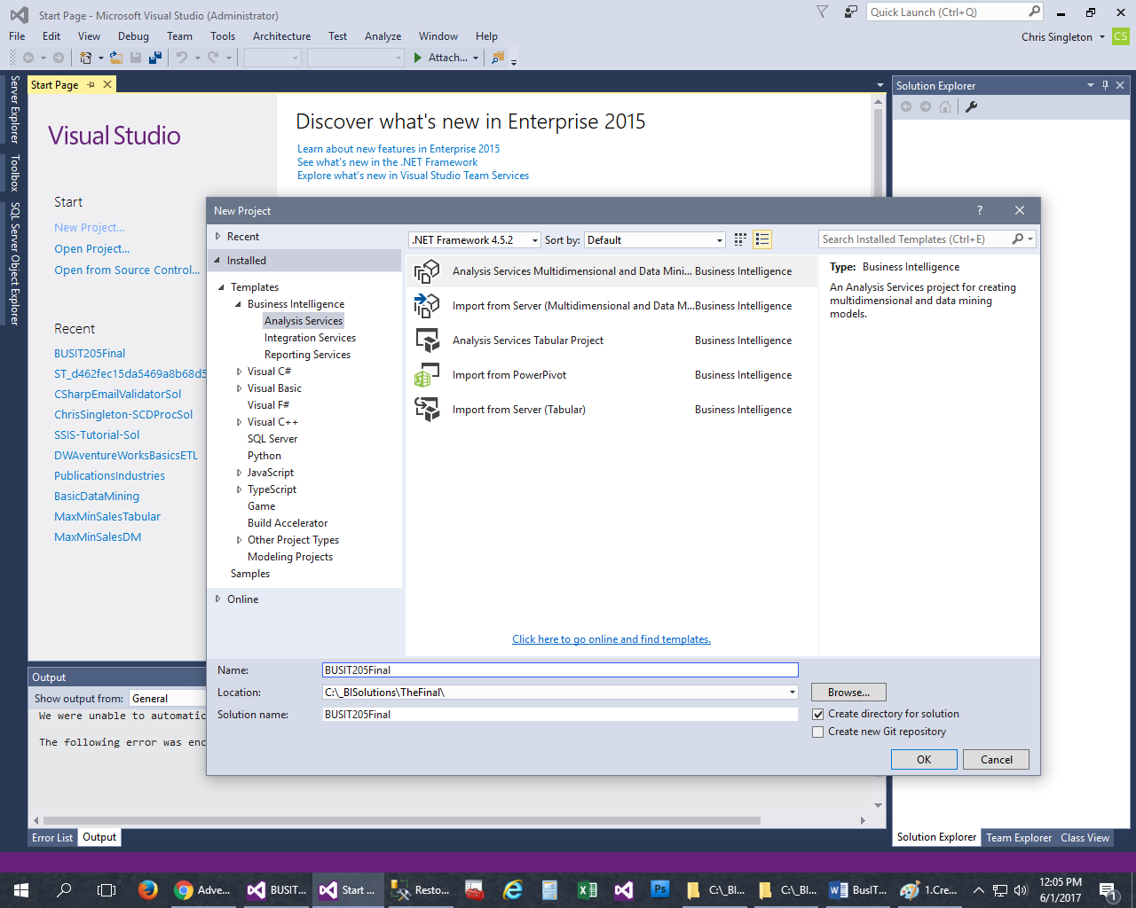

Next, configure your deployment/processing settings. To do this, just right click on the project file name and pick “**Properties**”.

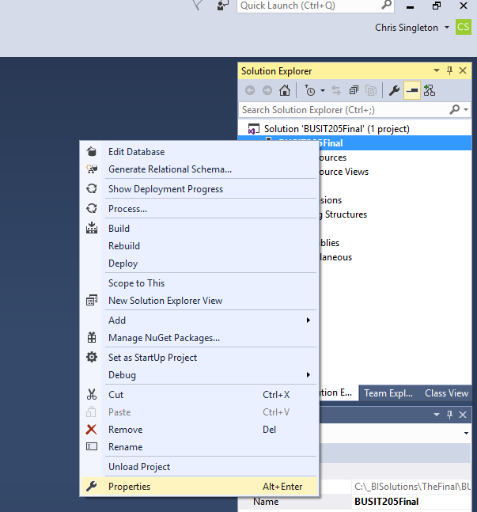

Configure the settings as shown.

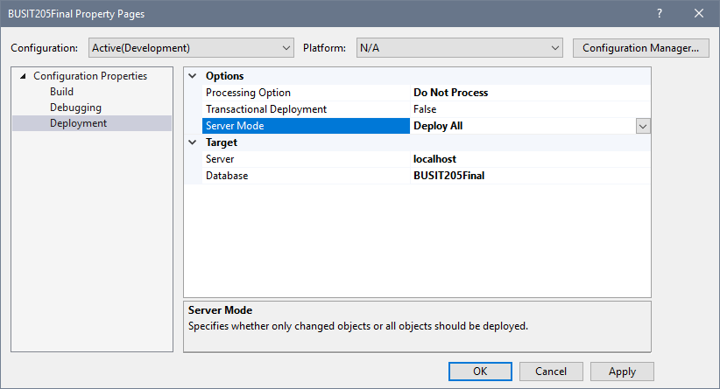

You need to set up a data source by right-clicking on the “**Data Sources**” folder and select “New Data Source”. Then you need to select the “New” button and then the connection manager will show. Use a “. (shown) or localhost, or a named instance” and point it to a database “**DW205Final**” by using the “**Select or enter a database name**” option.

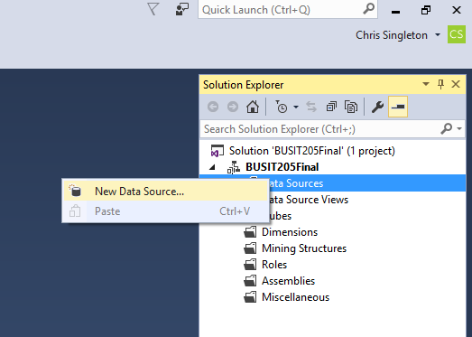

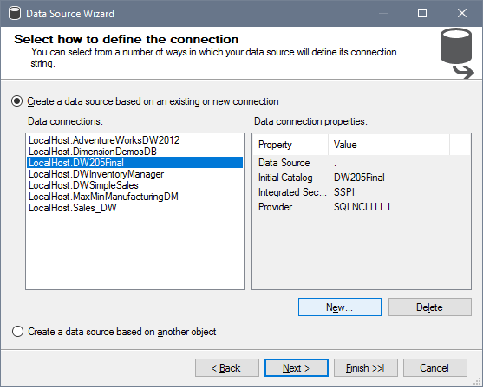

Connection Manager (Shown Below): Test the connection and select “**OK**” to exit.

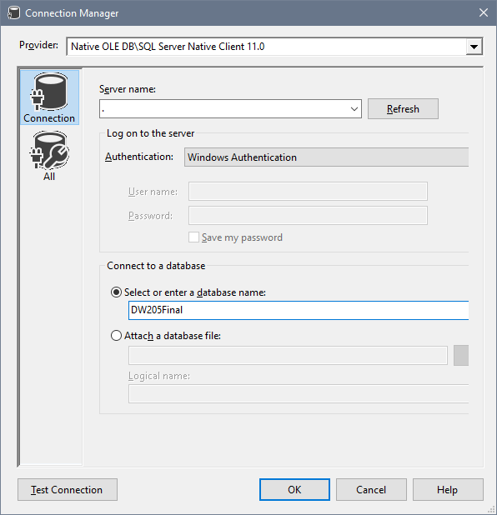

Once you click “**OK**” then click “**Next**” on the Wizard.



When creating a new connection, use the **service account** (name and password not needed).

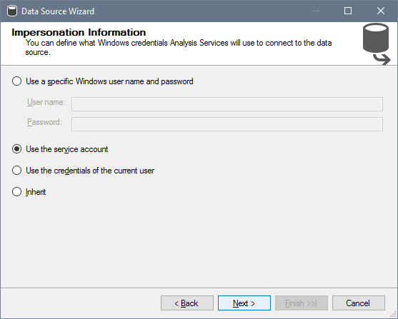

Type in a “**Data Source Name**”.

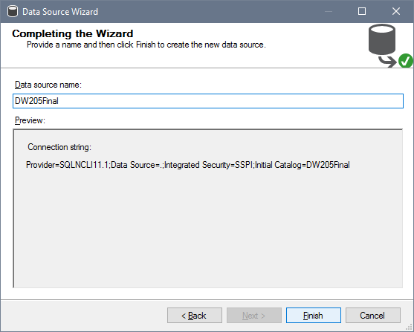

Right click on the “**Data Source Views**” folder to create a new data source view.

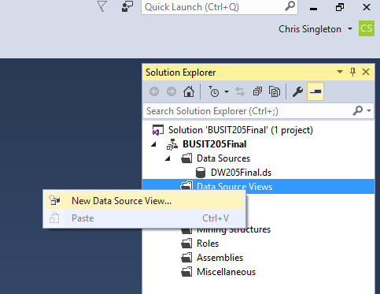

Pick the existing data source (shown), then “**Next**”.

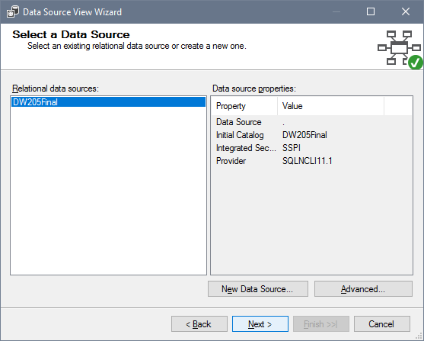

Select **all the views of each table** that you created earlier and click “**Next**”.

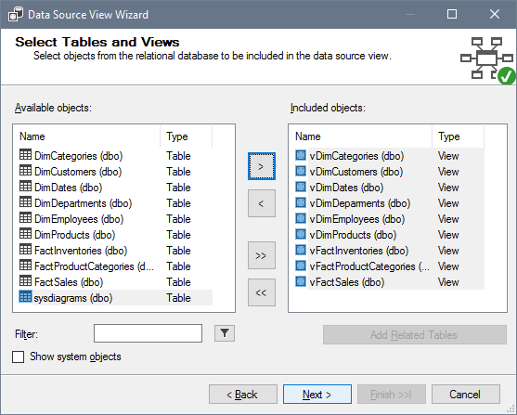

Name the Data Source View and click “**Finish**”.

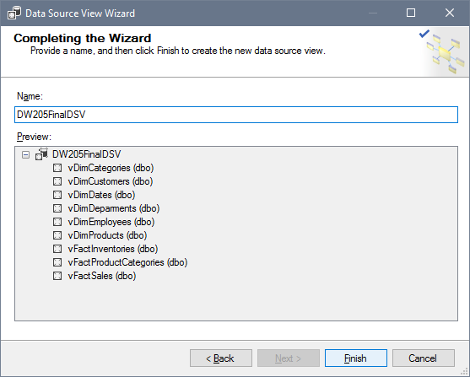

Arrange all the tables to set them up for connections ([Fact Sales] in the middle).

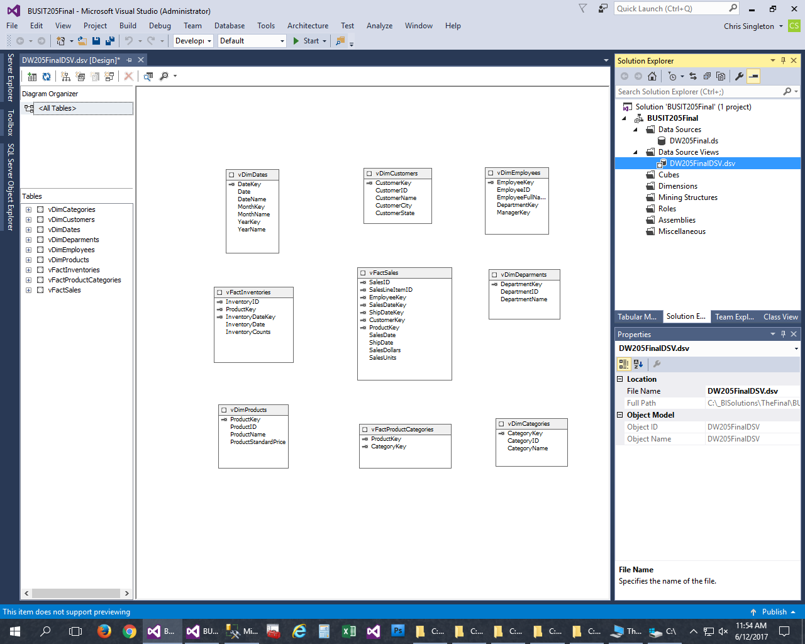

When creating relationships, always drag/drop from the fact table to dimension tables. Create the internal Parent to Child relationship by dragging the manager key to the [Employee Key] in the same table (best to do this early on).

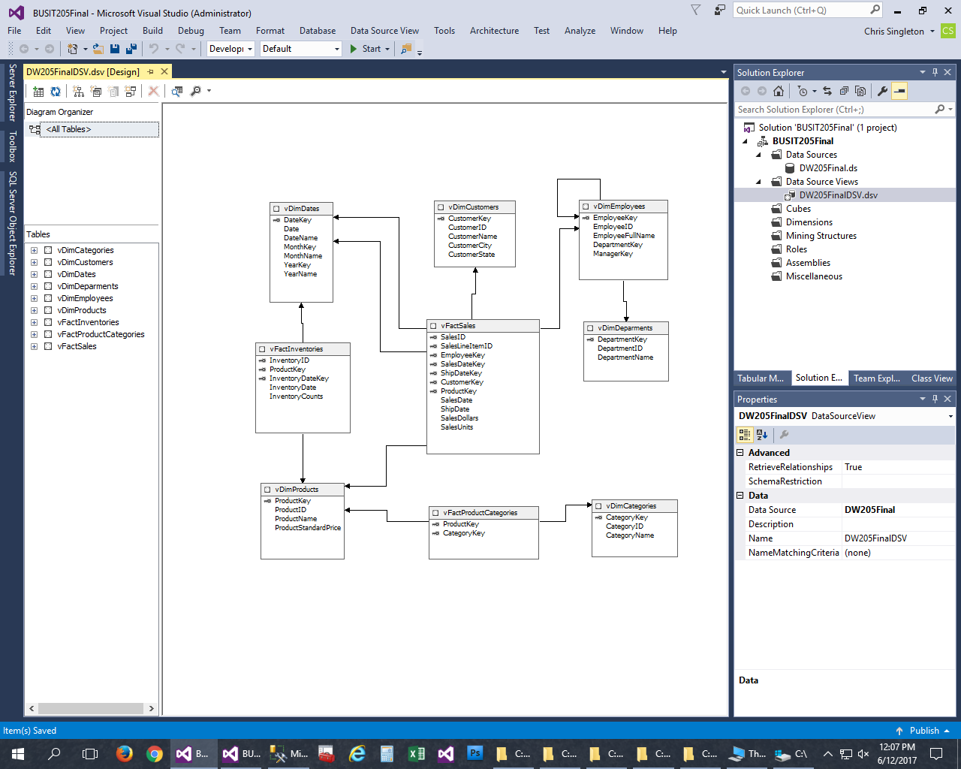

Now, it’s time to create our dimensions by right clicking on the “Dimensions” folder and selecting “**New Dimension**”.

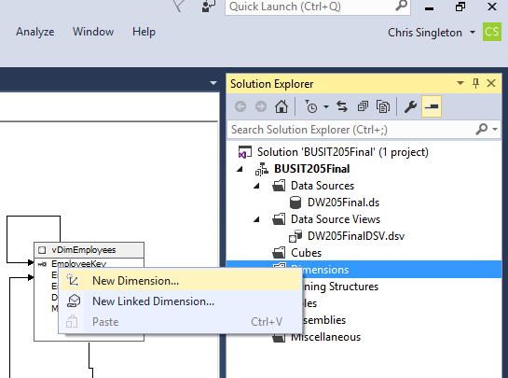

**Select “Use an existing table” and click “Next”.**

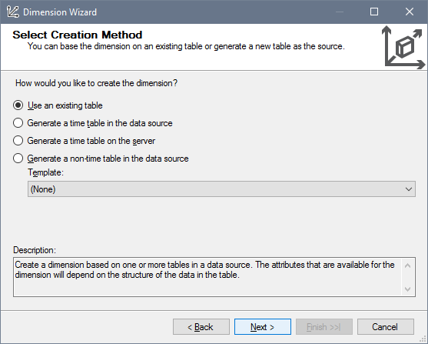

**Create [Dim Products] from the view.**

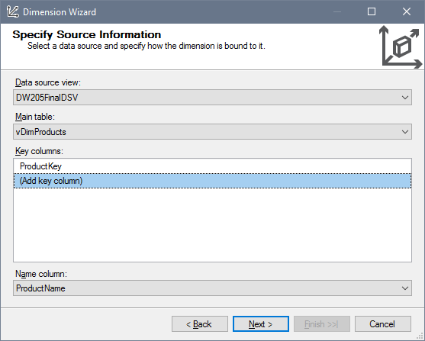

**Add Attributes.**

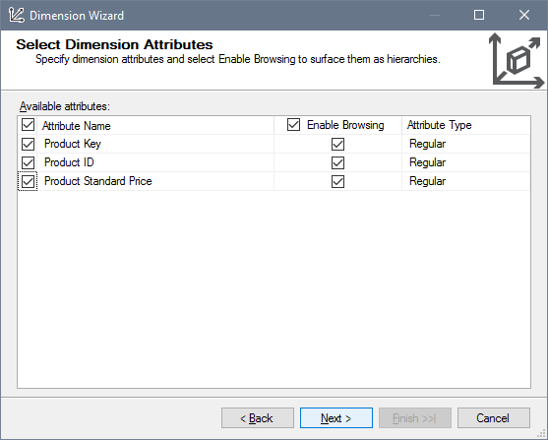

Name the dimension and click “**Finish**”.

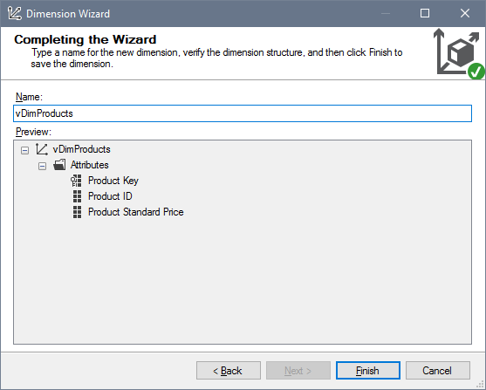

Next, do the same steps in creating all the dimensions beginning with the Employees dimension. Note, that this time it picks up on the department as being directly related.

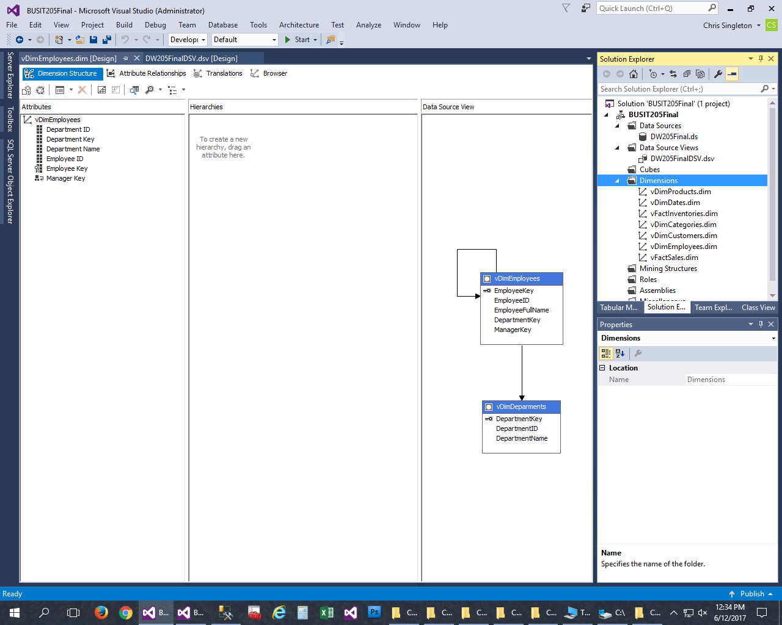

After the dimensions are created, it’s time to create the “**Cube**”. Right click on the “**Cubes**” folder and select “**New Cube**”.

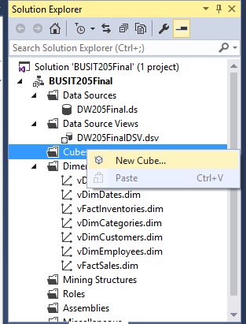

Select “**Use existing tables**” and then pick “**Next**”.

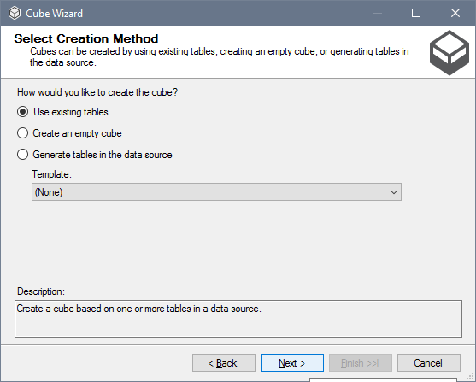

Pick “**Suggest**” button and then “**Next**”.

Note, that it picked “[**v Dim Employees**]”, because it can add “**Count**” as an attribute.

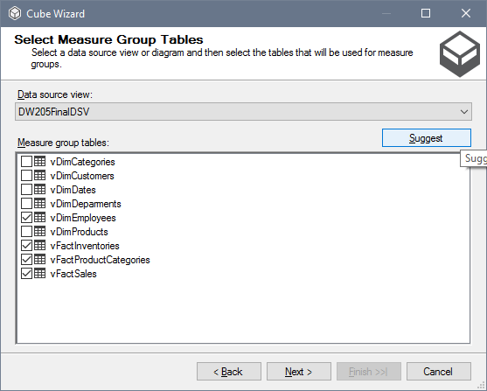

**Select Measures that you want to use.**

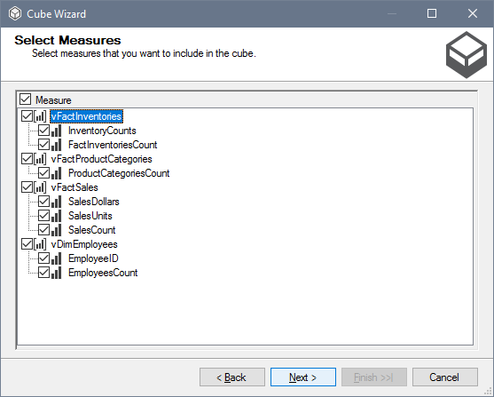

**Select the dimensions you want to include in the cube, then “Next”.**

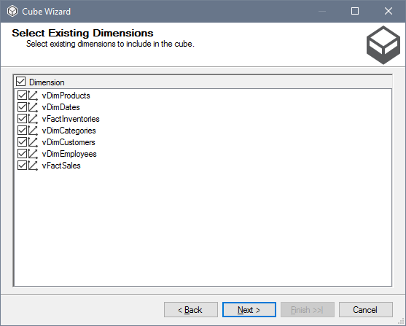

**Name the Cube and click “Finish”.**

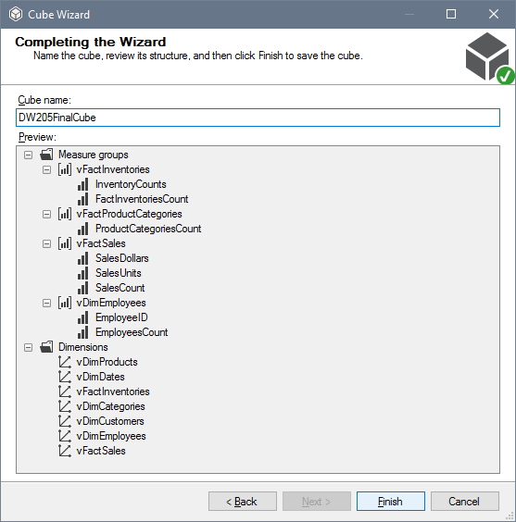

**Results of the Cube.**

**Note: This cube will count and sum automatically, unlike Tabular.**

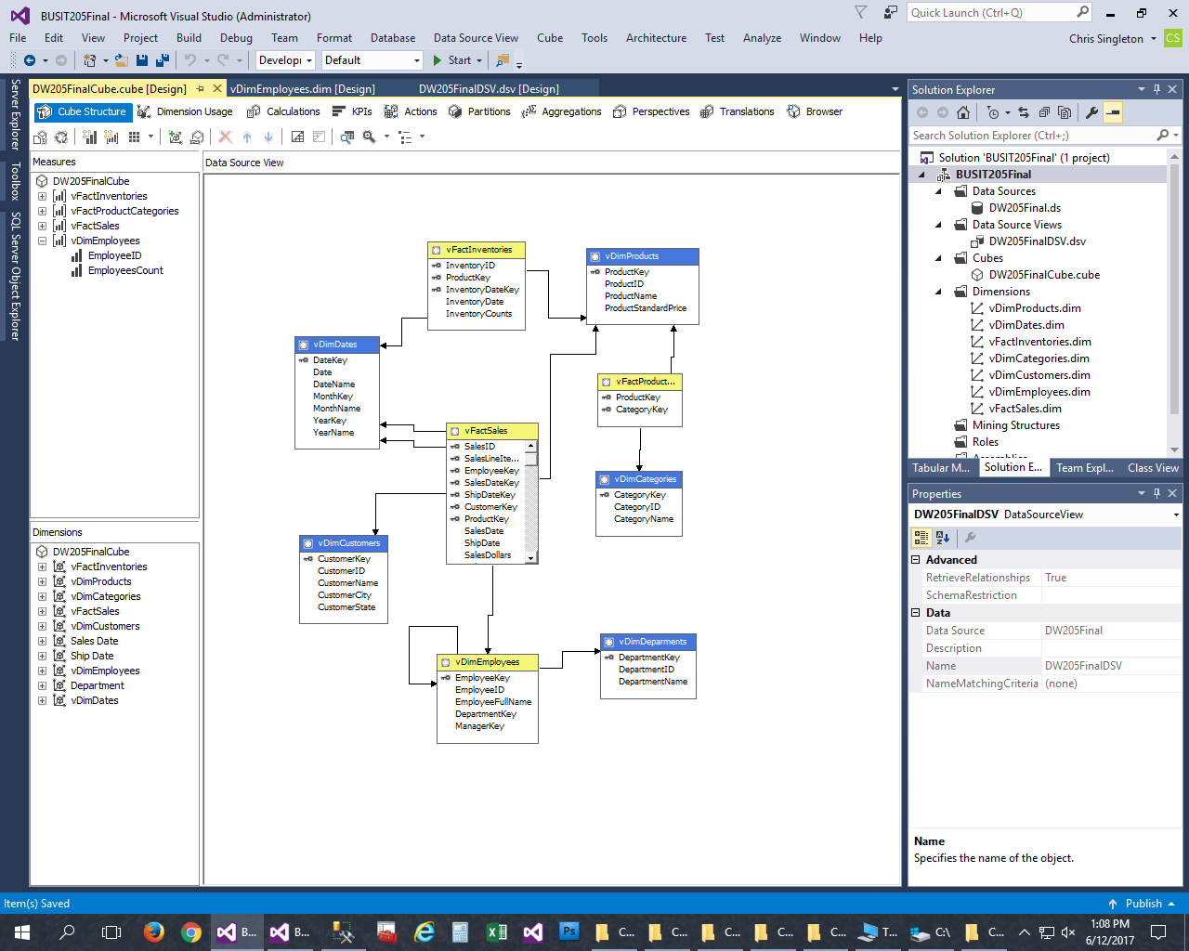

Right click on [Fact Sales] and create a new derived “**Named Calculation**”.

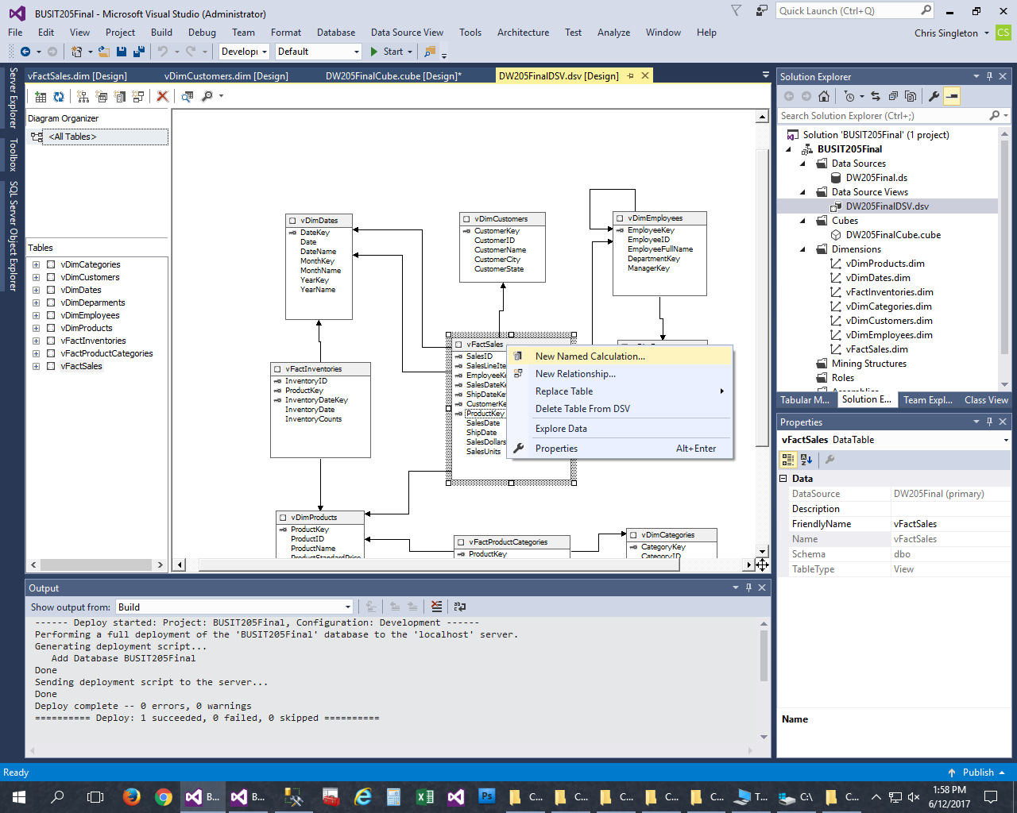

**Insert the formula into the box and name the column name appropriately.**

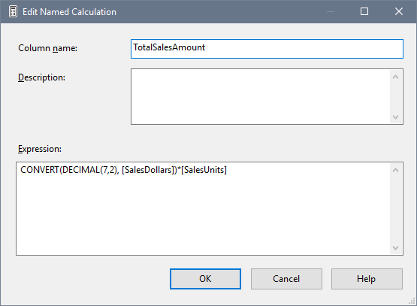

Create a “**Named Calculation**” for **Average Sales Amount**.

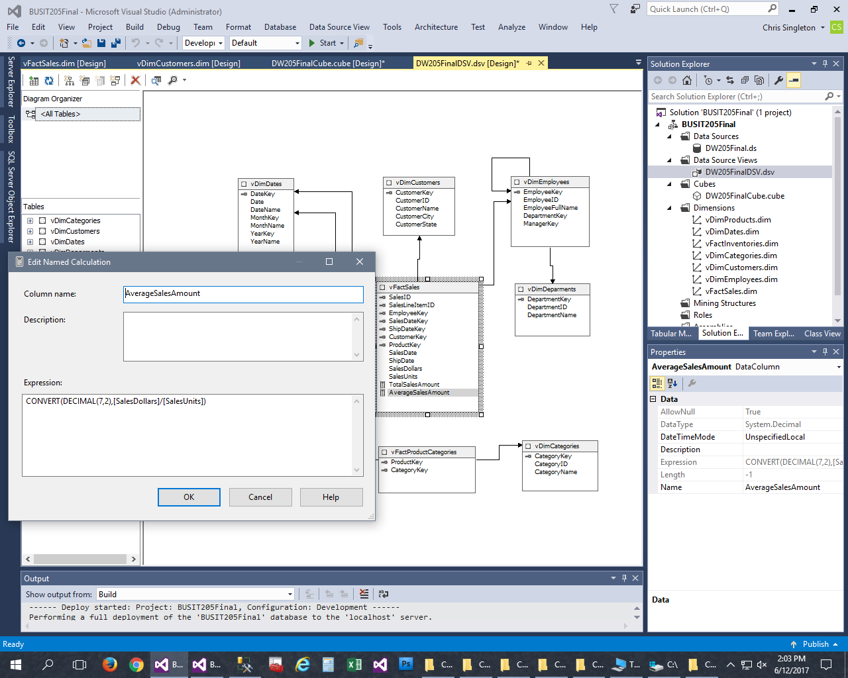

Named Calculation for [Sale To Ship Days].

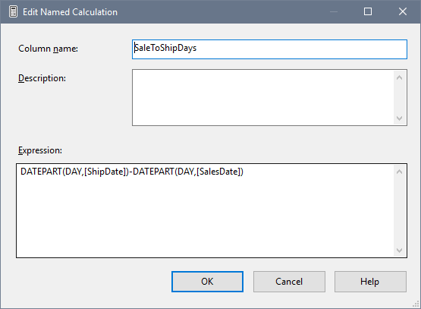

Extract the year from the [Date Key] in the date dimension.

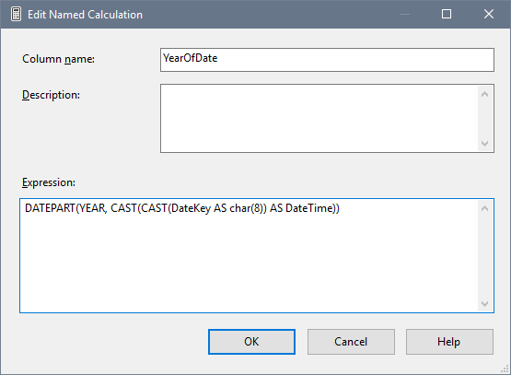

Creating the “Quarter of Year” from the DateKey.

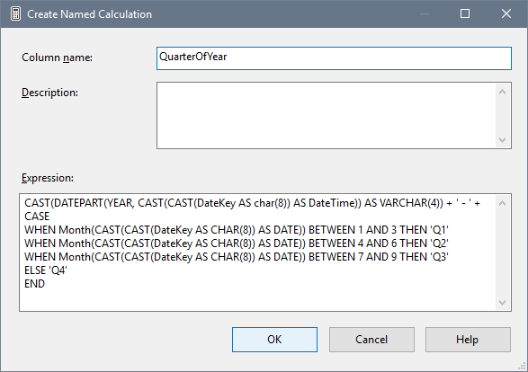

Creating the “**Month**” from the [**Date Key**].

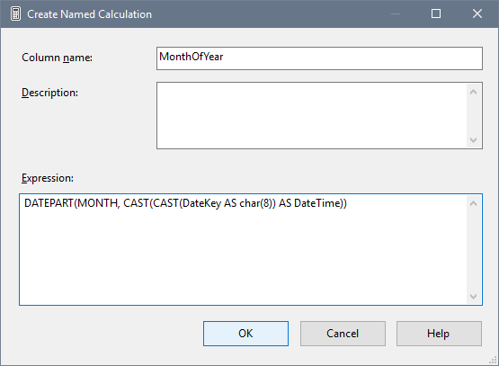

Get the “[**Day**] from the [**Date Key**]”

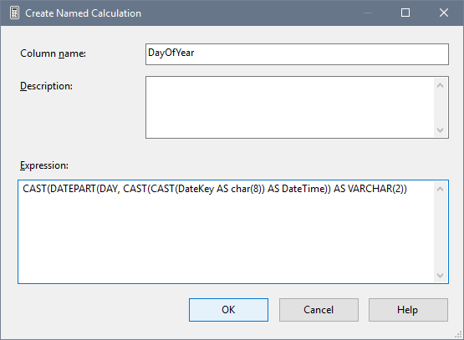

Double click on the “Cube” and go to the “Dimension Usage Tab”. Next, Create a reference dimension using [v Dim Employees] to [v Fact Inventories].

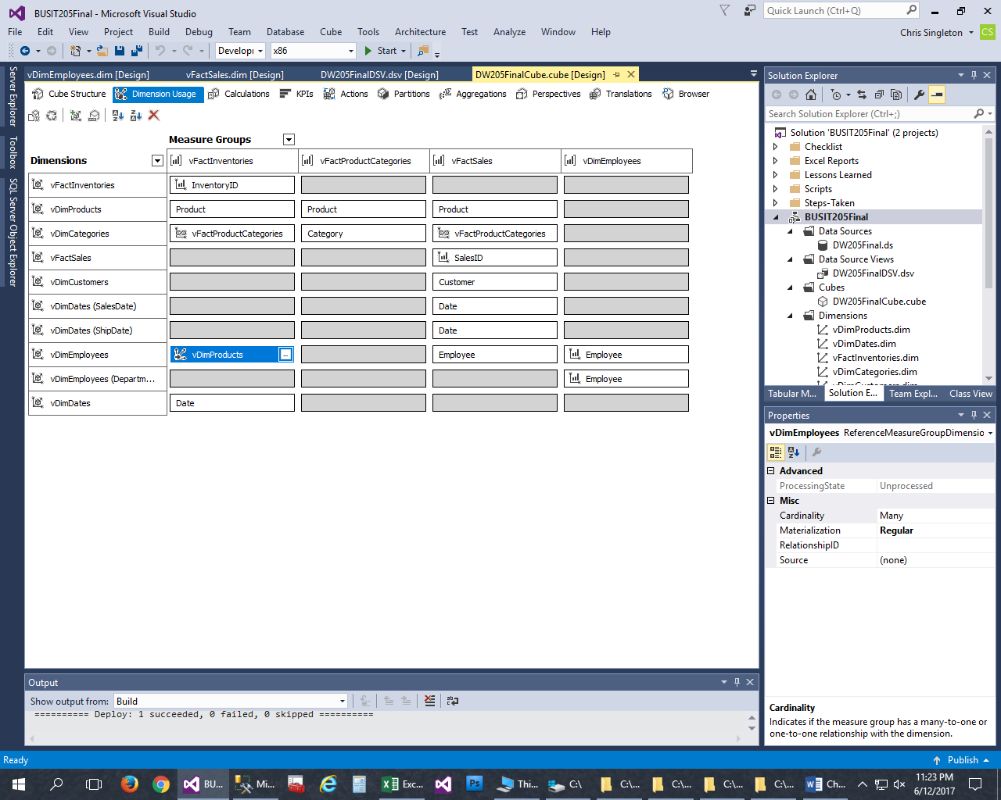

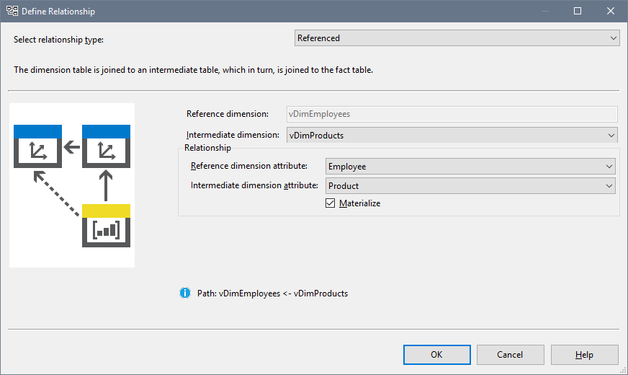

Create Many-to-Many dimensions.

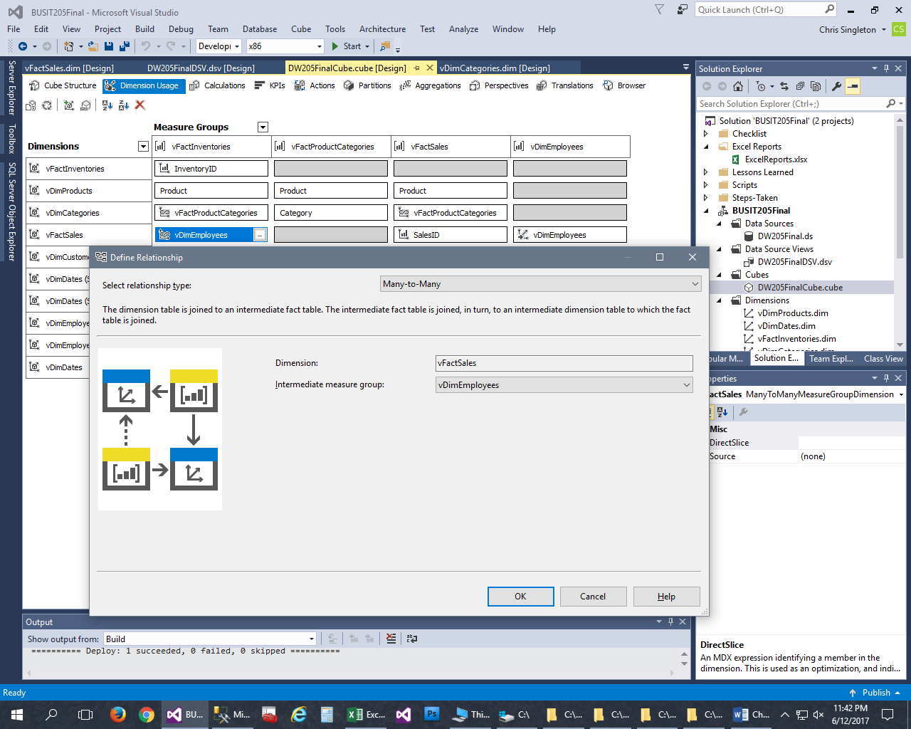

Create a Tabular Project inside a project.

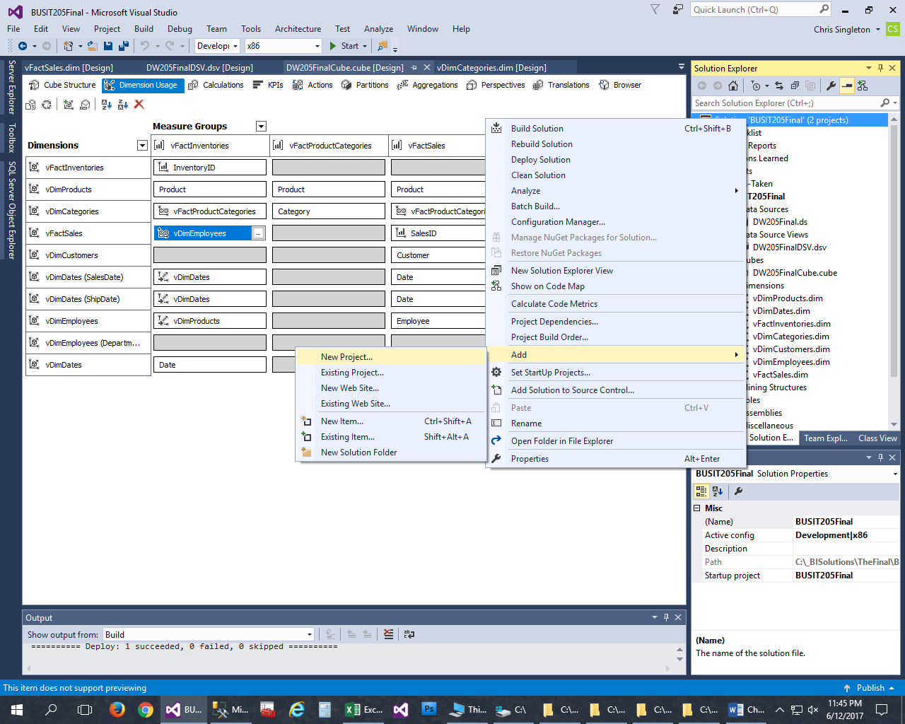

**Select “Analysis Services Tabular Project”.**

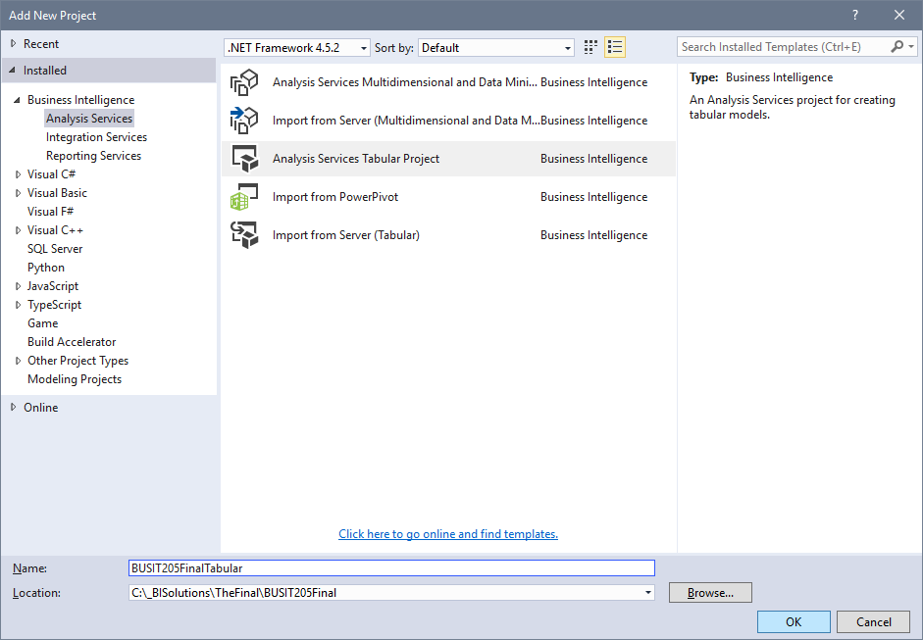

Tabular

Go to “**Model**” on the tool bar menu, then “**Import from Data Source**”.

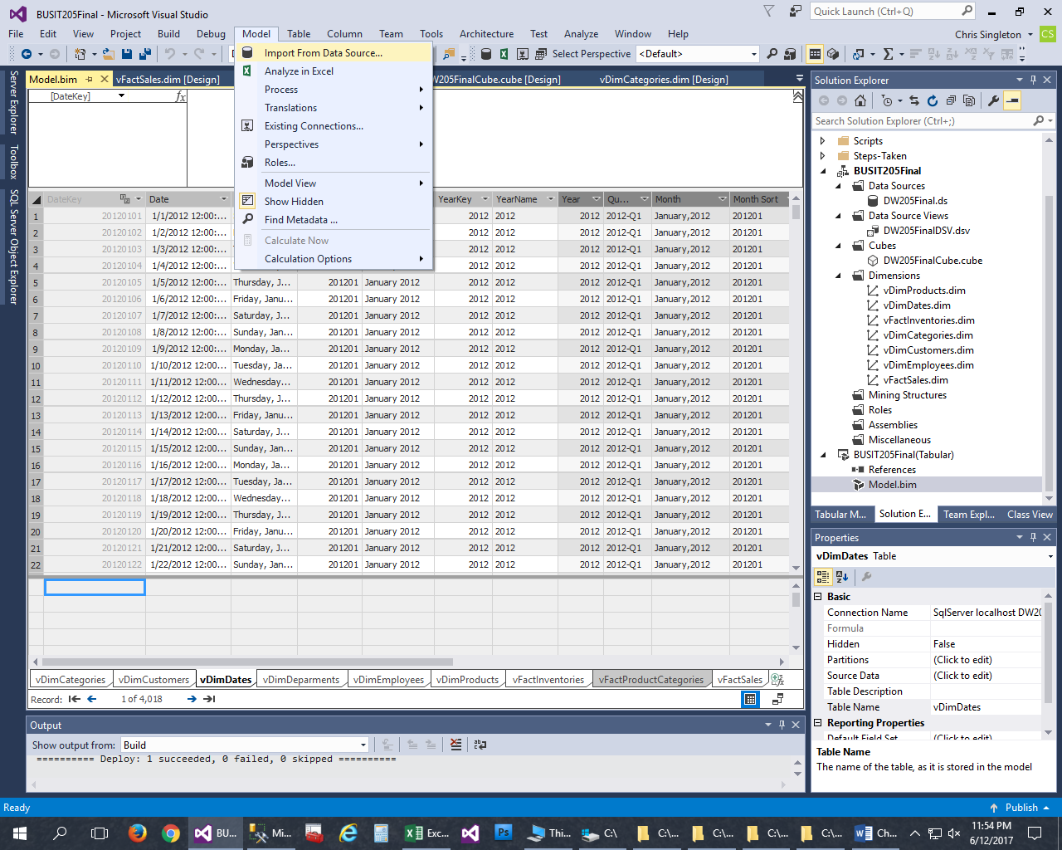

**Configure the connection.**

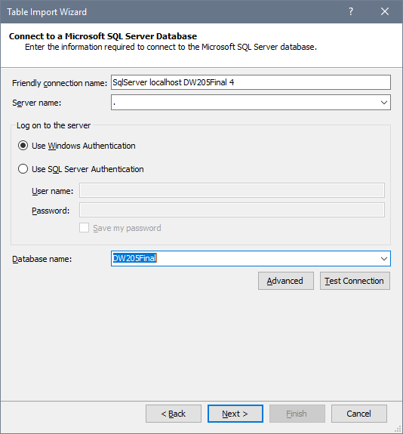

Choose “Service Account”.

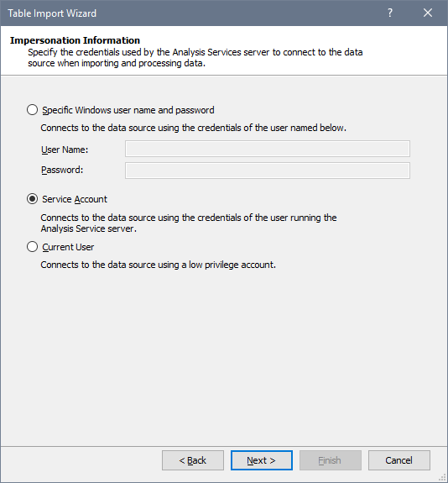

**Select the tables and click “Finish”.**

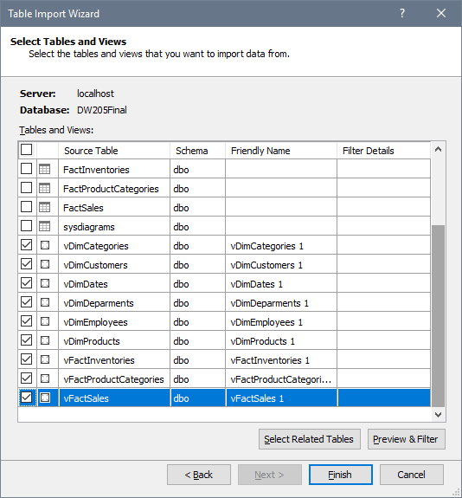

Then arrange the tables, drag drop from fact tables to dimension tables.

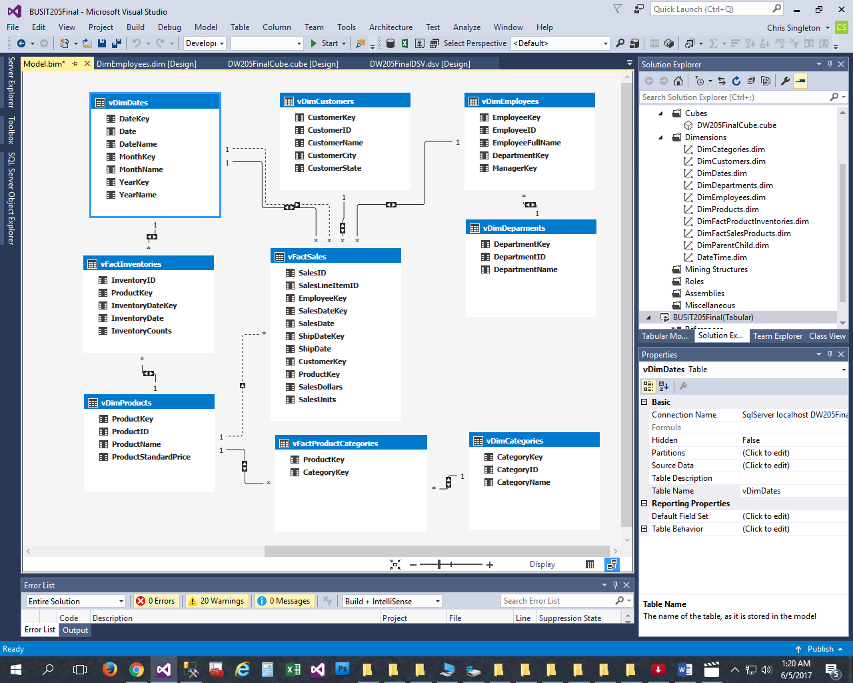

Create Hierarchies by right clicking on a table and selecting “Create Hierarchy”.

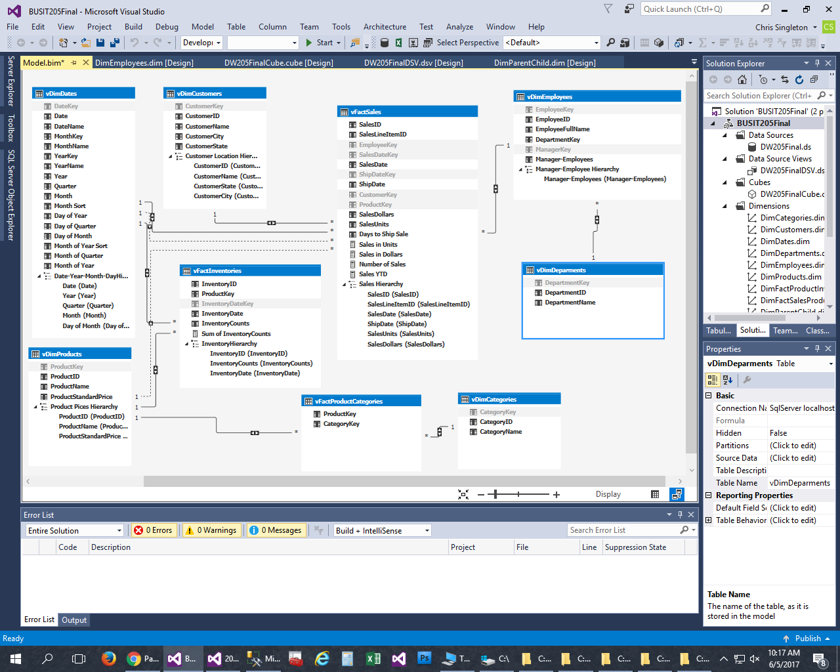

Simulate Parent-Child in the Employee Table inside Tabular by using the “**Path**” function.

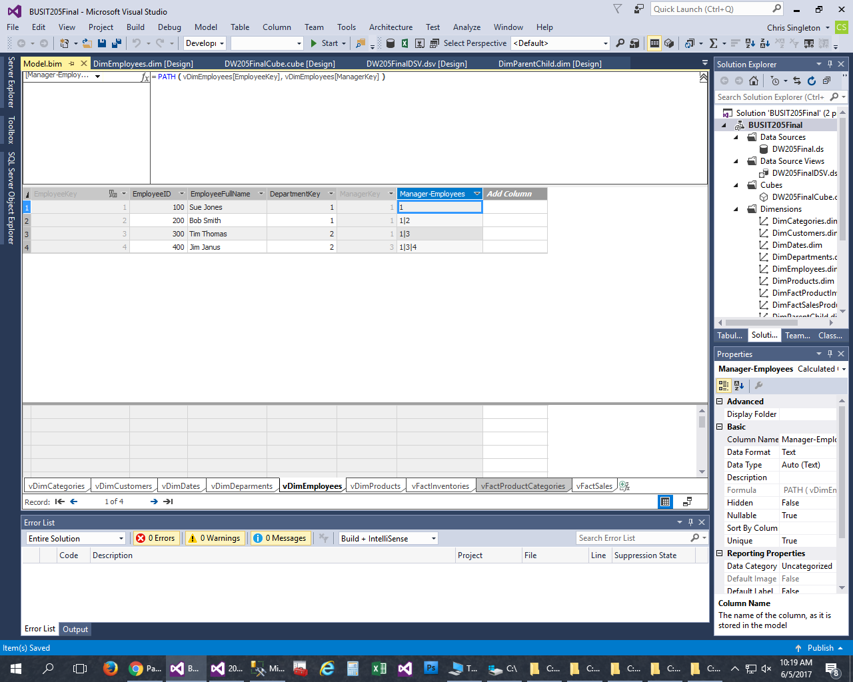

**Create Calculated Columns in Tabular.**

**Place your formula in the upper window in “Grid” mode.**

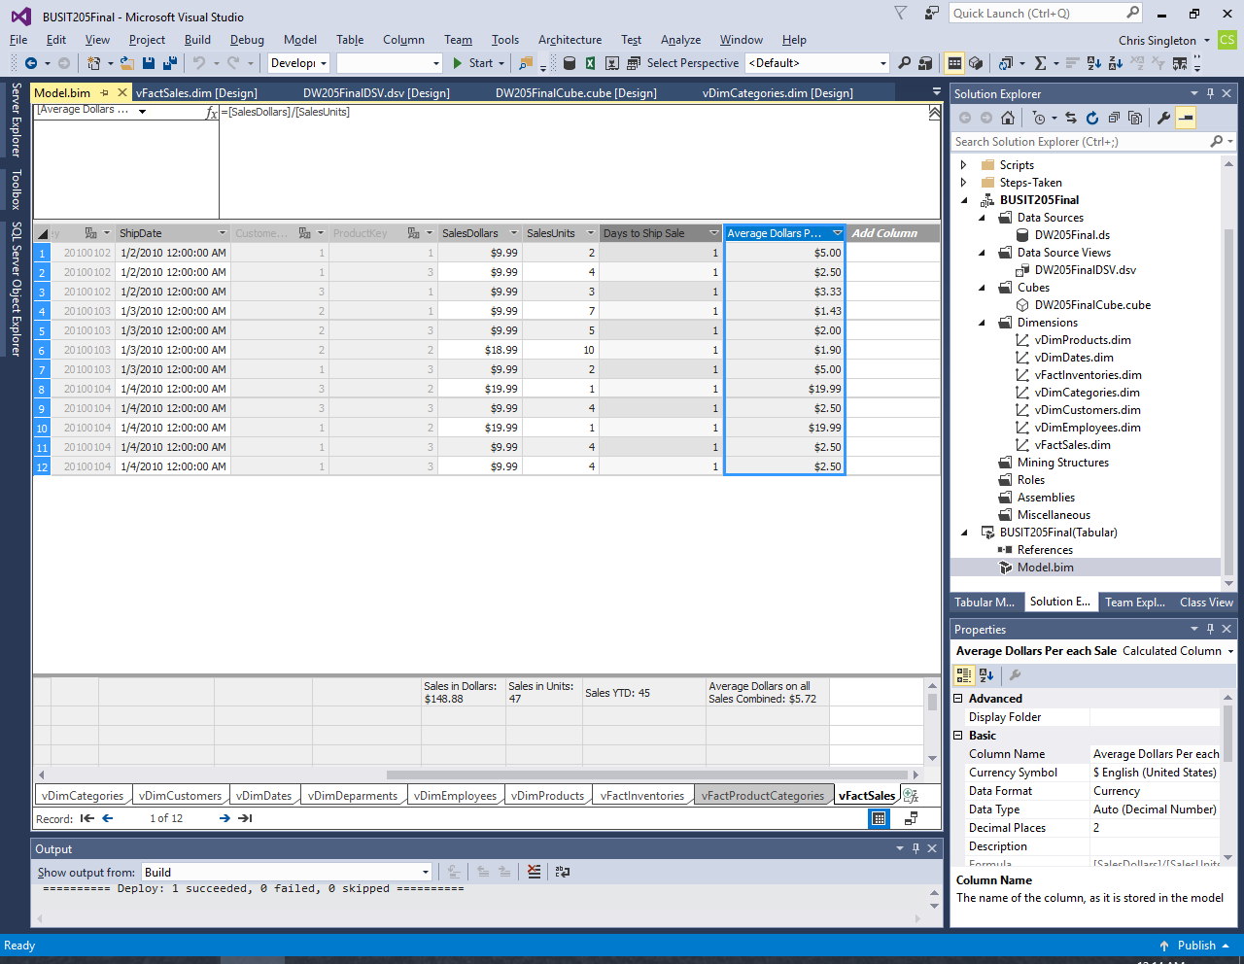

**Results in “Diagram” mode.**

