Directory: C:\Append TimeStamp

[How to append time stamp to the the filename while archiving the file (microsoft.com)](https://social.msdn.microsoft.com/forums/sqlserver/en-us/50ac4d6e-a3f6-421b-8757-ec59b7f6175e/how-to-append-time-stamp-to-the-the-filename-while-archiving-the-file?forum=sqlintegrationservices)

How to append time stamp to the the filename while archiving the file [RRS feed](https://social.msdn.microsoft.com/Forums/en-US/sqlintegrationservices/thread/50ac4d6e-a3f6-421b-8757-ec59b7f6175e?outputAs=rss)

[Archived Forums 361-380](https://social.msdn.microsoft.com/Forums/sqlserver/en-US/home?category=archived361)

 >

[SQL Server Integration Services](https://social.msdn.microsoft.com/Forums/sqlserver/en-US/home?forum=sqlintegrationservices)

* **Question**
* Question

[[Sign in to vote](https://social.msdn.microsoft.com/Forums/Account/Login?ReturnUrl=https%3a%2f%2fsocial.msdn.microsoft.com%3a443%2fforums%2fsqlserver%2fen-us%2f50ac4d6e-a3f6-421b-8757-ec59b7f6175e%2fhow-to-append-time-stamp-to-the-the-filename-while-archiving-the-file%3fforum%3dsqlintegrationservices%26prof%3drequired)](https://social.msdn.microsoft.com/Forums/Account/Login?ReturnUrl=https%3a%2f%2fsocial.msdn.microsoft.com%3a443%2fforums%2fsqlserver%2fen-us%2f50ac4d6e-a3f6-421b-8757-ec59b7f6175e%2fhow-to-append-time-stamp-to-the-the-filename-while-archiving-the-file%3fforum%3dsqlintegrationservices%26prof%3drequired" \o "Vote as helpful)

[0](https://social.msdn.microsoft.com/Forums/Account/Login?ReturnUrl=https%3a%2f%2fsocial.msdn.microsoft.com%3a443%2fforums%2fsqlserver%2fen-us%2f50ac4d6e-a3f6-421b-8757-ec59b7f6175e%2fhow-to-append-time-stamp-to-the-the-filename-while-archiving-the-file%3fforum%3dsqlintegrationservices%26prof%3drequired" \o "Vote as helpful)

[Sign in to vote](https://social.msdn.microsoft.com/Forums/Account/Login?ReturnUrl=https%3a%2f%2fsocial.msdn.microsoft.com%3a443%2fforums%2fsqlserver%2fen-us%2f50ac4d6e-a3f6-421b-8757-ec59b7f6175e%2fhow-to-append-time-stamp-to-the-the-filename-while-archiving-the-file%3fforum%3dsqlintegrationservices%26prof%3drequired)

Hello,

I was trying to do append time stamp to the the filename while archiving the file. I am trying thie expression in variable.

@[User::VarArchiveFolder]+ Replace(Replace(Replace(Replace( @[User::VarFileName],".","\_"+Substring((DT\_WSTR,50) GETDATE(),1,19)+"."),"-",""),":","")," ","\_")  
+(DT\_WSTR,4)YEAR(@[System::StartTime]) + "-"   
    + RIGHT("0" + (DT\_WSTR,2)MONTH(@[System::StartTime]), 2) + "-"   
    + RIGHT("0" + (DT\_WSTR,2)DAY( @[System::StartTime]), 2) + "\_"  
    + RIGHT("0" + (DT\_WSTR,2)DATEPART("hh", @[System::StartTime]), 2) + ""  
    + RIGHT("0" + (DT\_WSTR,2)DATEPART("mi", @[System::StartTime]), 2) + ""  
    + RIGHT("0" + (DT\_WSTR,2)DATEPART("ss", @[System::StartTime]), 2) + ""  
    + RIGHT("00" + (DT\_WSTR,3)DATEPART("ms", GETDATE()), 3)

But, It's failing and showing error message could not find part of the file. So, I changed file task operation move file to rename file. It's working now. But, my source file is .csv , the file is moving to archive like file (with changing filename). Is there away still move like .csv file ?

IsDestinationPathVariable,OverWriteDestination,IsSourcePathVariable all are set as True (FYI).

Please help me in this.

Thanks

prabha

Monday, March 13, 2017 7:17 PM

Avatar of Uppuluri

[Uppuluri](https://social.msdn.microsoft.com/profile/uppuluri/?ws=usercard-mini)

0 Points

**Answers**

* Question

[[Sign in to vote](https://social.msdn.microsoft.com/Forums/Account/Login?ReturnUrl=https%3a%2f%2fsocial.msdn.microsoft.com%3a443%2fforums%2fsqlserver%2fen-us%2f50ac4d6e-a3f6-421b-8757-ec59b7f6175e%2fhow-to-append-time-stamp-to-the-the-filename-while-archiving-the-file%3fforum%3dsqlintegrationservices%26prof%3drequired)](https://social.msdn.microsoft.com/Forums/Account/Login?ReturnUrl=https%3a%2f%2fsocial.msdn.microsoft.com%3a443%2fforums%2fsqlserver%2fen-us%2f50ac4d6e-a3f6-421b-8757-ec59b7f6175e%2fhow-to-append-time-stamp-to-the-the-filename-while-archiving-the-file%3fforum%3dsqlintegrationservices%26prof%3drequired" \o "Vote as helpful)

[1](https://social.msdn.microsoft.com/Forums/Account/Login?ReturnUrl=https%3a%2f%2fsocial.msdn.microsoft.com%3a443%2fforums%2fsqlserver%2fen-us%2f50ac4d6e-a3f6-421b-8757-ec59b7f6175e%2fhow-to-append-time-stamp-to-the-the-filename-while-archiving-the-file%3fforum%3dsqlintegrationservices%26prof%3drequired" \o "Vote as helpful)

[Sign in to vote](https://social.msdn.microsoft.com/Forums/Account/Login?ReturnUrl=https%3a%2f%2fsocial.msdn.microsoft.com%3a443%2fforums%2fsqlserver%2fen-us%2f50ac4d6e-a3f6-421b-8757-ec59b7f6175e%2fhow-to-append-time-stamp-to-the-the-filename-while-archiving-the-file%3fforum%3dsqlintegrationservices%26prof%3drequired)

Hi prabha,

***>> But, my source file is .csv , the file is moving to archive like file (with changing filename). Is there away still move like .csv file ?***

If you want to move and rename the source file, please have a look at following settings.

1. Variables

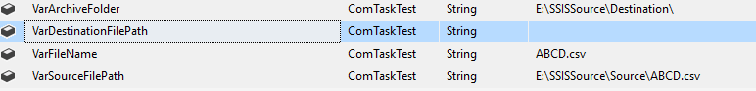

2. Package settings

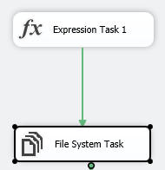

@[User::VarArchiveFolder] + Replace(Replace(Replace(@[User::VarFileName] ,".","\_"+Substring((DT\_WSTR,50) GETDATE(),1,19)+"."),":",""),"","\_")

3. Expression Task

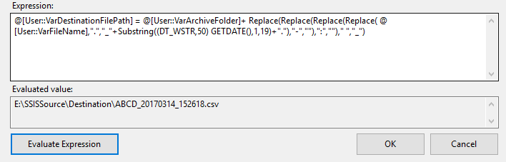

4. File System Task. Set property DelayValidation to True.

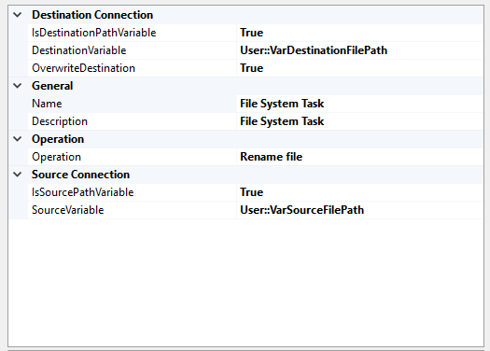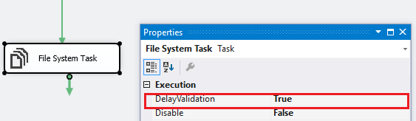

5. Result. After running, the "abcd.csv" in Source would be moved to Destination and renamed with time stamp.

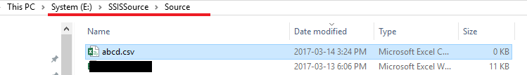

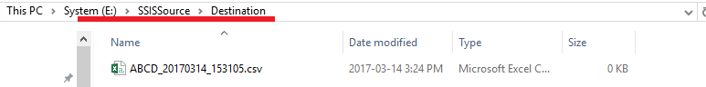

In your case, since it’s not clear how do define the two variables, if I directly use your above expression with my above variables, it would return following result which is not a right value. So, in your case, if you want to keep the archived file has .csv extension name, you’d better remove the last 7 lines which’re related to the system variable “System::StartTime”.

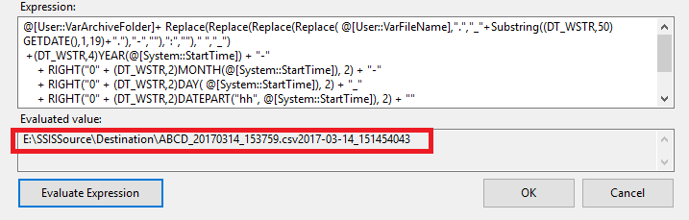

Best Regards,

Albert Zhang

MSDN Community Support  
Please remember to click "Mark as Answer" the responses that resolved your issue, and to click "Unmark as Answer" if not. This can be beneficial to other community members reading this thread. If you have any compliments or complaints to MSDN Support, feel free to contact [MSDNFSF@microsoft.com](mailto:MSDNFSF@microsoft.com).

* + Proposed as answer by [ArthurZ](https://social.msdn.microsoft.com/profile/arthurz?type=forum&referrer=https://social.msdn.microsoft.com/forums/sqlserver/en-us/50ac4d6e-a3f6-421b-8757-ec59b7f6175e/how-to-append-time-stamp-to-the-the-filename-while-archiving-the-file?forum=sqlintegrationservices" \o "About ArthurZ) *Wednesday, March 15, 2017 1:04 PM*
  + Marked as answer by [Uppuluri](https://social.msdn.microsoft.com/profile/uppuluri?type=forum&referrer=https://social.msdn.microsoft.com/forums/sqlserver/en-us/50ac4d6e-a3f6-421b-8757-ec59b7f6175e/how-to-append-time-stamp-to-the-the-filename-while-archiving-the-file?forum=sqlintegrationservices) *Wednesday, March 15, 2017 1:21 PM*

Tuesday, March 14, 2017 7:54 AM

Avatar of Albert_ Zhang

[Albert\_ Zhang](https://social.msdn.microsoft.com/profile/albert_%20zhang/?ws=usercard-mini)

4,100 Points

**All replies**

* Question

[[Sign in to vote](https://social.msdn.microsoft.com/Forums/Account/Login?ReturnUrl=https%3a%2f%2fsocial.msdn.microsoft.com%3a443%2fforums%2fsqlserver%2fen-us%2f50ac4d6e-a3f6-421b-8757-ec59b7f6175e%2fhow-to-append-time-stamp-to-the-the-filename-while-archiving-the-file%3fforum%3dsqlintegrationservices%26prof%3drequired)](https://social.msdn.microsoft.com/Forums/Account/Login?ReturnUrl=https%3a%2f%2fsocial.msdn.microsoft.com%3a443%2fforums%2fsqlserver%2fen-us%2f50ac4d6e-a3f6-421b-8757-ec59b7f6175e%2fhow-to-append-time-stamp-to-the-the-filename-while-archiving-the-file%3fforum%3dsqlintegrationservices%26prof%3drequired" \o "Vote as helpful)

[0](https://social.msdn.microsoft.com/Forums/Account/Login?ReturnUrl=https%3a%2f%2fsocial.msdn.microsoft.com%3a443%2fforums%2fsqlserver%2fen-us%2f50ac4d6e-a3f6-421b-8757-ec59b7f6175e%2fhow-to-append-time-stamp-to-the-the-filename-while-archiving-the-file%3fforum%3dsqlintegrationservices%26prof%3drequired" \o "Vote as helpful)

[Sign in to vote](https://social.msdn.microsoft.com/Forums/Account/Login?ReturnUrl=https%3a%2f%2fsocial.msdn.microsoft.com%3a443%2fforums%2fsqlserver%2fen-us%2f50ac4d6e-a3f6-421b-8757-ec59b7f6175e%2fhow-to-append-time-stamp-to-the-the-filename-while-archiving-the-file%3fforum%3dsqlintegrationservices%26prof%3drequired)

Hi Prabha,

You should do it in a Script:<http://agilebi.com/jwelch/2008/02/08/adding-headers-and-footers-to-flat-files/>

Arthur  
 [MyBlog](http://www.geekswithblogs.net/Compudicted/Default.aspx)  
  
[Twitter](https://twitter.com/ArthurZ)

Monday, March 13, 2017 7:40 PM

Avatar of ArthurZ

[ArthurZ](https://social.msdn.microsoft.com/profile/arthurz/?ws=usercard-mini)

Consultant Data Engineer...

87,847 Points

* Question

[[Sign in to vote](https://social.msdn.microsoft.com/Forums/Account/Login?ReturnUrl=https%3a%2f%2fsocial.msdn.microsoft.com%3a443%2fforums%2fsqlserver%2fen-us%2f50ac4d6e-a3f6-421b-8757-ec59b7f6175e%2fhow-to-append-time-stamp-to-the-the-filename-while-archiving-the-file%3fforum%3dsqlintegrationservices%26prof%3drequired)](https://social.msdn.microsoft.com/Forums/Account/Login?ReturnUrl=https%3a%2f%2fsocial.msdn.microsoft.com%3a443%2fforums%2fsqlserver%2fen-us%2f50ac4d6e-a3f6-421b-8757-ec59b7f6175e%2fhow-to-append-time-stamp-to-the-the-filename-while-archiving-the-file%3fforum%3dsqlintegrationservices%26prof%3drequired" \o "Vote as helpful)

[0](https://social.msdn.microsoft.com/Forums/Account/Login?ReturnUrl=https%3a%2f%2fsocial.msdn.microsoft.com%3a443%2fforums%2fsqlserver%2fen-us%2f50ac4d6e-a3f6-421b-8757-ec59b7f6175e%2fhow-to-append-time-stamp-to-the-the-filename-while-archiving-the-file%3fforum%3dsqlintegrationservices%26prof%3drequired" \o "Vote as helpful)

[Sign in to vote](https://social.msdn.microsoft.com/Forums/Account/Login?ReturnUrl=https%3a%2f%2fsocial.msdn.microsoft.com%3a443%2fforums%2fsqlserver%2fen-us%2f50ac4d6e-a3f6-421b-8757-ec59b7f6175e%2fhow-to-append-time-stamp-to-the-the-filename-while-archiving-the-file%3fforum%3dsqlintegrationservices%26prof%3drequired)

Hi Artur ,

Thnak you for your idea. We can do using variable also, instaead of script. (I am lack in scripting 0 So can you please suggest me where am I stuck ?

Thanks

prabha

* + Edited by [Uppuluri](https://social.msdn.microsoft.com/profile/uppuluri?type=forum&referrer=https://social.msdn.microsoft.com/forums/sqlserver/en-us/50ac4d6e-a3f6-421b-8757-ec59b7f6175e/how-to-append-time-stamp-to-the-the-filename-while-archiving-the-file?forum=sqlintegrationservices) *Monday, March 13, 2017 7:57 PM*

Monday, March 13, 2017 7:56 PM

Avatar of Uppuluri

[Uppuluri](https://social.msdn.microsoft.com/profile/uppuluri/?ws=usercard-mini)

0 Points

* Question

[[Sign in to vote](https://social.msdn.microsoft.com/Forums/Account/Login?ReturnUrl=https%3a%2f%2fsocial.msdn.microsoft.com%3a443%2fforums%2fsqlserver%2fen-us%2f50ac4d6e-a3f6-421b-8757-ec59b7f6175e%2fhow-to-append-time-stamp-to-the-the-filename-while-archiving-the-file%3fforum%3dsqlintegrationservices%26prof%3drequired)](https://social.msdn.microsoft.com/Forums/Account/Login?ReturnUrl=https%3a%2f%2fsocial.msdn.microsoft.com%3a443%2fforums%2fsqlserver%2fen-us%2f50ac4d6e-a3f6-421b-8757-ec59b7f6175e%2fhow-to-append-time-stamp-to-the-the-filename-while-archiving-the-file%3fforum%3dsqlintegrationservices%26prof%3drequired" \o "Vote as helpful)

[0](https://social.msdn.microsoft.com/Forums/Account/Login?ReturnUrl=https%3a%2f%2fsocial.msdn.microsoft.com%3a443%2fforums%2fsqlserver%2fen-us%2f50ac4d6e-a3f6-421b-8757-ec59b7f6175e%2fhow-to-append-time-stamp-to-the-the-filename-while-archiving-the-file%3fforum%3dsqlintegrationservices%26prof%3drequired" \o "Vote as helpful)

[Sign in to vote](https://social.msdn.microsoft.com/Forums/Account/Login?ReturnUrl=https%3a%2f%2fsocial.msdn.microsoft.com%3a443%2fforums%2fsqlserver%2fen-us%2f50ac4d6e-a3f6-421b-8757-ec59b7f6175e%2fhow-to-append-time-stamp-to-the-the-filename-while-archiving-the-file%3fforum%3dsqlintegrationservices%26prof%3drequired)

I thought somehow you wanted to append the data inside the file as a footer,

I was wrong. Sorry.

You did it right, if you want to move and rename in one hit this is correct what you did.

Otherwise, you need to move 1st, then rename the file.

A one step operation:

<http://www.rafael-salas.com/2007/03/ssis-file-system-task-move-and-rename.html>

Arthur  
 [MyBlog](http://www.geekswithblogs.net/Compudicted/Default.aspx)  
  
[Twitter](https://twitter.com/ArthurZ)

* + Proposed as answer by [Albert\_ Zhang](https://social.msdn.microsoft.com/profile/albert_%20zhang?type=forum&referrer=https://social.msdn.microsoft.com/forums/sqlserver/en-us/50ac4d6e-a3f6-421b-8757-ec59b7f6175e/how-to-append-time-stamp-to-the-the-filename-while-archiving-the-file?forum=sqlintegrationservices) *Tuesday, March 14, 2017 7:54 AM*

Monday, March 13, 2017 8:44 PM

Avatar of ArthurZ

[ArthurZ](https://social.msdn.microsoft.com/profile/arthurz/?ws=usercard-mini)

Consultant Data Engineer...

87,847 Points

* Question

[[Sign in to vote](https://social.msdn.microsoft.com/Forums/Account/Login?ReturnUrl=https%3a%2f%2fsocial.msdn.microsoft.com%3a443%2fforums%2fsqlserver%2fen-us%2f50ac4d6e-a3f6-421b-8757-ec59b7f6175e%2fhow-to-append-time-stamp-to-the-the-filename-while-archiving-the-file%3fforum%3dsqlintegrationservices%26prof%3drequired)](https://social.msdn.microsoft.com/Forums/Account/Login?ReturnUrl=https%3a%2f%2fsocial.msdn.microsoft.com%3a443%2fforums%2fsqlserver%2fen-us%2f50ac4d6e-a3f6-421b-8757-ec59b7f6175e%2fhow-to-append-time-stamp-to-the-the-filename-while-archiving-the-file%3fforum%3dsqlintegrationservices%26prof%3drequired" \o "Vote as helpful)

[0](https://social.msdn.microsoft.com/Forums/Account/Login?ReturnUrl=https%3a%2f%2fsocial.msdn.microsoft.com%3a443%2fforums%2fsqlserver%2fen-us%2f50ac4d6e-a3f6-421b-8757-ec59b7f6175e%2fhow-to-append-time-stamp-to-the-the-filename-while-archiving-the-file%3fforum%3dsqlintegrationservices%26prof%3drequired" \o "Vote as helpful)

[Sign in to vote](https://social.msdn.microsoft.com/Forums/Account/Login?ReturnUrl=https%3a%2f%2fsocial.msdn.microsoft.com%3a443%2fforums%2fsqlserver%2fen-us%2f50ac4d6e-a3f6-421b-8757-ec59b7f6175e%2fhow-to-append-time-stamp-to-the-the-filename-while-archiving-the-file%3fforum%3dsqlintegrationservices%26prof%3drequired)

(If I remember correctly), The move file option expects the Destination variable to be a directory, not a file which is why you get a failure on move file. To move and rename, follow like you've done. Not sure what you mean about "is there a way still move like .csv file", the end file will be whatever you name it.

Tuesday, March 14, 2017 1:09 AM

Avatar of RyanAB

[RyanAB](https://social.msdn.microsoft.com/profile/ryanab/?ws=usercard-mini)

5,455 Points

* Question

[[Sign in to vote](https://social.msdn.microsoft.com/Forums/Account/Login?ReturnUrl=https%3a%2f%2fsocial.msdn.microsoft.com%3a443%2fforums%2fsqlserver%2fen-us%2f50ac4d6e-a3f6-421b-8757-ec59b7f6175e%2fhow-to-append-time-stamp-to-the-the-filename-while-archiving-the-file%3fforum%3dsqlintegrationservices%26prof%3drequired)](https://social.msdn.microsoft.com/Forums/Account/Login?ReturnUrl=https%3a%2f%2fsocial.msdn.microsoft.com%3a443%2fforums%2fsqlserver%2fen-us%2f50ac4d6e-a3f6-421b-8757-ec59b7f6175e%2fhow-to-append-time-stamp-to-the-the-filename-while-archiving-the-file%3fforum%3dsqlintegrationservices%26prof%3drequired" \o "Vote as helpful)

[1](https://social.msdn.microsoft.com/Forums/Account/Login?ReturnUrl=https%3a%2f%2fsocial.msdn.microsoft.com%3a443%2fforums%2fsqlserver%2fen-us%2f50ac4d6e-a3f6-421b-8757-ec59b7f6175e%2fhow-to-append-time-stamp-to-the-the-filename-while-archiving-the-file%3fforum%3dsqlintegrationservices%26prof%3drequired" \o "Vote as helpful)

[Sign in to vote](https://social.msdn.microsoft.com/Forums/Account/Login?ReturnUrl=https%3a%2f%2fsocial.msdn.microsoft.com%3a443%2fforums%2fsqlserver%2fen-us%2f50ac4d6e-a3f6-421b-8757-ec59b7f6175e%2fhow-to-append-time-stamp-to-the-the-filename-while-archiving-the-file%3fforum%3dsqlintegrationservices%26prof%3drequired)

Hi prabha,

***>> But, my source file is .csv , the file is moving to archive like file (with changing filename). Is there away still move like .csv file ?***

If you want to move and rename the source file, please have a look at following settings.

1. Variables



2. Package settings



3. Expression Task



4. File System Task. Set property DelayValidation to True.



5. Result. After running, the "abcd.csv" in Source would be moved to Destination and renamed with time stamp.





In your case, since it’s not clear how do define the two variables, if I directly use your above expression with my above variables, it would return following result which is not a right value. So, in your case, if you want to keep the archived file has .csv extension name, you’d better remove the last 7 lines which’re related to the system variable “System::StartTime”.



Best Regards,

Albert Zhang

MSDN Community Support  
Please remember to click "Mark as Answer" the responses that resolved your issue, and to click "Unmark as Answer" if not. This can be beneficial to other community members reading this thread. If you have any compliments or complaints to MSDN Support, feel free to contact [MSDNFSF@microsoft.com](mailto:MSDNFSF@microsoft.com).

* + Proposed as answer by [ArthurZ](https://social.msdn.microsoft.com/profile/arthurz?type=forum&referrer=https://social.msdn.microsoft.com/forums/sqlserver/en-us/50ac4d6e-a3f6-421b-8757-ec59b7f6175e/how-to-append-time-stamp-to-the-the-filename-while-archiving-the-file?forum=sqlintegrationservices" \o "About ArthurZ) *Wednesday, March 15, 2017 1:04 PM*
  + Marked as answer by [Uppuluri](https://social.msdn.microsoft.com/profile/uppuluri?type=forum&referrer=https://social.msdn.microsoft.com/forums/sqlserver/en-us/50ac4d6e-a3f6-421b-8757-ec59b7f6175e/how-to-append-time-stamp-to-the-the-filename-while-archiving-the-file?forum=sqlintegrationservices) *Wednesday, March 15, 2017 1:21 PM*

Tuesday, March 14, 2017 7:54 AM

Avatar of Albert_ Zhang

[Albert\_ Zhang](https://social.msdn.microsoft.com/profile/albert_%20zhang/?ws=usercard-mini)

4,100 Points

<https://msbitutor.blogspot.com/2018/12/variable-used-as-source-or-destination.html>

### Variable used as a source or destination and is empty SSIS

- [December 04, 2018](https://msbitutor.blogspot.com/2018/12/variable-used-as-source-or-destination.html)

**Error:**  
Variable used as a source or destination and is empty SSIS  
  
**Solution :**  
  
Step 1:  
Click on that variable and press F4, that will take you to properties.  
Set EvaluteAsExpression=True  
  
Step 2:  
Set the DelayValidation property for the File System Task to True

[SSIS](https://msbitutor.blogspot.com/search/label/SSIS)

Set Variables (Below) 🡪

